Create an EC2 instance with ubuntu os.

Update the environment with command “sudo apt update”

Install docker with command “sudo apt install docker.io”

Pull the image from docker hub as below.

“sudo docker pull smaddula1982/houseprice:2.0”

Run the container using the below command.

“sudo docker run -it --name houseprice2 smaddula1982/houseprice:2.0”

The model will predict the test data price and ask for creation of synthetic data to predict price as below.

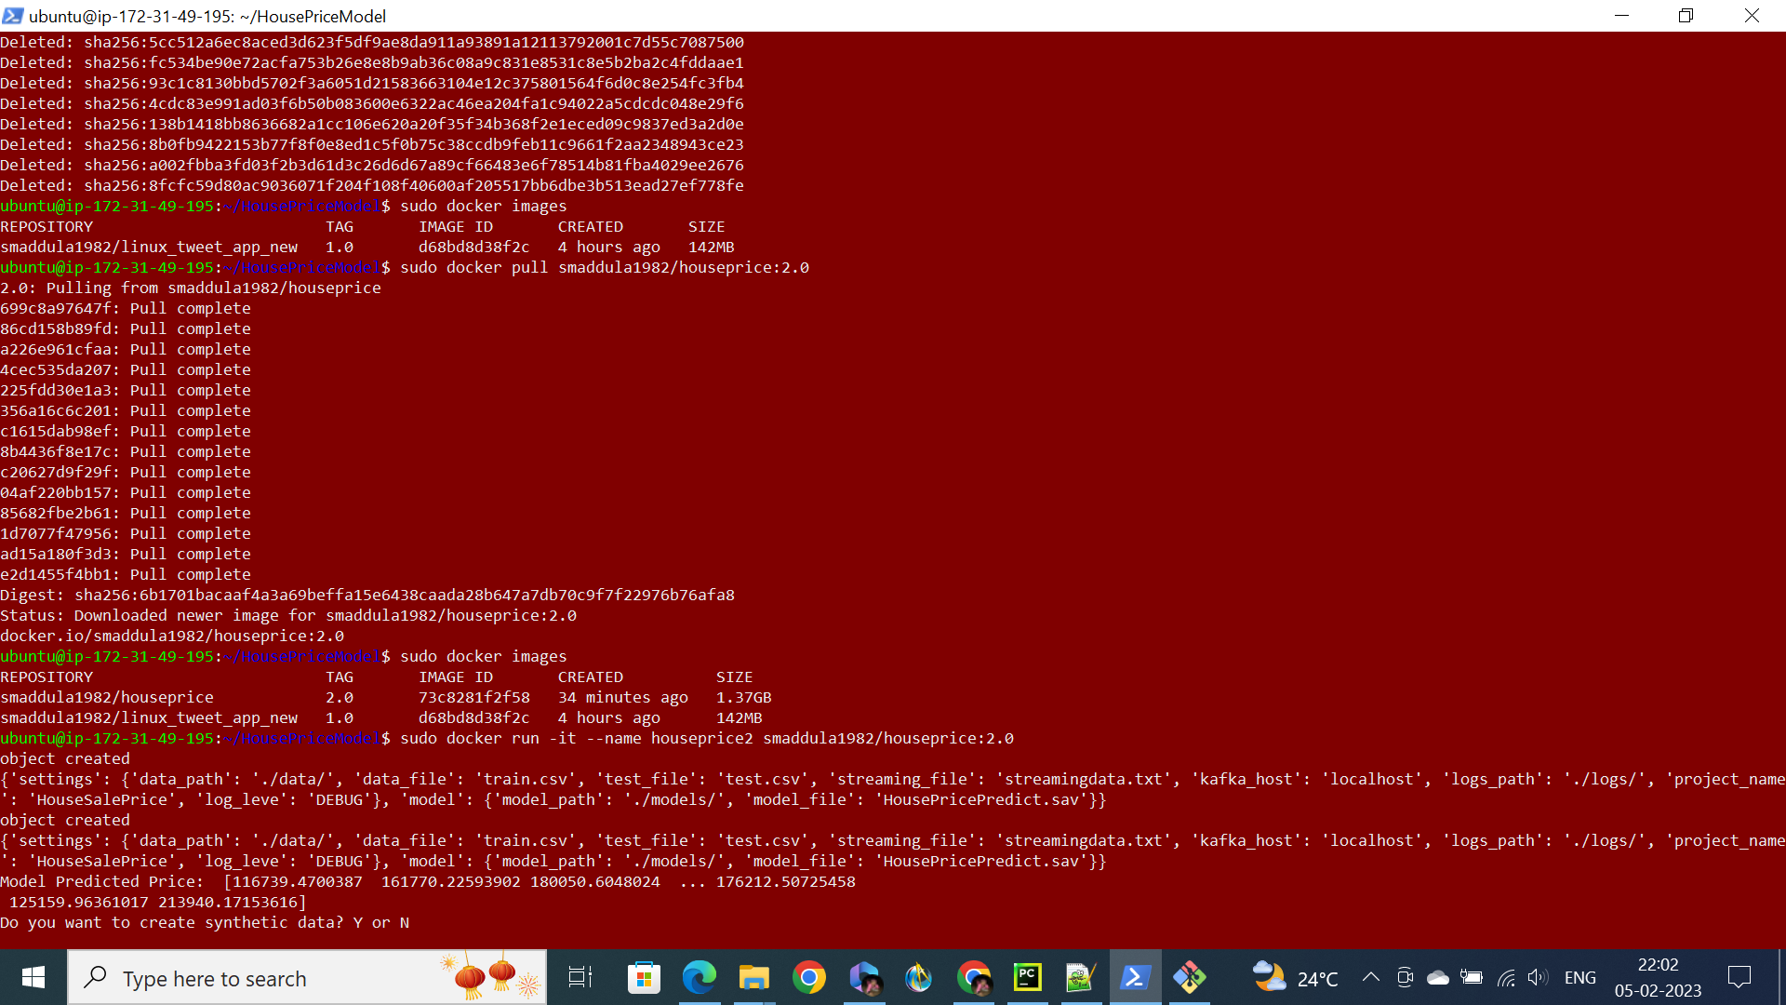

Press Y the model will create the sythetic data and predict the price of the created data as show below.

