1) Run Jenkins using below command

java -jar jenkins.war --httpPort=8282

2) Open the url http://localhost:8282/

3) Login with credentials

4) Configure Maven and JDK

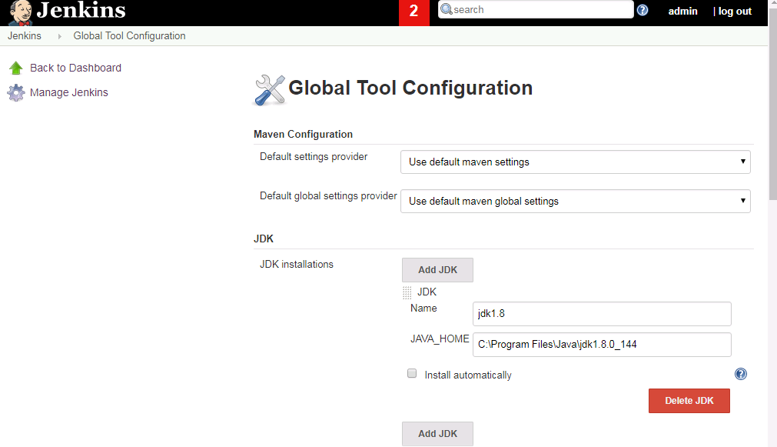

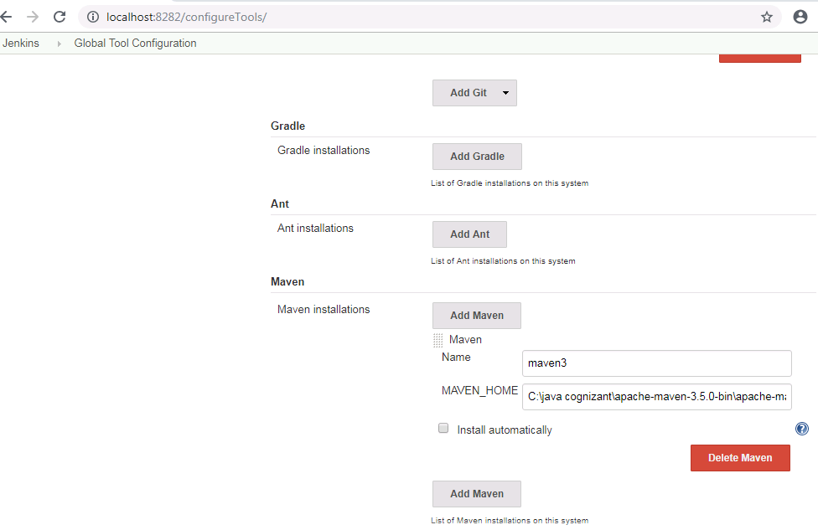

5) Create a new Pipeline project and configure git repository

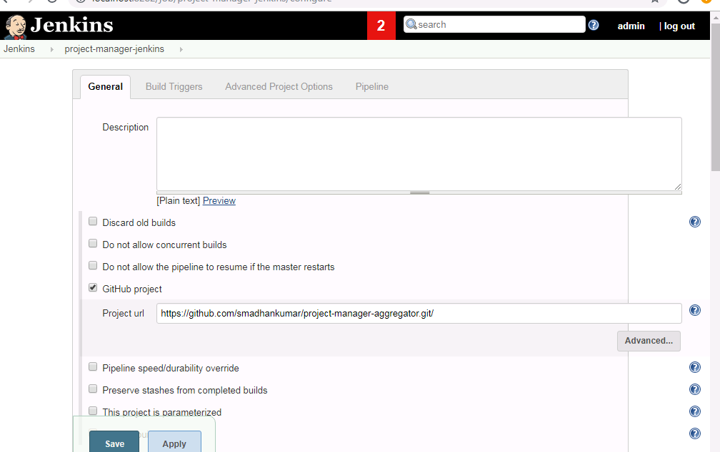

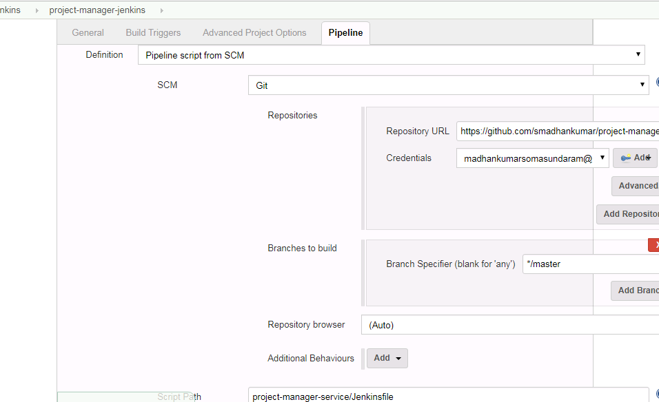

6) Click on Build Now option

