VISVESVARAYA TECHNOLOGICAL UNIVERSITY

Belagavi - 590018

Mini Project Report

Artificial Intelligence and Digital Image Processing

“3D Face Mesh Modeling for 3D Face Recognition”
BACHELOR OF ENGINEERING
IN
COMPUTER SCIENCE & ENGINEERING
Submitted by
NAME: Madhu Sudhan S
USN : 1DT19CS074

Guide:
Mrs. Chethana V

Prof. Dept. of CSE,
Department of Computer Science & Engineering

DAYANADA SAGAR ACADEMY OF TECHNOLOGY AND MANAGEMENT
Kanakapura Road, Udayapura, Bangalore-560 082
2022-2023
1

CONTENTS

Sl.  No. | Topic | Page No.
1 | Introduction | 1
 | 1.1 Introduction | 1
 | 1.2 Motivation | 3
2 | System Requirements | 4
 | 2.1 Hardware Requirements: | 4
 | 2.2 Software Requirements: | 4
3 | System Design | 5
 | 3.1 Implementation | 5
 | 3.2 Preprocessing | 5
 | 3.3 Predictive Modelling | 6
 | 3.4 Algorithm  3.5 3D facial points segmentation  3.6 face recognition  3.7 Range image database | 6  8  8  8
4 | Sample Code | 9
 | 4.1 Machine Learning Code | 9
5 | Conclusion | 12

Chapter 1

Introduction

Introduction

Face recognition has been a hot research area for its wide range of applications [1]. In human identification scenarios, facial metrics are more naturally accessible than many other biometrics, such as iris, fingerprint, and palm print [2]. Face recognition is also highly valuable in human computer interaction, access control, video surveillance, and many other applications.
Although 2D face recognition research made significant progresses in recent years, its accuracy is still highly depended on light conditions and human poses [3, 4]. When the light is dim or the face poses are not properly aligned in the camera view, the recognition accuracy will suffer.
The fast evolution of 3D sensors reveals a new path for face recognition that could overcome the fundamental limitations of 2D technologies. The geometric information contained in 3D facial data could substantially improve the recognition accuracy under conditions that are difficult for 2D technologies [5]. Many researchers have turned their focuses to 3D face recognition and made this research area a new trend.
A general work flow for 3D face recognition is shown in Fig. 1. The work flow could be decomposed into two phases and five stages. In the training phase, 3D face data are acquired and then preprocessed to obtain “clean” 3D faces. Then the data are processed by feature extraction algorithms to find the features that could be used to differentiate faces. The features of each face are then stored into the feature database. In the testing phase, the target face goes through the acquisition, preprocessing, and feature extraction stages that are identical to the stages in the training phase. In the feature matching stage, the features of the target face are compared with the faces stored in the feature database and calculate the match scores. When a match score is sufficiently high, we would claim that the target face is recognized.

As a result, it becomes more challenging and computationally expensive to accurately match two sets of 3D data (e.g., matching a subject’s probe data with the gallery’s). Our objective in this chapter is to illustrate a model- based approach that represents the 3D facial da ta of a given subject by a deformed 3D mesh model useful for face recognition application (Ansari, 2007). The general block diagram of the system is shown in Fig.1, which consists of the modeling stage and the recognition stage. In the modeling stage, only three facial feature points are first extracted from the range image and then used to align the 3D generic face model to the entire range data of a given subject’s face. Then each aligned triangle of the mesh model, with three vertices, is treated as a surface plane which is then fitted (deformed) to its corresponding interior 3D range data, using least squares plane fitting. Via triangular vertices subdivisions, a higher resolution model is generated from the coordinates of the aligned and fitted model. Finally the model and its triangular surfaces are fitted once again resulting in a smoother mesh model that resembles and captures the surface characteristic of the face. In the recognition stage, a 3D probe face is similarly modeled and compared to all faces in the database. Experimental application of the final deformed model in 3D face recognition, using a publicly available database, demonstrates promising recognition rates.

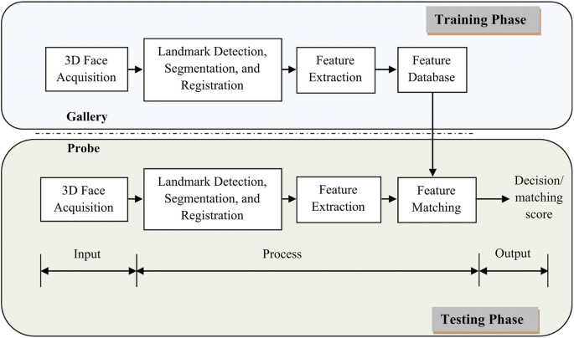

Fig. 1. 3D face modeling and recognition system.

Motivation

There are many existing algorithms handles the human face recognition. The purpose of these algorithms is to achieve an optimal recognition rate or near optimal recognition rate in real-time processing time. However, none of the algorithms achieved a100% recognition rate. Therefore, human face recognition is an incredibly exciting field for researchers. The neural network classifier is relying on robust features extraction methods. Neural network performs well with a low error rate by feeding strong distinction patterns and features. This research is motivated by the drawbacks and limitations of existing systems. Existing methods relays on simple preprocessing methods such as face detection and simple image using the traditional methods by adding an extra step (step 3) to obtain the T-Set based on the correlated training Dataset. .

CHAPTER 2
System Requirements

Hardware Requirements:

    - Processor : Intel Core i5

    - RAM Size : 8 GB

    - Keyboard : Standard QWERTY serial

    - Mouse : Standard serial or PS/2 mouse

    - Hard disk : 500 GB

Software Requirements:

    - Operating System : Windows 10

    - Platform : VS Code ,React .JS

    - Languages Used : Python

    - Domain : Machine Learning

    - Backend : Python and its various libraries like NumPy, Pandas, Matplotlib, Sklearn.

CHAPTER 3
System Design

Implementation
The dataset contains 5110 observations with 12 attributes. These 5110 observations are used in pre-processing. We import the dataset into our jupyter notebook.

Preprocessing

This section explains the pre-processing of the data, localization of the facial region, and the facial features extraction. Further details ar e given in (Mahoor et al., 2007). Range images, captured by laser scanners, have some artifacts, noise, and gaps. In the pre-processing step, we first apply median filtering to remove sharp spikes and noise, that occur during the scanning of the face, followed by interpolation to fill up the gaps, and low pass filtering to smooth the final surface. This is followed by face localization using facial template matching to discard the neck, hair, and the background areas of the range image. The facial range image template is correlated with the range images of a given face using normalized cross- correlation. We start by roughly detecting the lo cation of the nose tip and then translate the template such that the detected tip of the nose is placed on the location of the nose tip of the range image under test. Afterward, we iteratively apply a rigid transformation to the template and cross-correlate the result with the subject’s range image to find the best pose. Finally, the area underneath the template with the maximum correlation is considered as the localized facial region. Subsequently, we use Gaussian curvature to extract the two inner corners of the eyes and the tip of the nose. The surface that either has a peak or a pit shape has a positive Gaussian curvature value K > 0 (Dorai & Jain, 1997). Each of the two inner corners of the eyes has a pit surface type and the tip of the nose has a peak surface type that is detectable based on the Gaussian curvature. These points have the highest positive Gaussian curvature values among the points on the face surface. Fig.2.a shows the result of calculating the Gaussian curvature for one of the sample range images in the gallery.

3.3 Predictive Modelling

This section deals with modeling the human face using its extracted features and a generic 3D mesh model. The idea is to align the 3D model to a given face using the extracted 3D features then proceed with fitting the aligned triangles of the mesh to the range data, using least square plane fitting. Next, the aligned triangles of the model are subdivided to higher resolution triangles, before applying a seco nd round of plane fitting, to obtain a more realistic and a smoother fitted surface resembling the actual surface of the face. Fig.3.a shows our neutral 3D model with a total of 109 labeled feature vertices and 188 defined polygonal meshes. In addition, the model is design ed such that the left and right sides of the jaw fall within but not on the edges of th e face boundary. This approach avoids incorporating inaccurate data at the facial edges of the captured range images. We explain next the process of aligning the mesh model
to the range data

3.4 Global alignment

In the global alignment step, we rigidly align the 3D model using the three 3D feature points, P_{I}, obtained from the range image, and their corresponding feature vertices, P_{M}, in the model. Subscripts _{I} and _{M} indicate image features and model vertices, respectively. To achieve this goal, the model must be rotated, translated, and scaled. Eq.1 gives the sum squared error between P_{I} and P_{M} in terms of scale S, rotation R, and translation T for n = 3 points.

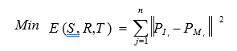

3.5 3D facial points segmentation

The first step prior to deforming the model is to segment and extract the 3D data points facing (above, below, or within) each mesh triangle using a computer graphic technique referred to as Barycentric Coordinate (Coxeter, 1969). A barycentric combination of three point vertices P₁, P₂, and P₃, forming a triangular plane is shown in Fig.4

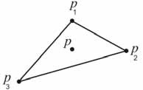

Fig. 4. The barycentric coordinates of a point p with respect to the triangle vertices. The coordinate of point p inside the triangle is defined by
Therefore, p lies inside the triangle and we say [ u, v, w] are the barycentric coordinates of p
with respect to p₁, p₂, and p₃ respectively. Equivalently, we may write

Now shows a 2D view of an actual 3D mesh model, superimposed on the range data points. The figure shows an example of segmented 3D data points within one triangle of the eyebrow meshes. We show next how to fit and de form the model’s triangles to be as closely as possible to the 3D data.
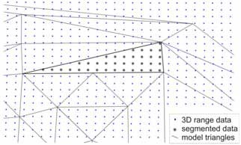
Fig. 6. Segmentation example of the 3D data points within one triangle using barycentric coordinates.

3.6 3D face recognition
Face recognition has received great attentions in the past few years. A recent literature
survey for 3D face recognition is given by (B owyer et al., 2006). The final result of Fig.10 gives a model with 401 deformed vertices specific to a given subject’s 3D range data. In this section we explore for different subjects the us e of the deformed final models in 3D face recognition. The recognition score is based on a decision level classifier applied to the
deformed models obtained from ranges images of a public database.

3.7 Range image database

The range images we use in this chapter are obtained from the publicly available GAVAB database captured by a 3D scanner (Moreno & Sanchez, 2004). This database contains seven facial range images of 61 subjects: two frontal images with normal expression, two images looking up and down, and three images with facial expression. Many subjects contain instances of dark regions in the face which do not reflect successful 3D scanning, producing in these cases incomplete facial surfaces. As a result, range image pre-processing and filtering are necessary preliminary steps. In this chapter, we are only concerned with modeling and recognizing the frontal images of the database under neutral expressions. Figure 11 contains an example of two views of the texture and range images of one subject. The texture images are not publicly available. For both sets of the frontal range images we obtain the 3D face models as outlined in previous section. One model is used as a query (probe) and the other model is used in th e gallery (database). We explain next the recognition technique.

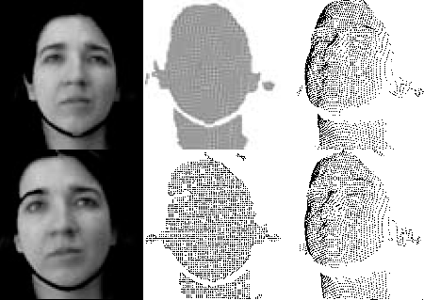

Fig. 11. Subject example of GavabDB (a) Textur ed 3D image (b) Same image without texture
(c) Same image rotated in 3D.

CHAPTER 4
Sample Code

4.1 React .JS Code

import React, { useRef } from "react";
import "./App.css";
import * as tf from "@tensorflow/tfjs";

import * as facemesh from "@tensorflow-models/facemesh";
import Webcam from "react-webcam";
import { drawMesh } from "./utilities";

function App() {
const webcamRef = useRef(null);
const canvasRef = useRef(null);

// Load posenet
const runFacemesh = async () => {
const net = await facemesh.load({
inputResolution: { width: 640, height: 480 },
scale: 0.8,
});
setInterval(()=>{
detect(net)
},100)
};

const detect = async (net) => {
if (
typeof webcamRef.current !== "undefined" &&
webcamRef.current !== null &&
webcamRef.current.video.readyState === 4
) {
// Get Video Properties
const video = webcamRef.current.video;
const videoWidth = webcamRef.current.video.videoWidth;
const videoHeight = webcamRef.current.video.videoHeight;

// Set video width
webcamRef.current.video.width = videoWidth;
webcamRef.current.video.height = videoHeight;

// Set canvas width
canvasRef.current.width = videoWidth;
canvasRef.current.height = videoHeight;

// Make Detections

const face = await net.estimateFaces(video);
console.log(face);

// Get canvas context
const ctx = canvasRef.current.getContext("2d");
requestAnimationFrame(()=>{drawMesh(face, ctx)});
}
};

runFacemesh();

return (
<div className="App">
<header className="App-header">
<Webcam
ref={webcamRef}
style={{
position: "absolute",
marginLeft: "auto",
marginRight: "auto",
left: 0,
right: 0,
textAlign: "center",
zindex: 9,
width: 640,
height: 480,
}}
/>

<canvas
ref={canvasRef}
style={{
position: "absolute",
marginLeft: "auto",
marginRight: "auto",
left: 0,
right: 0,
textAlign: "center",
zindex: 9,
width: 640,
height: 480,
}}
/>
</header>
</div>
);
}

export default App;

Chapter 5

Conclusion

A model-based algorithm for 3D face recognition from range images is presented. The algorithm relies on deforming the triangular meshes of the model to the range data establishing direct model vert ices correspondences with ot her deformed models in the database. These features correspondences gr eatly facilitate faster computational time, accuracy, and recognition comparisons. By only detecting three facial features and a generic model, we achieved a 90.2% rank one identification rate using a noisy database. The presented method is proved to be useful for fa ce recognition. However, the method can also be sensitive to noisy or missing data under the mesh model. In the conducted experiments, six subjects out of the 61 were not correctly recognized. The wrong recognition was mainly

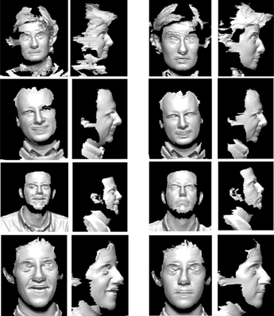
due to the dataset being either very noisy, incomplete, or the query range image set looks very different from the database set. Unfort unately, the range data pre-processing and filtering.
Fig. 15. Probe and database range images of four out of six subjects misrecognized.

