VISVESVARAYA TECHNOLOGICAL UNIVERSITY

Belagavi - 590018

Mini Project Report

Digital Image Processing

“AI Hand Pose Estimation”
BACHELOR OF ENGINEERING
IN
COMPUTER SCIENCE & ENGINEERING
Submitted by
NAME: Kruthik J
USN : 1DT19CS071

Guide:
Mrs. Chethana V

Prof. Dept. of CSE,
Department of Computer Science & Engineering

DAYANADA SAGAR ACADEMY OF TECHNOLOGY AND MANAGEMENT
Kanakapura Road, Udayapura, Bangalore-560 082
2022-2023
1

CONTENTS

Sl.  No. | Topic | Page No.
1 | Introduction | 1
 | 1.1 Introduction | 1
 | 1.2 Motivation | 2
2 | System Requirements | 3
 | 2.1 Hardware Requirements: | 3
 | 2.2 Software Requirements: | 3
3 | System Design | 4
 | 3.1 Implementation | 4
 | 3.2 Depth-based Methods | 4
 | 3.3 Image-bases Methods | 7
4 | Sample Code | 11
 | 4.1 React .JS Code | 11
5 | Conclusion | 14

2

Chapter 1

Introduction

Introduction

Hand pose estimation is currently getting a lot of attention in the computer vision field. Since the invention of Deep Learning, researchers started to apply it in all computer vision fields and get a breakthrough result and hand pose estimation was not an exception. In addition the RGBD cameras which produce depth map have become cheap, which lowers the cost of making and using hand base systems. On the other hand, huge investment of big tech companies like Google, Microsoft and Facebook on Augmented Reality (AR), Virtual Reality (VR) and Mixed Reality (MR) technology as new interactive personal computers, has broadened the applications of this field. Consequently, a relatively new branch in Human Computer Interaction (HCI) has been introduced to study the systems controlled by understanding user’s hands. In [20], Lee et al. detected hands to render an object in AR environment on the hand which was proportional to hand size. Piumsomboon et al. [27] focused on guessability in 40 different tasks in AR environment with studying hand gestures. Jang et al. [16] build an AR/VR system in egocentric viewpoint which was completely controllable via user’s hands. Figure 1 shows one of the applications of hand pose estimation used in egocentric viewpoint in AR/VR headset [16]. Nevetheless the applications of hand pose estimation are not limited to AR/VR technologies. Sridhar et al. [40] built a system working with a number of finger actions. Markussen et al. [21] also proposed a mid-air keyboard to type on air. Yin et al. [54] used hand pose estimation to design a system that understands sign language. In a similar study, Chang et al. [4] used finger tip detection and tracking to read alphabet written by finger in the air. Outside HCI field, Shlizerman et al. and Rohrbach et al. applied body and hand pose estimation systems for predicting body movements of a piano player [34] and to detect activities [31].

In recent years, the interest in systems controlled by fingers, made researchers more ambitious to the extent that they discarded 2.5D depth map images and tried to estimate hand pose by a single RGB image. This method is a harder task and needs a considerable larger data to train. Below, we will first explain the hand pose estimation problem and discuss its variations and next we will discuss different methods in solving this problem. At the end of the paper we will briefly investigate new datasets in this field and will see how the size of datasets have changed dramatically through time.

Motivation

Hand pose estimation enables users to manipulate virtual objects or draw directly with their hands instead of using intermediary tools controlled via 2D interfaces. It has a potential to provide natural, non-contact solution and there have been considerable research efforts in this area since the last two decades.

There is no global agreement on the number of joints used to model hands in different datasets. Those studies which want to compare their results for different datasets, have to change their model for each individual dataset. Albeit, 21 joints is now the most popular model and most of the datasets and pre-trained networks use this model. Figure 3 shows different number of joints in three popular hand datasets.

CHAPTER 2
System Requirements

Hardware Requirements:

    - Processor : Intel Core i5

    - RAM Size : 8 GB

    - Keyboard : Standard QWERTY serial

    - Mouse : Standard serial or PS/2 mouse

    - Hard disk : 500 GB

Software Requirements:

    - Operating System : Windows 10

    - Platform : VS Code ,React .JS

    - Languages Used : Python

    - Domain : Machine Learning

    - Backend : Python and its various libraries like NumPy, Pandas, Matplotlib, Sklearn.

CHAPTER 3
System Design

3.1 Implementation
Before deep learning revolution, people used to apply traditional machine learning and computer vision techniques for hand pose estimation. Wang et al. [50] used a color glove for user and then by using nearest neighbor they found the position of each color in the image and therefore the position of each specific part of the hand (Figure 4). However, among all traditional approaches, random forest and its variations was the most popular one [19, 43–46, 53]. At that time, this method was the most successful which made its way in the commercial products as well. Using depth camera, in Kinect, Microsoft applied random forest as a classifier for human body pose estimation [35]. They first normalized depth map data using their neighbors value to be invariant to rotation. Then, they labeled each part of the body (similarly for hands) with a label and tried to classify each pixel (with its neighbor pixels) as one of these labels.

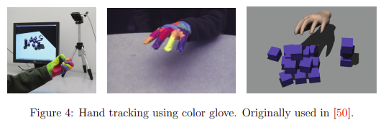

3.2 Depth-based Methods
Traditionally, depth map image based methods were the main method in hand and body pose estimation. Sinha et al. [38] used a regression-based method to find 21 joints in the hand, based on a depth map. They tried to find the location of joints in each finger independently. To this end, they trained a separate network for each finger to regress three joints on that finger. Note that although they used depth map to regress the coordinates, they also used RGB to isolate the hand and to remove all the other pixels included in the hand’s cropped frame. Unlike the next papers that we will discuss, Sinha et al. did not use a separate deep network for hand segmentationSubsequently, we use Gaussian curvature to extract the two inner corners of the eyes and the tip of the nose.

The surface that either has a peak or a pit shape has a positive Gaussian curvature value K > 0 (Dorai & Jain, 1997).
Each of the two inner corners of the eyes has a pit surface type and the tip of the nose has a peak surface type that is detectable based on the Gaussian curvature.
These points have the highest positive Gaussian curvature values among the points on the face surface.

Fig.2.a shows the result of calculating the Gaussian curvature for one of the sample range images in the gallery.

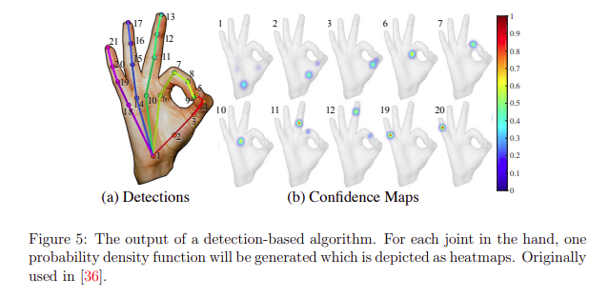
In their next paper [10], Ge et al. performed the similar approach and used three different CNNs. But instead of 2D renders, they generated three 3D shapes with Truncated Signed Distance Function (TSDF). In TSDF shapes, signed distance of the voxel to the closest surface will be stored in each voxel. Also for the fusion step, instead of multiplying the probabilities, they concatenated the output vectors and used three fully connected layers to get the final result. They tested their method on MSRA [29] and NYU [47] datasets and got the best results with a good margin comparing to other methods. Figure 8 shows schema of Ge et al. ’s [9] and [10] papers models. Inspired by Qi et al. ’s PointNet model in [28], Ge et al. [8] applied PointNet on their 3D shape estimate (HandPointNet). First they sampled from points in the 3D
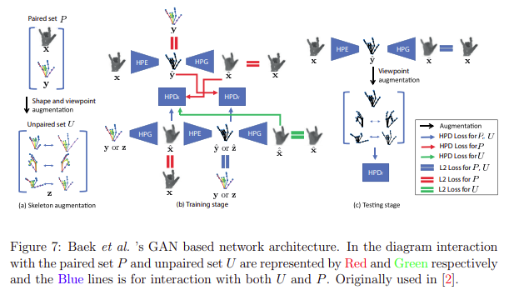

Using a similar 2.5D depth map to 3D voxel-based hand shape convertor, in [22] Moon et al. designed a detection-based, voxel-to-voxel network (V2V) to directly estimate the position of each hand part based on the estimated 3D hand shape. Since the input and output are in 3D, they used 3D CNN which does all the convolution and deconvolution operations in 3D domain. The idea behind this paper is that depth maps taken from different angels of a single hand have the same 3D pose. To estimate hand pose via depth maps, it is needed to train the model to produce the same pose for different depth map inputs. On the other hand, a 3D point cloud has exactly one 3D hand pose and therefore their relation is one to one. So instead of having a huge dataset to cover all the shapes of a hand, we can train the model on the 3D point cloud of that hand and directly generate 3D pose via 3D encoder and decoders. After the success of residual blocks of ResNet [14] in object classification, Moon et al. also used residual block with a deeper network. They applied their algorithm to
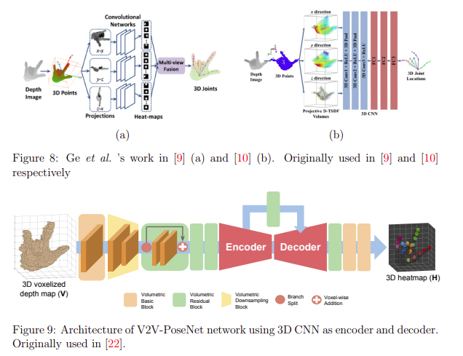
almost all the famous depth-based hand datasets and compared their method with a vast majority of algorithms and got the best result with a high margin compared to the others. One of the interesting facts about this algorithm is that, it can be easily applied to body pose estimation problem as well. They tested their algorithm on ITOP dataset [13] (both top-view and front-view) and reported their results. Figure 9 shows the architecture of V2V-PoseNet.

Image-based Methods

In spite of the fact that using a simple RGB image as an input gives the model a very good generalization power to be used everywhere, reducing the dimension of the input from 2.5D to 2D will make the task drastically harder. The data needed to train a network using RGB images is much bigger than the data needed to train a similar network using depth maps. Below we will first discuss the general approach used in the RGB-based networks, then we will discuss how the top tier image-based algorithms solved the high cost of annotating data and making a bigger datasets.

Therefore most of the influential studies in this section came up with their own dataset.

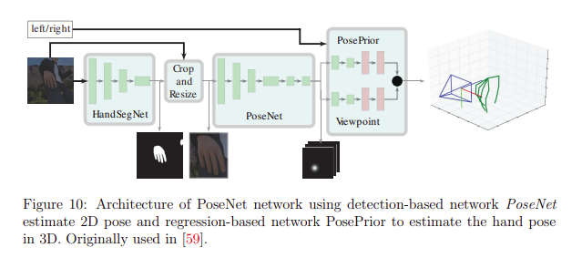
Note that image-based methods need to first isolate the hand (crop and resize) and then pass the cropped image to the network to estimate the pose. To do this, most of the image-based networks use a variations of SegNet [1] which is designed to segment a general picture (e.g. a street picture). Because of the binary classification (hand or background) and lack of variety in the input images, the hand segmentation is a relatively easier task than general segmentation problem. Therefore segmentation networks used in hand segmentation are more light weight than general SegNet and consequently faster to perform. In the following papers unless it is mentioned, one variation of SegNet is used for isolating the hands as a pre-processing step. One of the important works in the RGB-based methods is Zimmermann et al. ’s paper and dataset [59]. In this paper they used four different deep learning streams to make a 3D estimation of hand joints using a single RGB image. They first used a CNN called HandSegNet which is a light weight version of Wei et al. ’s [51] human body detector trained on hand datasets. As it is depicted in Figure 10, the output of HandSegNet is a mask picture showing the hand pixels. Based on this image, the hand is cropped and resized and is passed to the PoseNet network. PoseNet is a detection-based network which produces one probability density function (as a heatmap) for each hand joint. These predictions are in 2D and on the same coordinates of the input image.

To get a 3D estimation, Zimmerman et al. used a network called PosePrior to convert these 2D predictions to 3D hand estimation. This network is a regression-based network and predicts the coordinates of the joints followed by a normalization. In this step, they normalize the distances of the joints considering the farthest distance as 1 and dividing the other distances to that number. Finally, they find a 3D rotation matrix such that a certain rotated keypoints is aligned with y-axis of the canonical frame. As mentioned earlier, since the RGB image contains less information than depth disparity maps, the RGB-based network are harder to train and requires a larger dataset. The most important issue in image-based method is the occlusion case, that
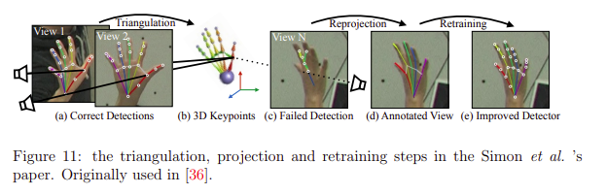
Dibra et al. in [5] designed a network which uses both RGB images and depth maps to estimate the hand pose. They used a specific network called SynthNet to estimate the hand pose which will be explained shortly. Next, with the generated 3D shape (3D shape of the whole hand not just the skeleton) they generate a depth map. They did the same process for depth map input as well. With the method explained above they generated a 3D model from the 2.5D depth map and then they calculated the loss of the algorithm from difference of two depth maps generated from these 3D models. Unlike almost all the papers discussed so far, Dibra et al. did not use a joint model. In this paper they came up with a new method for hand pose estimation which unlike

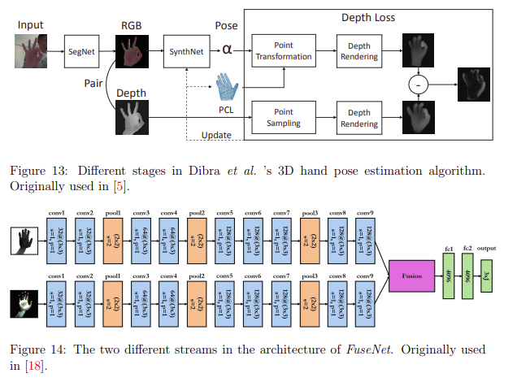

CHAPTER 4
Sample Code

4.1 React .JS Code

import React, { useRef } from "react";
// import logo from './logo.svg';
import * as tf from "@tensorflow/tfjs";
import * as handpose from "@tensorflow-models/handpose";
import Webcam from "react-webcam";
import "./App.css";
import { drawHand } from "./utilities";

function App() {
const webcamRef = useRef(null);
const canvasRef = useRef(null);

const runHandpose = async () => {
const net = await handpose.load();
console.log("Handpose model loaded.");
// Loop and detect hands
setInterval(() => {
detect(net);
}, 100);
};

const detect = async (net) => {
// Check data is available
if (
typeof webcamRef.current !== "undefined" &&
webcamRef.current !== null &&
webcamRef.current.video.readyState === 4
) {
// Get Video Properties
const video = webcamRef.current.video;
const videoWidth = webcamRef.current.video.videoWidth;
const videoHeight = webcamRef.current.video.videoHeight;

// Set video width
webcamRef.current.video.width = videoWidth;
webcamRef.current.video.height = videoHeight;

// Set canvas height and width
canvasRef.current.width = videoWidth;
canvasRef.current.height = videoHeight;

// Make Detections
const hand = await net.estimateHands(video);
console.log(hand);

// Draw mesh
const ctx = canvasRef.current.getContext("2d");
drawHand(hand, ctx);
}
};

runHandpose();

return (
<div className="App">
<header className="App-header">
<Webcam
ref={webcamRef}
style={{
position: "absolute",
marginLeft: "auto",
marginRight: "auto",
left: 0,
right: 0,
textAlign: "center",
zindex: 9,
width: 640,
height: 480,
}}
/>

<canvas
ref={canvasRef}
style={{
position: "absolute",
marginLeft: "auto",
marginRight: "auto",
left: 0,
right: 0,
textAlign: "center",
zindex: 9,
width: 640,
height: 480,
}}
/>
</header>
</div>
);
}

export default App;

Chapter 5

Conclusion

In this report we defined the hand pose estimation problem and explained the major methods of solving this problem in detail. We also reviewed some of the recent applications of this field. Since every data driven method needs sufficient data in the first place, we talked about major datasets and listed all the datasets in this field with their most important properties. We showed how this field have grown in just a few years, from completely controlled situations with color gloves to 3D hand pose estimation using a single RGB image. Although the papers discussed here show good results on these dataset they do not get satisfactory results in the real world problems. Most importantly, the result of most of these systems is worst than a simple nearest-neighbor baseline [55]. However, because of the interests of big technology companies in this field, perhaps in the near future we see much bigger and more generalized datasets and therefore very well performing models even on a single RGB image. If we reach this technology, using an AR/VR device as our new PC, typing on the air and control objects in the display with our
fingers will not be out of reach to.

