**TRIGGER**

Ex:No:19

Date:

Aim:

To implement trigger in MySQL

1)create a trigger and use it:

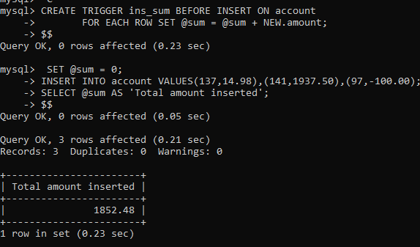

2) show trigger;

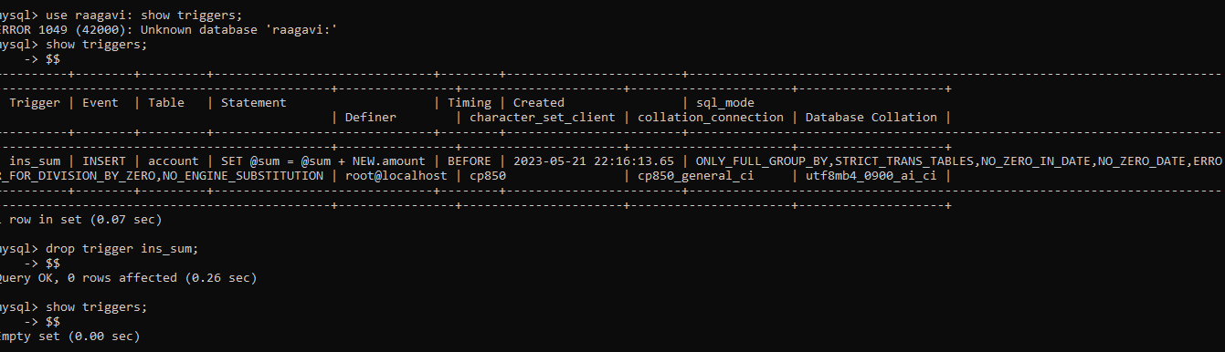

RESULT: Thus the trigger is executed successfull