**P01 Final Project**

**Author: Soumya Madichetty**

**Z-Number: Z23705586**

**Business Analytics Individual Project:**

**Task: Perform analytics using Power BI or Tableau**

1. Select a dataset having minimum of 1000 data rows.

2. Post the Dataset link on the discussion forum [Reserve your PROJECT Dataset here !](https://canvas.fau.edu/courses/144789/discussion_topics/1436355?wrap=1)

3. Ensure that the dataset chosen by you is not used by anyone else.

4. An indicative list of dataset sites are [https://data.gov/Links to an external site.](https://data.gov/), [https://www.kdnuggets.com/,Links to an external site.](https://www.kdnuggets.com/,) [https://www.kaggle.com/Links to an external site.](https://www.kaggle.com/)

***Note:****In PowerBI the dataset in Excel has to be in 'Table' form. Please convert the data to Table form in Excel before using it.*

5. Analyze the dataset by **creating 3 Dashboards – each having minimum of 4 visualizations.**Each of the Dashboard should represent one meaningful analysis for example: Revenue Analysis, Customer service analysis, Stock market analysis, Present value analysis, Product Sale analysis etc

6. Determine the following from your analysis on each Dashboard.

a. Positive Insights (at least 4 insights from each Dashboard)

b. Negative Insights – Showing ‘or’ Can lead to issues/concerns (at least 1 insight from each Dashboard)

**Submission Requirements**

**Prepare your results in the following format:**

Use 12 pt. Times New Roman font, ‘Double-spaced’ line spacing with 1" margins on all sides. You may some lose points if formatting is not followed.

**Report Outline**

1. **Report Title – Creative name for your report (1 point)**

“Unlocking the Talent Drain: A Comprehensive Analysis of Employee Attrition Factors and Insights”

1. **Introduction (2 points)**
   * **Purpose of the project analysis *(minimum 3 to 4 sentences)***

The purpose of this project analysis is to understand why employees leave their jobs. By looking at a pretend set of data created by IBM, we want to figure out what factors are linked to employees deciding to quit. The goal is to help companies know more about why people leave so they can make changes to keep their employees happy and not lose them. We're using numbers and information to find patterns that can guide businesses in making better choices to keep their team members content and committed to their jobs.

* **Describe the dataset you have selected: *(minimum 4 to 5 sentences)***
* **What is your dataset about?**

The dataset is about employees and their work-related information. It includes details like the level of education employees have, how satisfied they are with their jobs, and other factors that might influence whether they stay or leave their jobs. Essentially, it's a collection of information that helps us understand why employees might choose to leave a company.

**Below Indicates the values for Attributes:  
Education:**

1 'Below College'

2 'College'

3 'Bachelor'

4 'Master'

5 'Doctor'

**EnvironmentSatisfaction**

1 'Low'

2 'Medium'

3 'High'

4 'Very High'

**JobInvolvement**

1 'Low'

2 'Medium'

3 'High'

4 'Very High'

**JobSatisfaction**

1 'Low'

2 'Medium'

3 'High'

4 'Very High'

**PerformanceRating**

1 'Low'

2 'Good'

3 'Excellent'

4 'Outstanding'

**RelationshipSatisfaction**

1 'Low'

2 'Medium'

3 'High'

4 'Very High'

**WorkLifeBalance**

1 'Bad'

2 'Good'

3 'Better'

4 'Best'

* **Provide a link of your dataset.**

[**https://www.kaggle.com/datasets/whenamancodes/hr-employee-attrition**](https://www.kaggle.com/datasets/whenamancodes/hr-employee-attrition)

* **From which website you got it.**

Collected this Dataset from Kaggle website

* **Provide a list of all columns (only headings) and how many data rows.**

**List of Columns:**

* Age
* Attrition
* BusinessTravel
* DailyRate
* Department
* DistanceFromHome
* Education
* EducationField
* EmployeeCount
* EmployeeNumber
* EnvironmentSatisfaction
* Gender
* HourlyRate
* JobInvolvement
* JobLevel
* JobRole
* JobSatisfaction
* MaritalStatus
* MonthlyIncome
* MonthlyRate
* NumCompaniesWorked
* Over18
* OverTime
* PercentSalaryHike
* PerformanceRating
* RelationshipSatisfaction
* StandardHours
* StockOptionLevel
* TotalWorkingYears
* TrainingTimesLastYear
* WorkLifeBalance
* YearsAtCompany
* YearsInCurrentRole
* YearsSinceLastPromotion
* YearsWithCurrManager

**Number of Rows:**

Contains 1471 data rows including Header row.

1. **Analysis Methodology Followed**

* **Which analytical tool was considered (Power BI or Tableau) and any other info about them *(minimum 3 to 4 sentences).*(1 point)**

For this project, we considered Tableau as a potential analytical tool. Tableau's strength in creating visually appealing and interactive dashboards could be particularly beneficial for exploring and presenting insights from the employee attrition dataset. Tableau specializes in creating interactive and shareable dashboards. Known for its ability to handle diverse datasets and perform advanced analytics, Tableau is a preferred choice for many data analysts and business intelligence professionals. Its strength lies in generating visually compelling insights from complex data sets.

**Explain the visualization creation process *(minimum 4 to 5 sentences)*and using a couple visualization screen shots. (2 points)**

* The visualization creation process involves several key steps to effectively communicate insights from the data.
* Firstly, data cleaning and preprocessing are crucial to ensure accuracy and consistency. Once the data is prepared, the selection of appropriate visualization tools and techniques is essential. In this case, we chose Tableau for its robust capabilities in creating interactive and visually appealing dashboards.
* The next step involves defining the key metrics and dimensions to be visualized, aligning with the analysis goals.
* The actual creation of visualizations involves dragging and dropping data fields onto the canvas, selecting appropriate chart types, and refining visual elements for clarity.
* For example, the below visualizations gives the insights of Sum of Employee count by top 3 Education and Job role and visualization 2 gives the insights of Average of Monthly Income by Job level and Job role.
* These insights help organizations to make valuable decisions about retention of employees.

**Visualization screenshots:**

**Visualization 1:**

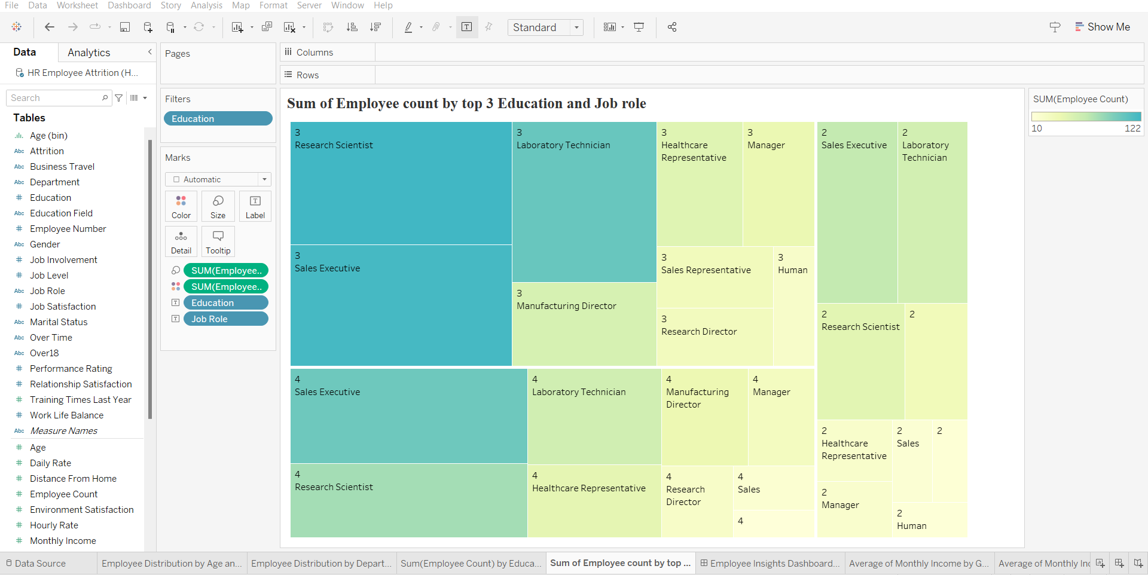

**Visualization 2:**

* **Provide ‘clear’ full screen shots of the Final 3 Dashboards. (4 points)**
* ***Points are awarded for the creativity of the dashboards, use of meaningful titles, formatting, organized arrangement of visualizations on each dashboard, easy readable font etc.***

**Dashboard 1 - Employee Insights Dashboard: Exploring Workforce Demographics:**

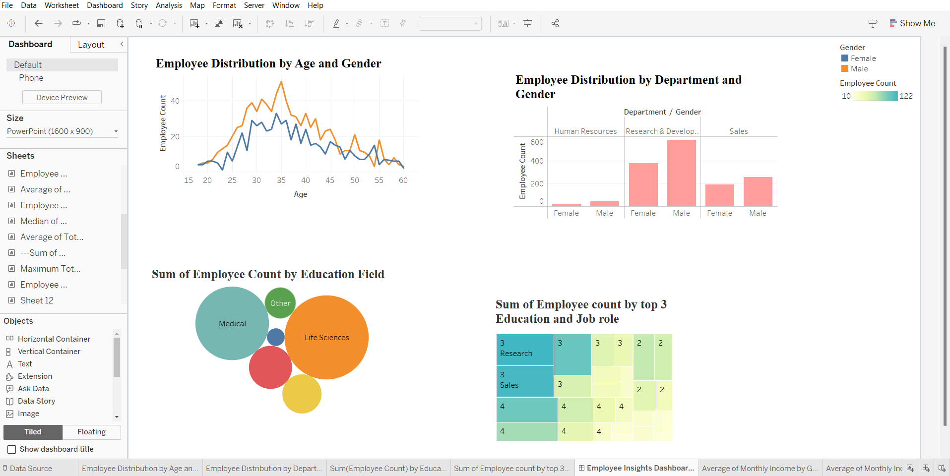

**Insights of Dashboard 1:**

|  |
| --- |
| **Dashboard 1 - Employee Insights Dashboard: Exploring Workforce Demographics:** |
| **Positive Insights** | **Negative Insights** | **Any other analysis comments.** |
| * Considering the employee distribution by the age factor most of the employees age between 30 to 40 years. | * The most Experienced employees are low over all in the company to guide or train the employees. | Company Should make a valuable decision how to retain the most experienced employees. So, that they can share their valuable experiences with younger employees. The employees should encourage new talents so that their innovated ideas bring great value to company. |
| * Research & development department has a greater number of employees with more male employees and female employees. | * The Human Resources department employees are fewer when compared to other departments and the education level Human resources contain College degree only. |  |
| * Majority of the employees has a good educational background and are mainly from life sciences and medical education fields. |  |  |
| * Many of the employers have bachelor’s degrees. The employees who have done Bachelors are working as Research scientists and Laboratory Technicians. |  |  |

**Dashboard 2 - Comprehensive Employee Job Details Dashboard:**

* There are 5 levels of Job levels starting from 1 to 5 (1,2,3,4,5). **A screenshot of a computer

  Description automatically generated**

**Insights of Dashboard 2:**

|  |
| --- |
| **Dashboard 2 - Comprehensive Employee Job Details Dashboard:** |
| **Positive Insights** | **Negative Insights** | **Any other analysis comments.** |
| * Average monthly Income is high for Manager Job level for both Male and Female with 17,409 and 16,915. | * The lowest average income is for Sales Representatives with below 2700. For male average monthly income is 2,587 and for female it is 2,672. | It seems that company provides the standard salary distribution based on Jobe level rather than the Job role.  Job level 1 has lower salary and Job level 5 has higher salary. |
| * The next highest monthly income is for Research director for both male and female employees with 16,658 and 15,144. | * The lowest average monthly income is for Job level 1 for the Job Role of Sales Representatives. |  |
| * The Highest Average monthly income is for the Job level 5 for the Job roles Manager and Research director with more than 19,000 incomes. | * Overall, it is observed that the number of employees of Sales Representative are not only less but eventually their Salary Income and Hikes are also comparatively low. |  |
| * The lowest Attrition can be observed for the job role health care representative. Although the greater number of employes are of sales executives. |  |  |
| * The highest average percentage salary hike is almost similar for 4 job levels from 1-4 with around 15% salary hike. |  |  |
| * Overall, it is observed that the Monthly income is high for the designations of Manager and Research Director. |  |  |

**Dashboard 3 - Dynamic Attrition Insights: Navigating Influential Factors:  
Attribute Values:**

|  |  |  |  |
| --- | --- | --- | --- |
| **Attribute numbers** | **JobSatisfaction:** | **WorkLifeBalance** | **RelationshipSatisfaction** |
| 1 | 'Low' | 'Bad' | 'Low' |
| 2 | 'Medium' | 'Good' | 'Medium' |
| 3 | 'High' | 'Better' | 'High' |
| 4 | 'Very High' | 'Best' | 'Very High' |

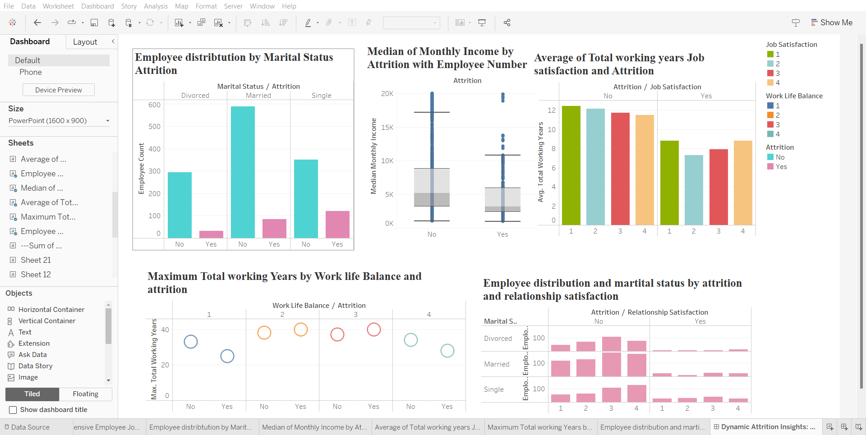

**Insights of Dashboard 3:**

|  |
| --- |
| **Dashboard 3 - Dynamic Attrition Insights: Navigating Influential Factors:** |
| **Positive Insights** | **Negative Insights** | **Any other analysis comments** |
| * 589 employees who are married and haven't left the company show that many people with stable marriages tend to stay in their jobs, indicating that being happily married might be linked to staying in the company. | * Experienced employees leaving due to job dissatisfaction (8.833 years) and even those with very high job satisfaction departing (8.808 years) raise concerns about retaining valuable, experienced talent. | The company should consider the factors why employees are leaving the company and should provide valuable resources for senior employees who has more experience so that the more experienced employees stay in the company. |
| * For employees with no attrition, the median monthly income of $5,204 indicates a mid-range income distribution within this subset of the workforce, potentially reflecting stability, and consistency in salary levels. | * Even though the employees reported having a good work-life balance, they left the company after working for 40 years. This raises concerns about what might be causing experienced employees to leave despite a perceived positive work-life balance. |  |
| * For employees who didn't leave, most monthly incomes fall between $1,051 and $17,181, and the typical or middle income is around $5,204. | * Overall, having a good work-life balance seems to keep employees for the long term. However, the departure of an experienced employee after 40 years, despite reporting a good work-life balance, raises questions about why some experienced staff still leave, even when they feel work-life balance is positive. |  |
| * Employees who stayed at the company, even with low job satisfaction, have an average of 12.43 years of experience. And those who are super happy with their jobs and stayed also have an impressive average of 11.494 years of experience. |  |  |
| * Even though the employees reported having a good work-life balance, they left the company after working for 40 years. This raises concerns about what might be causing experienced employees to leave despite a perceived positive work-life balance. |  |  |
| * Employees want to stay with the company for the long term, and this desire is strong regardless of their relationship status, showing that personal relationships don't seem to impact their commitment to the company. |  |  |

1. **Analysis Results - *Present result in a Table form . One table for each Dashboard.*(4 points)**

**Results for Dashboard 1- Comprehensive Employee Job Details Dashboard:**

Total Employee count in company: Male -882, female- 588

|  |  |  |
| --- | --- | --- |
| **Category** | **Highest Employee count** | **Low Employe count** |
| Age and Gender | Age – 35 & 34 Male- 33,  Female-51 | Age 60  Male- 3, female-2, |
| Education | Male: 379,  Female-582 | Male: 20,  Female-43 |
| Education field | Life sciences: 606  Education: bachelors | Human resources: 27  Education: College |
| Jobe Role | Research scientist- 122 | Human resources- 12 |

**Results for Dashboard 2 - Comprehensive Employee Job Details Dashboard:**

|  |  |  |  |
| --- | --- | --- | --- |
| **Category** | **Highest Value** | **Lowest Value** | **Comment** |
| Average of Monthly Income by Job Role | Job role: Manager  Male- 17,049,  Female-16,915. | Job role: Sales Representative,  Male: 2,587,  female-2,672. | The Average of Monthly Income is High for the Manager role and low for Sales representative. |
| Average of Monthly Income by Job level and Job Role | Job role: Research director  Average Monthly Income: 19,205,  Job level: 5 | Job role: Sales Representative –  Average Monthly Income: 2,507  Job level: 1 | The Average of monthly income is high for Research director role of job level 5 and low for Sales representative of Job level 1. |
| Employee Distribution by Job Role with Attrition | Job role: Sales Executive  Attrition: No -269  Job role: Laboratory Technician  Attrition: Yes - 62 | Job role: Research director  Attrition: Yes – 2  Job role: Human resources  Attrition: No – 40 | The number of employees leaving the company is high for the Job role of Laboratory Technician and Research directors who left company is low. |
| Average of Percentage Salary by Job level and Attrition | Job level: 4  Attrition: No -15.386%  Job level: 2  Attrition: Yes – 15.346% | Job level: 4  Attrition: No -14.453%  Job level: 5  Attrition: Yes – 13.400% | Employees who stayed at Job Level 4 had a bigger salary decrease than those who left at Job Level 2, showing differences in salary adjustments. |

**Results for Dashboard 3- Dynamic Attrition Insights: Navigating Influential Factors**

|  |  |  |  |
| --- | --- | --- | --- |
| **Category** | **Values** | |  |
| Employee distribution by Marital Status Attrition | **Attrition:** No  **Relationship status:** Married  **Employee**  **count:** 589 | **Attrition:** No  **Relationship status:** Single  **Employee**  **count:** 120 | The Highest number of employees who are married are seems to be stable in both personal and personal life where the company who left the company are more from the singles. |
| Median of Monthly Income by Attrition with Employee Number | **Attrition:** No  **Median Value:** 5,204  **Higher Median Monthly Income:** 17,181  **Lower Monthly Income:** 1,051 | **Attrition:** yes  **Median Value:** 3,202  **Higher Median Monthly Income:** 10,854  **Lower Monthly Income:** 1,009 | Comparatively the employees who left the company has lower Monthly Income then the employees who are still working in the comment. |
| Average of Total working years Job satisfaction and Attrition | **Attrition:** No  **Avg. of total years:** 12.162  **Job Satisfaction:** Low | **Attrition:** yes  **Avg. of total years:** 7.283  **Job Satisfaction:** Medium | Despite of low Job satisfaction employees are still working in company. However, the employees who are moderately satisfied are leaving the company. |
| Maximum Total working Years by Work life Balance and attrition | **Attrition:** No  **Work life balance:** Good **Max. Total work years:** 38  **Attrition:** yes  **Work life balance:** Good **Max. Total work years:** 40 | **Attrition:** yes  **Work life balance:** Bad **Max. Total work years:** 25 | While a positive work-life balance tends to retain employees for the long term, the departure of a seasoned employee after 40 years, despite reporting a positive work-life balance, prompts inquiries into the factors influencing experienced staff to leave, even in an environment perceived as balanced. |
| Employee distribution and marital status by attrition and relationship satisfaction | **Attrition:** No  **Marital status:** Married  **Relationship satisfaction:** High  **Employee count:** 178 | **Attrition:** yes  **Marital status:** divorced  **Relationship satisfaction:** Low  **Employee count: 7** | Overall Despite of the relationship status employees dedicate their work to the organization. How ever the Single are more employees who leave the company. Comparatively apart from relationship status many employees who work in the company are more than employees who are leaving the company. |

**5. Conclusion (1 point) Final conclusion on the analysis in at least 5 to 6 sentences.**

* In conclusion, the analysis of the provided data reveals several noteworthy insights into employee attrition and related factors. The positive correlation between a perceived good work-life balance and long-term employee retention is evident, as employees reporting such balance tend to stay with the company for extended periods.
* However, the departure of an experienced employee after 40 years, despite a reported positive work-life balance, raises concerns and underscores the complexity of factors influencing attrition.
* Additionally, educational qualifications and job satisfaction levels also play significant roles. Higher education levels, such as Master's and Doctorate, demonstrate lower attrition rates, emphasizing the value of education in retaining employees.
* On the contrary, employees with lower education levels, specifically below college, exhibit a higher attrition rate, signaling potential challenges in retaining staff with lower educational qualifications.
* The analysis further highlights potential disparities in salary adjustments, with different job levels and job satisfaction levels influencing average percentage salary changes. Employees leaving the company with high job satisfaction levels, despite experiencing a salary decrease, raise questions about the interplay between satisfaction and other factors contributing to attrition.
* Despite relationship status not emerging as a significant factor in long-term employee commitment, the departure of an experienced employee after 40 years necessitates a deeper exploration into nuanced elements influencing attrition, even in a seemingly positive work environment.
* Overall, this analysis underscores the importance of a multifaceted approach to understanding and addressing employee attrition, considering diverse factors such as education, job satisfaction, salary adjustments, and work-life balance.