**Supplementary Material**

**Figure S1:** Correlation matrix of model covariates showing a scatterplot of the relationship between each pair of covariates (black dots), and the associated Pearson correlation value (r). “RSlope” is reach slope (%), “LEf” is Lake Effect, “Elev” is elevation in meters, and “logRCA” is log-transformed upstream contributing area.

**Figure S2:** Candidate mesh surfaces tested for fitting the SPDE to estimate the GMRF for INLA stream temperature models for Banff National Park, AB, Canada. Blue lines demarcate the 100-m buffer used to constrain the GMRF. The red dots are digital sensor locations where stream temperature was measured. The selected mesh for building the barrier models in INLA is identified in red box.

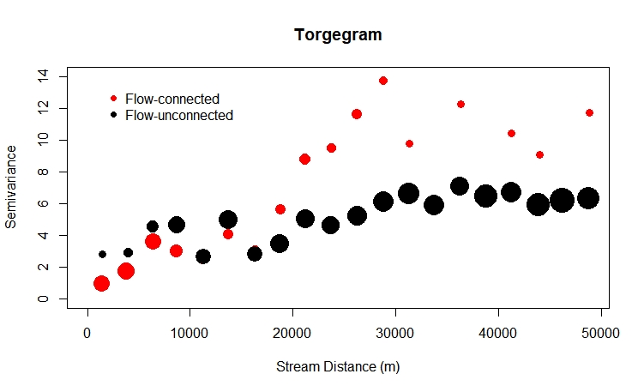

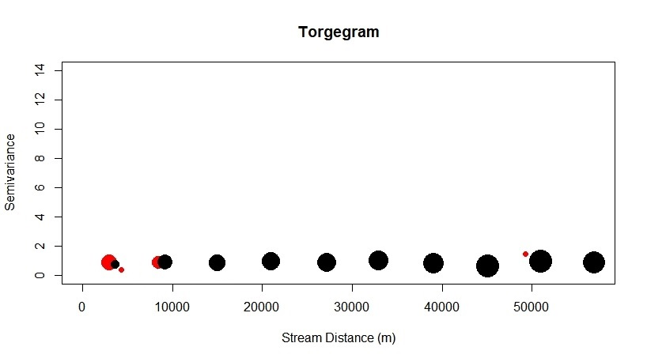

**Figure S3:** Torgegrams illustrating semivariance of the August mean stream temperature (AugTw) observations across stream distance for flow connected (red circles) and flow-unconnected sites (black circles) in Banff National Park, AB, Canada. Torgegrams were generated for both the raw data observations (top panel) and model residuals from the top fitted spatial stream network model (SSN-1; bottom panel). Symbol sizes are proportional to the number of data pairs at each distance interval. Plot generated in the SSN R package.

**Figure S4:** Semivariogram of Cressie’s semivariance (unitless measure) plotted against riverine distance (km) generated using the raw data (top panel), as well as from Pearson residuals from top fitted integrated nested Laplace approximation spatial stream temperature model for Banff National Park, AB, Canada (INLA-1; bottom panel).