AGILITY SPORTS

Database Technical
Design Document
  - AgilitySports_V2 · Microsoft SQL Server
CURRENT-STATE DESIGN WITH PRE-FIFA RECOMMENDATIONS
Design baseline: AgilitySchema_V2.sql, from MS SQL Server Management Studio “scripts” export.

Field | Value
Document status | Reviewed draft
Schema review date | July 14, 2026
Database | AgilitySports_V2
Platform | Microsoft SQL Server
Source artifact | AgilitySchema_V2.sql

Static review result: No remaining primary-key/candidate-key mismatch was found. The script is structurally coherent, but several recommended changes should be made before adding FIFA data.

1. Executive Summary
AgilitySports_V2 is a compact multi-sport player database organized into three SQL Server schemas: core for operational entities, reference for controlled code sets, and stats for sport-specific player statistics. The design uses composite relationships to keep each statistics row aligned with the sport assigned to its parent player.
The current script defines eight tables, eight primary or unique keys, eight foreign-key relationships, and a set of domain checks. The previous foreign-key candidate-key issue is correctly resolved by UQ_Players_playerID_sportCode on core.Players.

1.1 Final review findings
Priority | Finding
Critical before FIFA | sportCode is varchar(3) everywhere. The literal FIFA requires four characters, so the code will not fit. Widen the column consistently in every primary key, foreign key, and statistics table before loading FIFA.
High | stats.NBAPlayerStats lacks a CK_NBAPlayerStats_sportCode check, unlike the MLB, NFL, and NHL tables.
Medium | MLB bats has no domain check; MLB throws currently permits B; NHL handed currently permits B. Confirm intended code sets.
Medium | battingAverage decimal(5,2), savePct decimal(3,2), and integer NBA per-game values lose commonly expected precision.
Performance | core.Players has no indexes led by (sportCode, teamCode) or (sportCode, positionCode), the columns used by its two parent foreign keys.
Deployment | The script assumes the core, reference, and stats schemas already exist. A clean installation script should create them conditionally.

Design decision retained: This document preserves the current sportCode terminology and the separate stats tables. The sport-versus-league interpretation remains an explicit future decision.

2. Scope and Design Goals
The database is intended to store player profile information, team and position reference data, and a small set of sport-specific statistics for MLB, NBA, NFL, and NHL, with FIFA planned as an additional code and statistics domain.

2.1 In scope
- Canonical player records and current team/position assignment.
- Sport-controlled team and position code sets.
- One optional statistics row per player in the applicable sport-specific table.
- Referential integrity and basic domain validation.
- SQL Server deployment and indexing considerations.

2.2 Out of scope for this baseline
- Historical team assignments and trades.
- Multiple seasons of statistics for the same player.
- Games, schedules, standings, venues, and team-season records.
- Ingestion lineage, auditing, soft deletion, and source-system reconciliation.
- A resolved distinction between sport, federation, competition, and league.

3. Database Organization
Schema | Responsibility | Objects
core | Operational/master entities | Players, Teams
reference | Controlled code and lookup entities | Sports, PositionCodes
stats | Sport-specific extension tables | MLBPlayerStats, NBAPlayerStats, NFLPlayerStats, NHLPlayerStats

The schema separation is practical because it distinguishes stable reference data, primary business entities, and subtype-like statistical extensions. It should be treated as organization and permission scope—not as enforcement by itself. Sport-specific correctness is enforced through composite foreign keys and check constraints.

3.1 Design principles
Principle | Application
Referential integrity first | All relationships are implemented as trusted foreign keys rather than application-only conventions.
Controlled extensibility | Sport-specific columns remain in typed extension tables instead of a wide nullable table or EAV structure.
Readable ownership boundaries | Schemas communicate subject area: core, reference, and stats.
Conservative deletion | No cascading actions are defined; dependent data must be handled deliberately.
Incremental normalization | The current player-level grain is documented, with PlayerSeasons reserved as the future historical model.

3.2 Naming conventions
Objects generally follow PK_, FK_, UQ_, CK_, and IX_ prefixes. Future revisions should standardize acronym casing (for example espnTeamCode and era) and use descriptive names such as jerseyNumber instead of number.

4. Logical Data Model
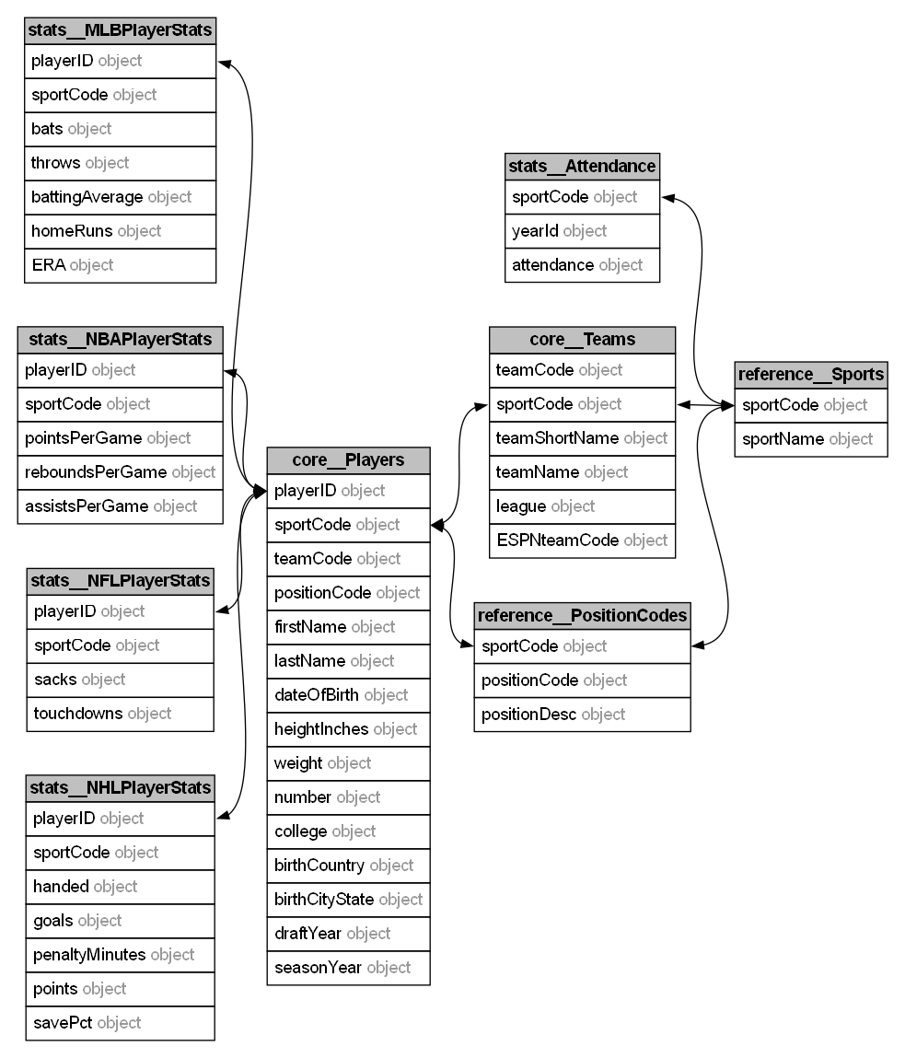
Figure 1. Current logical entity relationships. PK = primary key; FK = foreign key; UQ = unique candidate key.
The composite foreign keys from the stats tables to core.Players use (playerID, sportCode). Because playerID alone is the primary key, the additional unique constraint on (playerID, sportCode) is logically redundant but is required by SQL Server as the exact candidate key targeted by those foreign keys.

5. Entity Specifications

reference.Sports
Purpose: Defines the allowed sport codes.
Key: sportCode. Relationship summary: Referenced by Teams and PositionCodes.
Column | Type | Rules | Notes
sportCode | varchar(3) | PK, required | Controlled identifier; must be widened before FIFA.
sportName | varchar(50) | required | Display name.

core.Teams
Purpose: Defines teams within a sport.
Key: (sportCode, teamCode). Relationship summary: Each team belongs to one Sports row.
Column | Type | Rules | Notes
sportCode | varchar(3) | PK/FK, required | References reference.Sports.
teamCode | varchar(15) | PK, required | Unique within sport.
teamShortName | varchar(30) | nullable | Short display name.
teamName | varchar(50) | required | Full display name.
league | varchar(50) | nullable | Unconstrained descriptive league value.
ESPNteamCode | varchar(3) | nullable | External-source code.

reference.PositionCodes
Purpose: Defines sport-specific player positions.
Key: (sportCode, positionCode). Relationship summary: Each code belongs to one Sports row.
Column | Type | Rules | Notes
sportCode | varchar(3) | PK/FK, required | References reference.Sports.
positionCode | varchar(3) | PK, required | Unique within sport.
positionDesc | varchar(40) | required | Human-readable position.

core.Players
Purpose: Stores player profile, assignment, and season attributes.
Key: playerID. Relationship summary: Belongs to one team and optionally one position within the same sport.
Column | Type | Rules | Notes
playerID | int identity(3000,1) | PK | Surrogate identifier.
sportCode | varchar(3) | FK/UQ, required | Participates in all composite relationships.
teamCode | varchar(15) | FK, required | No free-agent/null state in current design.
positionCode | varchar(3) | FK, nullable | Optional sport-specific position.
firstName / lastName | nvarchar(50) | nullable | Unicode player name.
dateOfBirth | date | nullable | Birth date.
height | varchar(10) | nullable | Formatted value; not computational.
weight | int | nullable | Checked greater than 80.
number | int | nullable | Jersey number; consider renaming.
college / birthplace | nvarchar(100) | nullable | Profile metadata.
draftYear / seasonYear | smallint | nullable | Checked from 1970 through 2100.

5.5 Statistics extension tables
Table | Primary key | Measures | Sport enforcement
stats.MLBPlayerStats | (playerID, sportCode) | bats, throws, battingAverage, homeRuns, ERA | sportCode = 'MLB'
stats.NBAPlayerStats | (playerID, sportCode) | pointsPerGame, reboundsPerGame, assistsPerGame | Missing fixed-code check
stats.NFLPlayerStats | (playerID, sportCode) | sacks, touchdowns | sportCode = 'NFL'
stats.NHLPlayerStats | (playerID, sportCode) | handed, goals, penaltyMinutes, points, savePct | sportCode = 'NHL'

Each statistics table is a one-to-zero-or-one extension of core.Players. The composite foreign key prevents a statistics row from using a sportCode different from the parent player. The fixed-code checks prevent a sport-specific table from accepting rows for another sport; this check is currently absent for NBA.

6. Relationships and Cardinality
Constraint | Child columns | Parent columns | Cardinality
FK_Teams_Sports | core.Teams(sportCode) | reference.Sports(sportCode) | Many teams to one sport
FK_PositionCodes_Sports | reference.PositionCodes(sportCode) | reference.Sports(sportCode) | Many positions to one sport
FK_Players_Teams | core.Players(sportCode, teamCode) | core.Teams(sportCode, teamCode) | Many players to one team
FK_Players_PositionCodes | core.Players(sportCode, positionCode) | reference.PositionCodes(sportCode, positionCode) | Many players to optional position
FK_*PlayerStats_Player | stats.*(playerID, sportCode) | core.Players(playerID, sportCode) | Optional one-to-one extension

No cascading delete or update actions are defined. SQL Server therefore applies NO ACTION behavior: parent rows cannot be deleted or key values changed while dependent rows exist. This is the safer default for master data, but application workflows must delete or reassign dependent rows explicitly.

7. Data Integrity and Validation
Table | Column(s) | Current rule
core.Players | draftYear, seasonYear | NULL or 1970–2100
core.Players | weight | NULL or greater than 80
stats.MLBPlayerStats | battingAverage | NULL or 0–1
stats.MLBPlayerStats | sportCode | MLB
stats.MLBPlayerStats | throws | L, R, or B (review B)
stats.NBAPlayerStats | per-game metrics | NULL or nonnegative
stats.NFLPlayerStats | sportCode and counts | NFL; counts nonnegative
stats.NHLPlayerStats | sportCode, handed, savePct | NHL; handed L/R/B; savePct 0–1

7.1 Recommended integrity additions
- Add CK_NBAPlayerStats_sportCode CHECK (sportCode = 'NBA').
- Add CK_MLBPlayerStats_bats for L/R/S and restrict throws to the actual accepted values.
- Confirm whether NHL handed should permit only L/R.
- Add nonnegative checks for MLB homeRuns and ERA, plus NHL goals, penaltyMinutes, and points.
- Consider plausible upper-bound checks only where the source domain is stable; avoid arbitrary limits that reject future valid records.
- Add default constraints for each stats sportCode to reduce repetitive insert logic, while retaining the check constraints.

8. Datatype Readiness

8.1 Precision recommendations
Field | Current | Recommended | Reason
MLB battingAverage | decimal(5,2) | decimal(4,3) | Preserves values such as .275.
NHL savePct | decimal(3,2) | decimal(4,3) | Preserves values such as .918.
NBA per-game values | int | decimal(5,2) | Preserves values such as 27.4.
Players height | varchar(10) | smallint heightInches or heightCentimeters | Enables validation, sorting, and calculation.

9. Keys, Indexes, and Performance
Clustered primary keys are appropriate for the current small model. The unique constraint UQ_Players_playerID_sportCode creates a nonclustered unique index and is intentionally retained to support the exact composite foreign-key target required by the stats tables.

9.1 Recommended foreign-key indexes
CREATE INDEX IX_Players_sportCode_teamCode
ON core.Players (sportCode, teamCode);
CREATE INDEX IX_Players_sportCode_positionCode
ON core.Players (sportCode, positionCode)
WHERE positionCode IS NOT NULL;
These indexes support joins and parent-row integrity checks for the two composite foreign keys originating from core.Players. The stats-table foreign keys are already covered by their composite clustered primary keys.
Additional indexes should be driven by measured query patterns—for example player-name search, roster-by-season, or external ESPN code lookup—rather than added speculatively.

10. Deployment, Safety, and Operations

10.1 Clean-build prerequisites
IF SCHEMA_ID('core') IS NULL EXEC('CREATE SCHEMA core');
IF SCHEMA_ID('reference') IS NULL EXEC('CREATE SCHEMA reference');
IF SCHEMA_ID('stats') IS NULL EXEC('CREATE SCHEMA stats');
- Keep WITH CHECK when creating foreign keys and checks so existing data is validated and constraints remain trusted.
- Use SET XACT_ABORT ON and an explicit transaction for migrations that alter multiple related keys.
- Treat the generated baseline script and incremental migration scripts as separate artifacts; do not rerun baseline CREATE TABLE statements against an existing database.
- Avoid application reliance on identity values beginning at 3000 as a business rule.
- Define database principals and grant permissions at schema level where appropriate; for example, read-only reporting access to reference and stats.

11. Security and Data Classification
The player profile includes date of birth and birthplace data. Even when sourced from public sports records, these fields should be classified as personal data and exposed only when needed. The database currently contains no credentials, payment data, or authentication secrets.
- Use parameterized SQL or an ORM for all application access.
- Grant application identities only the SELECT/INSERT/UPDATE/DELETE permissions they require.
- Encrypt connections to SQL Server and use platform-managed secrets for connection strings.
- Add audit columns or change tracking only when a concrete operational requirement exists.
- Do not expose internal surrogate playerID values as an authentication or authorization mechanism.

12. Known Limitations and Evolution Path
Area | Current limitation / future decision
Player-season grain | seasonYear is stored on core.Players, so a player cannot retain multiple seasons without duplicate player records or overwriting the season. A future PlayerSeasons entity is the clean migration path.
Team history | teamCode is mandatory on Players; free agents, trades, and historical assignments are not represented.
Stats grain | Each sport stats table permits only one row per player/sport. It does not model statistics by season, competition, or team.
Sport taxonomy | Sports currently carries codes that may represent leagues, federations, or competitions. This is intentionally deferred.

13. Acceptance Criteria
- All tables create in a clean database after the three schemas are created.
- All primary, unique, foreign-key, and check constraints create WITH CHECK and remain trusted.
- A stats row cannot reference a nonexistent player or a player assigned to a different sportCode.
- A team and position code cannot reference a nonexistent Sports row.
- Invalid year, weight, percentage, and nonnegative-count values are rejected according to the defined checks.
- Before FIFA is introduced, sportCode is widened consistently and regression-tested across every key relationship.
- The NBA table receives the same fixed-code enforcement pattern as the other sport-specific tables.

Appendix B. Static Review Statement
This document is based on a static review of AgilitySchema_V2.sql. The script was not executed against the user’s SQL Server instance during document generation. The user reports that it currently completes without SQL Server errors. Static inspection found no unresolved candidate-key mismatch or foreign-key column-order mismatch.

