Slow Dough Pizza Co.
Decap CMS Content Management Integration
Technical Design Document

Version 1.1
Prepared for: Slow Dough Pizza Co. ownership & engineering
Scope: /admin content editor, GitHub-backed editorial workflow, CI/CD,
GitHub Pages + Azure Functions deployment

1. Overview
This document describes the design and implementation of a self-service content management workflow for the Slow Dough Pizza Co. marketing website, using Decap CMS (the actively maintained open-source successor to Netlify CMS). The goal is to let a non-technical pizza shop owner/manager make routine updates — adjusting the Daily Menu, publishing Blog posts in “The Baker's Journal,” and changing the “Dough Announcement” banner — without writing code or touching Git directly, while keeping every change reviewable, reversible, and safe.
Key outcomes delivered:
- A hidden, unlisted admin route at /admin that renders a brand-styled Decap CMS editor.
- Three owner-editable content areas (Daily Menu, Blog Posts, Dough Announcement) plus a bonus Store Hours collection, all backed by plain JSON/Markdown files in /content.
- A local editing mode for development/testing that requires no GitHub credentials.
- A production editing mode gated by real GitHub collaborator permissions via OAuth.
- An editorial workflow: every saved change opens a feature branch and a GitHub Pull Request instead of writing to main directly.
- Defense-in-depth validation against script/HTML injection in free-text fields.
- A GitHub Actions pipeline that automatically builds and deploys the site the moment a content PR is approved and merged to main.

2. Architecture at a Glance
Slow Dough is a static Vite + React single-page site (no server-side rendering, no backend database). Content that used to be hard-coded TypeScript objects (src/data/pizzaShopData.ts) has been extracted into plain-text files under /content, which are compiled into the site at build time via src/data/contentLoader.ts using Vite's import.meta.glob. Decap CMS is a pure client-side React application that edits those same files directly in the Git repository — there is no custom backend server for content storage. The only custom server-side code introduced is a minimal OAuth hand-off service (/oauth-provider) required by GitHub's OAuth spec, which never stores any content or tokens.
Deployment topology for the demo environment:
Component | Hosting | URL / identifier | Deployed by
Website + /admin | GitHub Pages (project site) | https://smagara.github.io/SlowDoughPizzaSite | .github/workflows/deploy.yml
Source of truth (content + code) | GitHub repository | smagara/SlowDoughPizzaSite, branch main | —
OAuth hand-off service | Azure Functions (Node 20, v4 model) | https://slowoauthfn-b3hzcgbnfch8bhbz.eastus2-01.azurewebsites.net (app: slowoauthfn) | .github/workflows/deploy-oauth-provider-azure.yml

All three environment-specific values (repo slug, Pages URL/base path, OAuth host / Function App name) are declared once in /site.config.json. vite.config.ts reads that file to set the production base path (/SlowDoughPizzaSite/) and to render admin/config.template.yml into the served /admin/config.yml; the deployment workflows read it with jq. Re-pointing the solution at a different repo, domain or Azure app is therefore a one-file change validated by npm run validate:config in CI.
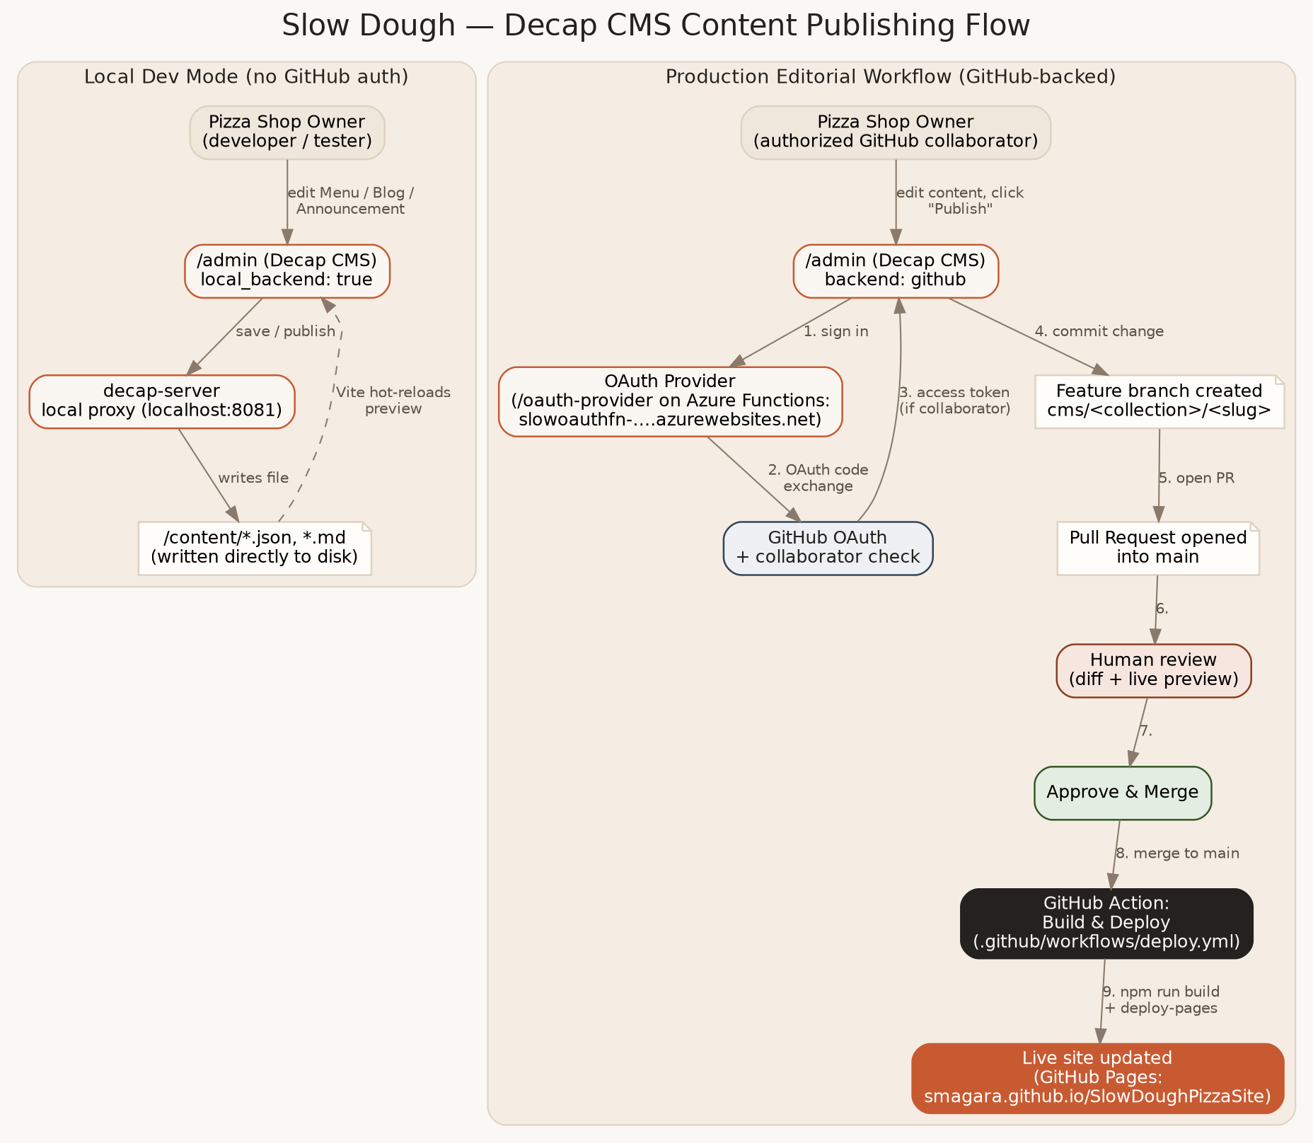
Figure 1 — End-to-end content publishing flow, local dev mode (left) and production GitHub-backed editorial workflow (right).

3. Content Model
Each editable area maps 1:1 to a Decap CMS “collection” and a file (or folder of files) under /content. This keeps the mapping between “what the owner edits” and “what the site renders” obvious and auditable in any PR diff.
CMS Collection | Storage | Type | Rendered by
Dough Announcement | content/announcement.json | Single file | Navbar.tsx banner, Hero.tsx headline
Daily Menu | content/menu.json | Single file, nested lists | MenuSection.tsx
Store Hours | content/hours.json | Single file, nested list | HoursAndLocation.tsx
Blog Posts | content/blog/*.md | Folder, one Markdown file per post | ArticlesSection.tsx

Blog posts store their long-form body as Markdown (YAML frontmatter for metadata, Markdown body below the --- separator) rather than the original nested {sectionHeading, paragraphs, quote} JSON structure. This trade-off was made deliberately: Decap's “markdown” widget is the natural authoring surface for long-form text (it gives the owner a familiar rich-text toolbar), and it collapses what used to be a fiddly nested-list editing experience into a single, forgiving text field. The front-end now renders that Markdown through a small sanitize-on-render pipeline (see Section 5).

4. The /admin Experience
/admin is intentionally not linked anywhere in the site's navigation, footer, or sitemap — it is discoverable only if you know the URL, functioning as the “hidden link” requested. It is still a fully public URL (anyone can load the login screen), so the real access boundary is enforced one layer down by the GitHub backend's collaborator check (Section 6), not by obscurity.
Decap CMS is bundled with Vite as a second, independent entry point (admin/index.html → src/admin/main.tsx) rather than pulled from a public CDN at runtime. This keeps the admin bundle versioned, code-reviewed, and reproducible alongside the rest of the codebase, and avoids a runtime dependency on a third-party CDN being available/unblocked.
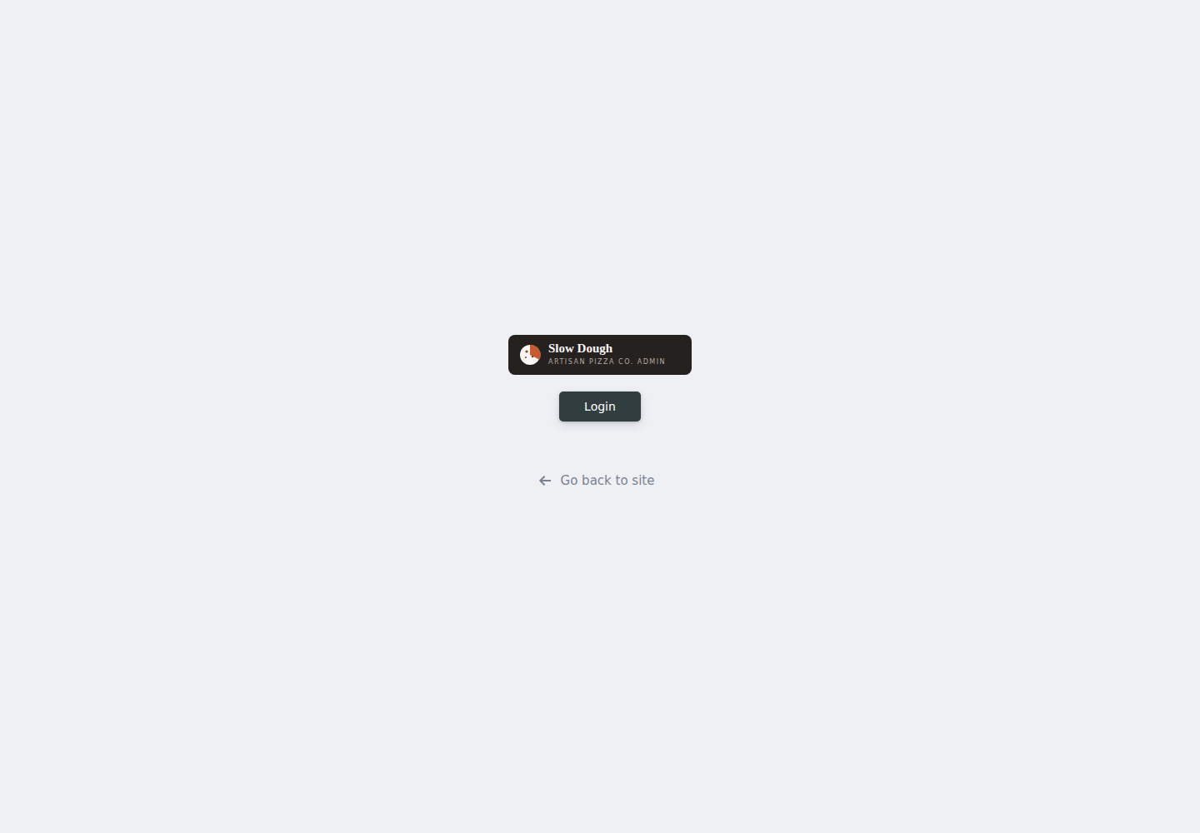
Figure 2 — Branded /admin login screen (custom logo, copy, and color palette).
Every collection registers a custom, brand-matched live preview pane (src/admin/previews.tsx + src/admin/previewStyles.ts) so the owner sees something close to the real site while editing, instead of Decap's generic default preview.
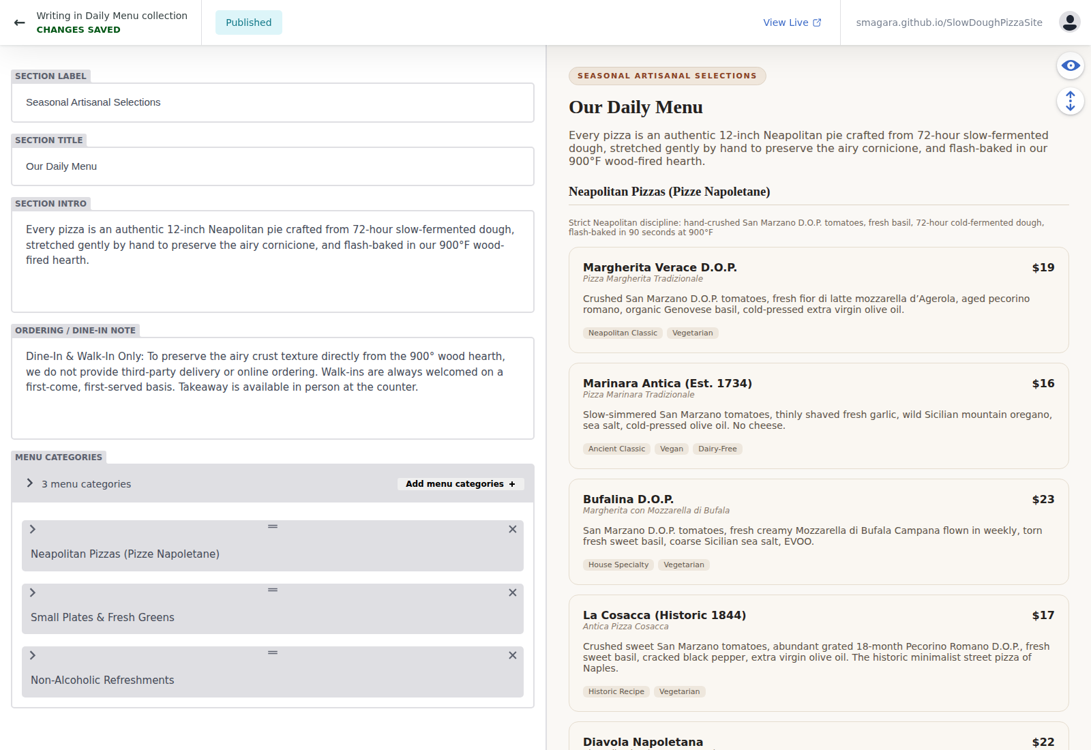
Figure 3 — Daily Menu editor: nested category/item lists on the left, live brand-styled preview on the right.
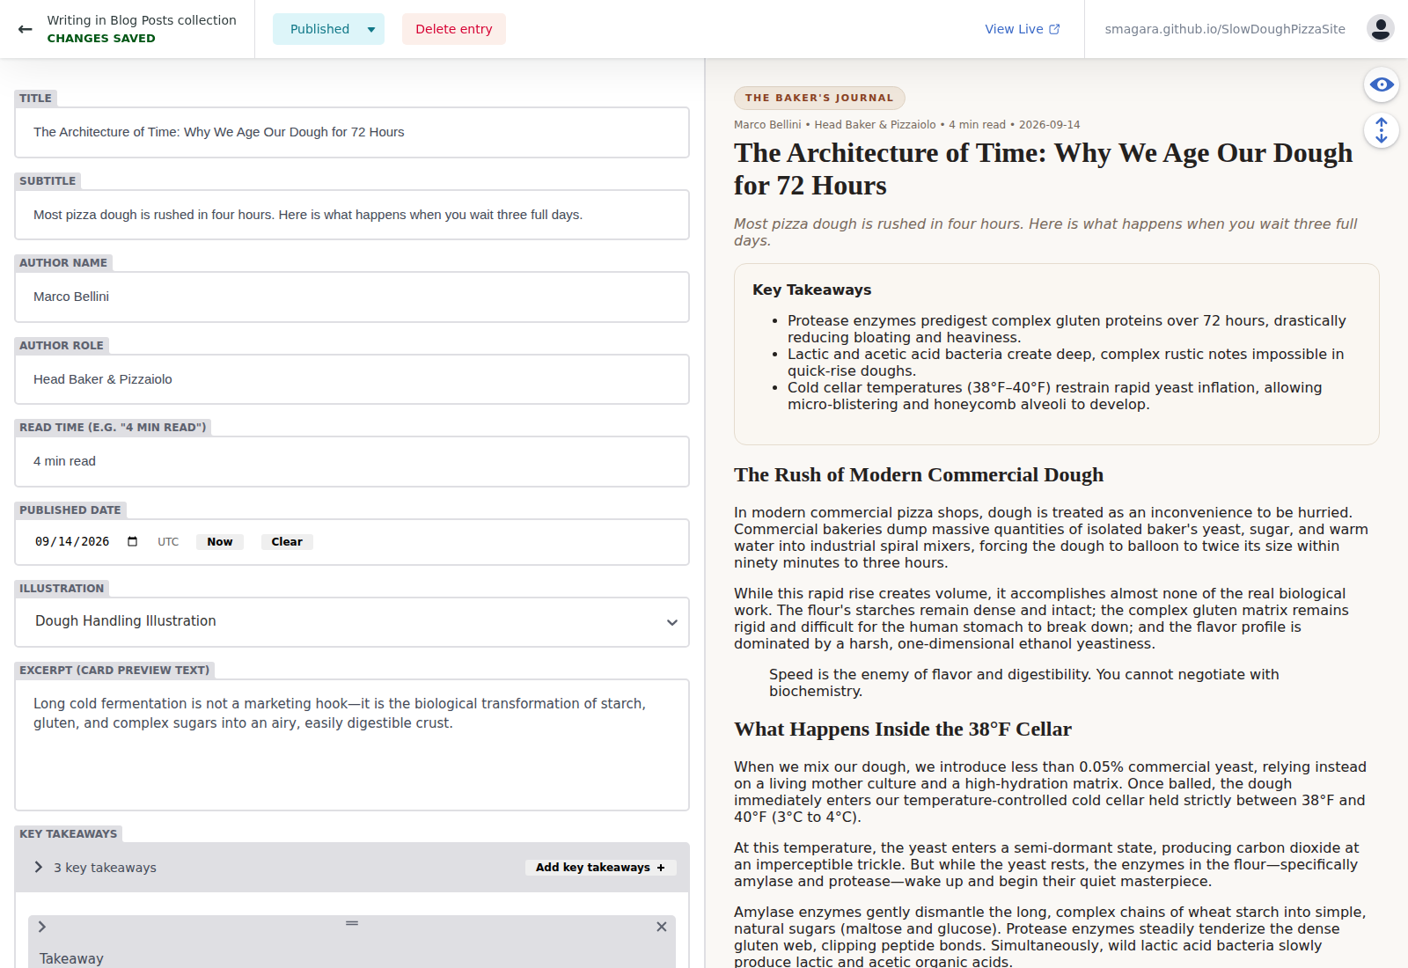
Figure 4 — Blog Post editor: Markdown body widget, metadata fields, and a preview matching the live article view (including the same pull-quote styling).

5. Free-Text Validation & Script-Injection Handling
Free text authored through a CMS is, by definition, untrusted input — even when the author is a trusted collaborator, mistakes (pasting rich text from a Word doc full of markup, or a stray <script> from a copy-pasted snippet) should not be able to compromise the site. Four independent layers guard against this:
- Layer 1 — CMS field patterns (public/admin/config.yml): every free-text string/text field most at risk (titles, descriptions, excerpts, banner text, the homepage intro) declares a regex “pattern” validator, e.g. ^((?!<script).)*$, that Decap enforces live in the editor before the Save/Publish button will even submit. This gives the owner immediate, specific feedback (“For security reasons, <script> tags are not allowed”) rather than a cryptic failure later.
- Layer 2 — Client-side publish guard (src/admin/main.tsx): a registerEventListener('prePublish', …) hook scans every field on submit for script/HTML-like patterns (<script, on\w+=, javascript:) as a friendly, defense-in-depth nudge that complements (but does not replace) Layer 1.
- Layer 3 — Render-time sanitization (src/lib/markdown.ts): the one field that is ever converted to real HTML — the blog post Markdown body — is parsed with marked (raw HTML tags for <script>/<style>/<iframe>/etc. are neutralized before parsing) and then passed through DOMPurify with a strict allow-list of tags/attributes before being handed to React's dangerouslySetInnerHTML. Every other field is rendered as plain React text children, which React escapes automatically — it is structurally impossible for those fields to execute as HTML/JS.
- Layer 4 — CI content validation (scripts/validate-content.mjs): the “PR Build Check” GitHub Action re-parses every JSON/Markdown file in /content on every Pull Request (including the ones Decap opens automatically) and fails the check if any field matches the same dangerous-content pattern, or if required fields / shapes are missing. This is the backstop that runs even if someone edits a file by hand outside of Decap entirely.
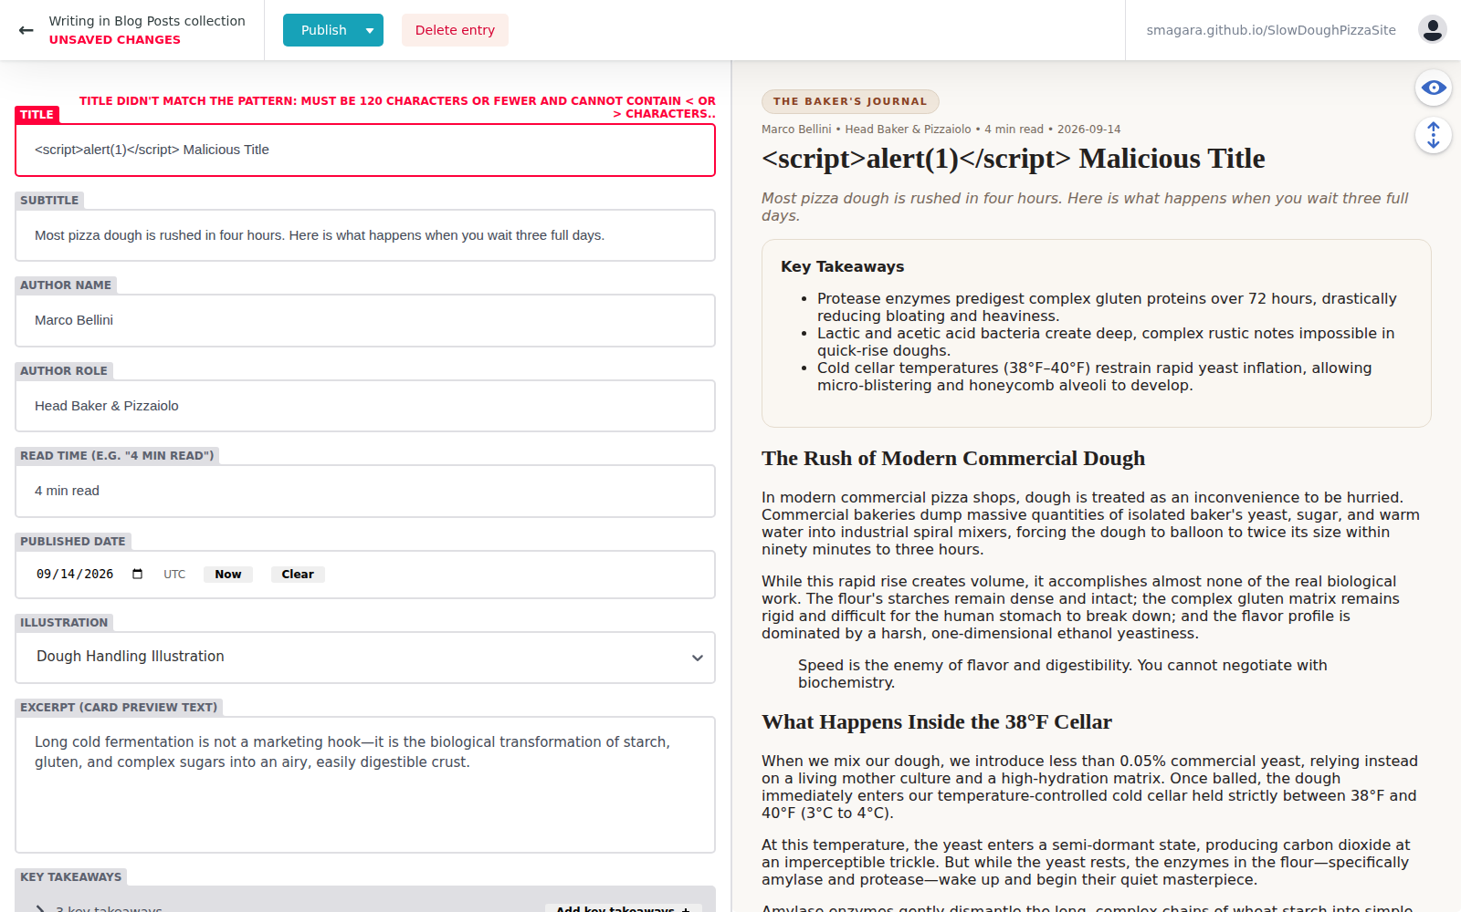
Figure 5 — Layer 1 in action: Decap blocks publishing a field containing a <script> tag and explains why, inline.

6. Access Control: Only Repository Collaborators
Decap's github backend is used specifically because access control is delegated entirely to GitHub itself rather than re-implemented: a user must (a) successfully complete GitHub's OAuth login flow, and (b) have at least write/collaborator access on the repository before Decap will let them open the editor or write a branch/PR. There is no separate username/password list for the CMS to leak or misconfigure.
Because a GitHub OAuth client secret can never be shipped to a static site's JavaScript bundle, a very small stateless hand-off service is required (/oauth-provider) to perform the “code → token” exchange server-side. This service:
- Holds no database and persists no tokens — it relays GitHub's token to the browser over a one-time postMessage handshake, exactly matching Decap's documented protocol.
- Runs in production as an Azure Function App (slowoauthfn, East US 2, Node.js 20, Functions programming model v4) exposing GET /auth, GET /callback and GET /healthz with no route prefix. The handlers (oauth-provider/azure/handlers.js) are thin adapters over a framework-agnostic core (oauth-provider/lib/github-oauth.js) and are covered by unit tests (npm test) that run in the deploy workflow before every release.
- The same core is also wired to an Express server (server.js + Dockerfile) and to Vercel functions (api/), so the service can be re-hosted without touching the OAuth logic.
- Uses a short-lived (5 minute), single-use, random state value carried in an HttpOnly/Secure/SameSite=Lax cookie on every login attempt to mitigate CSRF.
- Is deployed automatically by .github/workflows/deploy-oauth-provider-azure.yml, which supports either a publish-profile secret or a secret-less OpenID Connect (federated credential) login to Azure, and finishes with a live smoke test of /healthz and /auth. GitHub OAuth App credentials are never stored in the repository; they are Function App application settings.
Local development intentionally bypasses all of this: Decap's local_backend: true flag, combined with running npm run dev:cms, starts the decap-server file-system proxy (localhost:8081) and lets anyone with access to the dev machine edit content without any login — appropriate for a trusted local/dev environment, never exposed to the public internet.

7. Editorial Workflow: Feature Branches & Pull Requests
publish_mode: editorial_workflow is enabled in config.yml. This is a built-in Decap feature — no custom branch/PR automation was written. When the owner saves a change:
- Decap commits the change to a new branch named cms/<collection>/<slug>, never to main directly.
- Decap opens a GitHub Pull Request from that branch into main on the owner's behalf.
- The entry's status (Draft → In Review → Ready) is tracked inside the CMS's own “Editorial Workflow” board, giving the owner a kanban-style view of everything awaiting review.
- A human reviewer (e.g., the site's engineering contact) reviews the PR diff on GitHub — or the owner's own teammate — and approves/merges it like any other code change.
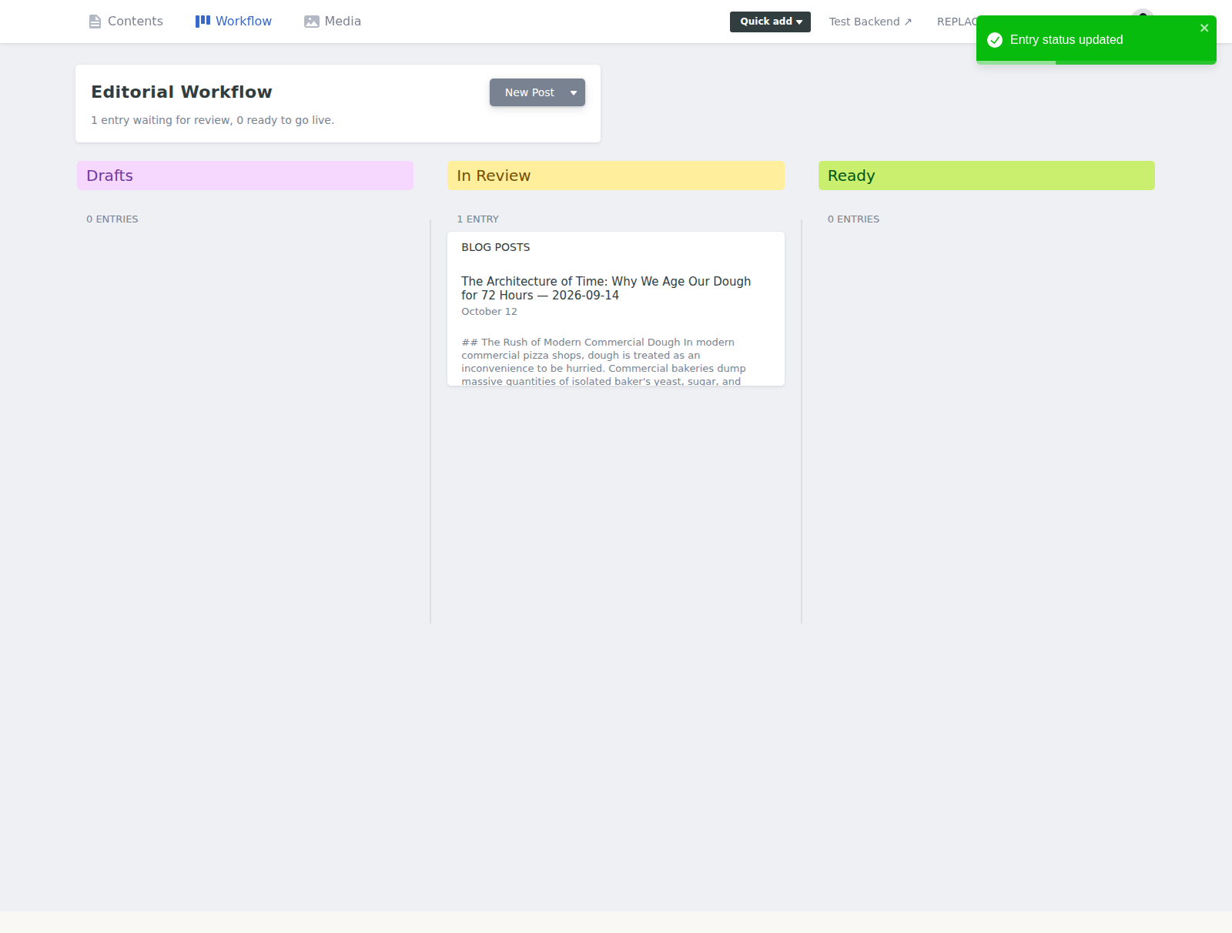
Figure 6 — The CMS's built-in “Editorial Workflow” board, showing a Blog Post entry moved to “In Review.” This corresponds 1:1 to an open GitHub Pull Request.
Figure 7 — Per-entry status control inside the editor: Draft / In review / Ready, with a “Publish” action that opens or updates the Pull Request.
An additional GitHub Action, pr-build-check.yml, runs on every Pull Request (including Decap's automatic ones) and fails the check if the content doesn't parse, is missing required fields, contains disallowed script-like content, or breaks the production build (npm run build). This gives a human reviewer a simple green/red signal before approving, on top of manually reading the diff.

8. CI/CD: Automatic Build & Deploy on Merge to main
.github/workflows/deploy.yml triggers on every push to main (i.e., immediately after a content PR — or any other PR — is merged). It installs dependencies, type-checks, runs npm run build, and publishes the resulting dist/ folder to GitHub Pages via the official actions/upload-pages-artifact and actions/deploy-pages actions. No manual deploy step is required; the owner's approved content is live within the time it takes the Action to run (typically well under two minutes for this project).
Workflow | Trigger | Purpose
pr-build-check.yml | pull_request → main | Validates content + type-checks + builds, surfacing failures to reviewers before merge.
deploy.yml | push → main (i.e., after merge) | Rebuilds the production bundle and deploys it to GitHub Pages.

Workflow | Trigger | Purpose
deploy-oauth-provider-azure.yml | push → main touching oauth-provider/** or site.config.json; manual | Tests, deploys the OAuth service to Azure Functions, smoke-tests the live endpoints.

Hosting note: the site is published as a GitHub Pages project site, so the build uses the /SlowDoughPizzaSite/ base path from site.config.json (local dev keeps "/"). Content edits never redeploy the OAuth service and vice-versa: each workflow has path filters for its own inputs. If the site moves to a custom domain or another static host, only site.config.json and the final “deploy” job need to change — the build and validation steps are host-agnostic.

9. Styling the Admin UI to Match the Brand
Decap CMS officially supports theming two areas of the editor: (1) the live preview pane per collection, via registerPreviewTemplate / registerPreviewStyle, and (2) top-level branding like the logo shown on the login screen, via the logo_url config key. Both are used extensively here — every collection has a bespoke preview component (src/admin/previews.tsx) built from the same color palette, font stack (Georgia serif headings, system-ui body text), and spacing used on the live site, so what the owner sees while editing closely matches what visitors will see.
The outer editor chrome (the collection list sidebar, the top toolbar, the login button itself) is intentionally left in Decap's own default styling. Decap does not currently expose an official, stable theming API for that chrome beyond the logo, and hand-overriding its internal, hashed CSS class names would be brittle across version upgrades. This trade-off is called out explicitly in Section 10 (Open Questions) as a candidate for future investment if deeper admin-wide theming becomes a priority.

10. Open Questions & Future Work
- One-time manual setup still required (documented in docs/INTEGRATION-GUIDE.md): registering the GitHub OAuth App (callback URL = the Azure host + /callback), adding OAUTH_GITHUB_CLIENT_ID / OAUTH_GITHUB_CLIENT_SECRET as Function App application settings, adding the Azure publish-profile (or OIDC) secrets to the GitHub repository, and switching GitHub Pages to the “GitHub Actions” source. None of these can be committed to the repo because they are secrets or account-level settings.
- Azure authentication method for deployments: the deploy workflow accepts either a publish profile (simplest) or OpenID Connect. Publish profiles depend on SCM basic-auth publishing, which Azure is gradually disabling by default on new apps; OIDC is the recommended long-term choice and the guide documents both.
- Custom domain: the demo runs under the GitHub Pages project path /SlowDoughPizzaSite/. Moving to a custom domain is a two-value change in site.config.json (site.url, site.basePath = "/") plus updating the GitHub OAuth App's homepage URL.
- Media/image uploads: the CMS config already points an “image” media library at public/images/uploads, but no collection currently has an image field (the site uses hand-drawn inline SVG illustrations, not uploaded photos). If the owner later wants to upload real food photography, adding an optional image field to the Blog/Menu collections is straightforward.
- Deeper admin-chrome theming: see Section 9 — full rebranding of Decap's outer shell (beyond the logo and preview pane) is possible but was judged not worth the brittleness/maintenance trade-off for this iteration.
- Multi-environment preview: there is currently no automatic “preview deployment” per Pull Request (e.g. a Vercel/Netlify preview URL). Reviewers rely on the CMS's own in-editor live preview plus reading the JSON/Markdown diff. Adding a PR preview deployment is a natural follow-up if richer visual review is desired.
- Notifications: no Slack/email notification is wired up for “new content PR opened” or “deploy succeeded.” GitHub's own PR/merge notifications are relied on today; a dedicated notification could be added to either GitHub Action if desired.

11. Appendix: File Manifest
Path | Purpose
content/*.json, content/blog/*.md | Owner-editable content, source of truth for the live site.
src/data/contentLoader.ts | Build-time loader that turns /content into typed data for React components.
src/lib/markdown.ts | Safe Markdown→HTML rendering (marked + DOMPurify) for blog bodies.
admin/index.html, src/admin/main.tsx | Vite entry point that bundles Decap CMS for /admin.
src/admin/previews.tsx, previewStyles.ts | Brand-matched live preview components per collection.
site.config.json | Single source of truth for repo slug, Pages URL/base path, Azure OAuth host + Function App name.
admin/config.template.yml | Decap CMS configuration template (backends, collections, fields, validation patterns); rendered by vite.config.ts into /admin/config.yml.
scripts/validate-site-config.mjs | CI check that site.config.json is complete and internally consistent.
public/admin/slow-dough-admin-logo.svg | Custom login-screen logo.
oauth-provider/ | Standalone GitHub OAuth hand-off service: Azure Functions v4 (production) + Express and Vercel variants, with unit tests.
.github/workflows/deploy-oauth-provider-azure.yml | CD: tests and deploys the OAuth service to the Azure Function App, then smoke-tests it.
.github/workflows/pr-build-check.yml | CI: validates content + type-checks + builds on every PR.
.github/workflows/deploy.yml | CD: builds and deploys to GitHub Pages on every push to main.
scripts/validate-content.mjs | Standalone Node script used by CI to validate all content files.
docs/ | This Technical Design Document, the manager's PDF guide, the integration/deployment runbook (INTEGRATION-GUIDE.md), and the flow diagram source.

Document Control
Author: Engineering (AI-assisted implementation)
Status: Implemented and wired to the demo environment (GitHub Pages + Azure Functions). Remaining one-time manual steps are listed in Section 10 and detailed in docs/INTEGRATION-GUIDE.md.

