Slow Dough Pizza Co.

Tina CMS Integration
Technical Design Document
Self-service content editing for the Slow Dough website on GitHub Pages: local edit mode with Tina CMS, and a GitHub Pull-Request workflow for production, restricted to repository collaborators.
Item | Value
Repository | https://github.com/smagara/SlowDoughPizzaSite_Tina
Live site | https://smagara.github.io/SlowDoughPizzaSite_Tina/
Staff editor | https://smagara.github.io/SlowDoughPizzaSite_Tina/#/edit
Stack | React 19 · Vite 8 · Tailwind 4 · Tina CMS 3.14 / @tinacms/cli 3.1 · Vitest 5 · GitHub Actions · GitHub Pages
Document version | 1.4 — 2026-10-18 (revision notes in §18, §20, §21; OAuth proxy plan in Appendix E)
Status | Prototype — deployed to GitHub Pages by the owner; PR workflow verified end to end (101 automated tests passing)

Contents
1. Executive summary
2. Goals, non-goals and constraints
3. Solution overview
4. Architecture
5. Content model (Tina schema)
6. Editing modes
7. Publishing flow (flow diagram)
8. Authentication and authorization
9. Input validation and content safety
10. Pull Request and branch strategy
11. Build, test and deployment pipeline
12. Design decisions (with alternatives considered)
13. Security considerations
14. Testing strategy
15. Operational runbook
16. Open questions and future work
17. Appendix
18. Revision 1.1 — local-testing feedback and resolutions
19. npm install notices — review and advice
20. Revision 1.2 — production feedback: workflow runtimes, collapsible layout, passcode sign-in
21. Revision 1.3 — remaining workflow warnings, shared devices, batching edits, document review
Appendix E (within §17): plan for a Cloudflare Worker OAuth proxy — “Sign in with GitHub” (proposal, not implemented).

1. Executive summary
The Slow Dough website was a hard-coded React single-page application: every menu price, blog essay and the "Today's Dough" banner lived inside TypeScript source. The owner needs routine self-service updates without a developer. This design integrates Tina CMS as the content layer while keeping the site a zero-cost static deployment on GitHub Pages.
The result has two complementary editing experiences driven by one Tina schema:
- Local edit mode (development/testing). npm run dev starts Tina's local GraphQL server and admin. Edits are written directly to JSON files under content/ and Vite hot-reloads the site. Both the stock Tina admin and the site-styled editor work in this mode.
- GitHub review mode (production). A hidden footer link opens a site-styled editor. Staff sign in with a GitHub token; the editor verifies they are a repository collaborator with write access, validates every field, then commits the change to a new cms/<user>/<timestamp> branch and opens a Pull Request against main. Merging the PR triggers a GitHub Action that rebuilds and redeploys the site.
Free-text input is validated identically in the Tina admin, in the staff editor and in CI (angle brackets, script URLs, event-handler fragments, HTML entities, control/zero-width characters, lengths, prices, dates, identifiers). A reviewer always sees a plain-English, field-level summary of what changed before anything is published.

2. Goals, non-goals and constraints

2.1 Goals (from the brief)
# | Requirement | How it is met
G1 | Integrate Tina CMS so the owner can update the Daily Menu, Blog posts and the Dough announcement | Tina collections menu, post, announcement (+ hours as a bonus) in tina/schema.ts; site renders from content/*.json
G2 | Local edit mode for dev testing | npm run dev → tinacms dev -c vite; Tina admin at /admin/index.html; editor auto-detects the local GraphQL API
G3 | Production integrates with GitHub; prototype runs on GitHub Pages | Static build deployed by deploy.yml; editor talks to api.github.com directly from the browser
G4 | Non-displayed link to a site-styled web form of the CMS-editable fields | Invisible ✎ Staff link in the footer → #/edit; schema-driven form using the site palette/typography
G5 | Only GitHub collaborators may access | GET /repos/{o}/{r}/collaborators/{user}/permission must be write/maintain/admin; GitHub enforces the same on every write
G6 | Reasonable validation of free text incl. script characters | Shared validation.ts rules applied in Tina ui.validate, in the editor, and in CI on every PR
G7 | Successful update → PR from a feature branch (not main) | Git Data API: tree → commit → refs/heads/cms/<user>/<stamp> → POST /pulls (base main)
G8 | Approval + merge to main → automatic build and deploy | deploy.yml on push: main → lint, tests, build, actions/deploy-pages
G9 | Documentation: TDD (Word) with flow diagram; staff PDF with screenshots | This document; docs/Staff-Editing-Guide.pdf
G10 | All tests pass | 101 Vitest tests (unit, backend, component, end-to-end editor flows) + tinacms audit + type-check

2.2 Non-goals
- Rich-text/Markdown authoring with embedded media. Essays remain structured (heading, paragraphs, pull quote) to match the existing layout and to keep validation tractable.
- Image/media uploads (no images are used by the site today).
- Live "visual editing" (Tina contextual editing inside the page). Local mode already gives instant preview via HMR.
- Multi-environment previews (e.g. a preview URL per PR). See Open questions.

2.3 Constraints
- GitHub Pages serves static files only — no server-side code, so no OAuth client secret can be held and no Tina self-hosted backend can run there.
- No paid services. TinaCloud's Editorial Workflow (branch + PR) is a paid tier and uses its own user directory rather than GitHub collaborators.
- The existing design, palette and component structure must be preserved.

3. Solution overview
Content was extracted from src/data/pizzaShopData.ts into JSON documents under content/ and that file was removed. A Tina schema (tina/schema.ts) describes each collection. The website loads the JSON at build time through Vite (src/content/index.ts), so visitors download no CMS code at all — the public bundle grew by ~4 KB (280.9 → 284.8 KB) and the staff editor is a separately code-split chunk (~62 KB) loaded only at #/edit.
Layer | Files | Responsibility
Content | content/settings/announcement.json  content/menu/menu.json  content/posts/<slug>.json  content/hours/hours.json | The only files staff change; committed to git and reviewed in Pull Requests.
Schema | tina/schema.ts, tina/config.ts, tina/tina-lock.json | Collections, fields, labels, help text and validation. Single source of truth.
Website | src/content/index.ts, src/components/* | Renders content; getPublishedPosts() hides drafts; dates formatted from ISO.
Staff editor | src/cms/EditorApp.tsx, components/*, useEditorStore.ts | Schema-driven form, dirty tracking, validation, review dialog, result panel.
Backends | src/cms/backends/localTina.ts, github.ts | Local: Tina GraphQL mutations. GitHub: collaborator check, read from main, branch + commit + PR.
Safety | src/cms/validation.ts, schemaValidation.ts, content.test.ts | Text/number/date/slug rules; whole-document validation; CI gate for every file in content/.
Pipeline | .github/workflows/ci.yml, deploy.yml, CODEOWNERS | PR checks; deploy on merge; owner auto-requested as reviewer.

4. Architecture
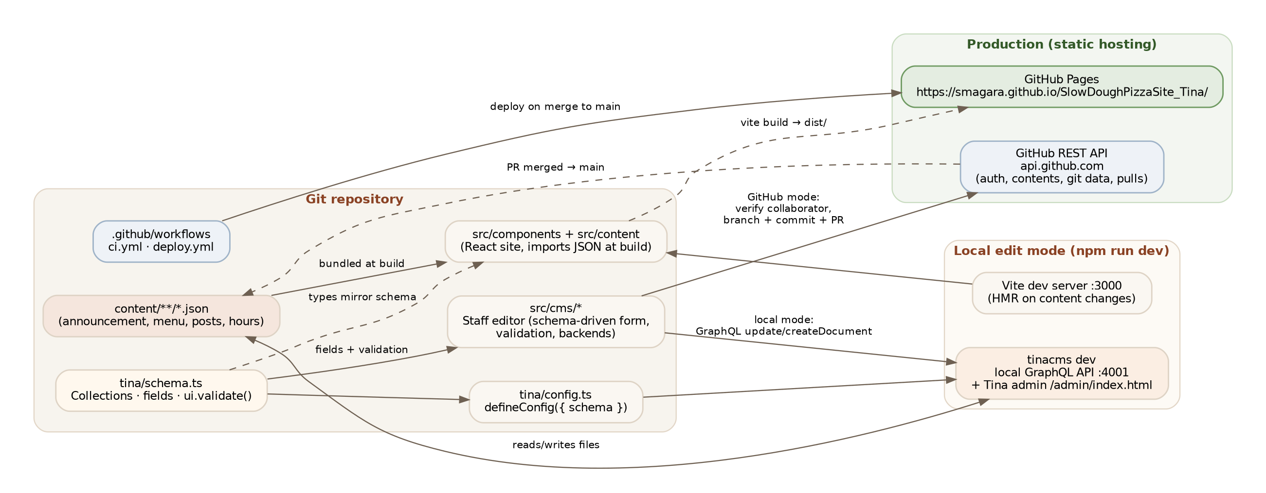
Figure 1 — Component architecture: one schema drives the Tina admin (local), the staff editor and CI validation. Production is fully static; the only runtime dependency is the GitHub REST API.

4.1 Runtime behaviour of the website
src/main.tsx renders Root, a tiny hash router. Any hash other than #/edit renders the unchanged App. #/edit lazily imports EditorApp. A hash route was chosen over a real path because GitHub Pages would return 404 for /edit on a hard refresh and because the site already uses #section anchors; #/edit cannot collide with an element id.

4.2 The hidden link
The footer contains <a id="staff-editor-link" href="#/edit">✎ Staff</a> rendered with opacity-0 so it is not displayed, but it stays in the tab order and becomes visible on hover/focus. This keeps the link discoverable for trained staff and for keyboard/screen-reader users (it has an accessible name) while remaining invisible to casual visitors. It is not a security control — access is enforced by GitHub authentication and collaborator permission.

4.3 Editor state management
useEditorStore holds, per collection, the original document (as loaded) and a working draft. A change set is derived by deep comparison (upserts = dirty or new drafts; deletes = flagged originals). Validation runs on every keystroke against the schema so the sticky action bar can show "N files changed · M issues to fix" and disable submission until clean.

5. Content model (Tina schema)
All collections use format: "json". Singletons (announcement, menu, hours) disable create/delete with ui.allowedActions and are marked global in the Tina admin. Blog posts are one file per post; the filename is the slug and is generated from the title (ui.filename.slugify). Field helpers (text, textarea, textList, slug) attach the shared validators so every string field has a length limit and the script-character rules.
Collection | Path | Key fields | Notable rules
announcement | content/settings | enabled (bool), headline* (≤80), detail (≤200) | Banner hidden when enabled is false
menu | content/menu | eyebrow, title*, intro, categories[] → {id*, title*, subtitle, items[] → {id*, name*, italianName, description*, price*, tags[], isVegetarian, isVegan}} | 1–12 categories, ≤40 items each, unique ids, price 0–999 with ≤2 decimals, ≤6 tags of ≤30 chars
post | content/posts | title*, subtitle, author*, authorRole, readTime, publishedDate* (datetime), artType* (dough|oven), draft, excerpt*, keyTakeaways[], content[] → {sectionHeading, paragraphs[]*, quote} | Dates 2000–2100; 1–12 sections; 1–20 paragraphs of ≤2000 chars; draft defaults to false (visible); drafts hidden on the site
hours | content/hours | schedule[] → {day*, hours*, statusNote, isClosed} | Exactly 7 entries

Migration notes: publishedDate moved from free text ("September 14, 2026") to ISO-8601 so Tina's date picker works; the site formats it with Intl.DateTimeFormat in UTC. A draft flag was added (default false – see D13). The post id/slug is now derived from the filename.

6. Editing modes

6.1 Local edit mode (development)
npm run dev # = tinacms dev --noTelemetry -c "vite --port=3000"
# Site: http://localhost:3000/
# Editor: http://localhost:3000/#/edit (auto-detects Tina on :4001)
# Tina admin: http://localhost:3000/admin/index.html
EditorApp probes http://localhost:4001/graphql (only when import.meta.env.DEV or VITE_CMS_MODE=local). If it answers, LocalTinaBackend is used: documents are read with the generic collection(...){ documents { ... _values } } query and written with updateDocument / createDocument / deleteDocument mutations — the same API the stock admin uses — so Tina owns the file writes. No authentication is required because the server only runs on the developer's machine.
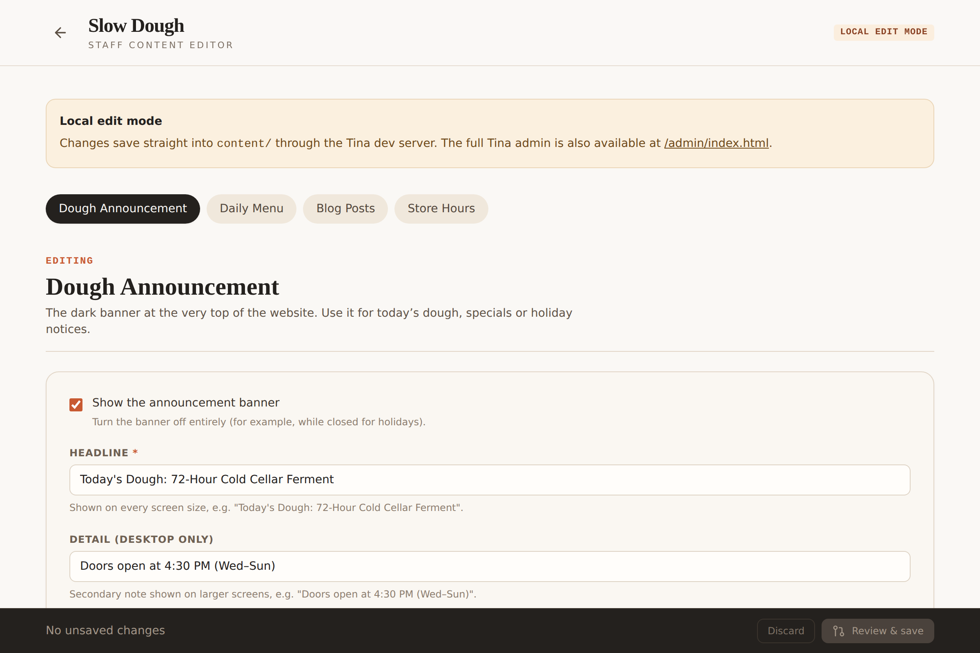
Figure 2 — Staff editor in local edit mode. The badge and notice make the mode explicit; the full Tina admin is one click away.
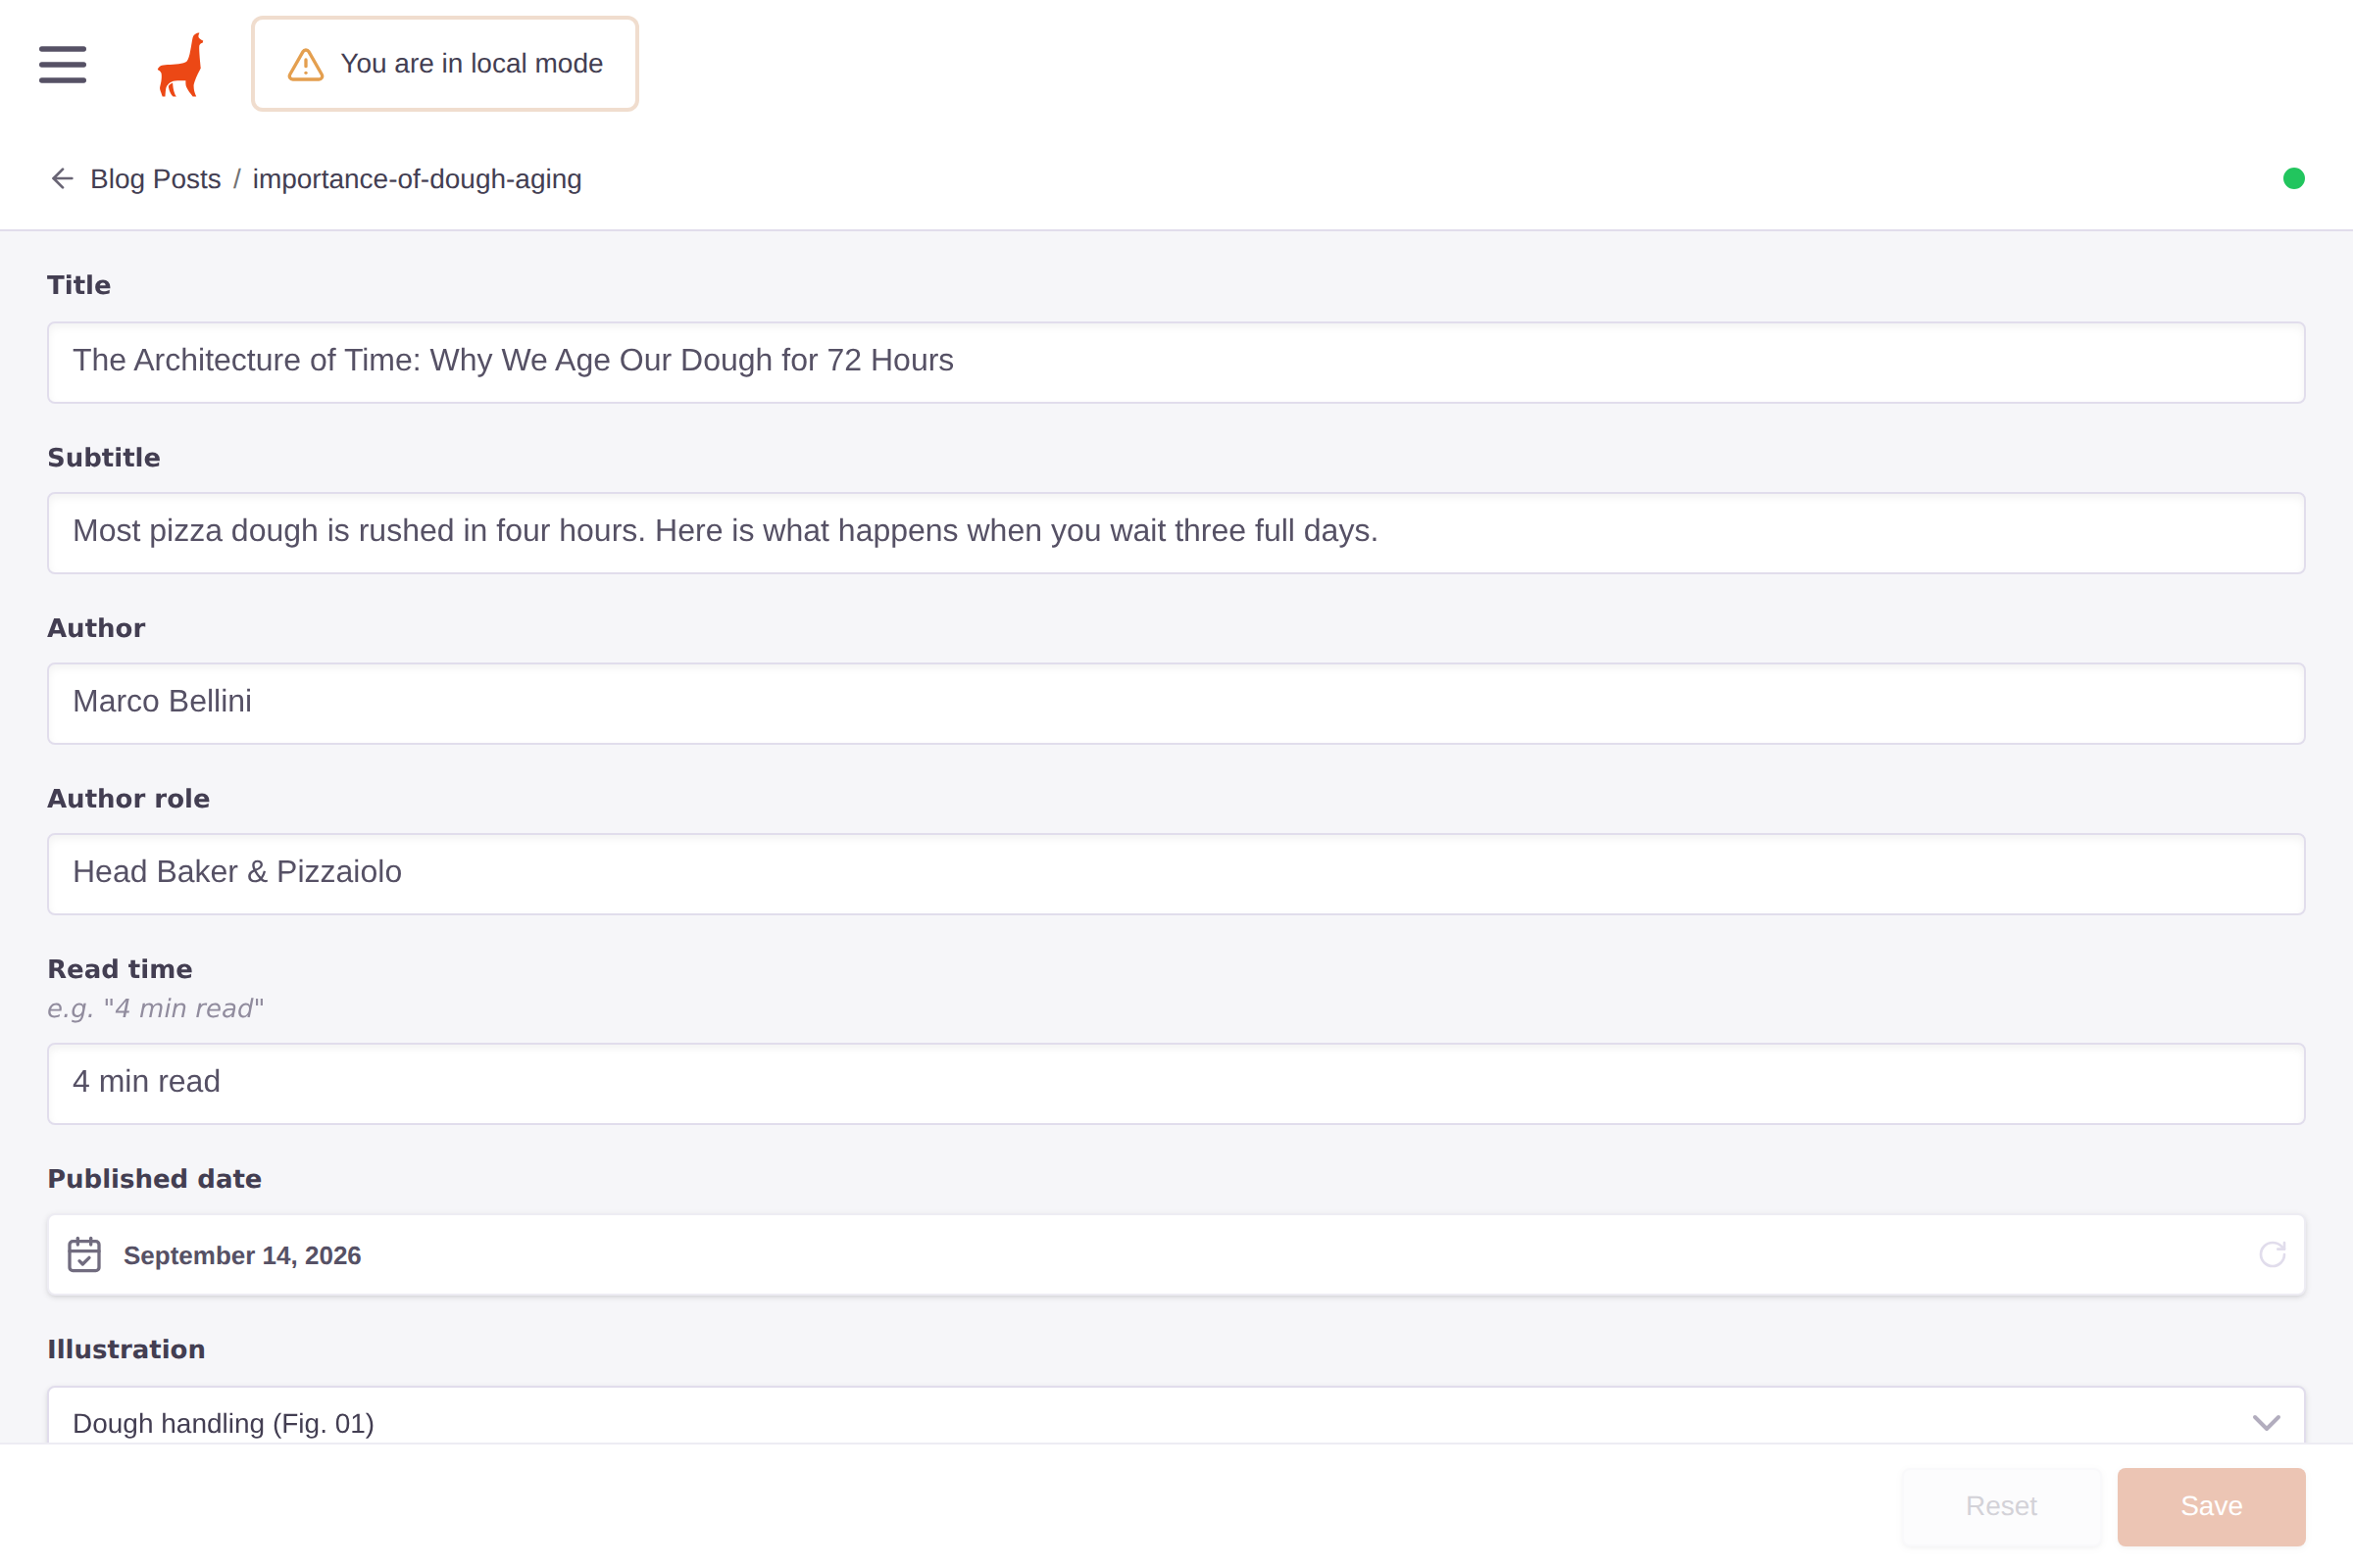
Figure 3 — The stock Tina admin (local mode) generated from the same schema, including the shared validation messages.

6.2 GitHub review mode (production)
On GitHub Pages there is no Tina server, so the editor uses GitHubBackend. It reads the current documents from branch main through the Contents API (so staff always start from what is live or about to be live, not from the possibly-stale bundle), and writes through the Git Data API as a single atomic commit on a fresh branch followed by a Pull Request. Forcing this mode during development is possible with VITE_CMS_MODE=github.

7. Publishing flow
Figure 4 is the end-to-end process from a staff member opening the hidden link to the website being republished.
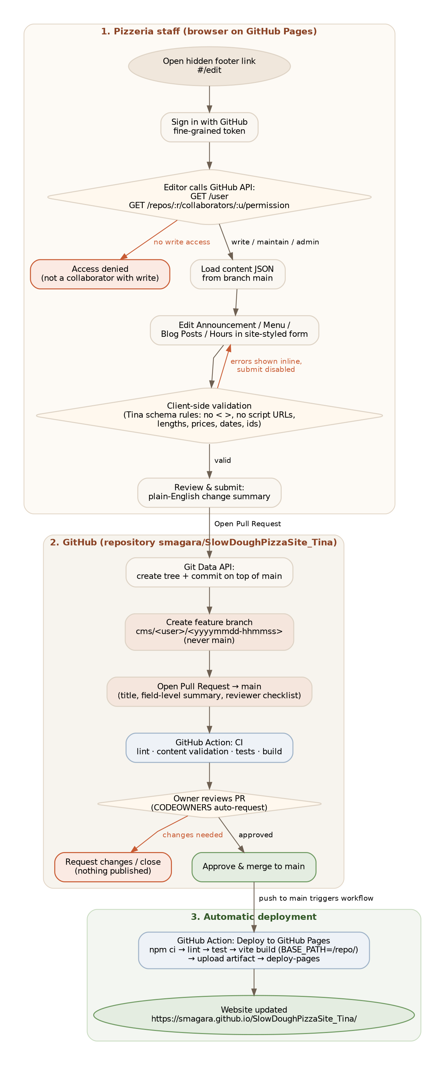
Figure 4 — End-to-end publishing flow. Red edges are the rejection paths; nothing reaches main without an approved Pull Request.

7.1 GitHub API call sequence
The staff editor performs the following REST calls. Steps ①–③ happen at sign-in/load; ④–⑧ happen when the user confirms the review dialog.
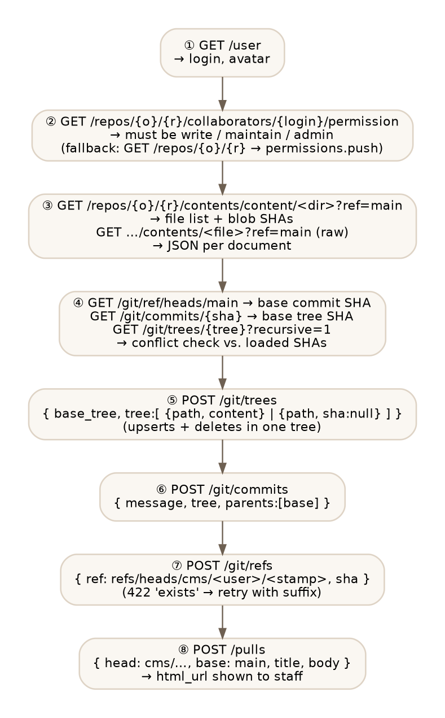
Figure 5 — GitHub REST calls made by the editor. Tree entries carry file content directly (no separate blob calls) and deletions are sha: null.

8. Authentication and authorization

8.1 Authentication — GitHub fine-grained personal access token
Staff paste a GitHub fine-grained personal access token scoped to this single repository with Contents: Read & write and Pull requests: Read & write. The token is sent only to https://api.github.com over HTTPS. For the current tab it lives in sessionStorage (cleared when the tab closes; never in cookies or the URL); "Sign out" removes it immediately and an inactivity timer locks the session. Optionally — and by default — the token is also remembered on the device encrypted with a user-chosen passcode (D17); only ciphertext is stored.
Why a token rather than "Sign in with GitHub" (OAuth)? The OAuth web flow requires exchanging a code for a token using the application's client secret, which cannot be embedded in a static site, and GitHub's device-flow endpoints do not send CORS headers so the browser cannot call them. Both therefore need a small server or proxy — see Open question Q1.

8.2 Authorization — repository collaborators with write access
After GET /user, the editor calls GET /repos/{owner}/{repo}/collaborators/{login}/permission and requires write, maintain or admin. If that endpoint returns 403/404 (which GitHub does for non-collaborators) the editor falls back to GET /repos/{owner}/{repo} and checks permissions.push; anything else produces the "not a collaborator with write access" message and the token is discarded.
This is a usability check on top of GitHub's own enforcement: a token without write permission cannot create refs, commits or pull requests in the repository in the first place, and branch protection on main means even collaborators cannot bypass review.
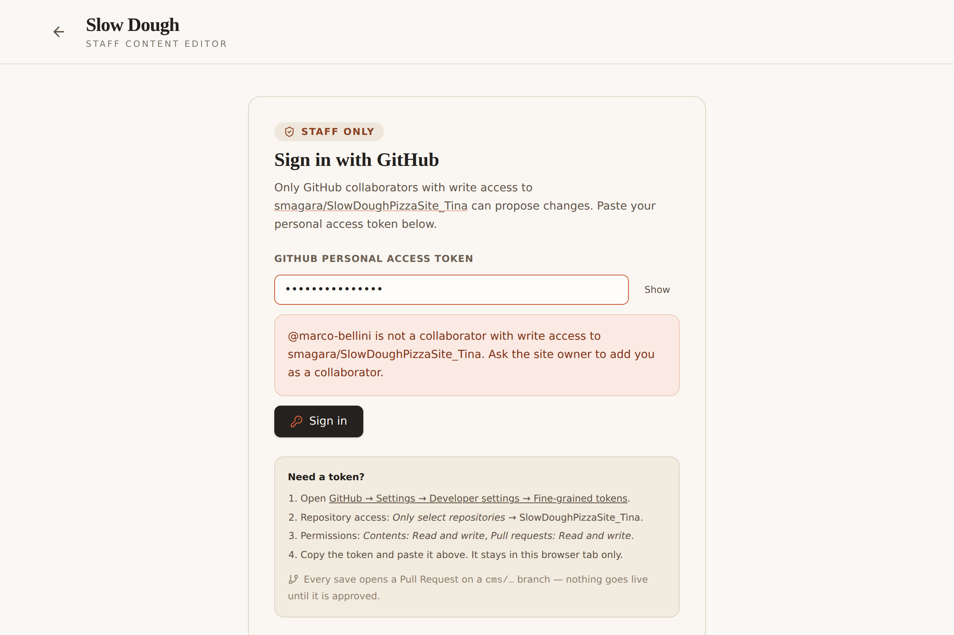
Figure 6 — A read-only collaborator (or a non-collaborator) is refused at sign-in.

9. Input validation and content safety
React escapes all rendered text and the site never uses dangerouslySetInnerHTML, so stored content cannot execute in the browser. The validation layer is defence in depth: it keeps markup-like and obfuscated input out of the repository so Pull Requests stay readable for a non-technical reviewer and so content could be reused safely elsewhere (e.g. a printed menu).
Rule (src/cms/validation.ts) | Example rejected input | Message
Angle brackets / tags | <script>alert(1)</script>, 1 < 2 | Angle brackets (< >) and HTML tags are not allowed.
Executable URL schemes | javascript:…, vbscript:…, data:text/html | "javascript:" URLs are not allowed.
Event-handler fragments | x" onclick=alert(1) | Event handler attributes (e.g. onclick=) are not allowed.
Numeric HTML entities | &#60;script&#62;, &#x3C; | Numeric HTML entities are not allowed.
Escaped unicode | \u003cscript\u003e | Escaped unicode sequences are not allowed.
Control / invisible characters | U+0000–U+001F, U+200B, U+202E (bidi override) | Control characters / Invisible characters are not allowed.
Line breaks in single-line fields | "line one\nline two" in a headline | Line breaks are not allowed in this field.
Length limits | short 80 · medium 200 · long 600 · paragraph 2000 | Please keep this under N characters (currently M).
Identifiers | Margherita, a--b, ../etc/passwd | Use only lowercase letters, numbers and single hyphens.
Prices | -1, 1000, 9.999, "abc" | Price cannot be negative / must be 999 or less / at most two decimals.
Dates | "yesterday", 1999-01-01 | Please enter a valid date / between 2000 and 2100.
Structure | duplicate item ids, 0 categories, 6 days of hours, unknown JSON keys | Duplicate item ID "…" / exactly 7 days / Unknown field "…".

Where the rules run:
- Tina admin: every field carries ui.validate → Save is disabled with the message shown inline (Figure 3).
- Staff editor: validateDocument() walks the schema on each change; errors are shown under the field, the containing list item is flagged "needs attention", and the submit button is disabled (Figure 7).
- CI: npm run validate:content (a Vitest suite) validates every file in content/ on every PR and on main, so a hand-edited or malicious PR cannot merge with invalid content.
- PR body: the optional reviewer note is stripped of </> and the change summary escapes Markdown metacharacters.
Invalid input is rejected, never silently rewritten. Normal pizzeria copy — accents, apostrophes, ampersands, degree symbols, en-dashes, "$19", "4°C" — passes (covered by tests).
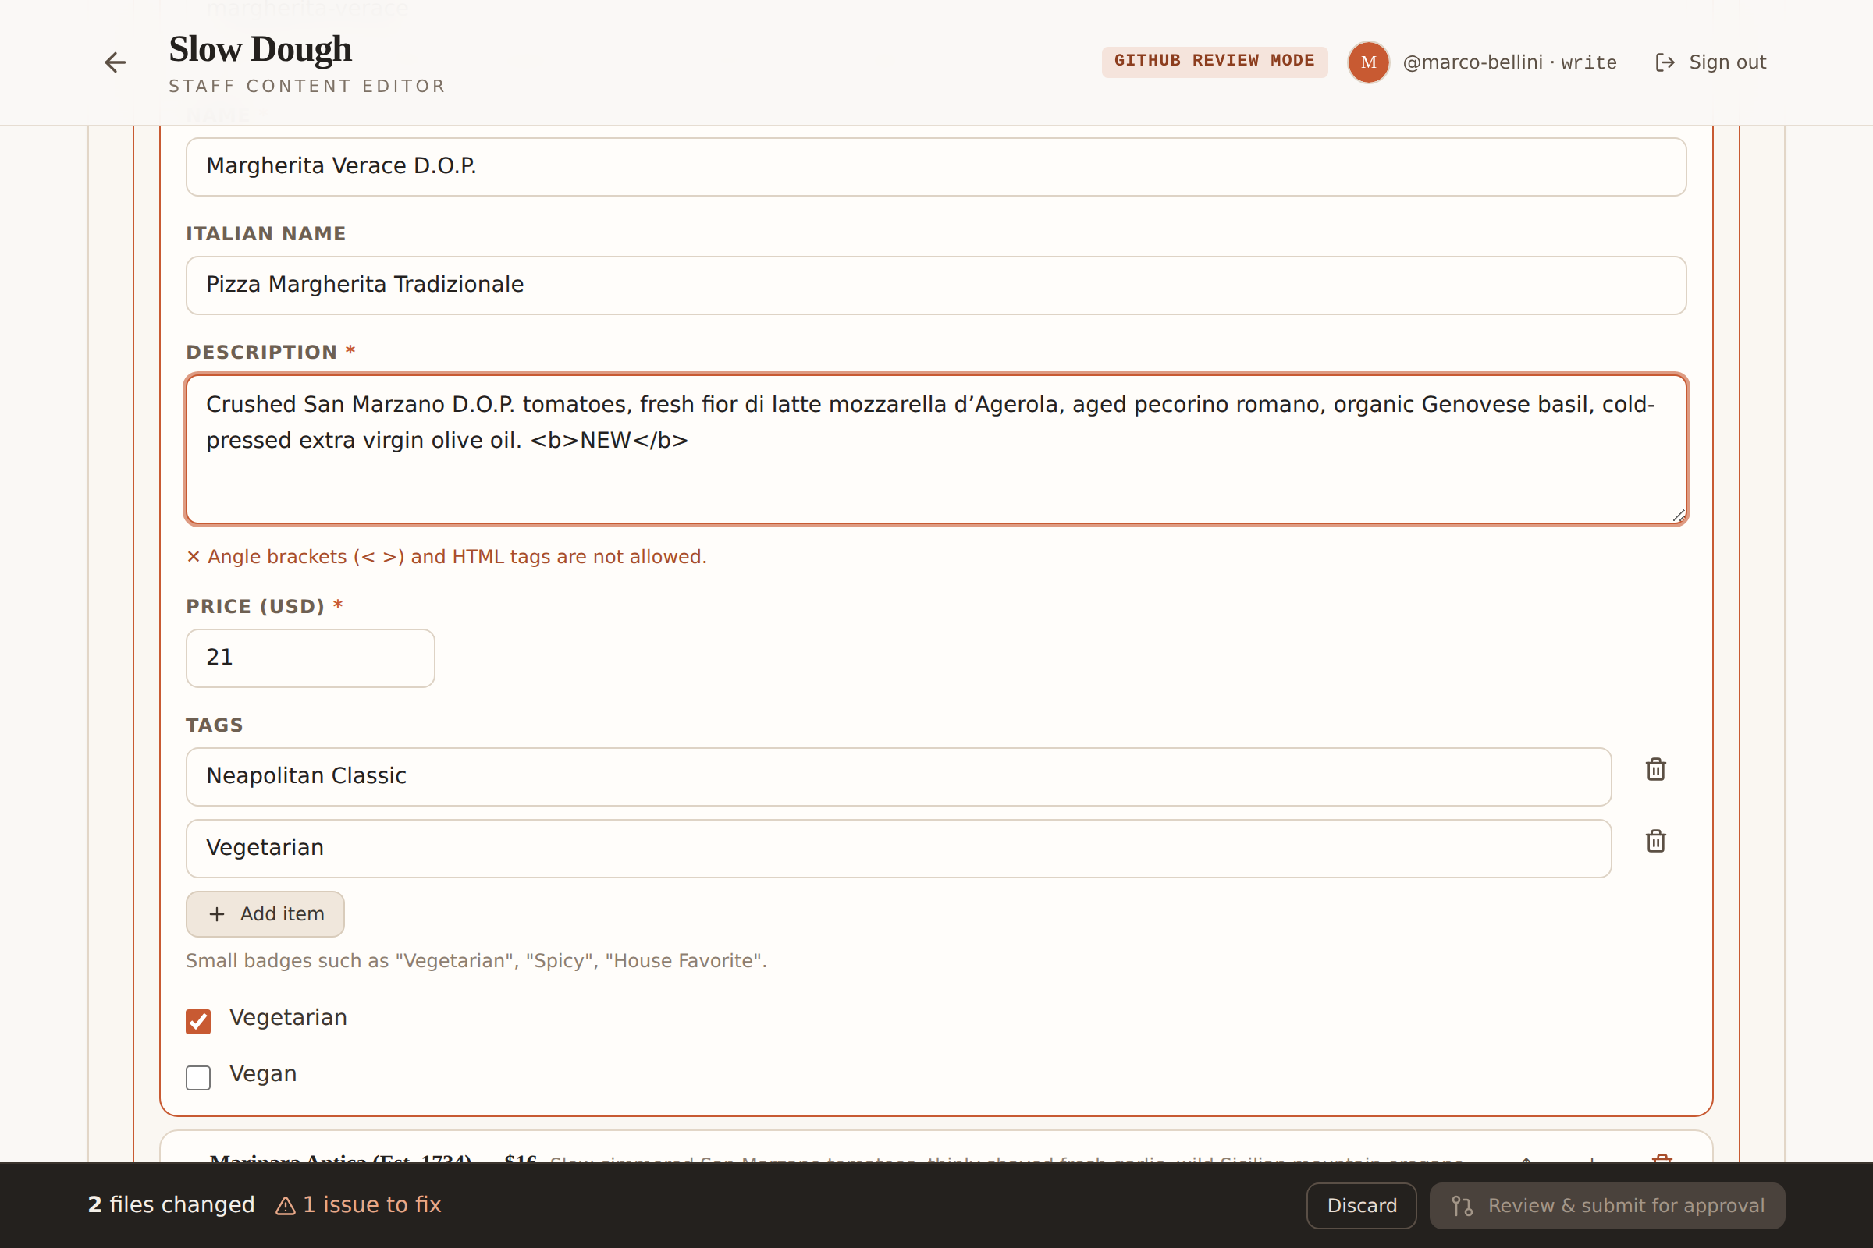
Figure 7 — Inline rejection of HTML in a menu description; the action bar reports "1 issue to fix" and submission is blocked.

10. Pull Request and branch strategy
Aspect | Decision
Branch name | cms/<github-login>/<yyyymmdd-hhmmss>
Collision handling | If POST /git/refs returns 422 "Reference already exists", retry with -2, -3.
Base branch | main (configurable via VITE_GITHUB_BASE_BRANCH). The editor refuses to generate a branch name equal to the base.
Commit granularity | One commit per submission containing all changed documents (creates, updates, deletes) — atomic and easy to revert.
Conflict detection | Each loaded file's blob SHA is compared with main's tree at submit time; if someone changed that file since load, the submission is refused with instructions to reload. Creating a post whose filename already exists is refused.
File format | Keys re-ordered to schema order, 2-space indent, trailing newline — minimal, readable diffs.
PR title | "Content update: <collections touched>" — editable by staff.
PR body | Submitter, optional note, then per document: file path, action, and field-level lines such as "Menu categories › Neapolitan Pizzas › Items › Margherita — $21 › Price (USD): 19 → 21", plus a reviewer checklist.
Reviewers | .github/CODEOWNERS (* @smagara) auto-requests the owner; branch protection should require 1 approval + green CI.
After submit | Editor shows PR number, branch and link; reloads documents so the working copy is clean.

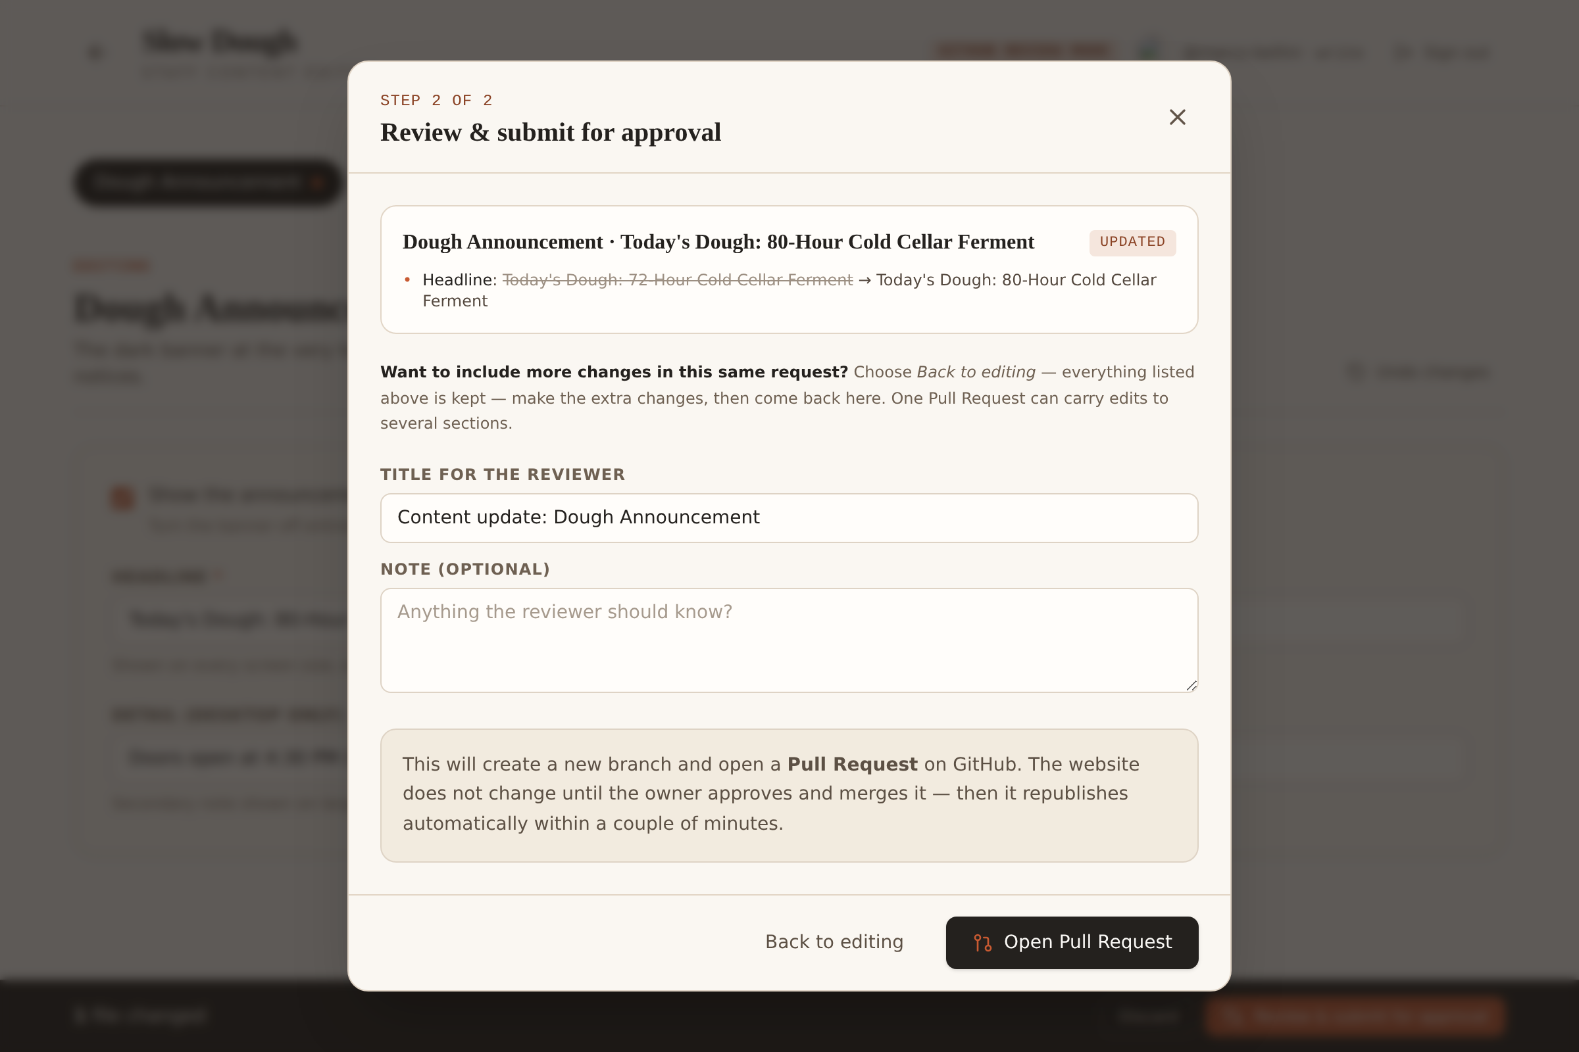
Figure 8 — Review dialog: plain-English change summary, editable PR title and optional note before the Pull Request is opened.
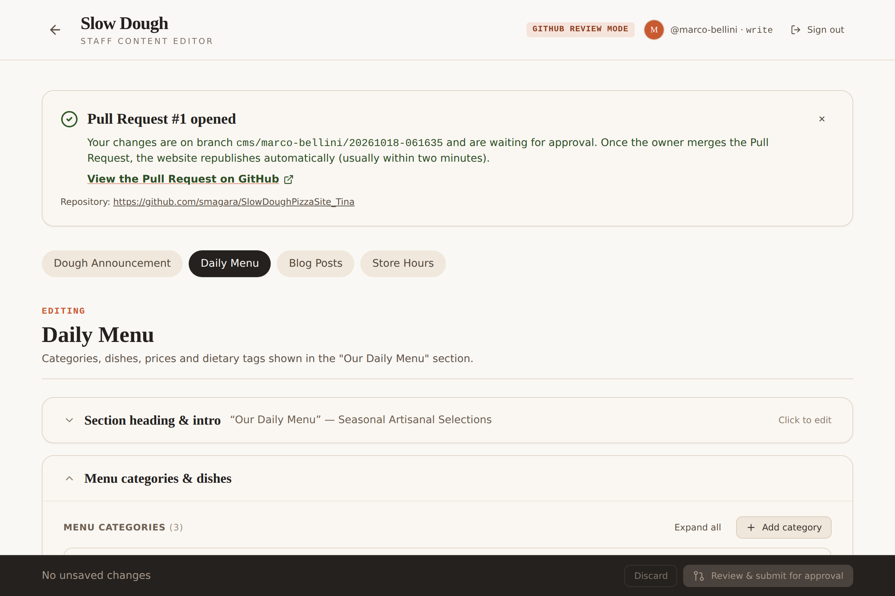
Figure 9 — Confirmation with the feature branch name and a link to the Pull Request.

11. Build, test and deployment pipeline
Workflow | Trigger | Steps
ci.yml | pull_request → main; push to any non-main branch | Node 24: npm ci → tsc --noEmit → validate:content → vitest → vite build (BASE_PATH) → tinacms audit
deploy.yml | push → main (i.e. a merged PR); manual dispatch | Node 24: npm ci → lint → tests → vite build with BASE_PATH=/<repo>/ and VITE_GITHUB_* → tar + upload-artifact (artifact "github-pages") → deploy-pages
dependabot.yml | weekly (actions) / monthly (npm, grouped) | Opens PRs that bump action majors (e.g. Node 24 runtimes) and grouped npm updates (tina, tooling)

GitHub Pages must be set to "Source: GitHub Actions". The pages concurrency group serialises deployments and never cancels an in-flight production deploy. BASE_PATH makes Vite emit /SlowDoughPizzaSite_Tina/assets/... URLs; public/.nojekyll prevents Jekyll processing. The stock Tina admin is deliberately not built for production (npm run build = vite build); npm run build:tina exists for a future TinaCloud adoption.

12. Design decisions (with alternatives considered)

D1 — Hybrid: Tina local mode + custom GitHub-PR editor (instead of TinaCloud or a self-hosted Tina backend)
TinaCloud is the usual production path but (a) its user directory is separate from GitHub collaborators, (b) branch+PR "Editorial Workflow" is a paid tier, (c) it adds a third-party dependency and credentials. Self-hosted Tina needs a Node server and a database — impossible on GitHub Pages. The hybrid keeps Tina as the content-modelling and local-editing layer and uses GitHub itself as the production backend. Trade-off: the production form supports only the field types used in this schema (string, textarea, select, number, boolean, datetime, string list, object, object list), not Tina's full widget set.

D2 — JSON documents, not Markdown
The existing essays are structured (heading / paragraphs / pull quote / takeaways) and the layout depends on that structure. JSON keeps a 1:1 mapping to the UI, is trivially validated field-by-field, and avoids shipping a Markdown/MDX renderer. Alternative (Markdown body with rich-text) was rejected for validation complexity and layout fidelity.

D3 — Site reads content via build-time JSON imports, not the Tina GraphQL client
Keeps the public bundle free of Tina runtime (≈4 KB growth), works identically in dev/CI/prod, and needs no network at runtime. Alternative (client.queries.* / useTina) would require the local server during build or TinaCloud in production.

D4 — One shared schema module without runtime tinacms imports
tina/schema.ts imports only types from tinacms, so the staff editor can import the collections without pulling the Tina runtime. tina/config.ts wraps it with defineConfig for the CLI.

D5 — Fine-grained PAT for authentication
The only zero-infrastructure option for a static site. Scoped to one repository and two permissions; kept in sessionStorage. Alternatives: OAuth via a small proxy (Cloudflare Worker / Netlify function) or a GitHub App — both need a hosted component (Q1).

D6 — Authorization via collaborator permission endpoint with repo-permissions fallback
Canonical GitHub signal for "is a collaborator with write access"; the fallback handles tokens that cannot read the collaborators endpoint. GitHub enforces the same permission on every write, so the check cannot be bypassed by editing client code.

D7 — Git Data API with a single commit and branch created at the new commit
Fewer calls (tree entries carry content; no blob calls), atomic multi-file changes including deletions, and the branch is never created pointing at main without changes. Alternative (Contents API PUT per file) produces one commit per file and no atomicity.

D8 — Read from main at sign-in and detect conflicts by blob SHA
Staff edit what is actually in the repository, not a stale bundle; a concurrent change to the same file is refused rather than silently overwritten.

D9 — Hash route #/edit and an invisible, focusable footer link
No 404s on static hosting, no collision with section anchors, code-split editor, accessible discovery for staff.

D10 — Reject, don't sanitise
Sanitising silently changes what staff typed; rejecting with a clear message keeps humans in control and keeps the rules simple and testable. React escaping remains the primary XSS control.

D11 — Store hours included as a fourth collection
It is the other change staff make routinely and costs nothing because the form is schema-driven. Can be removed from collections in one line if undesired.

D12 — Generated Tina artefacts are git-ignored; tina-lock.json is committed
tina/__generated__ and public/admin are rebuilt by tinacms dev/build; the lock file pins the compiled schema as Tina recommends.

D13 — New blog posts are visible by default (draft: false); Draft is an explicit opt-in (changed in v1.1)
v1.0 created new posts as drafts "to be safe", which local testing showed is surprising: the post saved correctly but never appeared. In production the Pull Request review is already the publishing gate, so hiding new posts by default added a second, invisible gate. Now a new post is visible once saved/approved; ticking Draft shows a prominent warning in the form, a "Draft · hidden from website" badge in the list, a one-click "Publish this post" button and an explicit flag in the review dialog.

D14 — Button styling is variant-based; no utility-class overrides (changed in v1.1)
The v1.0 action bar passed extra Tailwind classes to override a button variant. Tailwind resolves conflicting utilities by stylesheet order, not by className order, so the hover state could combine a cream background with white text. Each variant now sets background, text and border for rest, hover and disabled states explicitly (accent and darkGhost for the dark bar), guaranteeing readable contrast.

D15 — Redundant hours badge removed from the header (changed in v1.1)
The "Wed–Sun • 4:30 PM" badge (and the hard-coded hours line in the mobile drawer) duplicated information that the editable announcement banner and the Store Hours section already carry, and would silently contradict them after a CMS edit. Only CMS-driven text remains in the header.

D16 — Collapsible, summarised edit screens driven by a layout map (v1.2)
Staff asked for less scrolling and clearer context. src/cms/layout.ts groups each collection's top-level fields into panels with a one-line summary while collapsed (menu: "Section heading & intro" folded, categories open; posts: "Title & summary" open, "Author, date & illustration" and "Key takeaways" folded, "Essay sections" open). List items (categories, dishes, sections, days) start collapsed with a preview line and Expand/Collapse-all controls. Rule: a panel or item with a validation error cannot be collapsed and stays open after the fix, so nothing that needs attention is ever hidden and the field being typed in never disappears. The schema stays the single source of truth — fields missing from the layout map render in an always-open "Other details" panel.

D17 — "Remember me on this device with a passcode" instead of pasting the token each visit (v1.2)
Requested by the owner. Implementation: the verified token is encrypted in the browser with a key derived from a user-chosen passcode (PBKDF2-SHA-256, 600 000 iterations, random 16-byte salt → AES-256-GCM, random 12-byte IV) and only the ciphertext is kept in localStorage; the passcode is never stored. Each GitHub login has its own entry and passcode, so a shared laptop remembers everyone who uses it (v1.3, see §21.2). Five wrong passcodes wipe that person's entry; "Forget @name" / "Forget everyone" wipe on demand; a token is only remembered after the collaborator check succeeds; the tab session still uses sessionStorage and locks after 30 minutes of inactivity. Threat model: protects against casual use of a shared shop computer, not against someone who copies localStorage and brute-forces a short passcode offline — mitigated by the 600k-iteration KDF, the minimum length/blocklist, the single-repository fine-grained token and its expiry. Push-back considered: Tina's generally accepted production setups are TinaCloud (its own email/password login with a GitHub App doing the commits) or a self-hosted backend with an auth provider (e.g. Auth.js + GitHub OAuth). Both keep credentials on a server and give a "normal" login that browsers remember — but both require a hosted component, which this prototype deliberately avoids. The passcode vault is the best zero-infrastructure equivalent; the recommended end state remains a small OAuth proxy (Q1), at which point the vault can be deleted without touching the rest of the editor.

13. Security considerations
Threat | Mitigation
Stored XSS via content | React escaping (primary); validation rejects markup, script URLs, entities and obfuscation (defence in depth); CI validates files in PRs.
Unauthorised edits | GitHub token required; collaborator-with-write check; GitHub enforces permissions on refs/commits/PRs; branch protection on main; CODEOWNERS review.
Token leakage | Tab session in sessionStorage; sent solely to api.github.com over TLS; sign-out and the inactivity lock clear it; the on-device copy is AES-GCM ciphertext under a passcode-derived key (D17); fine-grained scope limited to one repo; expiry recommended ≤90 days.
Direct writes to main | Editor only creates cms/… refs and PRs; branch-name guard; branch protection makes main unwritable without review.
Path traversal / odd filenames | Filenames derive from slugify() and must match ^[a-z0-9]+(-[a-z0-9]+)*$; collection paths are fixed in the schema.
Lost updates | SHA-based conflict detection at submit; PR diff shows exactly what changes.
Supply chain | Lockfile committed; npm ci in CI; minimal runtime dependencies (no Tina runtime in the public bundle).
Rate limiting / API errors | Friendly mapping of 401/403/404/409/422 and rate-limit headers; operations are idempotent up to the branch creation step.

14. Testing strategy
Vitest 5 with jsdom and Testing Library. 101 tests across 11 files, all passing (npm test). GitHub and Tina are faked at the fetch boundary (src/test/mockGitHub.ts) so the full production flow runs offline and asserts on the exact API sequence.
Suite | Covers
validation.test.ts | All script/markup/URL/entity/control-character rules, lengths, slugs, prices, dates, normalisation; realistic pizzeria copy passes
schemaValidation.test.ts | Whole-document validation with precise paths (e.g. categories[0].items[0].price), duplicates, unknown keys, select options
content.test.ts | Every file under content/ validates; singletons have exactly one file (this is the CI content gate)
serialize.test.ts / diff.test.ts | Schema-ordered deterministic JSON; field-level change lines; PR Markdown body with sanitised note
backends/github.test.ts | Collaborator accept/deny (write/admin/maintain/read/none/bad token); read from main; submit creates tree → commit → cms/… ref → PR against main and never writes to main; deletes; conflict detection; branch-name retry; error mapping
backends/localTina.test.ts | Availability probe; list/strip private keys; update/create/delete mutations; error handling
EditorApp.test.tsx | End-to-end UI: sign-in, denial, token restore/sign-out, script input blocked, announcement edit → PR (incl. the batching tip), new blog post (visible by default) → PR, draft warning + one-click publish, newest-first post list, menu price → PR body line, local mode save, forced GitHub mode; passcode remember/unlock/forget; several people on one device; inactivity lock; collapsed groups and list items; error-forced open
components/site.test.tsx, Root.test.tsx | Site renders banner/menu/posts/hours from content; drafts hidden; post ordering/ids verified without hard-coding any post (new posts never break the suite); essay modal; hidden footer link; hash routing

Additional checks: npm run lint (TypeScript strict), npm run tina:audit (Tina's schema/content audit passes), production build with BASE_PATH verified with a headless browser (hidden link → editor → sign-in → edit → review → PR against a faked GitHub API).

15. Operational runbook

15.1 One-time repository setup
1. Settings → Pages → Build and deployment → Source: GitHub Actions.
2. Settings → Branches → Add rule for main: require a pull request (1 approval), require status checks (verify), include administrators.
3. Settings → Collaborators → add each staff member with the Write role.
4. Each staff member creates a fine-grained token (repo-only; Contents RW, Pull requests RW; expiry ≤ 90 days).
5. Optionally copy .env.example to .env if the owner/repo/base branch differ from the defaults.

15.2 Day-to-day
- Owner: review the PR (CI must be green), approve, merge. Deployment completes in roughly two minutes; progress is visible under Actions → Deploy to GitHub Pages.
- Developer: npm run dev for local editing; npm run check before pushing code changes; regenerate tina/tina-lock.json (automatic in npm run dev) when the schema changes.

15.3 Troubleshooting
Symptom | Likely cause / fix
"GitHub rejected the access token" | Expired or mistyped token; create a new fine-grained token.
"not a collaborator with write access" | User has Read role or is not a collaborator; owner adds them with Write.
"was changed on main after you loaded it" | Another PR merged in between; reload the editor and re-apply.
Editor shows sign-in during npm run dev | Tina server not running on :4001 (e.g. npm run dev:site was used) — start npm run dev or set VITE_CMS_MODE=local.
Deploy succeeded but assets 404 | BASE_PATH mismatch — must be /<repo-name>/ for project Pages or / for a custom domain.
A post saved but does not appear on the site | Its Draft box is ticked. Open the post → "Publish this post" (or untick Draft) → save/submit again.
"Node.js 20 is deprecated" annotations on workflow runs | Either an action pin is behind the current major (merge the Dependabot PR) or the warning comes from one of GitHub's own Pages actions that has no Node 24 release yet — see §21.1.
Staff forgot their device passcode | On the unlock screen choose "Forget @name" (or wait for 5 wrong attempts), then paste the GitHub token and pick a new passcode. Other people remembered on the device are unaffected.
Unlock says the token was rejected | The remembered token expired/was revoked. "Use a different token" → paste a fresh fine-grained token → it replaces the remembered one.
npm install prints peer/ install-script/ audit warnings | Expected with npm ≥ 12 and React 19 — see §19 for the line-by-line explanation and policy in package.json.

16. Open questions and future work

Q1 — Replace the pasted token with "Sign in with GitHub"?
Requires a tiny hosted OAuth proxy (e.g. a Cloudflare Worker or Netlify/Vercel function holding the client secret) or a GitHub App. Cost is near zero but it adds a component outside GitHub Pages. Recommended for a wider staff roll-out; the backend interface (ContentBackend) is unchanged. v1.2 reduces the day-to-day pain with the passcode vault (D17); an OAuth proxy would also let staff use GitHub passkeys and would remove token creation by staff. Appendix E is the implementation plan (v1.4).

Q2 — Adopt TinaCloud for production instead of / alongside the custom editor?
Would give the full Tina admin and visual editing in production, but users are managed in TinaCloud (not GitHub collaborators) and branch/PR workflow is a paid feature. npm run build:tina and TINA_CLIENT_ID/TINA_TOKEN are already wired for this experiment.

Q3 — Preview deployments per PR?
Reviewers currently see a field-level textual diff. A per-PR preview (e.g. build artifact + surge/Netlify preview, or a second Pages environment) would let the owner see the rendered result before merging.

Q4 — Should "write" collaborators be allowed to self-merge?
Recommended: no — branch protection requiring one approval by the owner (CODEOWNERS) keeps the approval step real. Confirm with the owner.

Q5 — Menu item ordering and categories across days?
The "Daily Menu" is one document; if the shop wants day-specific menus, add a menuOfTheDay collection or a availableDays field per item.

Q6 — Images for posts and menu items?
Tina media (public/uploads) is configured but the production editor has no upload UI; uploads would go through the Contents API as binary blobs with size limits and image-type validation.

Q7 — Token lifetime and rotation policy?
GitHub allows up to one year for fine-grained tokens; propose 90 days and a reminder in the staff guide.

Q8 — Rich text in essays?
If editors need bold/italic/links inside paragraphs, introduce Tina rich-text with a restricted toolbar and render with TinaMarkdown; validation would move to an allow-list of AST node types.

Q9 — Audit/notifications?
GitHub already records who opened/approved/merged each change. Slack/email notification on new cms/** PRs could be added via a GitHub Action.

Q10 — Private repository?
Everything works for private repos too (tokens scope to the repo; GitHub Pages for private repos needs GitHub Pro/Team).

17. Appendix

A. Environment variables
Variable | Default | Purpose
VITE_GITHUB_OWNER | smagara | Repository owner for PRs
VITE_GITHUB_REPO | SlowDoughPizzaSite_Tina | Repository name
VITE_GITHUB_BASE_BRANCH | main | PR base branch and source of truth for reads
VITE_CMS_BRANCH_PREFIX | cms | Feature-branch prefix
VITE_CMS_MODE | auto | auto | local | github
VITE_TINA_LOCAL_URL | http://localhost:4001/graphql | Local Tina GraphQL endpoint
BASE_PATH | / | Vite base; set to /<repo>/ by deploy.yml
TINA_CLIENT_ID / TINA_TOKEN | (unset) | Only for optional TinaCloud adoption

B. npm scripts
Script | Purpose
npm run dev | Tina local mode + Vite
npm run dev:site | Vite only
npm run build | Production build
npm run build:tina | Build incl. Tina admin (TinaCloud)
npm test | Vitest run
npm run validate:content | Content gate
npm run lint | tsc --noEmit
npm run tina:audit | Tina audit
npm run check | lint + test + build

C. Example committed document (content/settings/announcement.json)
{
"enabled": true,
"headline": "Today's Dough: 72-Hour Cold Cellar Ferment",
"detail": "Doors open at 4:30 PM (Wed–Sun)"
}

D. Example Pull Request body generated by the editor
## Content update from the Slow Dough staff editor
Submitted by **@marco-bellini**.
> Weekend special batch – please approve before Friday service.
### Dough Announcement: Today's Dough: 96-Hour Weekend Batch (updated)
`content/settings/announcement.json`
- ✏️ Headline: Today's Dough: 72-Hour Cold Cellar Ferment → Today's Dough: 96-Hour Weekend Batch
### Daily Menu: Our Daily Menu (updated)
`content/menu/menu.json`
- ✏️ Menu categories › Neapolitan Pizzas (Pizze Napoletane) › Items › Margherita Verace D.O.P. — $21 › Price (USD): 19 → 21
---
_Reviewer checklist: content reads correctly · prices/hours are right · no unexpected files changed. Merging to `main` deploys automatically to GitHub Pages._

E. Plan: "Sign in with GitHub" through a Cloudflare Worker OAuth proxy
Status: proposal (v1.4). Nothing in this appendix is implemented; the running editor keeps the token + passcode flow, which the owner has confirmed in production. This is the plan for Open Question Q1, written so it can be executed later without re-deriving the design.

E.1 What it changes — and what it does not
The proxy replaces only the first step of sign-in. Today a staff member pastes a personal access token; with the proxy they click "Sign in with GitHub", log in on github.com (password, passkey or 2FA — GitHub's choice, not ours) and approve the Slow Dough app once. The proxy swaps the one-time code that GitHub returns for an access token and hands that token to the editor. Everything after that is unchanged: the editor still calls api.github.com directly for the collaborator check, the content reads and the branch + Pull Request, and the staff guide's steps 3–6 stay exactly as they are.
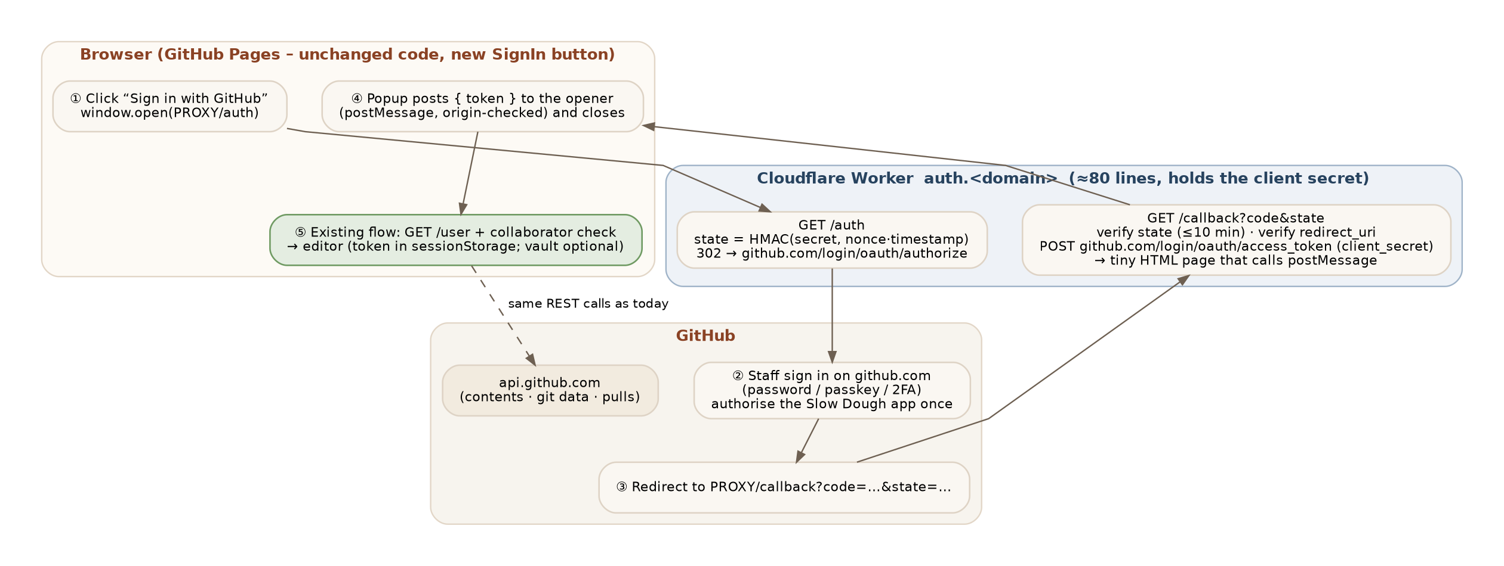
Figure 16 — Proposed sign-in via a Cloudflare Worker. Only steps ①–④ are new; ⑤ onward is the existing editor.

E.2 Push-back first: is it worth doing?
Reasons not to do it yet, stated plainly:
- The current flow works. With the per-person passcode vault, day-to-day sign-in is already one passcode. The proxy removes the one-time token creation (about five minutes per staff member, once) and the token-expiry renewal (every 90 days).
- It adds a hosted component. The prototype's selling point is "nothing but GitHub". A Worker is a second account, a second deployment, a secret to rotate, and a URL that must stay up for anyone to sign in. Free tier or not, someone has to own it.
- The token in the browser does not go away. In the simple design (E.3, option A) the OAuth token lands in the browser exactly where the pasted token lands today. The security gain is in how the token is *obtained*, not where it lives. Keeping the token out of the browser entirely (option B) means proxying every GitHub call and is a materially bigger project.
- Scope can get worse, not better. A classic GitHub "OAuth App" can only ask for coarse scopes: public_repo covers every public repository the person can write to, repo covers private ones too. A fine-grained token scoped to one repository is tighter. The fix is to register a GitHub App instead (E.4), whose user tokens are limited to the repositories the app is installed on — but that is a little more setup and its tokens expire after 8 hours unless that is switched off.
When it becomes worth it: more than a handful of staff, frequent turnover (onboarding = "click the button" instead of "create a token"), a wish to use GitHub passkeys, or a policy that staff must never handle raw tokens. Recommendation: implement option A behind a feature flag when the staff count grows, register a GitHub App rather than an OAuth App, and keep the token flow as the documented fallback.

E.3 Two possible shapes
 | A — Token-exchange proxy (recommended) | B — Session proxy
What the Worker does | Two routes: start the OAuth dance, exchange the code for a token, hand the token to the opener window. Stateless apart from a signed state value. | Does A, then keeps the token server-side (KV/Durable Object), sets an HttpOnly cookie, and forwards every GitHub API call the editor makes.
Editor changes | SignIn gains a button and a postMessage listener (~40 lines). GitHubBackend, vault, tests: unchanged. | GitHubClient base URL becomes the Worker; cookies + CORS credentials; sign-out and idle lock move server-side. Most backend tests need a new fake.
Token location | Browser (sessionStorage; vault optional). | Worker only; the browser never sees it.
Worker size / risk | ≈80 lines; no storage; a bug mostly means "cannot sign in". | ≈400+ lines; storage; the Worker becomes a credential store and a full proxy — a far more security-critical component.
Latency / cost | One extra request per sign-in. | Every editor request transits the Worker (still well inside the free tier, but slower).
Same pattern as | Decap/Netlify CMS GitHub backend with an external OAuth provider. | TinaCloud / self-hosted Tina backend.

E.4 GitHub side — register a GitHub App (preferred) or an OAuth App
1. GitHub → Settings → Developer settings → GitHub Apps → New GitHub App. Name "Slow Dough Staff Editor"; Homepage = the Pages URL.
2. Callback URL = https://auth.<your-domain>/callback (or the *.workers.dev URL until a custom domain exists). Tick "Request user authorization (OAuth) during installation". Leave webhooks off.
3. Repository permissions: Contents — Read and write; Pull requests — Read and write; Metadata — Read (automatic). No organisation or account permissions.
4. "Expire user authorization tokens": leave ON only if the editor will implement refresh tokens (E.6 step 5); otherwise switch it off so a sign-in lasts until revoked, like a classic token.
5. Install the app on smagara/SlowDoughPizzaSite_Tina only. Note the Client ID and generate one Client secret — the secret goes to the Worker and nowhere else.
If an OAuth App is used instead, the only differences are the scope parameter on the authorize URL (public_repo, or repo for a private repository) and the broader reach described in E.2. The authorization still only lets the editor do what the signed-in person can already do on GitHub; the collaborator check still applies.

E.5 Cloudflare side
1. Cloudflare account (free plan is sufficient: Workers allow 100 000 requests/day; a sign-in is two requests).
2. npm create cloudflare@latest slowdough-oauth → "Hello World" Worker, TypeScript. Keep it in its own small repository (or a proxy/ folder) so its deploys are independent of the website.
3. Secrets, never in code: npx wrangler secret put GITHUB_CLIENT_ID, GITHUB_CLIENT_SECRET, STATE_SIGNING_KEY (32 random bytes). Plain vars in wrangler.toml: ALLOWED_ORIGINS = "https://smagara.github.io", GITHUB_APP_SLUG.
4. Optional custom domain: add auth.<domain> as a Worker route; otherwise use slowdough-oauth.<account>.workers.dev and put that in the GitHub App callback URL.
5. npx wrangler deploy. Turn on Cloudflare's free rate limiting rule for the two routes (e.g. 30 requests/minute per IP) and keep "Workers Logs" at the default — tokens are never logged.
Worker outline (illustrative — to be written and reviewed at implementation time, not copied blindly):
export default {
async fetch(req, env) {
const url = new URL(req.url);
if (url.pathname === "/auth") {
const state = await sign(env.STATE_SIGNING_KEY, `${crypto.randomUUID()}.${Date.now()}`);
const g = new URL("https://github.com/login/oauth/authorize");
g.searchParams.set("client_id", env.GITHUB_CLIENT_ID);
g.searchParams.set("redirect_uri", `${url.origin}/callback`);
g.searchParams.set("state", state); // + scope=public_repo for an OAuth App
return Response.redirect(g.toString(), 302);
}
if (url.pathname === "/callback") {
const state = url.searchParams.get("state"), code = url.searchParams.get("code");
if (!(await verify(env.STATE_SIGNING_KEY, state, 10 * 60_000)) || !code) return new Response("Bad state", { status: 400 });
const r = await fetch("https://github.com/login/oauth/access_token", {
method: "POST", headers: { Accept: "application/json", "Content-Type": "application/json" },
body: JSON.stringify({ client_id: env.GITHUB_CLIENT_ID, client_secret: env.GITHUB_CLIENT_SECRET, code, redirect_uri: `${url.origin}/callback` }),
});
const { access_token, error } = await r.json();
if (!access_token) return new Response(`GitHub error: ${error ?? "no token"}`, { status: 502 });
// Hand the token to the editor window that opened the popup – only to the allowed origin.
const html = `<script>window.opener?.postMessage({ type: "slowdough:oauth", token: ${JSON.stringify(access_token)} }, ${JSON.stringify(env.ALLOWED_ORIGINS)}); window.close();</script>Signed in – you can close this window.`;
return new Response(html, { headers: { "Content-Type": "text/html", "Cache-Control": "no-store", "Referrer-Policy": "no-referrer" } });
}
return new Response("Not found", { status: 404 });
},
}; // sign()/verify(): HMAC-SHA-256 over nonce.timestamp with WebCrypto; verify also checks the timestamp age.

E.6 Editor side (future change, behind a flag)
1. New env var VITE_OAUTH_PROXY_URL. When unset (today), the sign-in screen is unchanged — this is the feature flag.
2. SignIn shows a "Sign in with GitHub" button above the token field; "Use a token instead" keeps the current path as fallback.
3. Click → window.open(${PROXY}/auth, "slowdough-oauth", "popup,width=600,height=700"); add a message listener that accepts only event.origin === new URL(PROXY).origin and data.type === "slowdough:oauth", then calls the existing signIn(token, remember). Remove the listener on unmount; time out after two minutes.
4. Everything downstream is untouched: collaborator check, content loading, PR creation, passcode vault (now optional — GitHub's own login cookie makes re-sign-in a click, so the vault could be retired in a later version), idle lock.
5. If GitHub App token expiry stays on: store refresh_token + expires_in, add a /refresh route to the Worker, and refresh when a 401 arrives. Recommended to defer by switching expiry off initially.
6. Tests: a fake window.open + synthetic MessageEvent in EditorApp.test.tsx (origin accepted/rejected, timeout); no Worker needed for unit tests. One manual end-to-end run against a test GitHub App before enabling the flag in deploy.yml.

E.7 Security checklist for the proxy
Control | Why
Signed, time-limited state (HMAC, ≤10 min) and exact redirect_uri | Blocks CSRF and authorization-code injection; GitHub also rejects mismatched redirect URIs.
postMessage to an explicit origin only (never *); listener checks event.origin | The token can only reach the real editor origin, not any page that opened the popup.
Secrets in Wrangler secrets; Cache-Control: no-store; no token logging | Token and secret never persist anywhere on Cloudflare.
Rate limit /auth and /callback; 404 everything else | Cheap abuse protection; the Worker has no other surface.
GitHub App installed on one repository; minimal permissions | Tokens cannot reach other repositories even if leaked.
Collaborator check stays in the editor | Signing in proves identity; write permission on this repository is still verified and enforced by GitHub.
Rotate the client secret yearly or on staff departure with admin access | Standard hygiene; rotation is wrangler secret put + GitHub App settings.

E.8 Effort, cost and open decisions
- Effort: about one developer-day (Worker, editor button + listener, tests, docs) plus roughly an hour of owner setup on GitHub and Cloudflare.
- Running cost: €0 on the Cloudflare free plan; an optional custom domain if one is not already owned.
- Decisions needed before starting: GitHub App vs OAuth App (recommendation: GitHub App); token expiry on/off (recommendation: off at first); who owns the Cloudflare account; whether to retire the passcode vault once OAuth is live; whether option B is ever required by policy.
- Rollback: unset VITE_OAUTH_PROXY_URL and redeploy — the token flow returns and the Worker can be deleted.

18. Revision 1.1 — local-testing feedback and resolutions
The owner ran the local edit mode on Windows (npm 12, Node 24) and reported the findings below. Menu and Hours edits worked as designed; the other items were analysed and resolved as follows.
# | Finding | Root cause | Resolution
F1 | Header "Wed–Sun • 4:30 PM" button is redundant and does not match the (editable) banner | Hard-coded text left over from the original site; not CMS-driven. | Removed the desktop badge and the hard-coded hours line in the mobile drawer (Navbar.tsx). The address line stays. Decision D15.
F2 | npm install warnings (peer dependency, install scripts, vulnerabilities) and a Node deprecation notice when starting the dev server | React 19 vs Tina's React 16–18 peer; npm 12 now blocks dependency install scripts by default; dev-only toolchain advisories; Tina CLI spawns with shell: true. | Reviewed line by line in §19. package.json now carries an overrides entry (silences ERESOLVE), an allowScripts policy, and build tooling moved to devDependencies so npm audit --omit=dev reflects what ships.
F3 | Hover state of the action-bar buttons ("Review & save") had unreadable text | Tailwind utility conflict: variant classes and override classes both set background/text; on hover the cream background won while the text stayed white. | Introduced accent and darkGhost button variants with explicit rest/hover/disabled colours; removed all className colour overrides. Decision D14.
F4 | A new blog post "did not save to the main site" | The post *was* saved (file present, validated by CI) – but v1.0 created new posts with draft: true, and the site hides drafts. The only signal was a small DRAFT badge. Verified with a headless-browser reproduction that Vite picks up new files immediately and the post appears as soon as Draft is unticked. | New posts now default to visible; "Create draft" renamed "Create post"; prominent draft warning + "Publish this post" button in the form; "Draft · hidden from website" badge in the list; draft flag in the review dialog. Decision D13.
F5 | npm test failed: "sorts posts newest first" expected importance-of-dough-aging but got some-thoughts-o-mine | The test hard-coded which post is newest, so any post staff add with a later date broke the suite – a brittle test, not a product bug. | Test rewritten to assert the invariants (ids derive from filenames, every date parses, order is descending) regardless of which posts exist. Added tests for the draft warning/publish button and the newest-first editor list (86 tests at v1.1).
F6 | Editor listed posts alphabetically while the site shows newest first | GitHub backend returned files sorted by name. | Editor list now sorted by publishedDate descending to match the website.

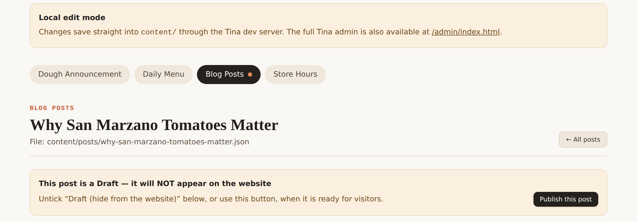
Figure 10 — v1.1: a post with Draft ticked now shows an unmissable notice and a one-click "Publish this post" action.
Figure 11 — v1.1: action bar with the "Review & save" button in its hover state (white on bright terracotta).

19. npm install notices — review and advice
Everything below is produced by the development toolchain; none of it affects the published website, whose runtime dependencies are only react, react-dom and lucide-react (build tooling was moved to devDependencies in v1.1).

19.1 ERESOLVE — react-final-form peer dependency
tinacms@3.14.1 depends on react-final-form@6.5.9, which declares react@"^16.8.0 || ^17.0.0 || ^18.0.0" as a peer. The project uses React 19, so npm warns that it is overriding the peer. The Tina admin is built by @tinacms/app, which ships its own React 18 (visible in the lockfile as node_modules/@tinacms/app/node_modules/react@18.3.1), so the warning is cosmetic — local testing confirmed the admin runs.
Advice: keep the overrides entry added to package.json (react-final-form → react: $react, react-dom: $react-dom). It removes the warning without changing what is installed (verified by re-resolving the lockfile). Remove it once Tina publishes a release whose peer range includes React 19.

19.2 Install scripts blocked (npm ≥ 12)
npm 12 introduced an allow-list for dependency lifecycle scripts: preinstall/install/postinstall are skipped unless the package is listed in allowScripts in package.json (managed with npm install-scripts approve|deny|ls|prune). Three packages were reported:
Package | What its script does | Needed here? | Policy
esbuild@0.28.x | Checks that the platform binary matches; installs it if the optional @esbuild/<platform> package is missing. | Usually no — the optional dependency provides the binary — but approving it is the safe default for Vite/Vitest. | approved
better-sqlite3@12.x | Downloads a prebuilt native binary (or compiles with node-gyp). | Only if Tina's optional search index is enabled; the module loads lazily, which is why tinacms dev ran fine with the script blocked. | approved
core-js@3.x | Prints a funding/"please sponsor" banner. | No. | denied

Advice: the policy is committed in package.json → allowScripts using name-only entries so routine version bumps do not re-trigger the warning; older npm versions ignore the field. Run npm install-scripts ls after dependency upgrades to review any newcomers, and never use --dangerously-allow-all-scripts.

19.3 "33 vulnerabilities (2 low, 10 moderate, 21 high)"
npm audit evaluates the whole tree, including @tinacms/cli, tinacms (admin UI), GraphQL tooling, jsdom and Vitest — all devDependencies that run only on a developer machine or in CI and are never served to visitors. The public bundle was verified to contain no Tina code (bundle growth ≈ 4 KB).
Advice: (1) run npm audit --omit=dev to see advisories that affect shipped code — expected to be empty; (2) review the full npm audit monthly and upgrade tinacms/@tinacms/cli together when fixes land (npx tinacms doctor reports the latest versions); (3) avoid npm audit fix --force, which crosses major versions and can break the Vite 8 / Vitest 5 / Tina 3 combination; (4) CI uses npm ci with the committed lockfile so the audited tree is exactly what runs.

19.4 DEP0190 DeprecationWarning during npm run dev
Node 24 warns when a child process is spawned with shell: true and an argument array. @tinacms/cli does this to run the -c "vite …" sub-command. The arguments are fixed strings from our own package.json, so there is no injection risk; the warning is informational and tracked upstream.
Advice: ignore it, or add node-options=--no-deprecation to a local (untracked) .npmrc if the noise is distracting. Do not set NODE_OPTIONS in the npm scripts — it is not portable to Windows shells.

19.5 Windows notes
- npm run clean no longer relies on rm -rf; it uses Node's fs.rmSync so it works in PowerShell.
- All other scripts are shell-neutral. Line endings: git is expected to normalise to LF; the JSON the editor commits always uses LF.

20. Revision 1.2 — production feedback: workflow runtimes, collapsible layout, passcode sign-in
The owner deployed to GitHub Pages, confirmed the v1.1 fixes, ran the complete flow in production (PR #2 "Content update: Dough Announcement, Daily Menu" with the staff note in the PR body), and raised the items below.
# | Request / finding | Analysis | Resolution
F7 | Workflow annotations: "Node.js 20 is deprecated … actions/checkout@v4, configure-pages@v5, setup-node@v4, upload-artifact@v4, deploy-pages@v4 are being forced to run on Node.js 24" | GitHub retired the Node 20 action runtime; v4/v5 pins of the official actions target Node 20 and are now run on Node 24 with a warning. The runs still succeed. | actions/checkout@v5, actions/setup-node@v5, actions/upload-pages-artifact@v4; configure-pages removed (Pages is already enabled and the site computes its own base path); jobs run on Node 24; engines.node >= 22. .github/dependabot.yml added so future action majors (incl. deploy-pages) arrive as PRs.
F8 | Local-mode instructions should suggest a page refresh | Vite hot-reloads the website tab, but staff may have the site open in a tab that was not focused or in a different browser. | Review dialog and "Saved locally" panel now say to refresh (F5) if the change is not visible, and the panel links to the website in a new tab.
F9 | Present the edit screens with some sections collapsed to clarify context and reduce scrolling | Every field and every list item was expanded; the menu alone was several screens long. | Layout map with collapsible, summarised groups; list items collapsed with previews; Expand/Collapse all; error-forced open. Decision D16.
F10 | Suggest creating a "passcode" on the GitHub login so staff do not have to find and paste the token each time — or push back on accepted Tina usage | Accepted Tina usage (TinaCloud login or self-hosted OAuth) needs a server; a static site cannot keep a session secret. A device-local passcode-encrypted vault gives the same day-to-day experience with no server. | "Remember me on this device with a passcode" (default on) + passcode unlock screen + "Forget this device"; wrong-passcode lockout. Decision D17 documents the trade-off and the recommended end state (Q1).
— | Confirmed by the owner | npm warnings resolved, button contrast, hours button removal, blog-post test, .github at repo root, Vitest report in the job summary, PR body quality. | No change.

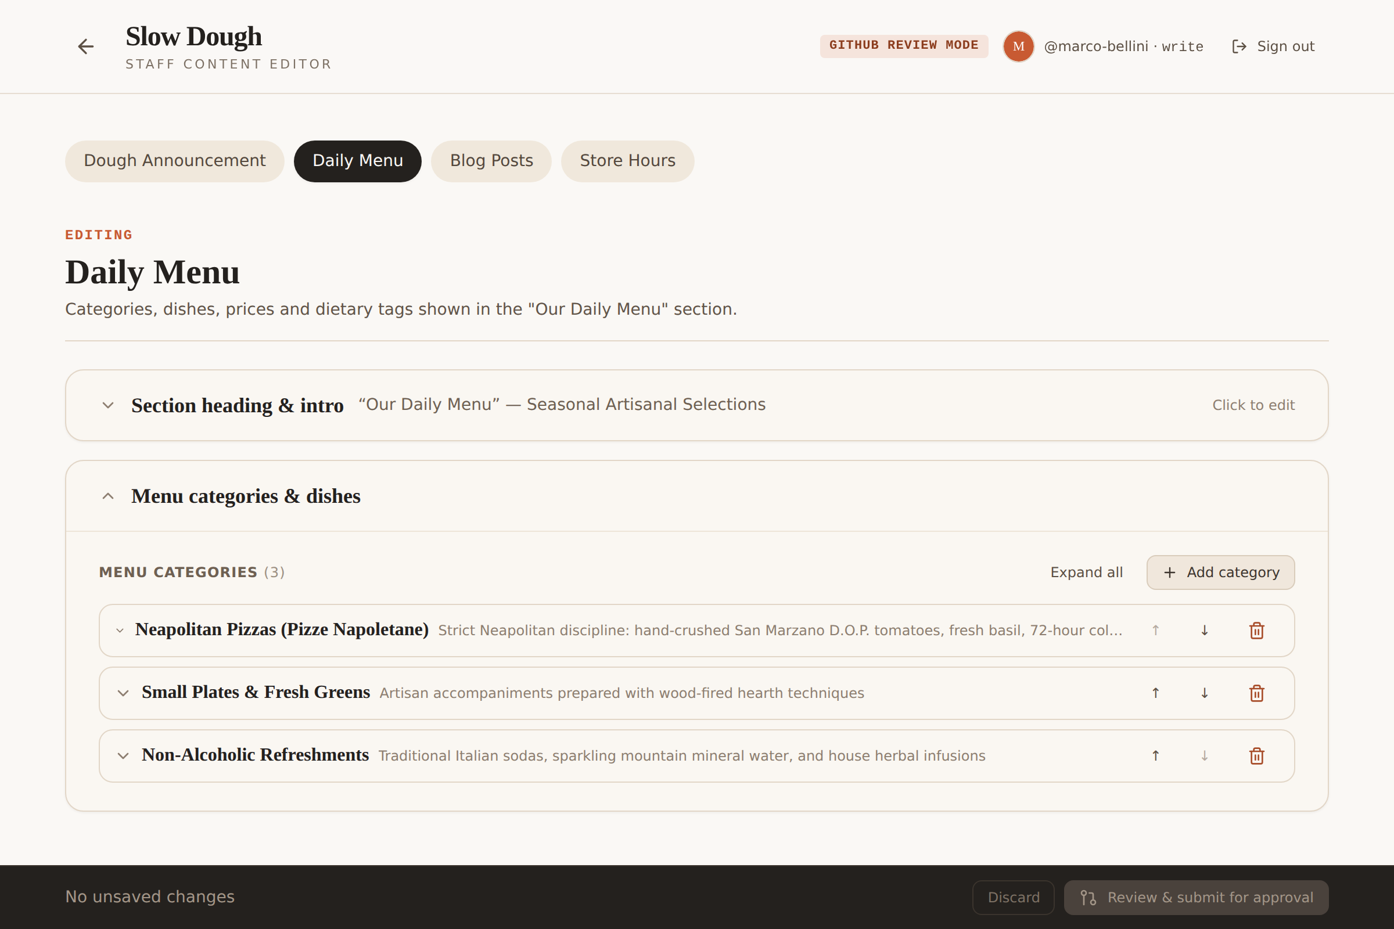
Figure 12 — v1.2: the Daily Menu opens with the heading group summarised and every category collapsed to one line (Expand all available).
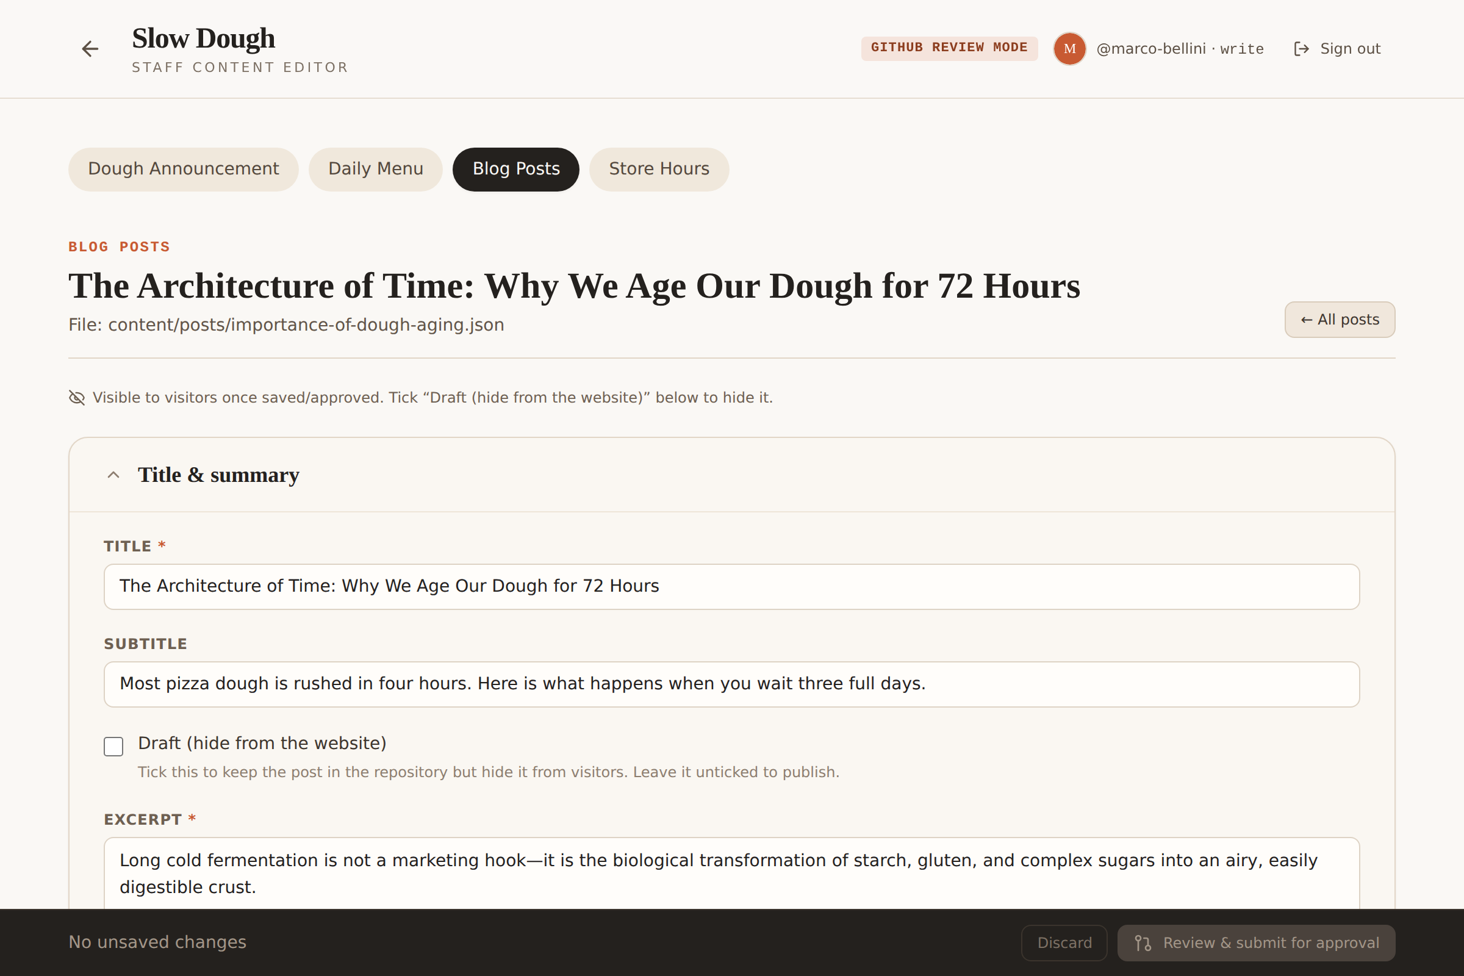
Figure 13 — v1.2: a blog post opens on "Title & summary"; author/date/illustration and key takeaways are folded with summaries.
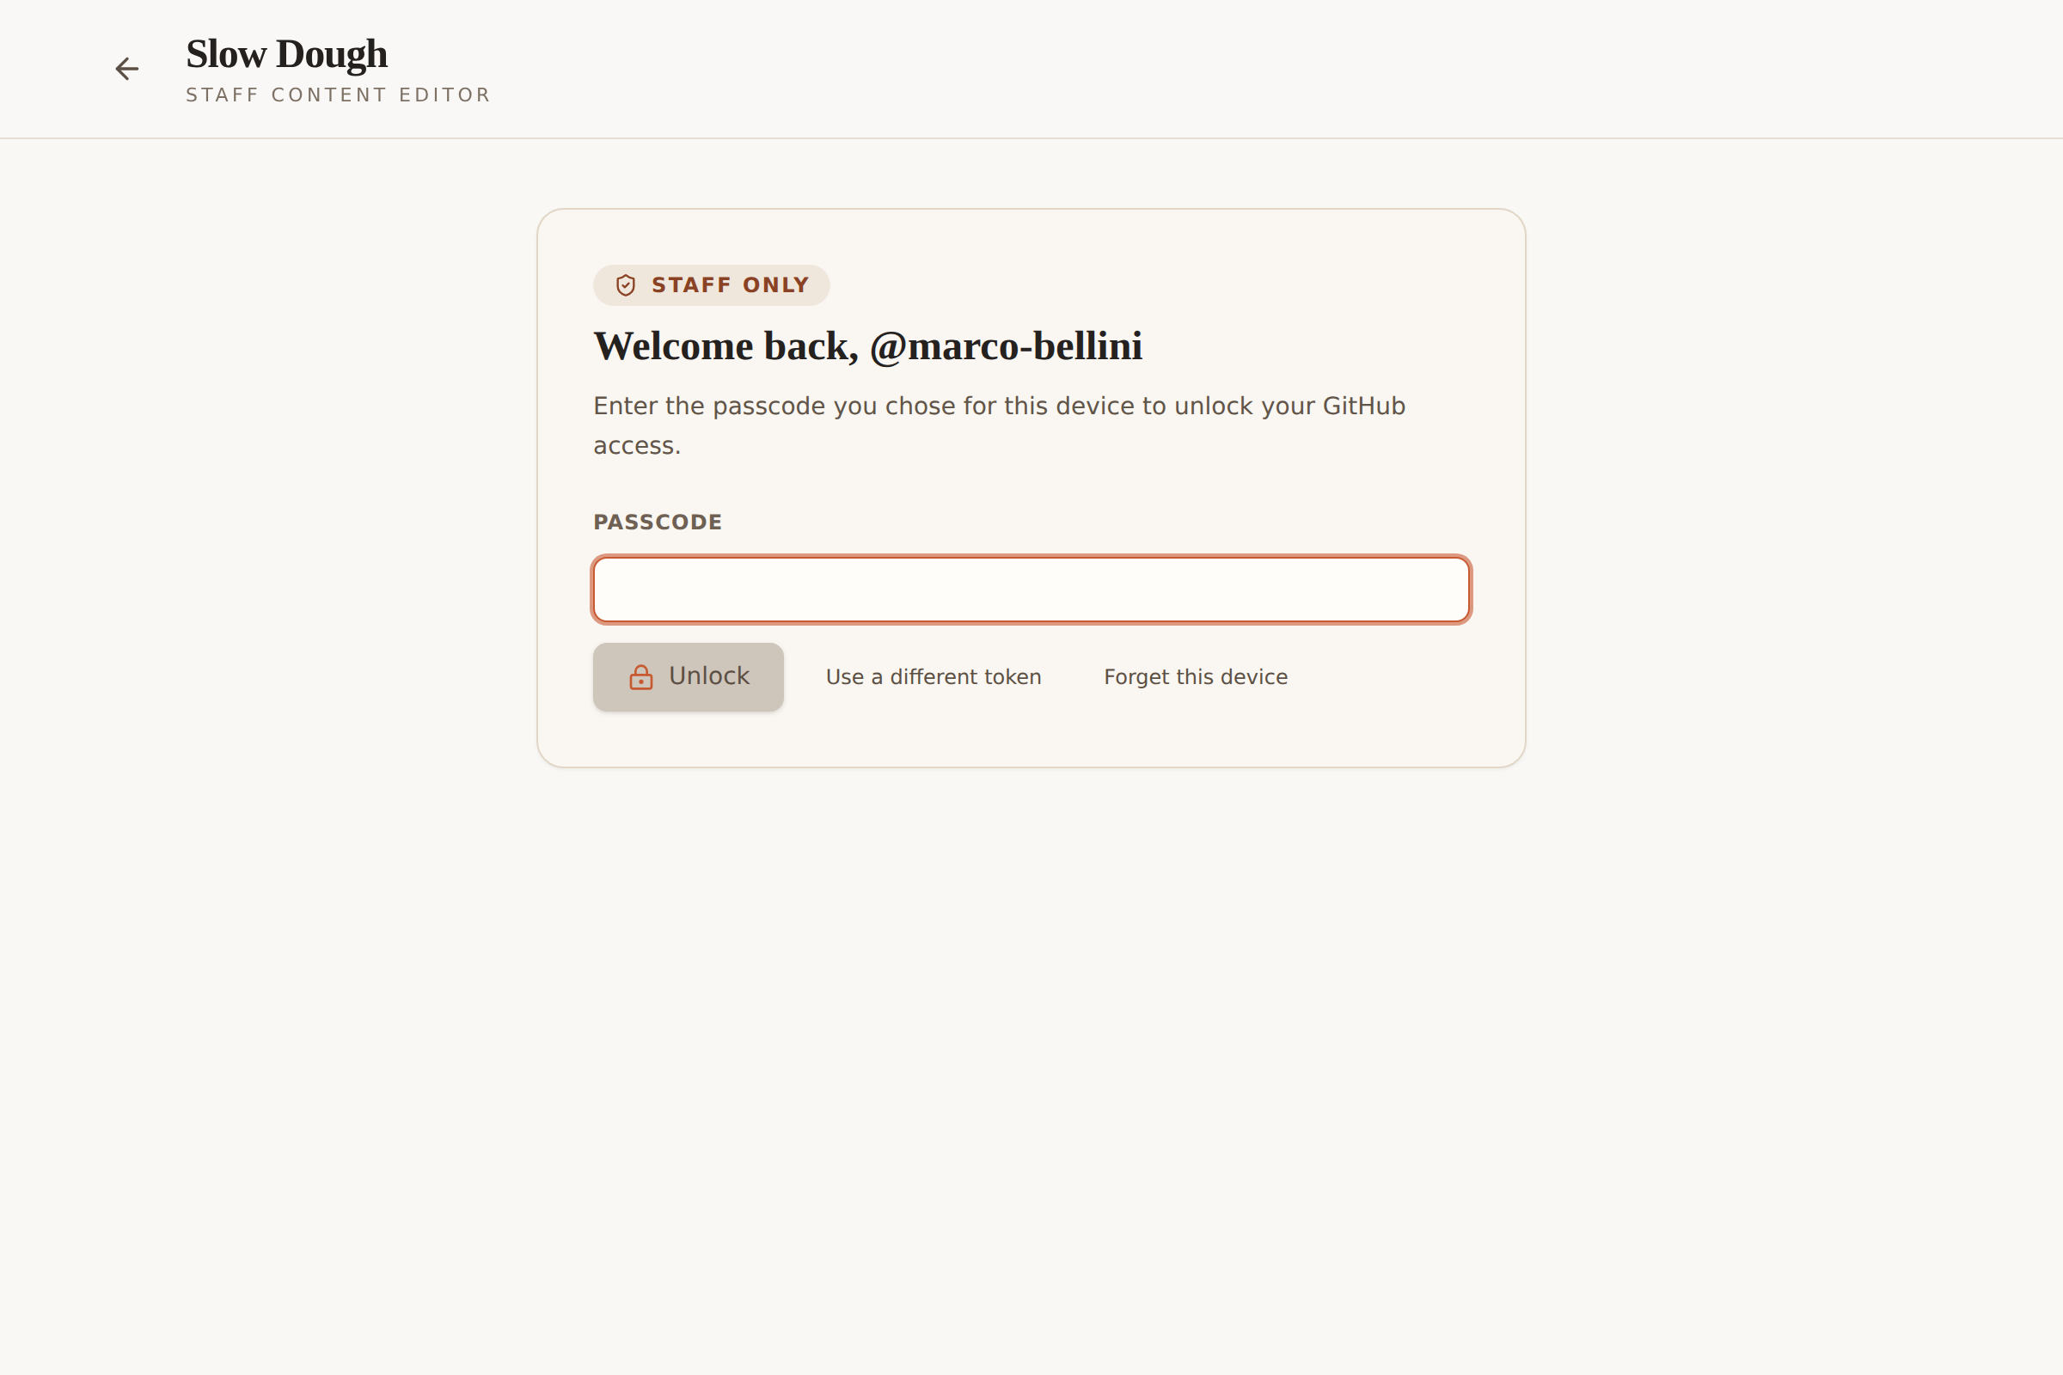
Figure 14 — v1.2: return visit on a remembered device — passcode only, with "Use a different token" and "Forget this device".

20.1 Passcode vault — data flow
first sign-in: token ──▶ GitHub /user + collaborator check ──ok──▶ sessionStorage (tab)
passcode + random salt ──PBKDF2-SHA-256 ×600k──▶ AES-256-GCM key
encrypt(token, key, random IV) ──▶ localStorage vault { users: { <login>: { salt, iv, ciphertext, failures } } }
next visit: pick name (if several) ──▶ passcode ──derive key──▶ decrypt ──▶ token ──▶ GitHub verification again ──▶ editor
wrong passcode: failures+1 for that login (5 ⇒ that entry erased) forget @name / forget everyone: entries erased
idle 30 min: tab session cleared ──▶ back to the passcode screen (vault untouched)
What is NOT stored: the passcode, the plaintext token (outside the tab session), or any GitHub password. What an attacker with the device would need: the passcode (or an offline brute force against 600k-iteration PBKDF2), and even then only a fine-grained token limited to this repository's contents and pull requests, which expires and can be revoked by the owner in GitHub → Settings → Collaborators / by the staff member under Developer settings.

21. Revision 1.3 — remaining workflow warnings, shared devices, batching edits, document review
All npm tests pass on the owner's machine and the Dependabot action bumps were merged. Four items remained.

21.1 Why two "Node.js 20 is deprecated" warnings survived the Dependabot bumps
The run summary now names two actions, and neither is one we pin directly:
Job | Action named in the warning | Where it comes from | Fix
build | actions/upload-artifact@ea165f8d… | actions/upload-pages-artifact@v4 is a composite action that calls actions/upload-artifact pinned to a Node 20 commit SHA. Dependabot cannot change a pin inside someone else's action. | Replaced the wrapper with its two steps: tar the dist/ folder exactly as the wrapper does and upload it with a current actions/upload-artifact@v5 under the artifact name github-pages that deploy-pages expects. Same artifact, no Node 20 code path.
deploy | actions/deploy-pages@v4 | GitHub's own deployment action has not published a Node 24 major (which is why Dependabot left it at v4). | The deploy job now sets FORCE_JAVASCRIPT_ACTIONS_TO_NODE24: true, the documented opt-in that runs Node 20 actions on Node 24 — what the runner already does, now stated explicitly. Dependabot will open a PR the day a v5 appears.

If GitHub keeps emitting the notice for deploy-pages despite the opt-in, the only way to make it disappear is to stop using that action. The ready alternative is "deploy from a branch": a workflow step that pushes dist/ to a gh-pages branch with plain git (no JavaScript actions involved) and Pages set to "Source: Deploy from a branch → gh-pages". It trades the deployment environment/URL bookkeeping of deploy-pages for a build-artifact branch in the repository; it is documented here as the fallback rather than applied, because the current deployment works and the warning is informational.
# fallback only – replaces the deploy job
- name: Publish to gh-pages branch
run: |
git config user.name github-actions && git config user.email github-actions@github.com
git --work-tree dist checkout --orphan gh-pages && git --work-tree dist add --all
git --work-tree dist commit -m "Deploy ${GITHUB_SHA}" && git push --force origin gh-pages
The third annotation ("ubuntu-latest will migrate to Ubuntu 26") is informational; the workflows do not depend on the image version. Pinning ubuntu-24.04 would silence it at the cost of a manual bump when that image is retired, so ubuntu-latest is kept.

21.2 Shared laptops and the passcode
Question raised: how does the passcode work if staff share a laptop or terminal — do they need separate machines? Answer: no. The vault is now per person:
- The first time, each person pastes their own GitHub token and chooses their own passcode. The device then remembers everyone (up to eight people) under their GitHub names.
- On later visits the screen asks "Who is editing?" — pick your name, type your passcode. Wrong-passcode counting, "Forget @name" and the 5-strike wipe are per person; "Forget everyone" clears the device.
- The editing session belongs to the tab: closing the tab, "Sign out", or 30 minutes without mouse/keyboard activity (warning shown after 29) returns to the passcode screen and discards unsaved edits. This stops the next person at the counter from submitting under the previous name.
- Separate browser profiles (or separate machines) remain the stronger option where accountability matters, because GitHub attributes every PR to the token's owner; the per-person vault is designed so that a shared counter laptop still works correctly without it.
- What the passcode does not do: it is not a GitHub credential and never leaves the device; it only unlocks the locally encrypted token. GitHub still performs the collaborator check on every unlock.
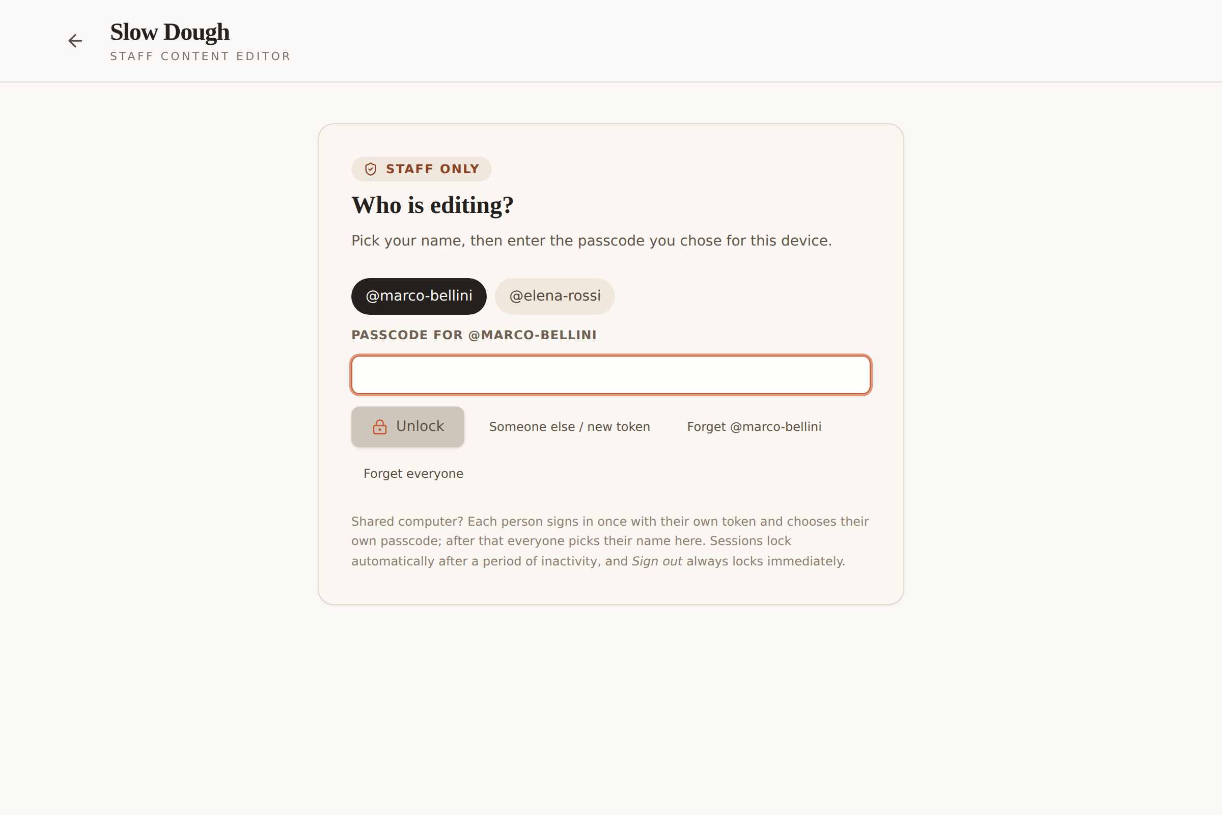
Figure 15 — v1.3: a shared device remembers several people; each picks their name and enters their own passcode.

21.3 Batching several edits into one Pull Request ("Back to editing")
The review dialog's "Back to editing" button returns to the editor with every change so far intact, so staff can edit the announcement, then the menu, then the hours, and only then open a single Pull Request that lists all of it. The dialog now says so explicitly. Guidance added to the staff guide:
One Pull Request for several edits | One Pull Request per edit
+ One approval, one deployment; related changes (new dish + new price + banner) go live together and can never be half-published. | + Each change is reviewed on its own merits; a problem with one does not hold up the others.
+ Less noise for the owner; the PR body still lists every field that changed. | + Smaller, quicker reviews; easy to revert one thing.
− If the owner rejects one item, nothing in the batch is published until it is fixed (the editor loads from main, so the rejected batch has to be redone). | − More notifications and more deployments; two PRs that touch the same file may conflict (the second is refused at submit with "changed on main" once the first merges, and must be reloaded).
− Unsaved edits sit in the browser until submitted — a closed tab or the inactivity lock loses them. | − Related changes can go live minutes apart.

Rule of thumb given to staff: batch changes that belong together (tonight's menu), submit separately when they do not (a blog post and a price correction).

21.4 Document review
- Fixed the fragment "The only thing staff change." and a stale test count; decisions re-ordered (D15 before D16/D17); code formatting in decision headings; §8.1 and §13 updated for the passcode vault; a note that belonged to v1.2 removed from the v1.1 table.
- Removed forced page breaks that produced an empty page after Figure 4 and near-empty pages before the revision sections; sections now flow.

