Project: Intelligent Social Vehicle

Masters Project 2016
Final Report
Simone Magri

Project Proposal

Use case for this project is the Ambulance Scenario, this is described in detail in the literature review.

999 perhaps use case description is moved into here.

Initially, we had intended to use the Hexo+ drones in the research and development of a drone control system for use in the ambulance scenario. More specifically, it was for the development of a Front-end Control System. This would involve working out how to fly a swarm of drones(we have five hexo+ drones) from the ambulance to a particular target location. However, here were many significant delays in our request for general information and the acquisition of the SDK(Software Development Kit) for the hexo+ drones, both fundamental to development of the Front-end Control System. This coupled with the fact that hexo+ is no longer the market leader with respect to technical specifications of their drone, we started looking into other drone families. DJI family of drones were then looked into as it is the current commercial market leader amongst their drone offerings, and they have a readily available SDK.

However, we have five existing hexo+ drones and the DJI phantom 4 had not arrived by the time the main development for this project was to take place. Consequently I decided that I would focus on the development of the Back-end Control System of the Drone Control System, for the Ambulance Scenario. Thus abandoning development on the Front-end Drone Control System for the time being.

Literature Search

This was composed of two main sub-parts. With a review of the traditional literature of academic papers[1]. Two principal candidates, pointed out by mabiclab colleges, were the focus of this preliminary review. Christan Wietfeld and Sebastien Varrier. A list of papers to be read was identified using google searches and reading the abstracts of these papers. Abstract summary notes are provided, as well as summary notes after the paper has been read. This traditional review of the literature was followed by a review of the technical features, or specification, of the drones offered by the current commercial market leader of drone manufacturers, DJI. Included in the latter review are comparisons between DJI and the Hexo+ drones. The traditional literature review is yet to be completed and the technical review is done at this stage.

The review is as such:

Use case for this project is the: Ambulance Scenario

- A number of drones will be mounted on the ambulance in designated areas.
- A ROS/Qt GUI based application will be run on a computer/embedded system.
- In the ambulance It is used to control and monitor the flying drones.
  - It is used to control and monitor the flying drones.
  - Drones will fly off the ambulance to the designated target.
  - One or more drones(?) will fly off the ambulance at any particular time.
- Initially 5 Hexo+ drones were to be used. But due to lack of SDK arrival and the poor nature of our dealings with Hexo+, for instance:
  - SDK at least a year after it was promised, should be on the way now though(cross fingers)
    - Hexo+ is extremely slow to respond to our requests
    - Hexo+ appear to have cash flow problems(eg battery situation)
- We have ordered a DJI Phantom 4 for prototyping, to hedge our bets.
- Other reason for doing this is that the Hexo+ are now substantially behind the market leaders, feature wise.
Drone Control System

- Is the ambulance computer and drones form a drone control system
  - It consists of a front-end and back-end control system
- For my masters project
  - I will produce a proof of concept prototype for the the back-end control system using a single Hexo+
  - Front-end work:
    - Could not be done since we don't have the Hexo+ SDK
    - And as the DJI Phantom 4 has not arrived yet

Back-end Control System Diagram

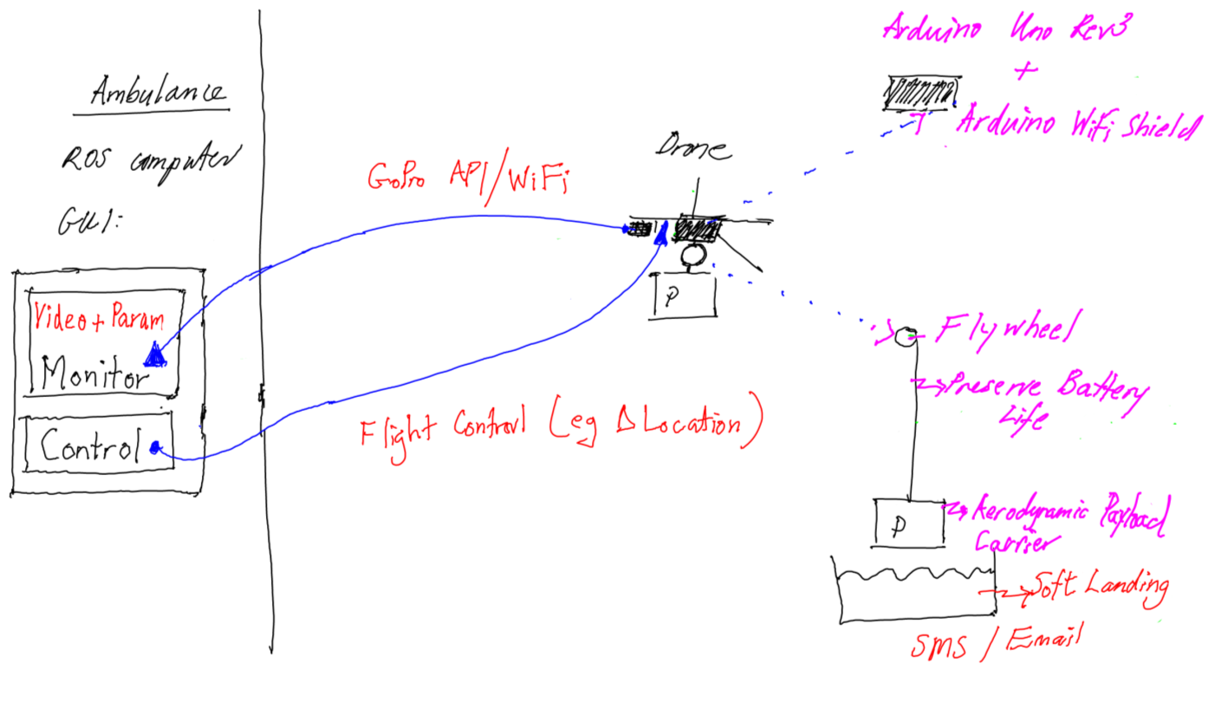

Back-End Control System(1) Ambulance ROS computer:

- ROS/Qt GUI computer application in the ambulance
  - Needs to be there regardless of what drone we are using
  - Visual Monitoring of drones will be via live video from the GoPros
    - Using GoPro API and streamed via WiFi
    - This will be part of the ROS Monitoring Node(publisher/subscriber)
    - You can mount a GoPro on the DJI Phantom4
      - I think instead of the native camera
      - so code will immediately be reusable
- Monitoring of drone flying parameters
  - Will be part of the ROS Monitoring Node also
- Drone flight will be mostly autonomous,
  - any manual flight control will be done from the ROS Control Node(publisher/subscriber)
  - Currently, we do not have the SDK would allow ideal changing of the drone's location,
    - So, Hexo+ flight control, location changing, at this stage:
    - would have to be via a GPS phone application that spoofs it's location, use FakeGPS Free App (Android)
    - Hexo+ will lock onto where it thinks is the GPS location of your phone

Back-End Control System(2) Arduino Rev 3 & Arduino WiFi Shield

- An Arduino with a WiFi Shield attached will be mounted to the underside of the Hexo+
- It will control a servo or stepper motor (will demonstrate this later)
- And it will form part of a client/server coding system
- The client code is in the ROS Control Node within the ROS/Qt GUI
  - It will use TCP/IP socket connections to communicate with the arduino via the WiFi shield
- The server code will run on the arduino and will control the motor to winch down/up the payload
- Arduino will be powered by the existing battery connector on the Hexo+
  - Arduino voltage between 7-12Volts
  - Hexo+ battery is 11.1V from 3S, so 3.7V per cell(2S=7.4, 3S=11.1)
    - I've done this as, @home I use a 9V battery but it's heavy, 43g, weight reduces my flight time
  - WiFi shield is powered from the Arduino +5V
    - Shield has same pin-outs as the arduino uno

Back-end Control System(3) Payload Delivery

- Will demonstrate part of this system later
- I will Winch down payload to preserve battery power
  - Flywheel on end of motor
  - Servo or Stepper Motor will be used to winch down the cable(why servo/or stepper):
    - Rotation angle
    - Continuous servo may not perform as well, slippages of wheel etc
    - Servos easier to power
    - Stepper motors require an additional circuit(H-Bridge Motor Driver chip to drive high voltage motors from TTL 5V logic)
  - Will have a 3D printed Aerodynamic carrier
  - Payload will be delivered to 'X mat' or QR-code soft target plate, once released from cable
    - OpenCV pattern matching code will be used to accomplish this
    - Landing should be a soft one(eg pillow) due to delicate nature of cargo
  - SMS or email payload arrival message to official
- Observation about one DJI Phantom 4 payload delivery system I've seen recently
  - Overall system design is similar, with a servo used
  - Pin release mechanism; mine is winch down
  - About 85g in total; mine is ~100g but about 60-80g if I can get away with smaller parts
  - Drop/Deliver from a height; would be dangerous for us, would need to fly down to get closer to target first
  - My system is a little different, it remains to be seen which is the best method for this task
  - Developing my own system certainly gives you an appreciation for the DJI Phantom 4 system

Front End Control System Diagram ie Flight Control System

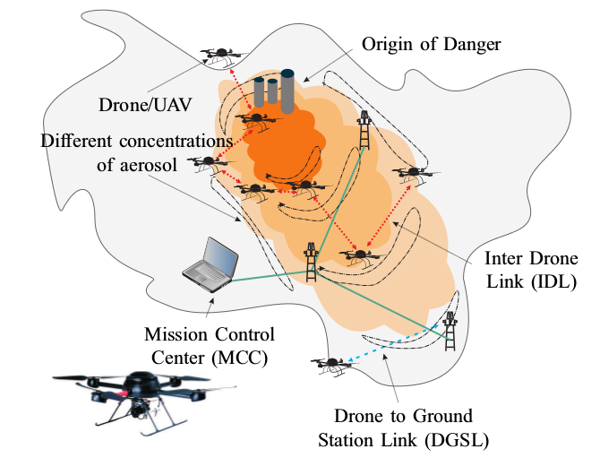

Drone/Mesh Drone flying may be informed by AI algorithms and methods the sexy part of this project will be in this area

Front-end Control System Description

- Drones are also known as UAVs, that is, Unmanned Autonomous Vehicles
- Drones will fly off the back of the ambulance individually or in unison(?)
  - Which of those it is, has implications for the flight control system...(can explain)
  - So the ambulance scenario may not require flying a group of drones in a mesh system
  - However,
- Other use cases may require UAV flying in a mesh system:
  - Looking for lost bush walkers during the day and night(djiPhantom4)
    - May use facial recognition and audio messages for this task
  - Fire fighting, to survey the fire more quickly and cheaply
  - Chemical spill fighting, ascertaining nature of the chemicals and their plumes
- Literature I've read indicates control of UAV flights in a mesh uses:
  - WiFi for UAV-UAV communications
  - Mobile cellular networks for communications from UAV to the mission control centre
  - And that, Flight Control is determined by a feedback based control system
    - Input is taken from the sensors(ultrasonic, radar, sonar) located on the drones to provide feedback for the control system
    - My observation, your control system is only as good as your sensors, bad sensor data leads to a bad flight path
- We now come to an important point:
- Drone/Mesh Drone flying may be informed by AI algorithms and methods
- I think the sexy part of this project will be in this area

Front-end Control System, Some thoughts on using Radar/Sonar

- Hexo+ does not have any obstacle avossidance system
  - That got me thinking about obstacle avoidance systems for a drone/UAV
- I had an idea! to use Radar to avoid UAV-UAV collisions and UAV-Obstacle collisions
  - Literature:
    - Backed this up, Christian Wietfield(used FMCW(Frequency Modulation Continuous Wave)-radar) is doing one or both of these, it's a little unclear
    - A quick look seems to indicate a low cost radar system is limited by range, some meters to tens of meters, these systems can be as small as fingernail
- DJI Phantom 4 uses Sonar, Cameras, and AI control for obstacle avoidance
  - Not sure how that will work:
    - I've seen videos that show it avoiding a big rock formation
      - however, promotional videos are one thing and real life performance can be another eg battery life specification of 28min, which is about 23min in real life
    - Not sure how it will go with tree branches, birds, and even other drones...etc
- Thinking about obstacle avoidance systems left me with more Questions:
  - Why would you use Radar over Sonar and visa-versa?
  - Decided to investigate both a little

RADAR/Active SONAR basic understanding may be useful
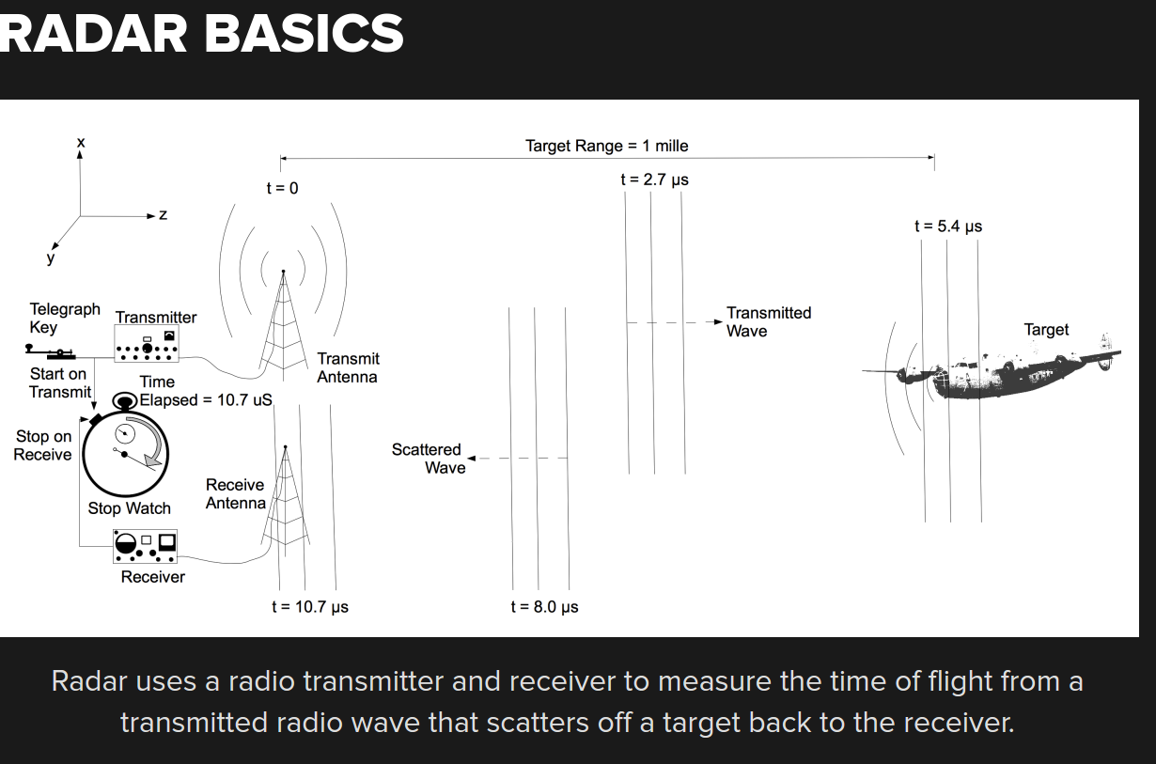

Radar(RAdio Detection And Ranging)

- Radar works by sending out pulses of radio waves from a transmitter which are reflected off the object and detected/measured by the receiver system.
  - Properties of the received signal are analysed to give us the object's:
  - Presence
  - Direction/Angle
  - Distance/Range
  - Speed/Velocity
- Radar is already used in aircraft anti-collision systems and flight control systems
  - Thus a stable and reliable technology
- Radio waves are electromagnetic waves in the radio spectrum
  - They range from <1Hz to about 100GHz(to the end of the microwave range)
  - Aside: at radio telescope needed to not use microwaves in tower and quarters when astronomers were observing in certain bands
- Note of interest: High tech radar systems are associated with:
  - digital signal processing
  - machine learning
  - and are capable of extracting useful information from very high noise levels

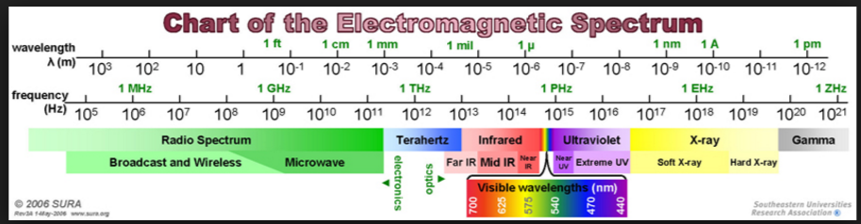

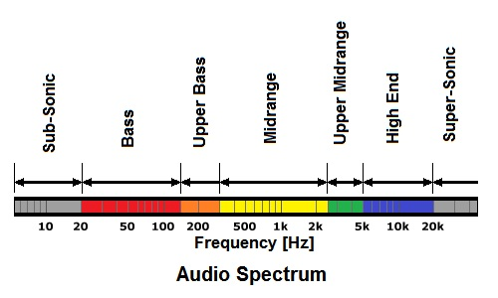

Active Sonar(Sound Navigation And Ranging)
- Active Sonar works similarly to radar by sending out pulses and analysing the reflected waves
  - but it uses sound waves not electromagnetic waves, and thus is a mechanical (or pressure) wave, so need a medium to travel in
    - Detects(presence)
    - Gives Bearings(direction/angle)
    - Distance/range
    - Radial speed/velocity
    - Or detect other vessels
  - Used as a means of Active Acoustic location:
    - It can take place in gases(atmosphere), liquids(h2o), and solids(eg earth)
- The acoustic frequencies(sound waves) used vary from the very low infrasonic to the extremely high ultrasonic
  - Infrasonic, low-frequency sound, <20Hz(lower limit of human hearing) and down to about 0.1Hz
  - Ultrasonic, high-frequency sound, >20kHZ(the upper limit of human hearing) and upto about several GHz.

In Summary: Radar vs Sonar

- Active Sonar was used in air before the introduction of Radar
- Literature,
  - Radar is said to be a far more effective system than Active Sonar
  - Active Sonar was rendered as obsolete during world war 2 by the introduction of radar
- Still Not clear to me at this stage why one would choose Radar over Sonar or visa-versa, requires further investigation
  - some thoughts that may impact this:
    - Submarines rely on sonar as radar, at depth, is highly attenuated in water
    - Sonar is cheaper
    - Radar has a greater range than sonar(in air)?
    - Sonar is used in air for robot navigation

Which is the Superior Drone?

I'm going to compare a few drones, to show you which is the Superior Drone:
The drones will be:
- Hexo+ (commercial drone)?
- DJI Phantom 4 (commercial drone)?
- DJI Matrice 100 (developer drone)?

- These are commercial and developer drones currently on the market.

Comparison: Hexo+ and DJI drones

Feature | Hexo+ | DJI Phantom4 | DJI Matrice 100
Cost Drone | $1307 | $1999 | $5699
Cost GoPro(Hero4 Black)$679 | $679  (Drone + GoPro=$1986) | Inbuilt Camera or GoPro | No Built in camera(SLR)
SDK | August 2016 | MobileSDK(App SDK) | MobileSDK, OnboardSDK
SDK ROS integration | Not Sure | No | Yes
Weight | 1.7kg(inc batter + gimble) | 1.38kg | 2.355kg
Flight Time average | 8min(15min spec) | 23min(28min spec) | 40min(spec)(2 batteries)
Payload Delivery System | No | Yes(random drop) | No(make own)
Payload Maximum Weight | (Gimble+Camera=>min)~270g | 462g | 1kg
Obstacle Avoidance | No | Yes(Sonar) | No(Need Guidance System)
Autonomous Flight | Yes | Yes | No(make own)
Follow Me | Yes | Yes | Yes
Range Maximum(from were you stand) | 100m(Follow Me) | 5km(Lightbridge) | 5km(Lightbridge)
Altitude Maximum(above sea level) | 4.8km | 6km | 5km
Operating Temperature | -10deg-50deg | 0deg-40deg | -10deg-40deg
Speed | ~75km/hr | ~75km/hr | ~75km/hr
Live View(what drone camera sees) | No, or 2nd phone's GoPro App | Yes, Phone/Tablet | Yes, Phone/Tablet
Lens Field Of View | 0-90deg | 0-94deg | No Built in Camera(SLR)
RC Control | PPMSUM transmitter(open drone to install) | Yes, standard | Yes
Vision Positioning System(VPS) | No Indoor Flying | Yes Indoor Flying | Yes
Flight Planning | No | Yes | Yesterday

1, average flight time, specifications never seems attainable
2, increase the payload weight decreases the flight time
3, below zero for bush walkers in mountains, or into a fire
4, non-standard for Hexo+, retrofitted by opening drone
5, weight significant for flight regulations

Which is the Superior Drone?

Less than 2k budget, the DJI Phantom 4

Your a developer, and have a Greater that 2k budget DJI Matrice 100

Beyond the Consumer Drones

Hexo+ and DJI Phantom 4 are consumer drones

Professional Drones

Developer Drones

Beyond Consumer Drones(eg DJI family)

- The DJI Phantom 4 is the current market leader in consumer drones
  - Above the consumer drones are the professional drones, for instance in the DJI family:
    - The biggest difference between these models is:
      - quality of the cameras and components(eg motors, propellers)
      - some even allow you to mount a digital SLR
  - Cost is the other major difference:
    - DJI Phantom 4, $1,999
    - DJI inspire 1 v2.0, $3,399
    - DJI inspire 1 Pro, $5,899
    - DJI Inspire 1 Raw, $11,199
  - They suite:
    - Those who do budget add campaigns
    - Hollywood productions
    - Wedding Photographers/Video-graphers
- Also, above the consumer drones are the developer drones, for instance in the DJI family:
  - The biggest difference between these models is:
  - That come with an onboardSDK that gives you access to flight control and other things
  - Importantly, it allows you to attach your own embedded system via a serial port/Uart
  - Cost is the other major difference:
    - Matrice 100, $5,699, designed for research
    - Matrice 600, $7,899, for professional aerial photography and industrial applications

DJI SDK's (Software Development Kit)

- Without an SDK we can not develop our front-end system
- One of the big reasons for looking at the DJI drones is because they have a readily available SDK

- The DJI SDK's are:
  - MobileSDK(Phantom 4 & Matrice 100; Android & IOS)
  - OnboardSDK(Matrice 100; Windows/QT, Linux/ROS, Embedded System)
  - GuidenceSDK(Matrice 100; Linux/ROS & Embedded Systems)

MobileSDK(DJI Phantom 4, DJI Matrice 100)

- Mobile SDK
  - Allows you to customise your app
  - Platforms Supported: IOS 8.0+ and Android 4.2.2+
    - Several tutorials/examples are provided on how to use the SDK for different applications
    - Developer guide and API documentation
    - Some level of flight control(High and Low level)
      - Predefined fight path
        - Waypoint, Hotpoint, FolowMe
      - RC control, manual flying
        - During which SDK allows monitoring of live video and sensor data
      - Stick commands
        - To simulate pilot
    - Telemetry and sensor data
      - GPS position
      - Compass, barometer, velocity, altitude
    - Obstacle avoidance
    - Camera(eg exposure, aperture, ISO speed) and Gimble Control
    - Live Video Feed from the drone's camera
    - Battery monitoring & control
    - Eg Explain flight control with touch screen app, finger pointing and point of interest

OnboardSDK(Matrice100)

- Platforms Supported: Windows/QT, Linux/ROS and Embedded Systems
- Only Linux and Embedded Systems are of interest to me/project
  - Raw communication wrapped in ROS packages
  - Toolchain:
    - c++ compiler gcc2.8.1/5.3.1
    - Bash shell
    - GNU Make
- Platform: Ubuntu 14.04/16.04
- Is for C/C++ embedded systems programmers
- Provides control functions(eg flight control) from a C++/ROS environment(eg official ros pkgs)
  - And the Key ones for us:
    - Local/Global Navigation(go to a specified local/global position)
    - Take-off and Landing control
    - Photo Taking
    - Start/Stop Video Recording
  - Also includes a Simulator
- Most Importantly, it allows you to integrate your own hardware with DJI flying platforms
  - Using the API provided you can, for instance, use a sensor connected to your embedded system(eg arduino) to control the trajectory of the vehicle
  - It's fantastic for prototyping

GuidanceSDK(Matrice 100)

- GuidanceSDK
  - Platforms Supported: Linux/ROS & Embedded System Integration
  - The SDK for the Obstacle Avoidance System
    - You can use with Matrice100 and Matrice600
  - Consists of ultrasonic sensors and stereo cameras
    - looks like a bunch of ultrasonic sensors like I use on my arduino projects
    - Gives you full control of your guidance
      - That is, control drone movement WRT position, velocity, altitude, rotation rates etc...s

Results:

All code written for the core and non-core results is provided on my github repository. Namely, https://github.com/smagri/proj30cp.

Core Results:

For those not familiar with ordering electronic parts over the internet, know that it can take quite some time. Starting with the initial large amount of research for parts not used before, followed by peculiarities of ordering from different vendors, then the time for arrival of parts, some weeks if from overseas. Ordered parts for Back-End system(time taken at least 2weeks)

Getting the Hexo+ to fly

To initially get the drones flying for familiarity and to facilitate

(display hexo+ 3rd party battery connection and connectors)
Five drones came without native batteries
After much frustration at not being able to fly the Hexo+
Decision taken after some time to fit a 3rd party battery to the drone
After much research for suitable batteries and power connectors
Suitable batteries difficult to obtain due to change in regulations regarding shipping to Australia from overseas
Hexo+ is now flyable, see video in next slide
Many test runs made to learn how it flys and works

WiFi servo and stepper and motor control circuits:

An Arduino Uno rev3 board with a WiFi shield installed into it was used as the embedded development platform that would interface communication between the GUI application commands to control the servo/stepper motor. Remember that this arduino embedded system will be taped to the underside of the hexo+ drone in the prototype system.

Both stepper motor and servo motors were evaluated in this project. Mainly to get a feel for which may be more suitable in a final and finished product, or even for what to focus further development on. At this stage it appears that the servo motor is most easily controlled, and has the more simpler powering requirements. The stepper motor may require some tweaking before it operates properly.

Fundamental difference between the servo and stepper motors are in their design and operation. The servo is simply a simple DC motor and generally only has rotation between 0-180degrees. However, due to the requirement of contentious rotation, that is 360degree rotation was required for delivering the payload, a continuous servo motor was evaluated.

The servo can be powered via the +5V signal coming from the arduino uno and controlled via a single arduino digital IO pin, more specifically pin D9. The potentiometer, or variable resistor, between the arduino uno's +5V and ground pins appears to assist in the stability of the circuit, though for the servo this doesn't seem critical. I have done my experiments without the pot for the servo and it works quite well999. Refer to figure 999 for the arduino/servo motor control circuit.

999 include figure arduino_servo.png

And refer to figure 999 arduino_stepper or the arduino to stepper motor control circuit.

999 include figure arduino_stepper.png

However, the servo motor does not have the precision of the stepper motor.

Also note that the testing of these circuits was done with both 9V batteries and the hexo+ battery charging JST-11 connector, not the main EC3 power connector that interfaces with the drone.

WiFi motor control arduino servers:

Arduino based Servo Motor Control Server & the Arduino based Stepper Motor Control Server:

The arduinoServoServer.ino controls a servo motor, and is thus the arduino servo motor server .
The arduinoStepperServer.ino controls a stepper motor, and is thus the arduino stepper motor server .

Both these servers run one on a particular arduino board. Obviously, this is due to the arduino being a microcontroller, thus only runs one task at a time, as opposed to a microprocessor.

For detailed??? process of doing this, or method, involved refer to README.arduinoServoServer.

For detailed??? process of doing this, or method, refer to README.arduionoStepperServer and the arduino server code at arduinoStepperServer.ino.

Arduino IDE and the impact on the choice of board to provide the needed wifi facility:

To write, build and download the above mentioned server code to the arduino uno board one requires the used of the arduino IDE(Integrated Development Environment). On the standard ubuntu 14.04 system that I developed this system on the version of the IDE that was on the system is the 1.0.5.

Writing code for the arduino is very similar to writing in c or c++, but not exactly. For instance you write to the arduino serial console in your code but fprintf()'s will not work. It also does seem to be built with classes given the documentation. Thus being a c coder myself it was quite easy to adapt to coding for the arduino. To the credit of the arduino community there are may examples of how to write code to control various sensors and shields. This readily available help contributed to my decision to use it for prototyping, especially when compared to the beaglebone black. The beaglebone black has a much smaller user base than the arduino community. The other contributing factor was that I had used the arduino !DE for a home based project before.

The version of the IDE played a critical part in the choosing of which particular arduino, or arduino shield to use. For the 1.0.5 version of the arduino IDE there is no support for the arduino yun by default. The yun has wifi included on-board, without requiring a separate shield. The cost of the yun was also less than the arduino uno plus wifi shield. The latest version of the arduino IDE is version 1.6.12 and it clearly and natively has support for the arduino yun.

In addition to the situation with the yun the choice of wifi shield was also impacted by the support or otherwise of the shield in version 1.0.5 if the the arduino IDE. The wifi 101 shield is now supported in the 1.6.12 version of the IDE, but was not supported in the 1.0.5 version. Hence the use of the arduino wifi shield instead, and it defiantly was supported in the older version of the IDE. The one downside to choosing the arduino wifi shield instead of the arduino wifi shield 101 is that the arduino wifi shield has now been retired, so they will be hard to get. However, given that, when one gives a brief look at the WiFi Chat Server Code(the code my arduino servers were build from) for the 101 vs wifi shield, it looks about identical. To me it looks like the 101 library is now native in the arduino IDE and thus its wifi code uses the same function calls on the outside when compared with the wifi shield, with the underlying class having the 101 specific code.

For reference, at this time and at sparkfun, which is generally good value and a good benchmark, the relative costs in the arduino boards discussed are:

Arduino uno r3 is $34.49 aud.
Arduino Yun is $103.60 aud,
Arduino WiFi Shield 101 is $97.41 aud and $99 aud at LBE – sparkfun appeared not to this one,
Arduino WiFi Shield $117.43 aud.

Thus is one could choose the Yun you probably would if it came down to just cost. It is also clear that once you add a wifi shield of some kind to the arduino uno the beaglebone black starts to look much more appealing. The pro's and cons of this are discussed in the future work section later.

Significant issues with the development of the arduino motor control servers:

It's still not clear at this stage whether the stepper or servo motor will be used in production. Some empirical tests need to be run. The nature of these empirical tests should be testing what sort of torque is required in these motors to carry a typical payload weight. Also to be decided is the accuracy in rotation of the motor that is required. There are 200 steps, each step travels 1.8 degrees, for the stepper motor, so it is incredibly accurate. For the servo motor you just turn on or off the power to the motor when you want it to stop, and the turn the power on again when you want it to move, or rotate. Significantly, each time the servo is stopped it continues to travel just a little beyond the time that power was cut to it, it travels just a few degrees extra, but is noticeable.

Also note that I have chosen a continuous rotation servo which has 360 degree rotation, as opposed to a traditional servo which has 180 degree rotation. However, contentious rotations servos can have inaccuracies and limitations, hence the decision to evaluate a stepper motor as well.

Also, some thought should be given to the ease of use with either type of motor. The servo motor powering and control is just a simple circuit, see figure 999. While the stepper motor is more complex in it's powering and control circuitry, figure 999. The stepper motor control works quite well. However, there appears to be issues with the stepper motor circuit.

Testing revealed that the best operating voltage for the H-Bridge SN754410 driver circuit is about 9 volts at the Vcc2 input, even though it has a range of 4.5 to 36 volts. Outside of these voltage ranges the stepper would not operate properly. On symptom was a rotation of less than 200 steps, when it was programmed to do one rotation of 200 steps. The movement, or rotation, of the motor sounded very laboured in these instances, probably not a good sign. From memory this would happen most often in the clockwise direction than in the anti-clockwise direction.

The performance of the stepper motor also seemed coupled with the speed at which you set it to operate at. That is, when you set the speed in the server code there seems to be a sweet point of operation, see the code for details. So above the sweet point and below the sweet point the motor would either not turn at all or turn in a laboured fashion, as described above. See future work for thoughts on this situation going into the future.

There are a few other things that are worrisome in stepper motor control circuit. One being the motor gets a bit too hot for my liking, as does the H-Bridge chip, when in operation, and especially when the input control voltage is is increased from ~9V to ~12V. This situation needs to be investigated further. As a starting point one needs to look at the PWM(Pulse Width Modulation) output signals from the arduino and how they are driving the H-bridge, this may require and understanding of how the arduino library functions are working in driving the motor. The other point of investigation would be what I think may be the reference voltages for the Arduino, or R1 values. Here a simple voltage divider circuit may solve the problem. I have made some initial experiments as to this voltage divider circuit, currently a R1=1k and R2=1k stabilises the the stepper motor. By stabilises the motor I mean that the clockwise rotation doesn't travel a lot more, say a few degrees, beyond the 200 steps per rotation, for each rotation. The anti-clockwise direction seems to be at 200 steps, to the naked eye. Before using the voltage divider circuit the extra travel, beyond 200 steps, was more pronounced. I have used various R1 and R2 voltage divider values and the ratio doesn't seem to matter too much, just having a resistor between +5V and ground is useful, with the resistance tapped as input to A0(analog input zero) of the arduino. [this is a bit wishy washy, needs fixing 999].

Library Function xfer2as(), in xfer2as.cpp

This function name stands for 'transfer to arduino server'. It is the library function that allow client applications to communicate with the respective arduino motor control server.

In this function TCP/IP socket code is used to connect to the respective arduino server, arduinoServoServer or arduinoStepperServer. This function is run from the client application, at one or more times, to initiate requests and get responses from an Arduino motor control Server.

So you pass the rotation direction, as a character '1' for clockwise and '0' for anti-clockwise This parameter if for the servo motor or the stepper motor.

Some interesting, or important, parts of the code in this function are described in the following. Obviously, all the unix systems calls used can be learnt about from their respective man pages. The arduino appears to only be able to read one byte, or one character, at a time. So for instance, to transfer the four bytes of an integer from the client, say the number of rotations for the stepper motor, from the gui, one had to convert this integer value to four separate bytes. You would then send these bytes, on at a time, to the relevant arduino server. The arduino server would then need to reconstruct the integer from the four bytes. See the code for the details of how all this was done. However, one more thing is of note on this issue, that is the endianess of both sides of this four byte transfer. Endianness is the order of the bytes than compose a digital word in computer memory. Words may be represented in big-endian or little-endian, thus indicating where their LSB(least significant byte and MSB(most significant byte) is. I have developed this software on an Intel processor and there are little-endian processors. With little-endian the LSB is the right most byte in the word, thus at the lowest address value of the four bytes. Four big-endian it is the opposite, the MSB is at the lowest address value of the four bytes. So I have little-endian on the client side and as it so happens the server side, or code running on the arduino. Clearly then, you can see that there was no need to cater for different endianess of the client and server code.

Library Function sendSMS(),

I think relying on humans to pick-up the payload in a timely manner, before the drone leaves the destination sight, is unreliable. As battery power is paramount in mind, with the hexo+ only giving you eight minutes of flying time. For instance, that human could be in the toilet , not on site that day, in a meeting...etc. Consequently, code in the form of a library function has been written, that sends an SMS to a relevant official, once payload had been delivered to destination.

One could argue here that we should land the drone and wait for the relevant official to pick-up the payload. Who would retrieve the payload and return the payload carrier to the drone for it's return flight. At this stage I have taken the decision that we would loose too much flying time by having the drone land and take-off at each destination. If empirical results show otherwise I may change to this more interventionist approach. The code for this function is within the main ambulance gui code on the usb drive.

GUI application for the ambulance, running on a ROS computer:

Initially the GUI was to be suitable as a final piece to be used by the ambulance staff. However, during development it became clear that two versions of the GUI needed to be developed, a user version and an engineering version. The engineering version would be the most feature rich as it will facilitate the testing and development of the the back-end drone control system. The user version will have a subset of the engineering controls, and probably displayed in a different format. A similar distinction will probably be made between the user an engineering versions of the front-end software control system. The distinction has also been drawn due to not being able to easily foresee what the final requirements for the actual user are. In addition, this system could be adapted to other use case scenarios with different but similar requirements.

At this stage I would imagine the engineering and user version code base will be the same. With different options being enabled or configured for each respective system.

The GUI was developed using the opensource, cross-platform, widget library called Qt. Development with the Qt widget toolkit is most easily facilitated with

QR codes are machine readable code consisting of black and white squares, typically used for storing URL's or other information. One requires software to encode and decode a QR code. For instance I have used, qtqr for encoding and decoding, and zbarimg to decode these patterns, but there are many programs that exist to encode and decode QR codes. In this project, I have generated the QR codes for various strings, their files are in on the attached usb drive, in the directory qrcodes/00?.png 999. Then I have used mplayer to take a screenshot, every time it is running and only when the user presses the s keyboard button(lower case s). These files are stored in qrcodes/shot????.png. Currently, you then have to manually parse each screenshot with the csh script called png2qrCode.argv1. This is to be done foreach screenshot individually. See the 'Future Work' section for my plans for this code for the future, essentially how I plan to integrate this with the gui.

The program mplayer is always running when video is streaming from the gopro,

mplayer command to start video is:

mplayer -vf screenshot -nosound -geometry 532x340-16+65 udp://:8554";

-vf screenshot allows you to press s on the keyboard to take a screenshot.
-nosound is optional, I just used to prevent feedback from my desktop speakers to the gopro.
-geometry is obvious, and as per any x based program.
the gopro video stream on a udp socket on port 8554.

For the future. My png2qrCode.argv1 script needs to be integrated into the playStreamedCameraVideo() function of the gui, in the same way that my startStreaming script is. Again as a detached process within qt, that is, it keeps running even if the calling program exits. It's kind of like putting the script to run in the background and your gui program continues on. Of note here is that the QProcess member function startDetached(program_name, argument_list) is used to start the script running in this manner. Also, the mplayer invocation in this function starts in the foreground, and obviously needs to be invoke differently(you can't see the stream if it's started in the background). It is invoked as a normal process, and will exit if the calling program exits. However, bear in mind, that here I am using a QProcess class member function start(program_name, argument_list), as if you don't mplayer will not be used as part of the overall gui event loop. So, just calling mplayer in a c function system() call will not make mplayer part of the gui event loop, it just never returns from the system() call and mplayer is started and the rest of your gui code does not execute.

Non-Core Results:

The first non-core result was to gain familiarity with ROS(Robot Operating System) programming. This was mainly to fulfil robot programming milestones that were to be required for future work with the drones. In addition, it was to provide a personal milestone of relevance to my professional development, that being c++ and ros programming experience.

Using the Microcone to be strapped to the PR2 robot.

JSK software:

Initially, it was thought that using the JSK software could be used to control the Microcone, thus being used to distinguish the seven angles/voices talking into the Microcone. Hence, it was hoped this would be a task to help me get familiar with ROS. However, after the initial investigation into the jsk software it proved the path to using it for such a task was not going to be too time consuming a task, especially when compared with other ways to get upto speed with ROS.

ROS tutorials:

I had a discussion with work colleges and they suggested various ROS tutorials would help me get upto speed with ros.
I decided to do some introductory ROS tutorials, simple publisher and subscriber

ROS node for changing voice on a ROS-Indigo system, describe small bug(see README)
This will form the skeleton of my ROS Control Node, where I will put my TCP/IP socket code

Initially, it was hoped that trying to use the Microcone to decipher voices once it's mounted on a robot.

Going through ROS examples namely999:
- simple publisher subscriber for the old indigo_workspace
- simple publisher subscriber for a catkin_ws(catkin workspace)
- creating a first package with both the indigo_workspace and catkin_ws
- node_example, listner.cpp & talker.cpp, and, listner_node.cpp & talker.cpp
- all the above lead to the development of the ros voice_node, simplePub.cpp & simpleSub.cpp, and, simplePub_node.cpp & simpleSub_node.cpp.
all of this code is on the supplied usb drive, just the source files.

Why go from an indigo_workspace to a catkin_ws?

It eventually became clear that a catkin_ws was being used in the ROS programming documentation. Thus it was thought best to create this workspace for the neophyte to follow the examples more easily.

Why ROS example called node_example & my voice_node ROS code?

At this stage it is thought that the GUI front-end would interface to a ros node on the ambulance ros based computer, hence going through the most obvious helpful example that would facilitate me writing this. This voice_node allows you to change the voice of a ros catkin system and pronounce whatever words you like. It publishes on two topics and subscribes to those two topics, namely, txt4TTStopic and voiceNameTopic. One topic is the text that is required to convert to speech and the other topic is the voice to use to speak the text, these are in the publisher node, simplePub.cpp. The corresponding subscriber topics are 999

There still appears to be a bug in the voice_node code, which also seems present in the ros sound_play node. See README.voice_node, attached on the usb drive, for a description on how to run the voice_node publisher & subscriber nodes, see some sample output, and a more detailed description of the bug.

Some other design decisions explained:

Payload delivery system:

WiFi:

The arduino, plus wifi shield plugged in, will be taped to the underside of the drone for testing. The drone could potentially be flying around, so clearly a wired ethernet connection was out of the question. WiFi, typically with a range of about (46m indoors) and 92m outdoors was going to be enough for the prototype back-end control system.

Hollow Oval Dome as the payload carrier:

***insert design here***

The intention for this is that a hollow oval dome be a compromise between a suitable payload carrier and an aerodynamic system. This was just an idea of mine and has not been tested in empirically, or in any wind tunnels as such. The bottom of the dome will have a slit and perhaps a hinge like system of the release of the payload.

Dome Landing Platform:

*** insert design here ***

This is essentially a square fitting the outer dimensions of the payload carrier. The platform will sit on level ground and have a sizable slit in the bottom so water can drain away. In addition, the level platform will have a QR code painted/printed on it to allow for verification of the landing place/building.

Overall use of motors, pulleys, and detaching mechanism:

Currently, one end of the pulley wire is permanently attached to the top of the oval enclosure and the other end is permanently attached to the pulley. Thus the pulley wire requires manual unhooking for release and reuse. The pulley is attached to the shaft of the motor mechanism on the cable. So after a winch down of the payload wire at the enclosure end nees.................................

Decision to deliver payload from a hight via motors instead of landing.

Given that the payload needs to be external to the drone body, as we have no control over the drone design. We cant just land the enclosure flush on the ground with the drone still attached to the pulley mechanism.

Future Work:

My estimate was that there is about four months worth of work required to develop the back-end system alone. This would be to get it to a state were you could make judgements, of success or otherwise, about different design decisions. I have had about two months worth of work on the back-end system, three months would have produced a more useful result.
So looking into the future the QR code script and mplayer function needs to be integrated into the gui, as described earlier.
Not a lot but a bit more robust error handling in the odd sport.
One could even investigate porting the arduino code to a Beaglebone Black embedded system. It clearly is the next step up in development platforms. There you would be able use a full OS like ubuntu on your system, making your client-server code more portable. The Beaglebone community support is not as large are the Arduino community but is probably large enough for the expertise of the people within the UTS MagicLab group.

Front-end control system using a swarm of hexo+ and/or dji phantom 4 drones.
Very very long term, Interface the dji matrice to existing and future developed systems.
Investigation and evaluation of the of the Beaglebone Black and Rasberry Pi 2, with respect to suitability.

Investigation into why the stepper motor circuitry doesn't appear to be very stable, for reasons outlined in Motors section above.

It was originally intended that the hollow dome payload carrier be a 3D printed design. However, given the short time span for development in this project this was not possible. It is estimated, after consultation with colleagues, that it would take about a week to get upto speed with a suitable cad design package, allowing you then to do the design. So this would be future work.

One very important work that needs to happen soon is the consultation with industry or ambulance groups. This will help shape the design, development and research into the future.

