Project: Intelligent Social Vehicle

Masters Project 2016
Final Report
Simone Magri

Project Proposal

Use case for this project is the Ambulance Scenario, this is described in detail in the literature review.

999 perhaps use case description is moved into here.

Initially, we had intended to use the Hexo+ drones in the research and development of a drone control system for use in the ambulance scenario. More specifically, it was for the development of a Front-end Control System. This would involve working out how to fly a swarm of drones(we have five hexo+ drones) from the ambulance to a particular target location. However, here were many significant delays in our request for general information and the acquisition of the SDK(Software Development Kit) for the hexo+ drones, both fundamental to development of the Front-end Control System. This coupled with the fact that hexo+ is no longer the market leader with respect to technical specifications of their drone, we started looking into other drone families. DJI family of drones were then looked into as it is the current commercial market leader amongst their drone offerings, and they have a readily available SDK.

However, we have five existing hexo+ drones and the DJI phantom 4 had not arrived by the time the main development for this project was to take place. Consequently I decided that I would focus on the development of the Back-end Control System of the Drone Control System, for the Ambulance Scenario. Thus abandoning development on the Front-end Drone Control System for the time being.

Literature Search

This was composed of two main sub-parts. With a review of the traditional literature of academic papers[1]. Two principal candidates, pointed out by mabiclab colleges, were the focus of this preliminary review. Christan Wietfeld and Sebastien Varrier. A list of papers to be read was identified using google searches and reading the abstracts of these papers. Abstract summary notes are provided, as well as summary notes after the paper has been read. This traditional review of the literature was followed by a review of the technical features, or specification, of the drones offered by the current commercial market leader of drone manufacturers, DJI. Included in the latter review are comparisons between DJI and the Hexo+ drones. The traditional literature review is yet to be completed and the technical review is done at this stage.

The review is as such:

Use case for this project is the: Ambulance Scenario
- A number of drones will be mounted on the ambulance in designated areas.
- A ROS/Qt GUI based application will be run on a computer/embedded system.
- In the ambulance It is used to control and monitor the flying drones.
  - It is used to control and monitor the flying drones.
  - Drones will fly off the ambulance to the designated target.
  - One or more drones(?) will fly off the ambulance at any particular time.
- Initially 5 Hexo+ drones were to be used. But due to lack of SDK arrival and the poor nature of our dealings with Hexo+, for instance:
  - SDK at least a year after it was promised, should be on the way now though(cross fingers)
    - Hexo+ is extremely slow to respond to our requests
    - Hexo+ appear to have cash flow problems(eg battery situation)
- We have ordered a DJI Phantom 4 for prototyping, to hedge our bets.
- Other reason for doing this is that the Hexo+ are now substantially behind the market leaders, feature wise.

Drone

Control System
- Is the ambulance computer and drones form a drone control system
  - It consists of a front-end and back-end control system
- For my masters project
  - I will produce a proof of concept prototype for the the back-end control system using a single Hexo+
  - Front-end work:
    - Could not be done since we don't have the Hexo+ SDK
    - And as the DJI Phantom 4 has not arrived yet

Back-end Control System Diagram

Back-end Control System Diagram

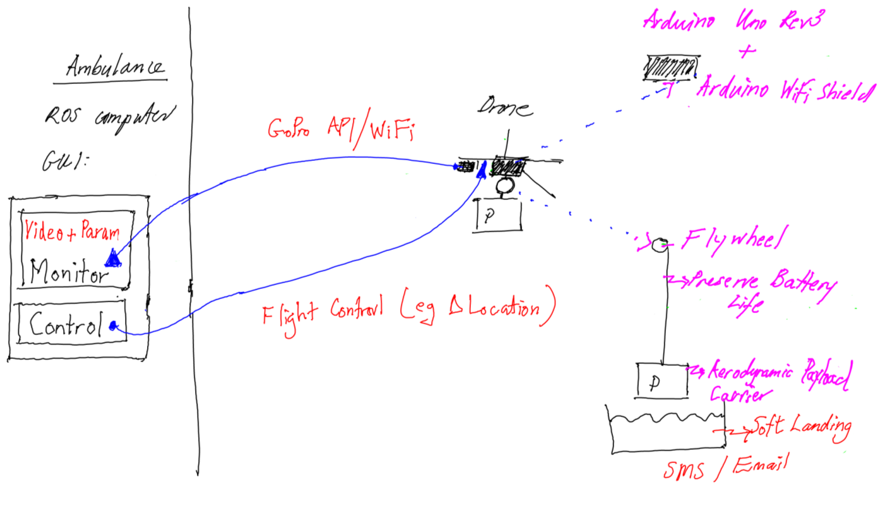

Back-End Control System(1) Ambulance ROS computer:

- ROS/Qt GUI computer application in the ambulance
  - Needs to be there regardless of what drone we are using
  - Visual Monitoring of drones will be via live video from the GoPro
    - Using GoPro API and streamed via WiFi
    - This will be part of the ROS Monitoring Node(publisher/subscriber)
    - You can mount a GoPro on the DJI Phantom4
      - I think instead of the native camera
      - so code will immediately be reusable
- Monitoring of drone flying parameters
  - Will be part of the ROS Monitoring Node also
- Drone flight will be mostly autonomous,
  - any manual flight control will be done from the ROS Control Node(publisher/subscriber)
  - Currently, we do not have the SDK would allow ideal changing of the drone's location,
    - So, Hexo+ flight control, location changing, at this stage:
    - would have to be via a GPS phone application that spoofs it's location, use FakeGPS Free App (Android)
    - Hexo+ will lock onto where it thinks is the GPS location of your phone

Results:

All code written for the core and non-core results is provided on my github repository.

Core Results:

To initially get the drones flying for familiarity and to facilitate

An Arduino Uno rev3 board with a WiFi shield installed into it was used as the embedded development platform that would interface communication between the GUI application commands to control the servo/stepper motor. Remember that this arduino embedded system will be taped to the underside of the hexo+ drone in the prototype system.

Both stepper motor and servo motors were evaluated in this project. Mainly to get a feel for which may be more suitable in a final and finished product, or even for what to focus further development on. At this stage it appears that the servo motor is most easily controlled, and has the more simpler powering requirements.

Servo and Stepper motor circuits:

Fundamental difference between the servo and stepper motors are in their design and operation. The servo is simply a simple DC motor and generally only has rotation between 0-180degrees. However, due to the requirement of contentious rotation, that is 360degree rotation was required for delivering the payload, a continuous servo motor was evaluated.

The servo can be powered via the +5V signal coming from the arduino uno and controlled via a single arduino digital IO pin, more specifically pin D9. The potentiometer, or variable resistor, between the arduino uno's +5V and ground pins appears to assist in the stability of the circuit, though for the servo this doesn't seem critical. I have done my experiments without the pot for the servo and it works quite well999. Refer to figure 999 for the arduino/servo motor control circuit.

999 include figure arduino_servo.png

The
And refer to figure 999 arduino_stepperf or the arduino to stepper motor control circuit.

999 include figure arduino_stepper.png

However, the servo motor does not have the precision of the stepper motor.

Also note that the testing of these circuits was done with both 9V batteries and the hexo+ battery charging JST-11 connector, not the main EC3 power connector that interfaces with the drone.

Arduino based Servo Motor Control Server
For detailed process of doing this, or method, involved refer to README.arduinoServoServer.

Arduino based Stepper Motor Control Server
For detailed process of doing this, or method, refer to README.arduionoStepperServer.

Significant issues with the development of the arduino server:
to be able to connect to the

Library Function xfer2as()
The library function to allow client applications to communicate with the respective arduino motor control server.

Here TCP/IP socket code is used to connect to the respective arduino server, arduinoServoServer or arduinoStepperServer.

Library Function sendSMS(),
I think relying on humans to pick-up the payload in a timely manner, before the drone leaves the destination sight, is unreliable. As battery power is paramount in mind, with the hexo+ only giving you eight minutes of flying time. For instance, that human could be in the toilet , not on site that day, in a meeting...etc. Consequently, code in the form of a library function has been written, that sends an SMS to a relevant official, once payload had been delivered to destination.

One could argue here that we should land the drone and wait for the relevant official to pick-up the payload. Who would retrieve the payload and return the payload carrier to the drone for it's return flight. At this stage I have taken the decision that we would loose too much flying time by having the drone land and take-off at each destination. If empirical results show otherwise I may change to this more interventionist approach. The code for this function is within the main ambulance gui code on the usb drive.

GUI application for the ambulance, running on a ROS computer:

Initially the GUI was to be suitable as a final piece to be used by the ambulance staff. However, during development it became clear that two versions of the GUI needed to be developed, a user version and an engineering version. The engineering version would be the most feature rich as it will facilitate the testing and development of the the back-end drone control system. The user version will have a subset of the engineering controls, and probably displayed in a different format. A similar distinction will probably be made between the user an engineering versions of the front-end software control system. The distinction has also been drawn due to not being able to easily foresee what the final requirements for the actual user are. In addition, this system could be adapted to other use case scenarios with different but similar requirements.

At this stage I would imagine the engineering and user version code base will be the same. With different options being enabled or configured for each respective system.

The GUI was developed using the opensource, cross-platform, widget library called Qt. Development with the Qt widget toolkit is most easily facilitated with

Non-Core Results:

Gaining familiarity with ROS(Robot Operating System) programming. This was to fulfil robot programming milestones that will be required for future work with the drones.

Initially, it was hoped that trying to use the Microcone to decipher voices once it's mounted on a robot.

Going through ROS examples namely999:
- simple publisher subscriber for the old indigo_workspace
- simple publisher subscriber for a catkin_ws(catkin workspace)
- creating a first package with both the indigo_workspace and catkin_ws
- node_example, listner.cpp & talker.cpp, and, listner_node.cpp & talker.cpp
- all the above lead to the development of the ros voice_node, simplePub.cpp & simpleSub.cpp, and, simplePub_node.cpp & simpleSub_node.cpp.
all of this code is on the supplied usb drive, just the source files.

Why go from an indigo_workspace to a catkin_ws?

It eventually became clear that a catkin_ws was being used in the ROS programming documentation. Thus it was thought best to create this workspace for the neophyte to follow the examples more easily.

Why ROS example called node_example & my voice_node ROS code?

At this stage it is thought that the GUI front-end would interface to a ros node on the ambulance ros based computer, hence going through the most obvious helpful example that would facilitate me writing this. This voice_node allows you to change the voice of a ros catkin system and pronounce whatever words you like. It publishes on two topics and subscribes to those two topics, namely, txt4TTStopic and voiceNameTopic. One topic is the text that is required to convert to speech and the other topic is the voice to use to speak the text, these are in the publisher node, simplePub.cpp. The corresponding subscriber topics are 999

There still appears to be a bug in the voice_node code, which also seems present in the ros sound_play node. See README.voice_node, attached on the usb drive, for a description on how to run the voice_node publisher & subscriber nodes, see some sample output, and a more detailed description of the bug.
Future Work:

Front-end control system using a swarm of hexo+ and or dji phantom 4 drones.
Very very long term, Interface the dji matrice to existing and future developed systems.
Investigation and evaluation of the of the Beagle Board and Rasberry Pi, with respect to suitability.

