**GIT Repo for the script:**

<https://github.com/smahaboob1/Bash_Scripts.git>

#!/bin/bash

NEWLINE(){

echo ""

}

USAGE(){

echo "This script is a common library for many bash tools."

}

TS(){

date +"%m-%d-%Y %T"

}

ERROR(){

if [ $# -gt 0 ]

then

echo "Printing Error: "

for arg in $*

do

echo "$*"

break

done

else

echo "No argument provided to the script."

fi

}

###################################

# Main Script Logic Starts Here #

###################################

case "$1" in

TS)

TS

;;

-h)

USAGE

;;

NEWLINE)

NEWLINE

;;

ERROR)

ERROR ${@:2}

;;

Esac

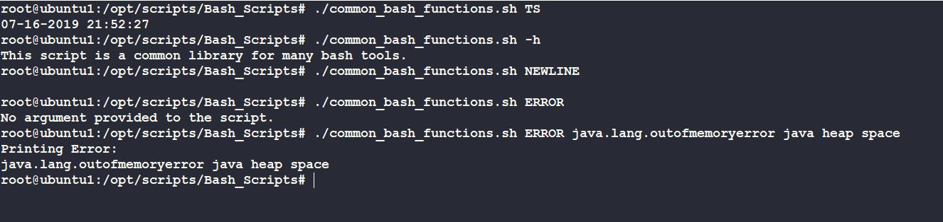

**Making functions to all users in server:**

1. **Vi /etc/profile**
2. **Add script to the file**

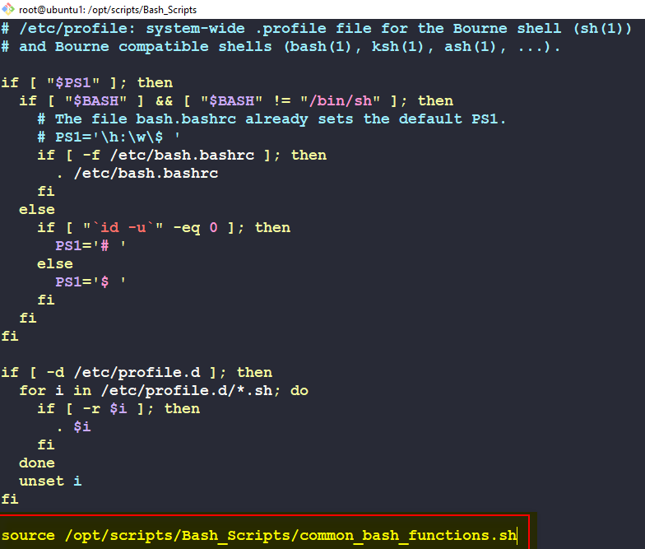

1. **Now all users have access to the functions**

