**CSC 872**

PATTERN ANALYSIS AND MACHINE INTELLIGENCE

FAST PROTOTYPING  
#3

Submitted by

Sudha Mahadik SFSU ID-916429142

San Francisco State University

Output of the code:

After applying PCA for training, selecting top eigenvector equal to 20 and LDA classification while testing, to male and female folder images respectively I got the following output.

Unclassified Female Images:

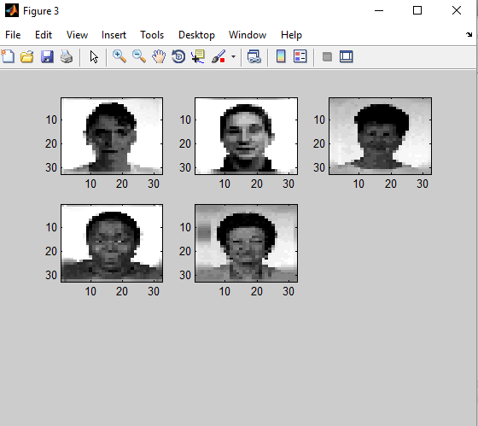

Unclassified male Images:

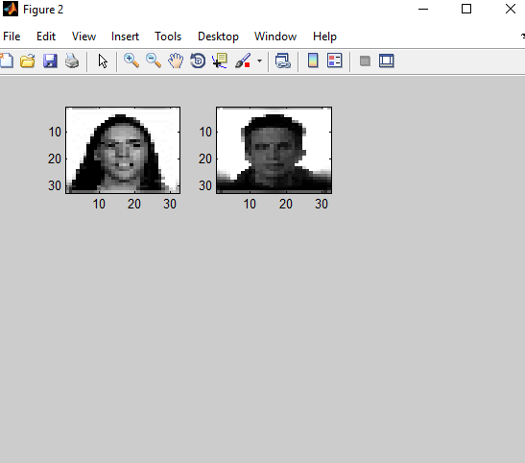

Accuracy:

As total unclassified images are 7 , accuracy can be calculated as :

{[99(all images) – 7 (unclassified images) ]/99(total images)} * 100 = **92.92%**

With top eigen vectors selected = 50 , I got following output :

Unclassified females :

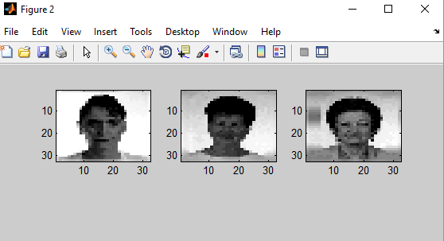

Unclassified males:

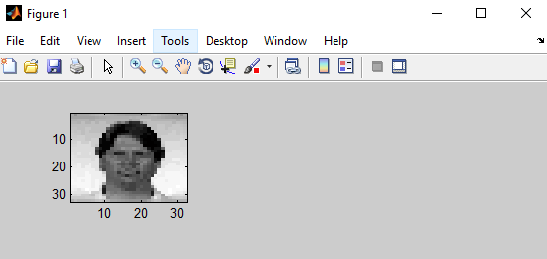

Accuracy = 95.95%

Thus , we can see that as number of top eigenvectors selected increased , classification accuracy also increased.