# CS 3340 – Introduction to OOP and Design

# Project 3 - Android Application

**Pedometer and BMI Calculator Using GPS**

# Documentation

Gayathiri Shriram (MS5754)

Shravya Mahankali (GE5327)

Sahil Chopra

# Android SDK Used:

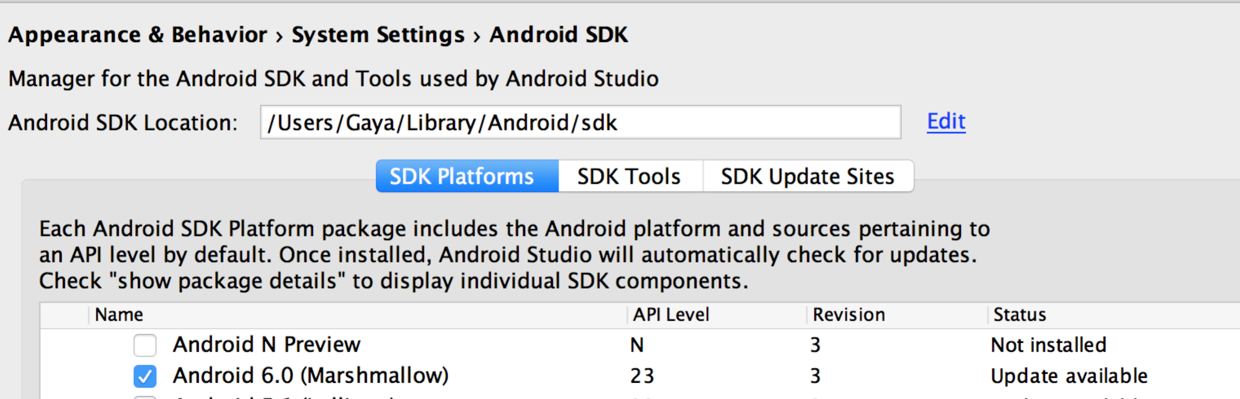

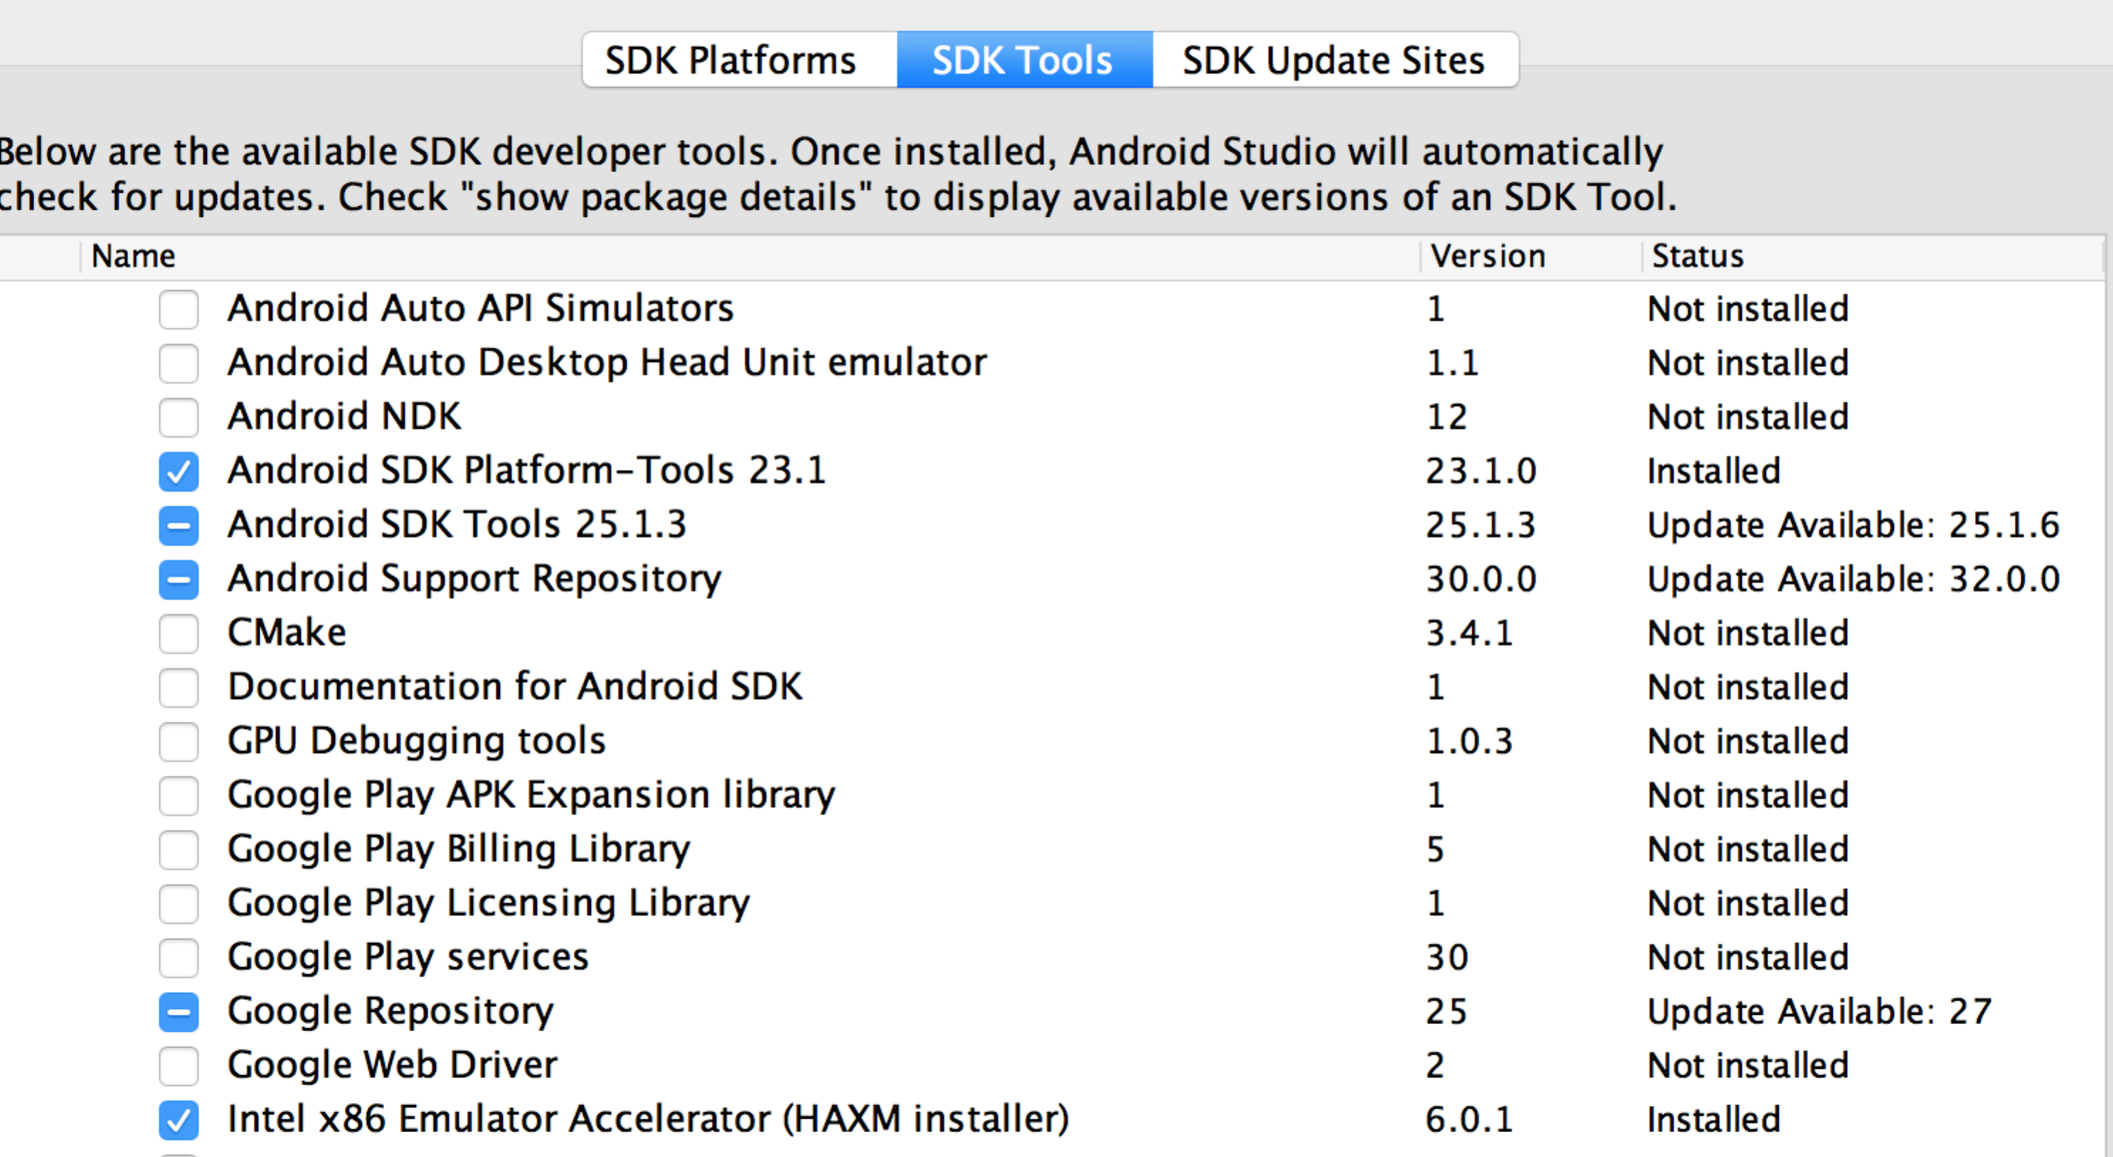

# AVD Used:

