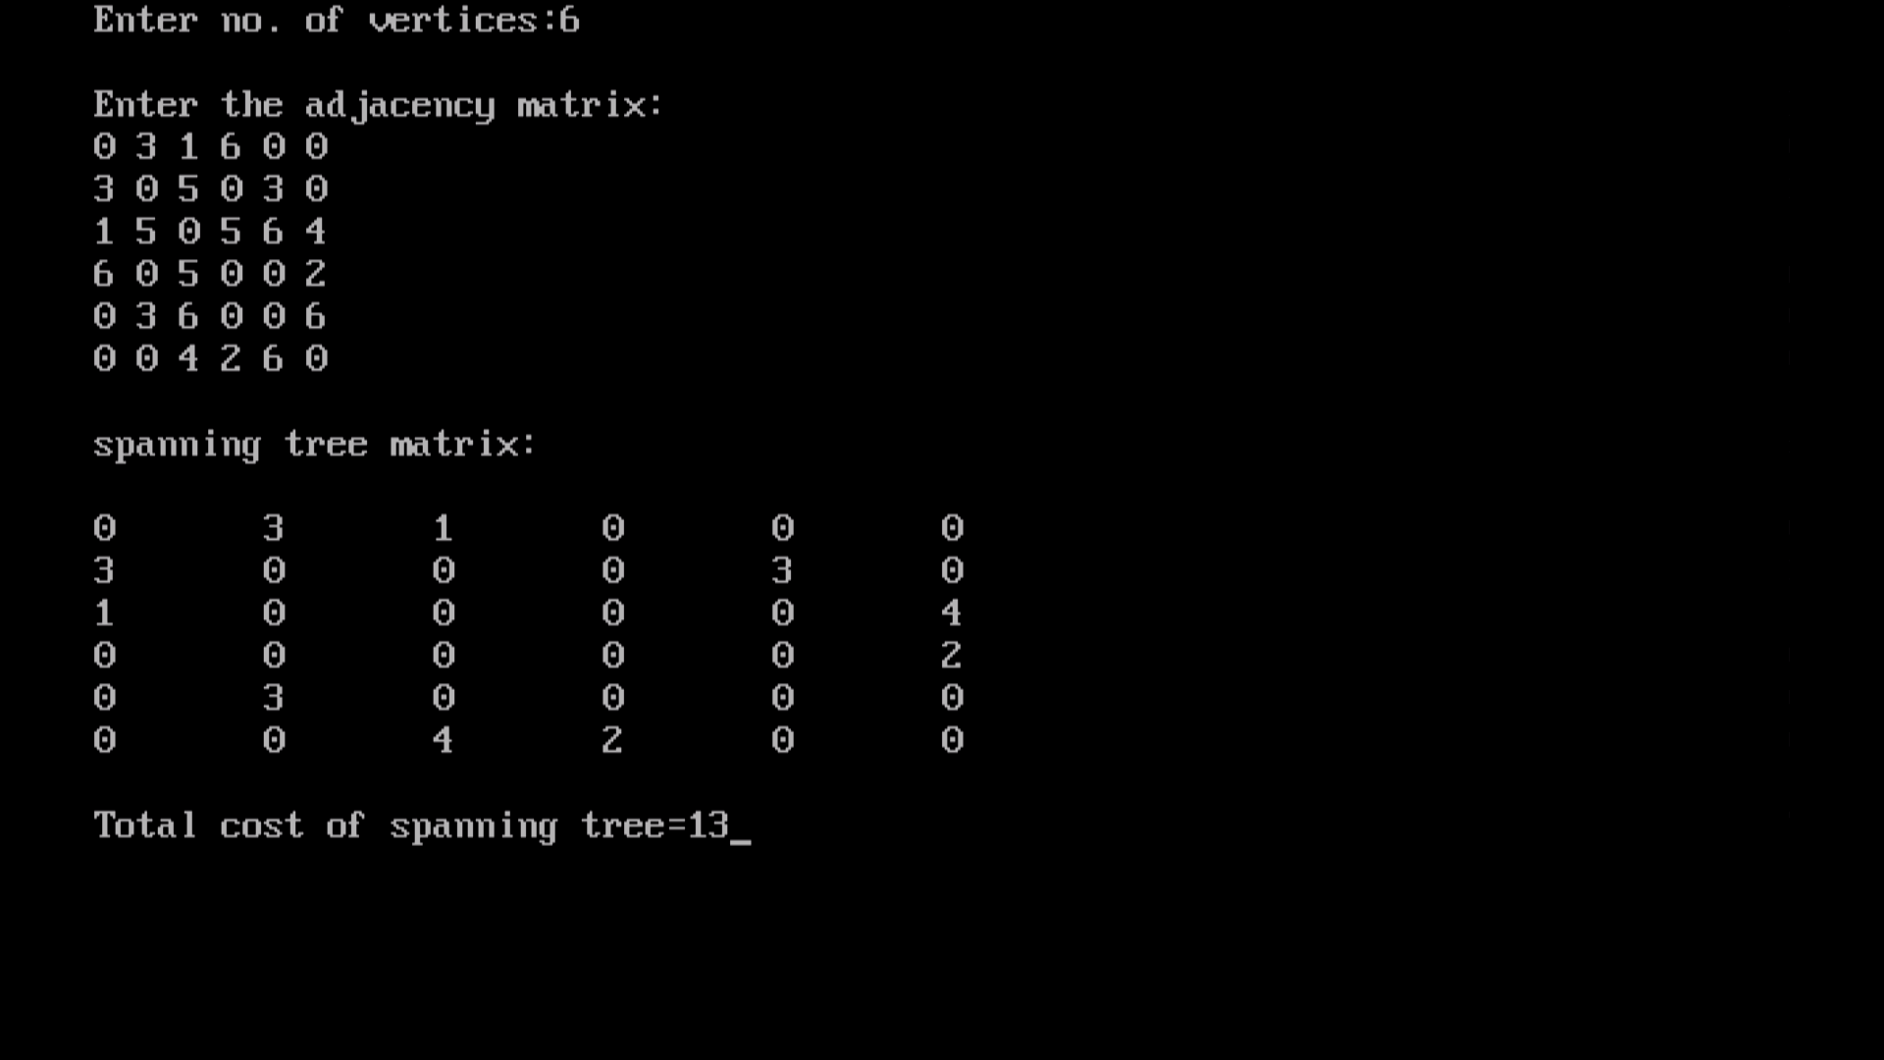
Program for prims :
#include<stdio.h>
#include<conio.h>

#define infinity 9999
#define MAX 20

int G[MAX][MAX],spanning[MAX][MAX],n;

int prims();

int main()
{
int i,j,total_cost;
printf("Enter no. of vertices:");
scanf("%d",&n);

printf("\nEnter the adjacency matrix:\n");

for(i=0;i<n;i++)
for(j=0;j<n;j++)
scanf("%d",&G[i][j]);

total_cost=prims();
printf("\nspanning tree matrix:\n");

for(i=0;i<n;i++)
{
printf("\n");
for(j=0;j<n;j++)
printf("%d\t",spanning[i][j]);
}

printf("\n\nTotal cost of spanning tree=%d",total_cost);
getch();
return 0;
}

int prims()
{
int cost[MAX][MAX];
int u,v,min_distance,distance[MAX],from[MAX];
int visited[MAX],no_of_edges,i,min_cost,j;

//create cost[][] matrix,spanning[][]
for(i=0;i<n;i++)
for(j=0;j<n;j++)
{
if(G[i][j]==0)
cost[i][j]=infinity;
else
cost[i][j]=G[i][j];
spanning[i][j]=0;
}

//initialise visited[],distance[] and from[]
distance[0]=0;
visited[0]=1;

for(i=1;i<n;i++)
{
distance[i]=cost[0][i];
from[i]=0;
visited[i]=0;
}

min_cost=0; //cost of spanning tree
no_of_edges=n-1; //no. of edges to be added

while(no_of_edges>0)
{
//find the vertex at minimum distance from the tree
min_distance=infinity;
for(i=1;i<n;i++)
if(visited[i]==0&&distance[i]<min_distance)
{
v=i;
min_distance=distance[i];
}

u=from[v];

//insert the edge in spanning tree
spanning[u][v]=distance[v];
spanning[v][u]=distance[v];
no_of_edges--;
visited[v]=1;

//updated the distance[] array
for(i=1;i<n;i++)
if(visited[i]==0&&cost[i][v]<distance[i])
{
distance[i]=cost[i][v];
from[i]=v;
}

min_cost=min_cost+cost[u][v];
}

return(min_cost);
}

Link for program :
https://www.thecrazyprogrammer.com/2014/06/prims-algorithm-and-program-for-minimum-cost-spanning-tree.html

