Front page without login:

Opening the website (Default <http://127.0.0.1:5000/> address) will give you the view on figure 1when not logged in

Figure 1: Front page without login

Here you got the options of Home(Returns to this page), Cereals(Lists all cereals in database), Login(Login to system, required for multiple operations), Sign up(Create user).

Signup:

To create a user, click on the sign up button where you will be redirected to a view that looks like figure 2

Figure : Signup page

Here you type in your username and password for the username.

If username is already in use, you will be redirected back to the signup page like figure 3

Figure 3: Signup username in use

On a successful signup you will be redirected to the login page view described in next section

Login:

When going to the login page you will be given the view shown on figure 4

Figure 4: login page

Type in your username(name) and password (Your password) and the remember me button will keep you logged in for future visits. If you typed your information incorrectly you will be redirected back with a message seen on figure 5. On successful login you will be transferred back to the front page with a changed view described in next section

Figure 5: failed login

Frontpage with login:

When logged in, your view should look similar to before exception the option bar in top left corner is now changed and you are greeted in the middle with “hello” and your username which can be seen on figure 6

Figure 6: frontpage with login

You now got the options to Add cereal(A pageview for adding a cereal manually), upload csv file(Pageview to upload a csv file and add the content to the database) and logout(Logging out, making your view look like the initial frontpage)

Cereals view

Figure 7: Cereals list view

When clicking the Cereals button, you will be redirected to a view seen on figure 7 and figure 8. Here you will be shown the cereals that are in database on top as seen on figure 7. Clicking on one of the elements in the box will redirect you to a page where the individual cereal information is shown with a picture (If one is uploaded) and addition options that is shown in the section of individual Cereal view.

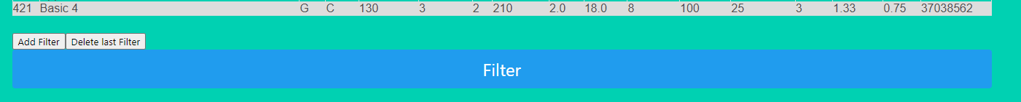

Figure 8: Filter options

At the bottom of the listing of all the cereals seen in figure 8, you will see 2 small buttons (add filter, delete filter) and filter. 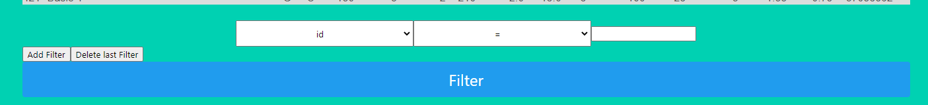

Figure 9: Filter added

The add filter button will add a filter option that shows directly above as shown in figure 9. The first box will show you the options of all the fields that exist for the cereal, the second box will give you the operator you wish to use (=,!=,<,>,<=,>=) and the textbox is for the value you wish to filter from. You can add as many filters as you wish.

Delete filter button will remove the last (Bottom of the filters that were added). To execute your filter options, press the filter buttons where you will be redirected back to the cereals view again seen on figure 10, where the list will now show the cereals that are valid for the given criteria of the filters.Graphical user interface, website

Figure 10: Filtered list view

If the input to the filter was invalid (Giving is a letter value for instance) it will list all the cereals again and show you a message at the top of the box that says you gave invalid input as shown on figure 11

Figure 11: Invalid filter input

Specific cereal view

Figure 12: Specific cereal view

In the individual cereal view seen on figure 12, you will have the information like the listing of all the cereals and a picture at the bottom too. If you are logged in you will have the 3 blue button options too, delete cereal deletes from the database and redirect you back to the listing of all the cereals along with a message on top stating it has been deleted seen in figure 13



Figure 13: Deleted cereal

To upload a file, click the “Choose file” button and select your image file and click upload cereal picture button. You will be redirected back to the page you are currently on with a message ontop either saying an error message if the image file was invalid or wrong file type. Or if you updated it will say you successfully updated the picture (And it should show in picture field at the bottom with your updated picture).

The last option is to update Cereal where it will redirect you to the Update cereal view described in the next section

Add/Update cereal:

Figure 14: Update/Add cereals view

When clicking the add button or updating a cereal you will be redirected a page looking like figure 14.

If you are updating a specific cereal, it will have the fields prefilled with their given values and have the extra option showing “ID” which is not editable but only shows the ID of the cereal is assigned. If adding a new cereal none of the fields will be prefilled and the ID box will not exist.

When you have done your changes there is a blue button at the bottom with Add/Update cereal to submit your changes. If you made an error, you will be redirected back to the page with a message on top showing you made an error on one of the fields. On success you will be redirected back to the list view with a message at the top saying you added or updated successfully.

Upload CSV

Figure 15: Upload csv

Clicking the Upload csv file button will direct you to a view seen on figure 15. Press the “choose file” button to pick the file to upload, and press upload csv file.

On success you will be redirected to the cereal list view showing you a message you successfully added a number of cereals to database.

On error, if you picked the wrong file format or did not upload a file you will be redirected back to upload csv page with a error message on top saying the mistake.