1. Aggregation is a specialized form of association that happens to imply containment, is differentiated from a “normal” association by placing a diamond at the end of the association line that touches the “containing” class.

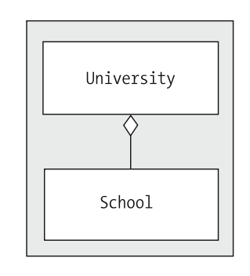

1. A filled diamond signals composition, a strong form of aggregation in which the “parts” cannot exist without the “whole,” uses a filled-in/black diamond rather than an

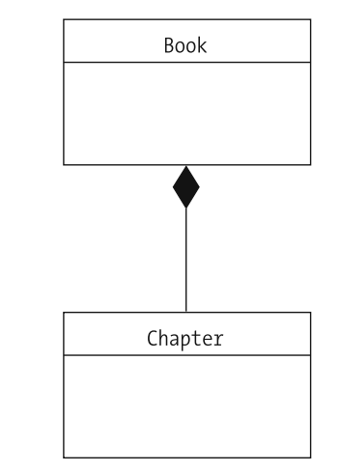

1. Inheritance: Inheritance (generalization/specialization) is illustrated by connecting a derived class to its base class with a line, and then marking the line with a triangle that touches the base class. Inheritance lines should not be labeled, as they unambiguously represent the “is a” relationship

