Struts——an open-source MVC implementation
This article introduces Struts, a Model-View-Controller implementation that uses servlets and JavaServer Pages (JSP) technology. Struts can help you control change in your Web project and promote specialization. Even if you never implement a system with Struts, you may get some ideas for your future servlets and JSP page implementation.
Introduction
Kids in grade school put HTML pages on the Internet. However, there is a monumental difference between a grade school page and a professionally developed Web site. The page designer (or HTML developer) must understand colors, the customer, product flow, page layout, browser compatibility, image creation, JavaScript, and more. Putting a great looking site together takes a lot of work, and most Java developers are more interested in creating a great looking object interface than a user interface. JavaServer Pages (JSP) technology provides the glue between the page designer and the Java developer.
If you have worked on a large-scale Web application, you understand the term change. Model-View-Controller (MVC) is a design pattern put together to help control change. MVC decouples interface from business logic and data. Struts is an MVC implementation that uses Servlets 2.2 and JSP 1.1 tags, from the J2EE specifications, as part of the implementation. You may never implement a system with Struts, but looking at Struts may give you some ideas on your future Servlets and JSP implementations.
Model-View-Controller (MVC)
JSP tags solved only part of our problem. We still have issues with validation, flow control, and updating the state of the application. This is where MVC comes to the rescue. MVC helps resolve some of the issues with the single module approach by dividing the problem into three categories:

- Model
The model contains the core of the application's functionality. The model encapsulates the state of the application. Sometimes the only functionality it contains is state. It knows nothing about the view or controller.
- View
The view provides the presentation of the model. It is the look of the application. The view can access the model getters, but it has no knowledge of the setters. In addition, it knows nothing about the controller. The view should be notified when changes to the model occur.
- Controller
The controller reacts to the user input. It creates and sets the model.
MVC Model 2
The Web brought some unique challenges to software developers, most notably the stateless connection between the client and the server. This stateless behavior made it difficult for the model to notify the view of changes. On the Web, the browser has to re-query the server to discover modification to the state of the application.
Another noticeable change is that the view uses different technology for implementation than the model or controller. Of course, we could use Java (or PERL, C/C++ or what ever) code to generate HTML. There are several disadvantages to that approach:
- Java programmers should develop services, not HTML.
- Changes to layout would require changes to code.
- Customers of the service should be able to create pages to meet their specific needs.
- The page designer isn't able to have direct involvement in page development.
- HTML embedded into code is ugly.
For the Web, the classical form of MVC needed to change. Figure 1 displays the Web adaptation of MVC, also commonly known as MVC Model 2 or MVC 2.
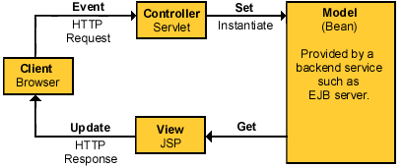
Figure 1. MVC Model 2

Struts, an MVC 2 implementation
Struts is a set of cooperating classes, servlets, and JSP tags that make up a reusable MVC 2 design. This definition implies that Struts is a framework, rather than a library, but Struts also contains an extensive tag library and utility classes that work independently of the framework. Figure 2 displays an overview of Struts.
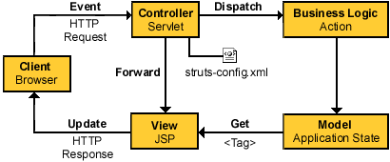
Figure 2. Struts view

Struts overview
- Client browser
An HTTP request from the client browser creates an event. The Web container will respond with an HTTP response.
- Controller
The Controller receives the request from the browser, and makes the decision where to send the request. With Struts, the Controller is a command design pattern implemented as a servlet. The struts-config.xml file configures the Controller.
- Business logic
The business logic updates the state of the model and helps control the flow of the application. With Struts this is done with an Action class as a thin wrapper to the actual business logic.
- Model state
The model represents the state of the application. The business objects update the application state. ActionForm bean represents the Model state at a session or request level, and not at a persistent level. The JSP file reads information from the ActionForm bean using JSP tags.
- View
The view is simply a JSP file. There is no flow logic, no business logic, and no model information -- just tags. Tags are one of the things that make Struts unique compared to other frameworks like Velocity.
Struts details
Displayed in Figure 3 is a stripped-down UML diagram of the org.apache.struts.action package. Figure 6 shows the minimal relationships among ActionServlet (Controller), ActionForm (Form State), and Action (Model Wrapper).
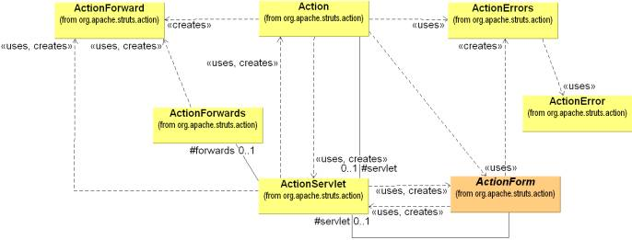
Figure 3:the relationship between ActionServlet (Controller)、 ActionForm (Form State) and Action (Model Wrapper)
The ActionServlet class
Do you remember the days of function mappings? You would map some input event to a pointer to a function. If you where slick, you would place the configuration information into a file and load the file at run time. Function pointer arrays were the good old days of structured programming in C.
Life is better now that we have Java technology, XML, J2EE, and all that. The Struts Controller is a servlet that maps events (an event generally being an HTTP post) to classes. And guess what -- the Controller uses a configuration file so you don_t have to hard-code the values. Life changes, but stays the same.
ActionServlet is the Command part of the MVC implementation and is the core of the Framework. ActionServlet (Command) creates and uses Action, an ActionForm, and ActionForward. As mentioned earlier, the struts-config.xml file configures the Command. During the creation of the Web project, Action and ActionForm are extended to solve the specific problem space. The file struts-config.xml instructs ActionServlet on how to use the extended classes. There are several advantages to this approach:
- The entire logical flow of the application is in a hierarchical text file. This makes it easier to view and understand, especially with large applications.
- The page designer does not have to wade through Java code to understand the flow of the application.
- The Java developer does not need to recompile code when making flow changes.
Command functionality can be added by extending ActionServlet.
The ActionForm class
ActionForm maintains the session state for the Web application. ActionForm is an abstract class that is sub-classed for each input form model. When I say input form model, I am saying ActionForm represents a general concept of data that is set or updated by a HTML form. For instance, you may have a UserActionForm that is set by an HTML Form. The Struts framework will:
- Check to see if a UserActionForm exists; if not, it will create an instance of the class.
- Struts will set the state of the UserActionForm using corresponding fields from the HttpServletRequest. No more dreadful request.getParameter() calls. For instance, the Struts framework will take fname from request stream and call UserActionForm.setFname().
- The Struts framework updates the state of the UserActionForm before passing it to the business wrapper UserAction.
- Before passing it to the Action class, Struts will also conduct form state validation by calling the validation() method on UserActionForm.Note: This is not always wise to do. There might be ways of using UserActionForm in other pages or business objects, where the validation might be different. Validation of the state might be better in the UserAction class.
- The UserActionForm can be maintained at a session level.
Notes:
- The struts-config.xml file controls which HTML form request maps to which ActionForm.
- Multiple requests can be mapped UserActionForm.
- UserActionForm can be mapped over multiple pages for things such as wizards.
The Action class
The Action class is a wrapper around the business logic. The purpose of Action class is to translate the HttpServletRequest to the business logic. To use Action, subclass and overwrite the process() method.
The ActionServlet (Command) passes the parameterized classes to ActionForm using the perform() method. Again, no more dreadful request.getParameter() calls. By the time the event gets here, the input form data (or HTML form data) has already been translated out of the request stream and into an ActionForm class.
Note: "Think thin" when extending the Action class. The Action class should control the flow and not the logic of the application. By placing the business logic in a separate package or EJB, we allow flexibility and reuse.
Another way of thinking about Action class is as the Adapter design pattern. The purpose of the Action is to "Convert the interface of a class into another interface the clients expect. Adapter lets classes work together that couldn_t otherwise because of incompatibility interface" (from Design Patterns - Elements of Reusable OO Software by Gof). The client in this instance is the ActionServlet that knows nothing about our specific business class interface. Therefore, Struts provides a business interface it does understand, Action. By extending the Action, we make our business interface compatible with Struts business interface. (An interesting observation is that Action is a class and not an interface. Action started as an interface and changed into a class over time. Nothing's perfect.)
The Error classes
The UML diagram (Figure 4) also included ActionError and ActionErrors. ActionError encapsulates an individual error message. ActionErrors is a container of ActionError classes that the View can access using tags. ActionErrors is Struts way of keeping up with a list of errors.
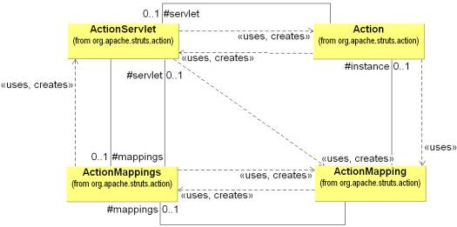
Figure 4:the relationship between Command (ActionServlet) and Model (Action)
The ActionMapping class
An incoming event is normally in the form of an HTTP request, which the servlet Container turns into an HttpServletRequest. The Controller looks at the incoming event and dispatches the request to an Action class. The struts-config.xml determines what Action class the Controller calls. The struts-config.xml configuration information is translated into a set of ActionMapping, which are put into container of ActionMappings. (If you have not noticed it, classes that end with s are containers)
The ActionMapping contains the knowledge of how a specific event maps to specific Actions. The ActionServlet (Command) passes the ActionMapping to the Action class via the perform() method. This allows Action to access the information to control flow.
ActionMappings
ActionMappings is a collection of ActionMapping objects.

Struts pros
- Use of JSP tag mechanism
The tag feature promotes reusable code and abstracts Java code from the JSP file. This feature allows nice integration into JSP-based development tools that allow authoring with tags.
- Tag library
Why re-invent the wheel, or a tag library? If you cannot find something you need in the library, contribute. In addition, Struts provides a starting point if you are learning JSP tag technology.
- Open source
You have all the advantages of open source, such as being able to see the code and having everyone else using the library reviewing the code. Many eyes make for great code review.
- Sample MVC implementation
Struts offers some insight if you want to create your own MVC implementation.
- Manage the problem space
Divide and conquer is a nice way of solving the problem and making the problem manageable. Of course, the sword cuts both ways. The problem is more complex and needs more management.
Struts cons
- Youth
Struts development is still in preliminary form. They are working toward releasing a version 1.0, but as with any 1.0 version, it does not provide all the bells and whistles.
- Change
The framework is undergoing a rapid amount of change. A great deal of change has occurred between Struts 0.5 and 1.0. You may want to download the most current Struts nightly distributions, to avoid deprecated methods. In the last 6 months, I have seen the Struts library grow from 90K to over 270K. I had to modify my examples several times because of changes in Struts, and I am not going to guarantee my examples will work with the version of Struts you download.
- Correct level of abstraction
Does Struts provide the correct level of abstraction? What is the proper level of abstraction for the page designer? That is the $64K question. Should we allow a page designer access to Java code in page development? Some frameworks like Velocity say no, and provide yet another language to learn for Web development. There is some validity to limiting Java code access in UI development. Most importantly, give a page designer a little bit of Java, and he will use a lot of Java. I saw this happen all the time in Microsoft ASP development. In ASP development, you were supposed to create COM objects and then write a little ASP script to glue it all together. Instead, the ASP developers would go crazy with ASP script. I would hear "Why wait for a COM developer to create it when I can program it directly with VBScript?" Struts helps limit the amount of Java code required in a JSP file via tag libraries. One such library is the Logic Tag, which manages conditional generation of output, but this does not prevent the UI developer from going nuts with Java code. Whatever type of framework you decide to use, you should understand the environment in which you are deploying and maintaining the framework. Of course, this task is easier said than done.
- Limited scope
Struts is a Web-based MVC solution that is meant be implemented with HTML, JSP files, and servlets.
- J2EE application support
Struts requires a servlet container that supports JSP 1.1 and Servlet 2.2 specifications. This alone will not solve all your install issues, unless you are using Tomcat 3.2.
- Complexity
Separating the problem into parts introduces complexity. There is no question that some education will have to go on to understand Struts. With the constant changes occurring, this can be frustrating at times.
Future of Struts
Things change rapidly in this new age of software development. In less than 5 years, we have seen things go from cgi/perl, to ISAPI/NSAPI, to ASP with VB, and now Java and J2EE. Sun is working hard to adapt changes to the JSP/servlet architecture, just as they have in the past with the Java language and API. You can obtain drafts of the new JSP 1.2 and Servlet 2.3 specifications from the Sun Web site. Additionally, a standard tag library for JSP files is appearing.

