#include<stdio.h>

#include<unistd.h>

int

main(void){

int pid1 = fork();

int pid2 = fork();

if(pid1 == 0) {

//子进程1

printf("b\n");

} else if (pid2 == 0){

//子进程2

printf("c\n");

} else {

//父进程

printf("a\n");

}

return 0;

}



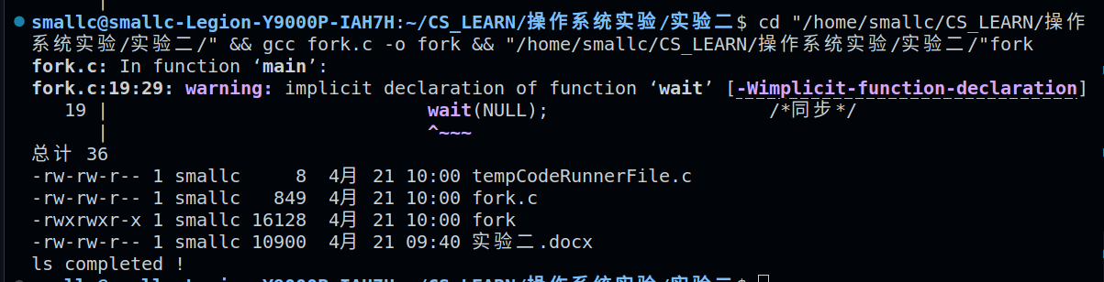

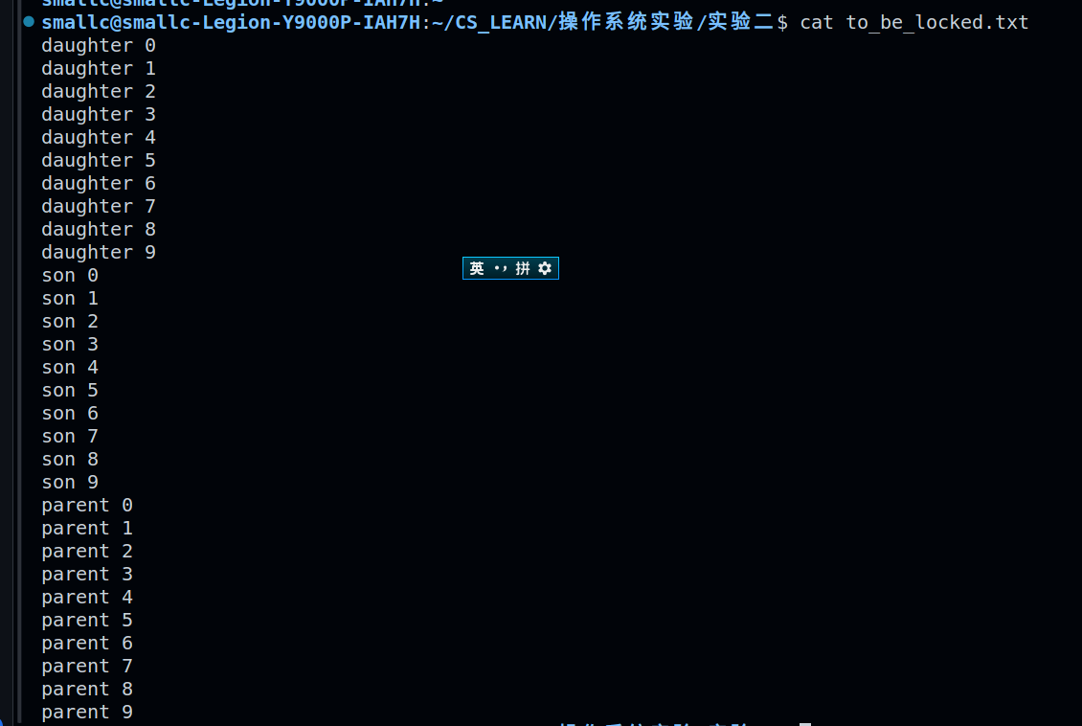

#include<stdio.h>

#include<unistd.h>

#include<stdlib.h>

int

main(void) {

int fd[2];

pipe(fd);

//先接受P1

if(fork() == 0) {

//子进程1

char buf[] = {"Child 1 is sending a message!\n"};

write(fd[1], buf, sizeof(buf));

close(fd[1]);

exit(0);

}else {

char buf[100];

read(fd[0], buf, sizeof(buf));

printf(buf);

}

//接受P2

if(fork() == 0) {

//子进程2

char buf[] = {"Child 2 is sending a message!\n"};

write(fd[1], buf, sizeof(buf));

close(fd[1]);

exit(0);

}

else {

char buf[100];

read(fd[0], buf, sizeof(buf));

printf(buf);

}

return 0;

}

