Prototypes
The prototype is designed for the current multi-factor stock selection system. It keeps the interface simple and clear while covering the main user workflow: login, dashboard overview, strategy configuration, backtesting, and result analysis. The frontend prototype follows the actual implementation direction using Jinja2 templates, Bootstrap 5, Axios, and ECharts and connects to Flask backend services for data processing and analysis.

有登录页面吗？
- Dashboard Page
The dashboard gives users a quick overview of stock data, built-in factors, model status, backtest tasks, and recent strategy progress.
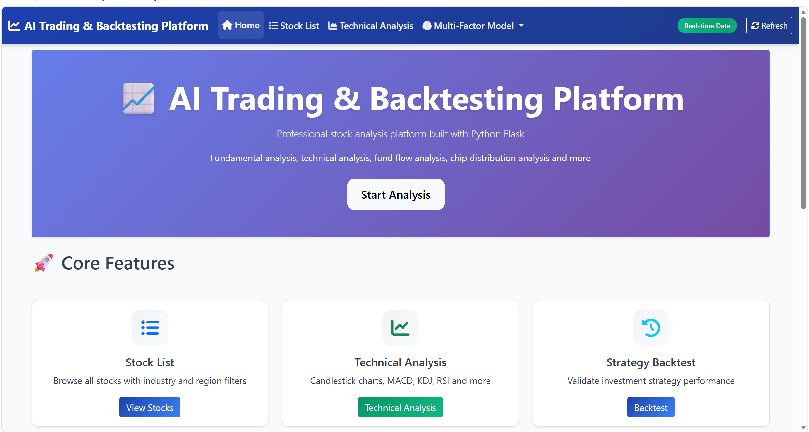
下面的页面增加解释
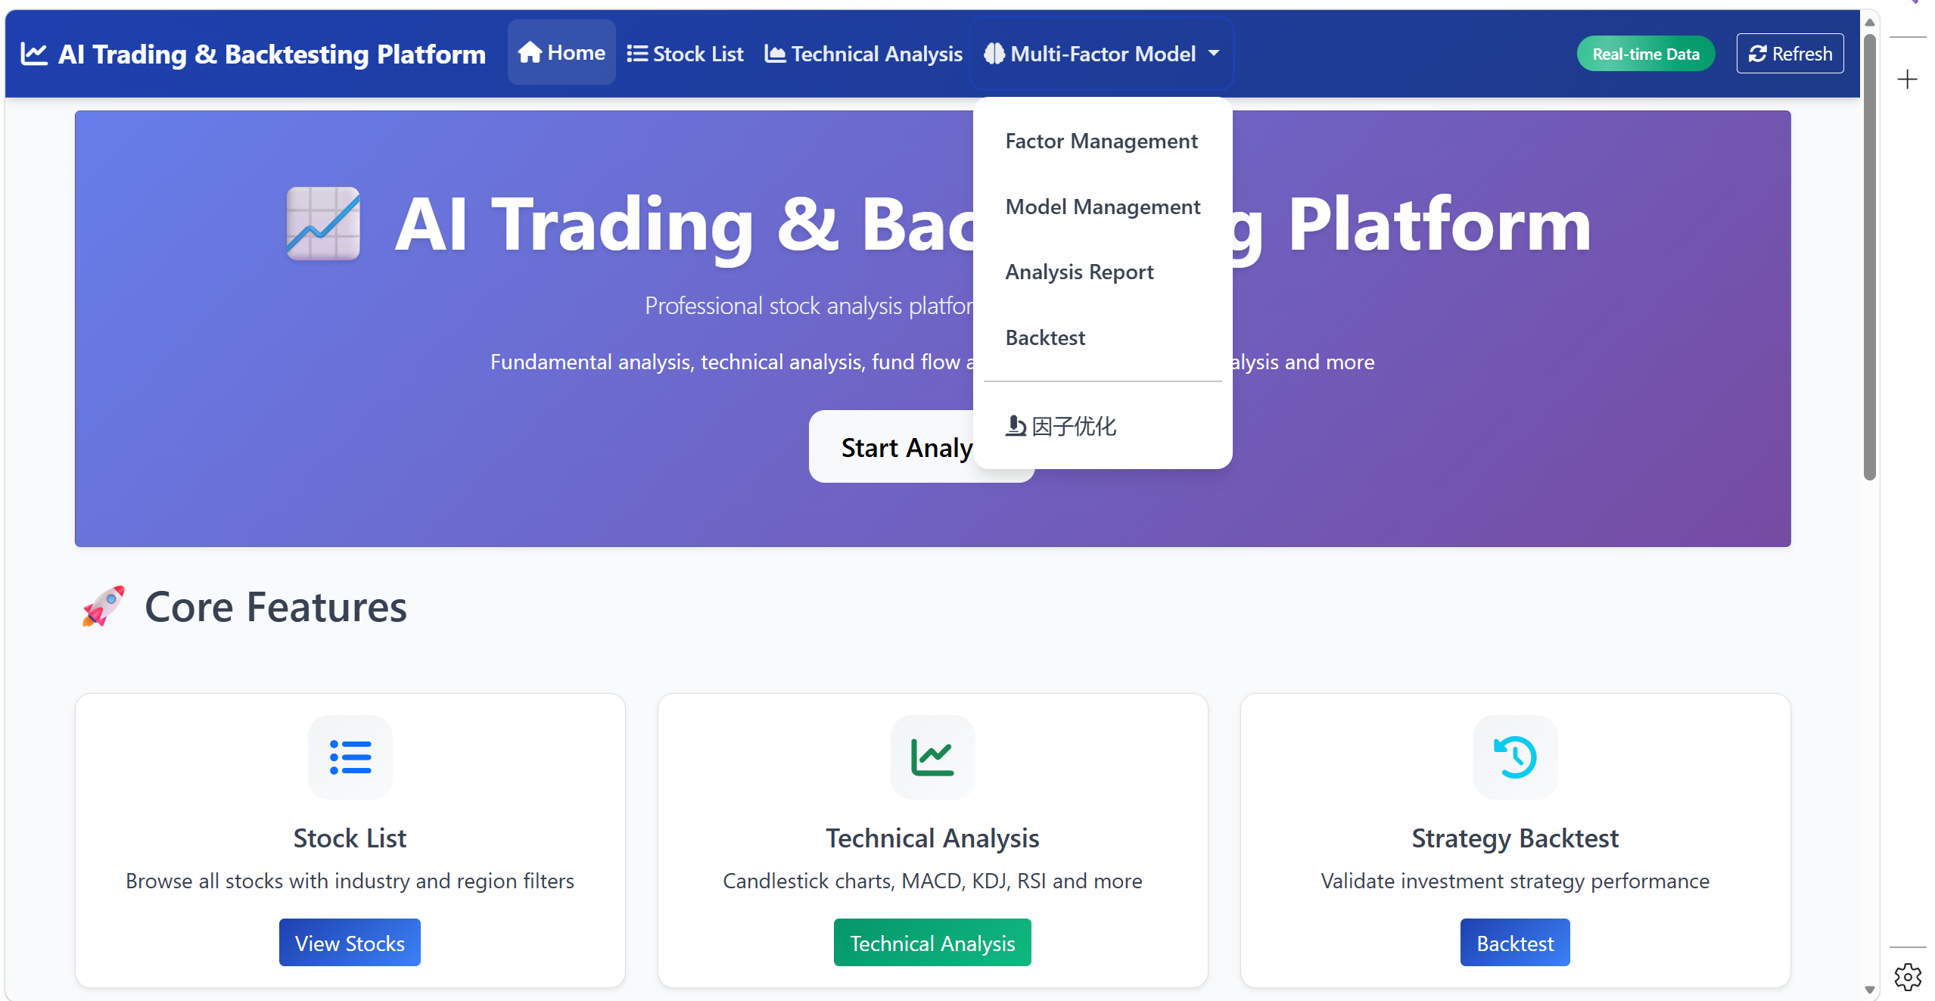

- Stock List
下面的页面增加解释
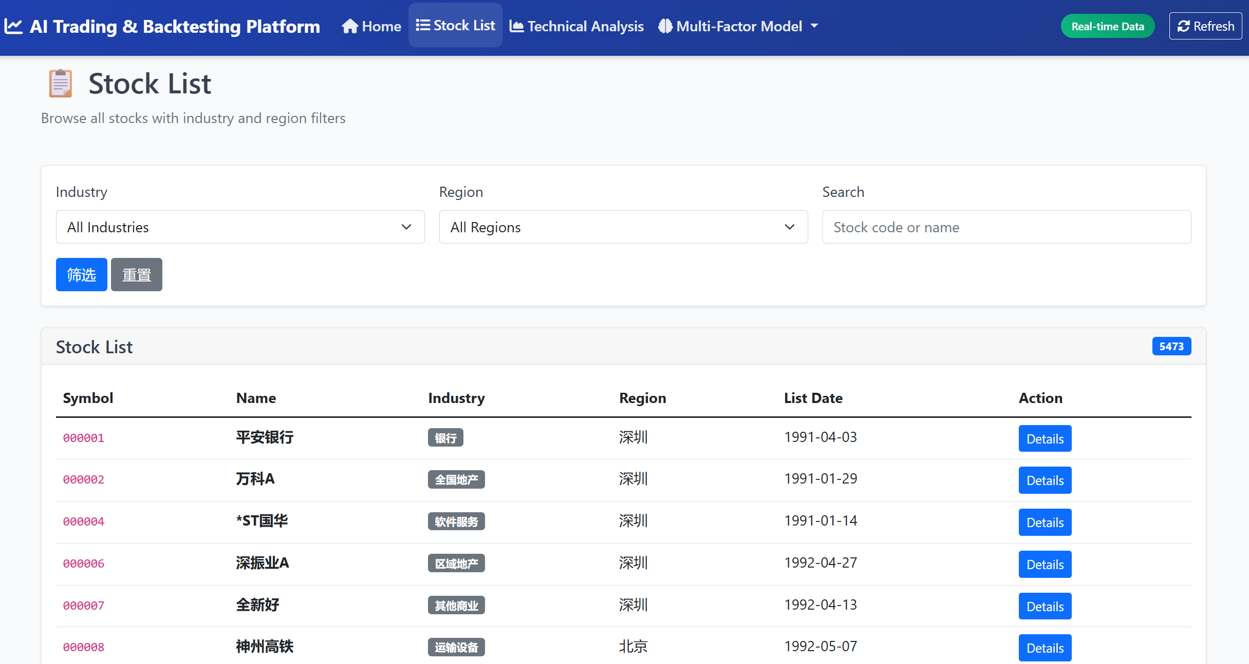

- Strategy Backtest
The backtesting page allows the user to set the testing period, initial capital, rebalancing frequency, and risk limits. The backend then runs the backtesting engine and returns the task status.

The result page displays the equity curve, drawdown chart, selected stock list, portfolio weights, and performance indicators such as annual return, Sharpe ratio, maximum drawdown, and win rate.
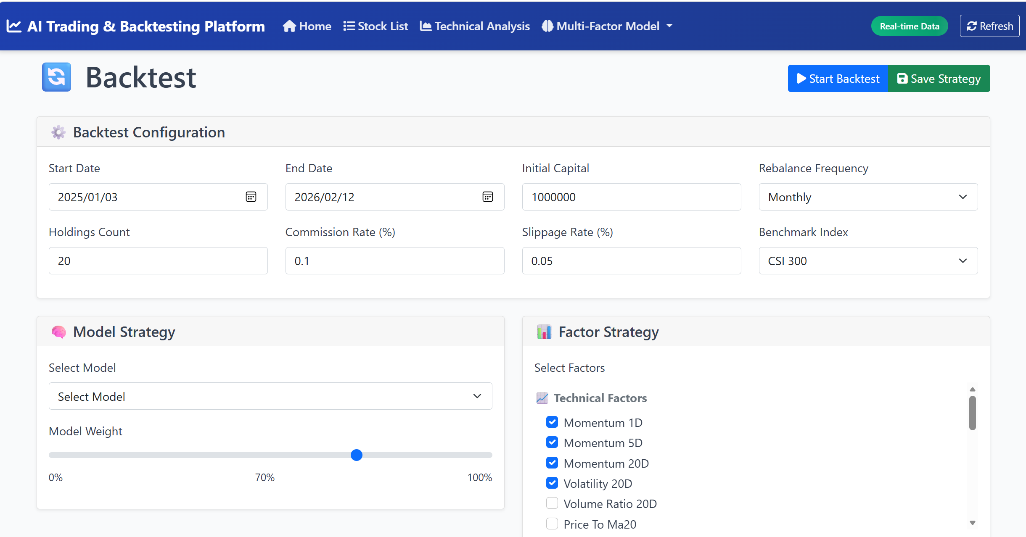
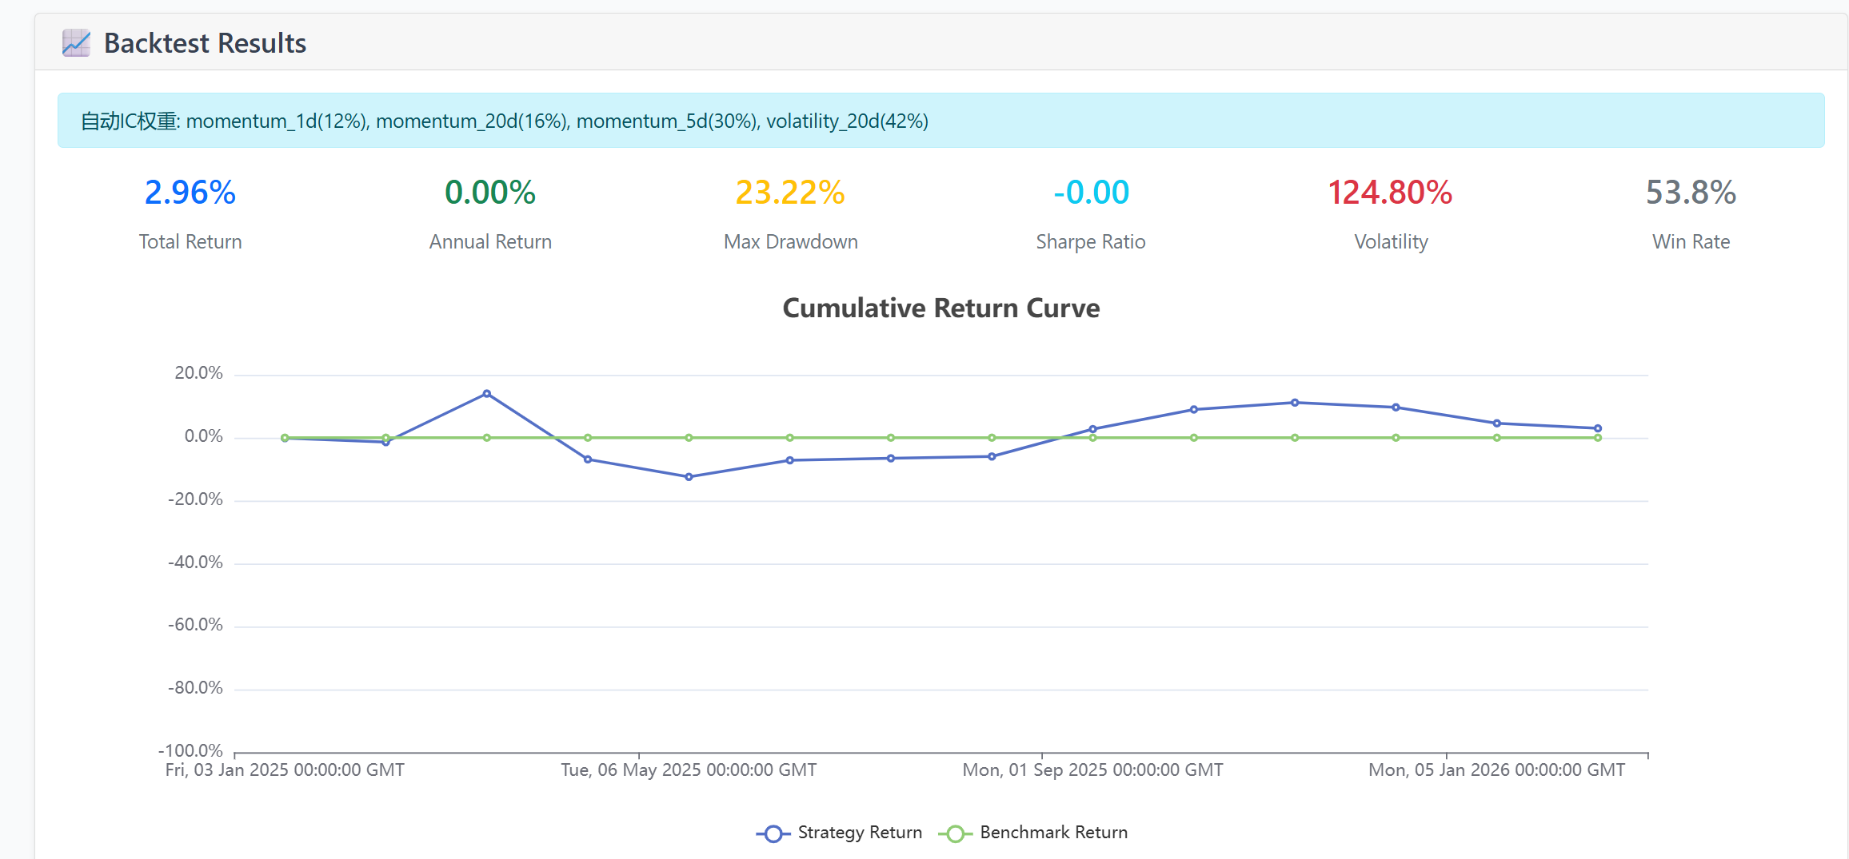

Techcnology Analysis这部分麻烦再详细一些（图片和解释）
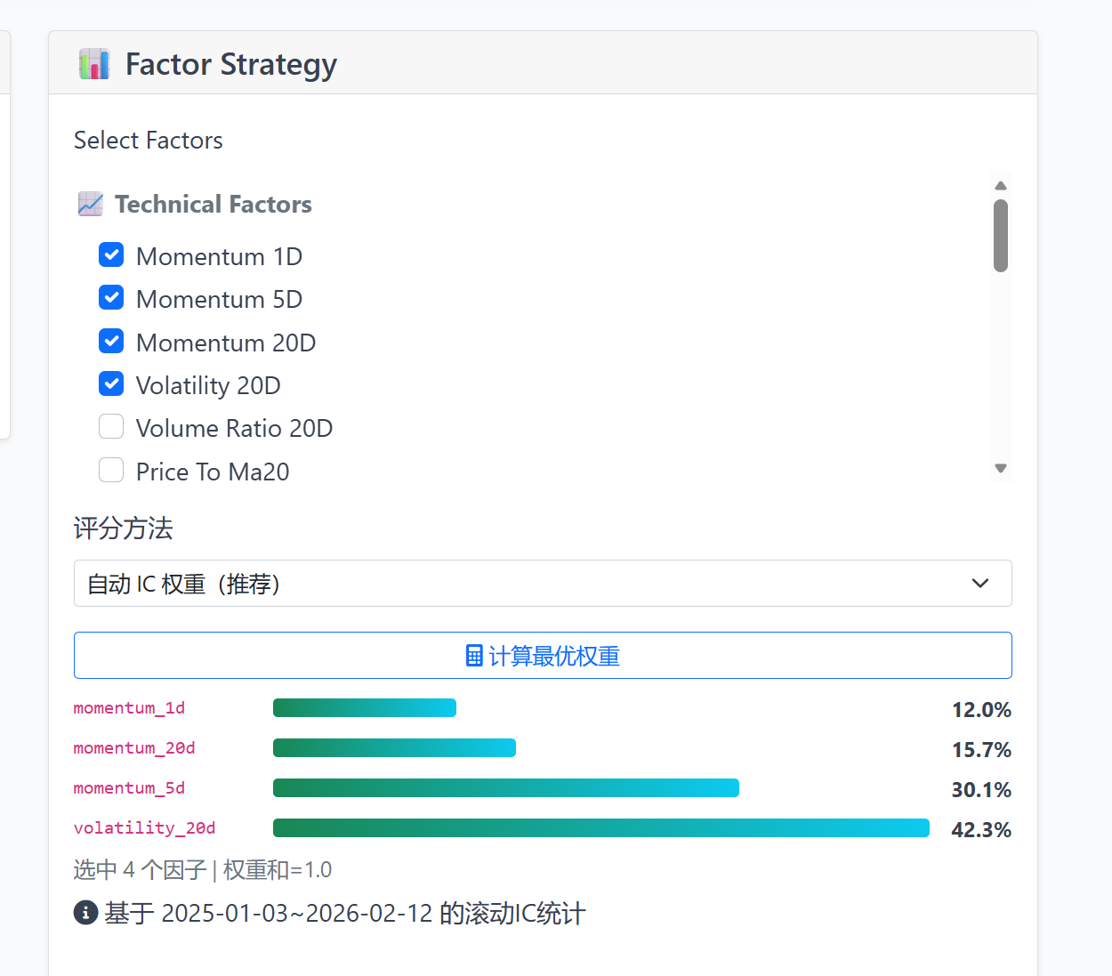

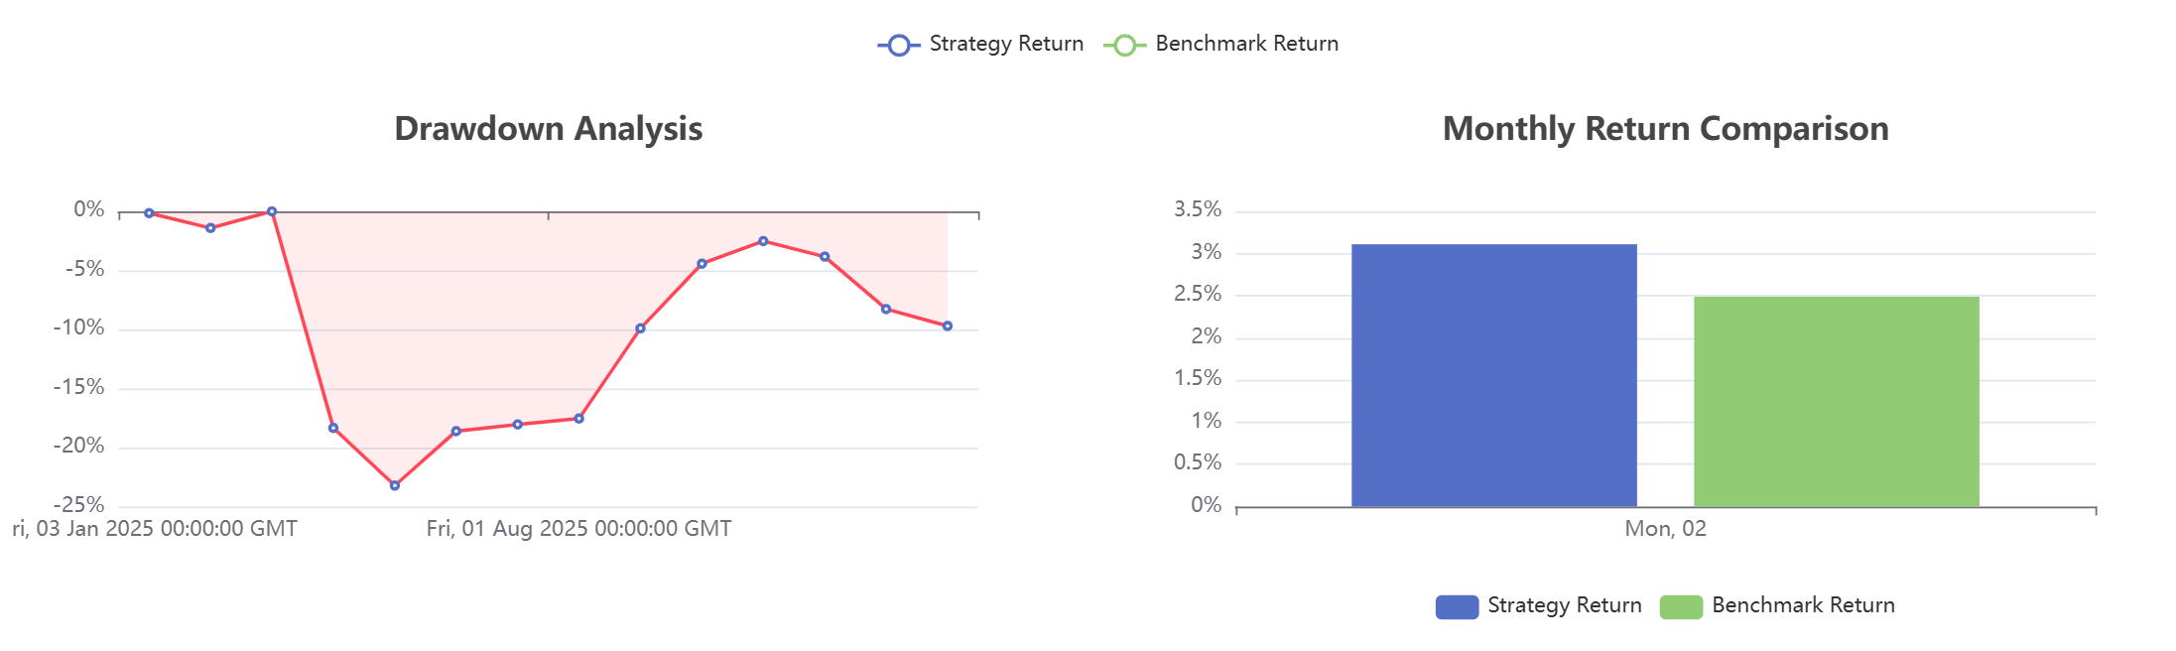
这个图是关于什么部分的？

