Menu In Nodes Bug 1#:
Could not use drop down menus;
Fix found here: https://github.com/xyflow/xyflow/issues/2936
needed to add className=”nodrag” to each text field
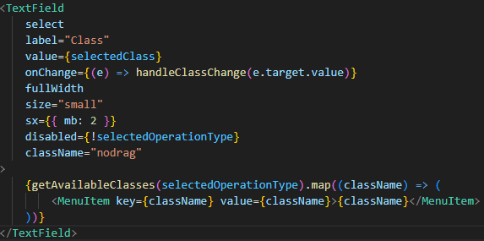
This fixed the issue
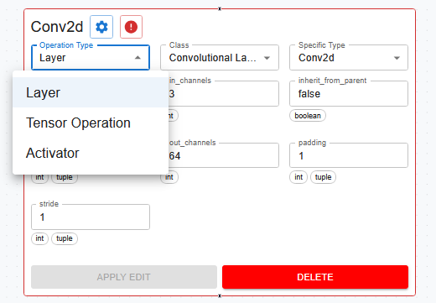
Error when switching to the new TorchNode architecture for nodes:
A small typo, that hard coded operation type in the new node creator, tripped this error for input
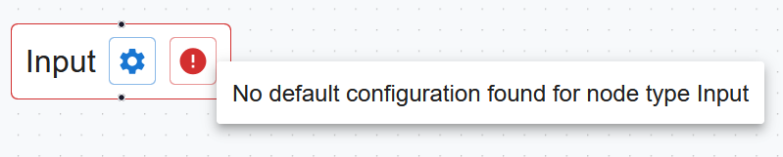
Not having the operation type set to “Input” (it was hardcoded to Layer) stopped this line from preventing this error appearing,
Simply changing the operation type in TorchNodeCreator.createNode() to not be hardcoded fixed this
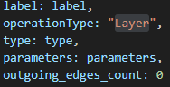 -> 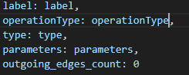
empty text fields
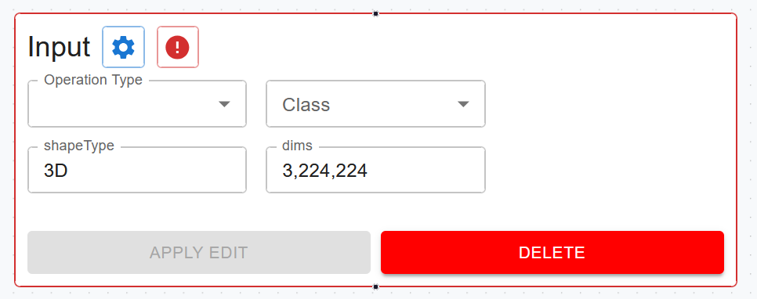
This bug appears because the edit functionality, does not get told want to display when an input node is selected for editing. It was fixed by removing the visibility of the text fields on input and output nodes, these nodes are meant to immutable, so its intended.
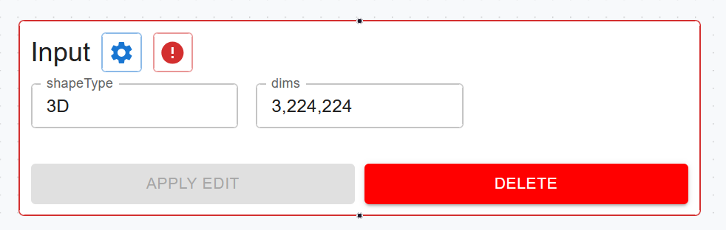

All Edges being deleted sometimes.
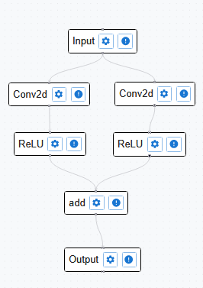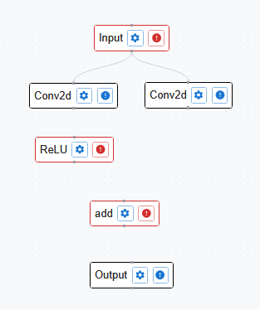
“activator2” (ReLU on the right) is deleted.
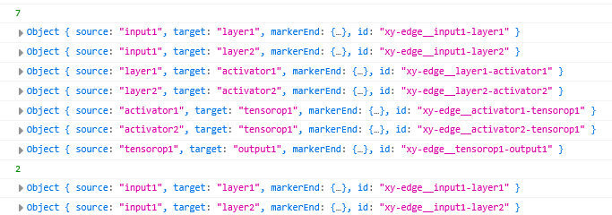
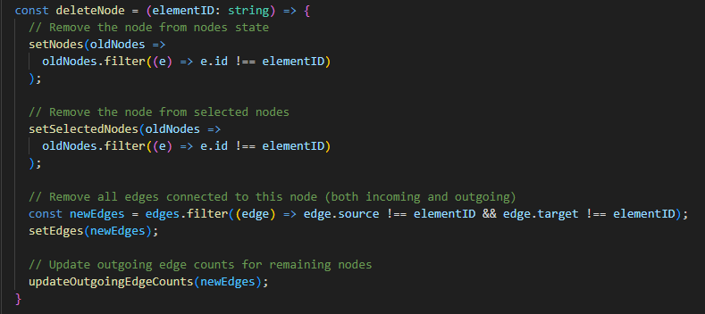

Oddly, the edges are not being removed by the below function, something else is destroying them.
Commenting out the line, fixes this bug, but edges still need to be deleted, so the logic in this line is flawed.
Reverting to an old build, the bug is not present, so it must be relating to the custom nodes implementation.
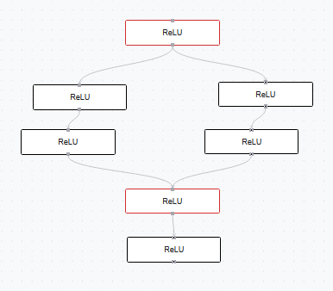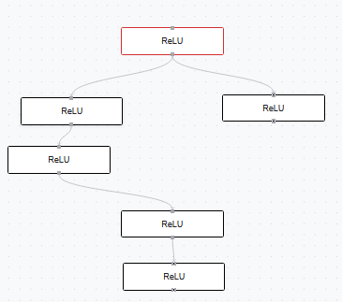
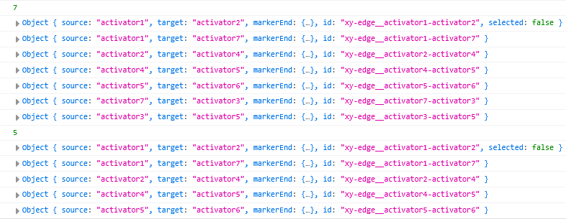
It was found to be a concurrency issue, during the re-render caused by deleting the nodes, the nodes and edges list are empty (likely something relating to react-flow). The code (shown before) had this print statement put in
Repeated three more times (with start included), to check if the setters had any effect. The print statement proves this theory, and the setters are setting the edges list to the empty edges array instead of filtering it.
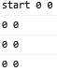
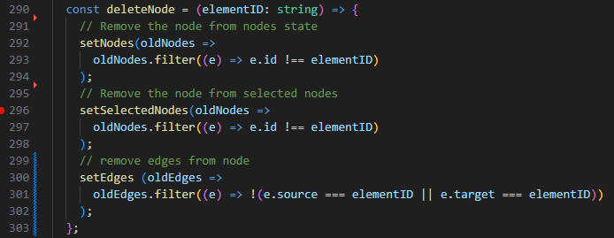
Changing to this version, squashed the bug. SetEdges needed to use the conventional layout shown here, this meant that the old version was referred to rather than the version active during the re-render.
updateOutGoingEdgeCounts was moved into this useEffect function, hopefully maintaining its previous functionality.
Nodes not updating properly on Operation Type change or Specific Type change:
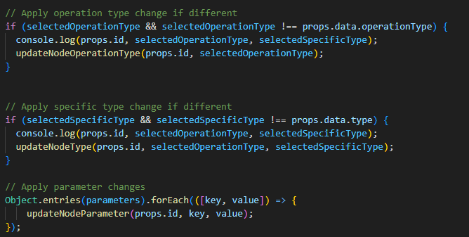
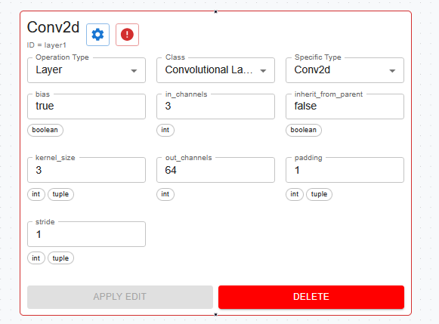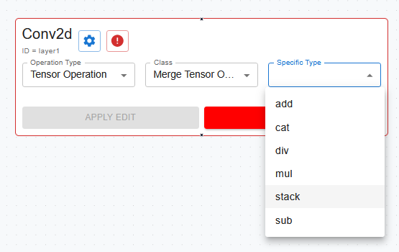
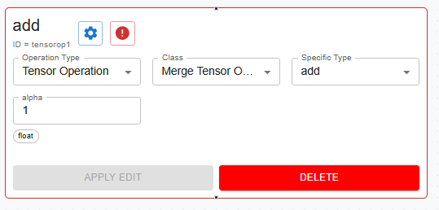
Even though stack is selected, and add node is produced instead.
This is because when the node is edited, a new ID is made, so the lines following in the code snippet, after calling updateNodeOperationType, that update the specific type or parameters (updateNodeType, or the code following //apply parameters changes) are now using an outdated ID, the solution, is to make updateNodeOperationType, updateNodeType, perform the duties of function below them. Returning the new ID and using it, may look cleaner but is wasteful in terms of calls.
Errors around in_channels out_channels not matching, too many errors.
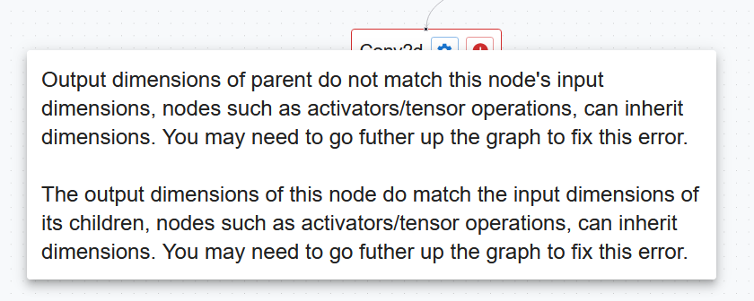
In channels match
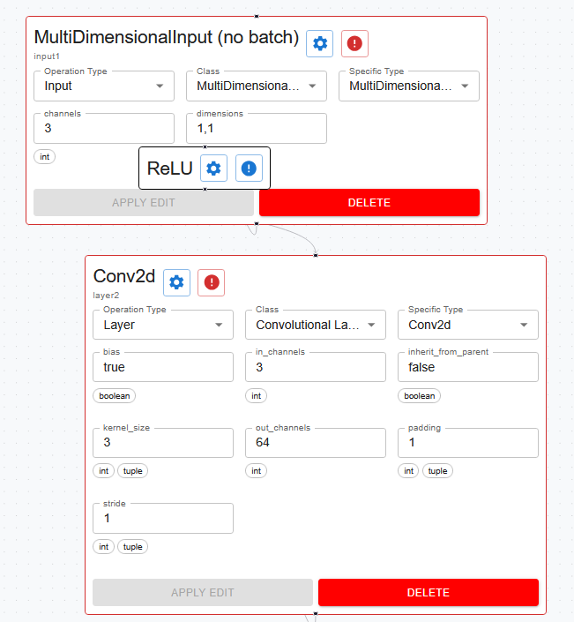

This is node structure, ReLU inherits its channels from the input.
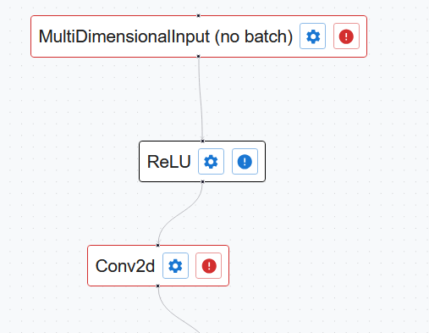
Hence, the error around the parent’s output channels (multi-dimensional input) not matching the child’s (conv2d) input channels is false.
To fix, change this line to
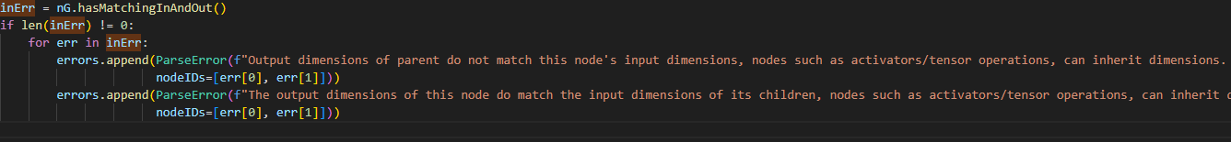
This 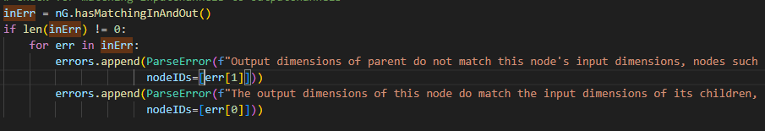
Parameters don’t update live when the undo button is pressed after updating a parameter.

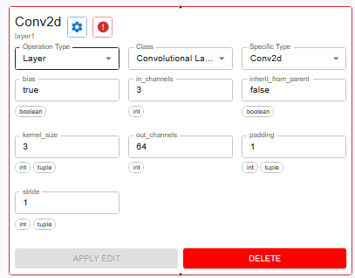
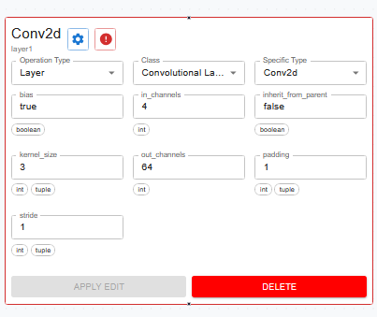
Undo pressed
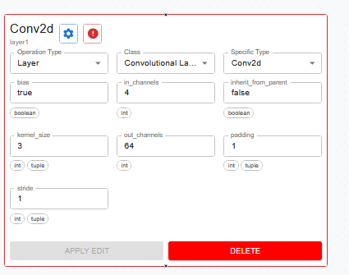
Remains the same. If opened and closed, the parameter updates.
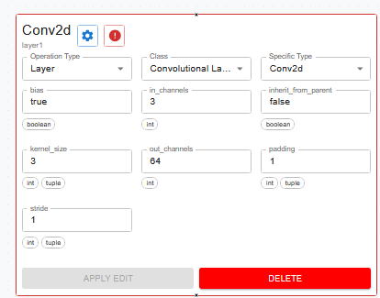
This function was created, as updateNodeParameter was being too many times on one update (one call per parameter), and only one “era” (each segment of time when a user perform certain actions, pressing undo goes back one era, redo goes forward) needed to be added to the undoList.
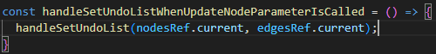
However, I assumed that calling it like this would give the most upto date version for the nodes list using the nodes list reference.
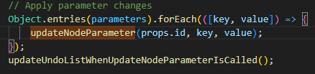
Unfortunately, it did not. And the new “era” was just a copy of the current without the parameter change. In order to force the update to happen later in the event queue, I had to use setTimeout without a delay. This resolve the error.
Parameters display not updating on undo/redo.
When going back and fourth on undo/redo, the console shows that the node is updating in the list. However, the node is node updating while expanded.
Forcing a re-render using this code did not fix the error, so the error is not in TorchNode.ts
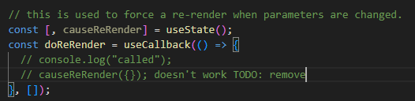
The parameters displayed on screen come from these values/hooks
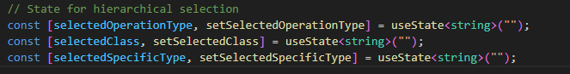
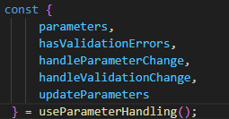
To update these values this useEffect must be triggered, as this was not my code, I was not aware (I being toby), Rohin helped fix this error.
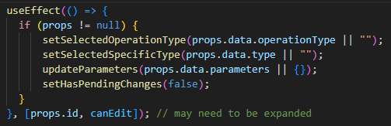
Updating the dependencies list fixed the error
