**INDIRA GANDHI NATIONAL OPEN UNIVERSITY**

**PROJECT REPORT TITLED**

“**AI System for Automobile Resale Pricing”**

**Submitted by**

**Mr. Srijan Mallick**

Enrolment no: 176716214

**Under the guidance of**

**Mr. Suhas Lawand**

**Submitted to the School of Computer and Information Sciences, IGNOU**

**in partial fulfilment of the requirements**

**for the award of the degree of**

Program Code: Master of Computer Application (MCA)

Course Code: MCSP060

Study Center Code: 1632

**Year of Submission** **2021**

**Master of Computer Application**



**Indira Gandhi National Open University**

**Mumbai – 410206**

|  |  |
| --- | --- |
| **PROFORMA FOR THE APPROVAL OF MCA PROJECT PROPOSAL (MCSP-060)** | |
| **Project Proposal No: .......................**  ***(For office use only)*** | **Enrolment No.:** 176716214 **Study Centre:** 1632, Pillai College  **Regional Centre:** Mumbai  **RC Code:** 49 **E-mail:** smallick974@gmail.com **Mobile/Tel No.:** +91 9870603499 |
| **1. Name and Address of the Student** | Mr. Srijan Mallick  E4/5, Shantiniketan CHS., Ugantak Complex, Sukapur,  New Panvel, Dist: Raigad, Maharashtra – 410206 |
| **2. Title of the Project\*\*\*** | **AI System for Automobile Resale Pricing** |
| **3. Name and Address of the Guide** | Mr. Suhas Lawand  Prince Paradise, A/26,Near Ghodke hospital, Old Panvel-410206 |
| **4. Educational Qualification of the Guide  (Attach bio-data also)** | Master in Computer Engineering  **(*in Computer Science / IT only)** |
| **5. Working / Teaching experience of the Guide\*\*** |  |
| 10 years of teaching as Lecturer: (3rd Jan 2008 to 31St March 2017) - Pillai Polytechnic New Panvel and Assistant Professor: (1st April 2017 till date) Pillai College of Engineering New Panvel | |
| **6. Software used in the Project\*\*\*** |  |
| Python, Jupyter notebook, Anaconda, AI Programming libraries and framework modules, HTML, CSS | |
| **7. If already pursued BCA/BIT from IGNOU,**  **mention the title of the project (CS-76) and the s/w used** | NA |
| **8. Project title of the Mini Project (MCS-044) and the s/w used** | Project Title: **Digital Image Watermarking for PDF Files**  S/W used: Java Maven with Servlet, HTML 5, jQuery, JavaScript, CSS |
| **9. Is this your first submission?** | Yes |
| Signature of the Student | Signature of the Guide |
| Date: 29/11/2021 | Date: 29/11/2021 |
| **For Office use Only**  Approved Not Approved | Name:  Signature, Designation, Stamp of the  Project Proposal Evaluator  Date: |
| **Suggestions for reformulating the Project** | |

**RESUME OF THE PROJECT GUIDE**

**I. PERSONAL INFORMATION**

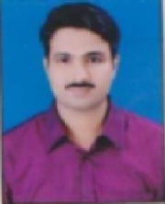

**Name** : Suhas J.Lawand

**Address** : Prince Paradise ,A/26,

Near Ghodke hospital

Old Panvel-410206

**Mobile No**. +91 9821127648

**E-Mail :** suhas_lawand@yahoo.com, [suhas@mes.ac.in](mailto:suhas@mes.ac.in)

**CAREER OBJECTIVE**

To associate with an organization that gives me a chance to prove my knowledge and efficiency and enhance my skills in the field of technology and be a part of the team that excels in work towards the growth of the organization

**II. EDUCATIONAL CREDENTIALS**

□ Master in Computer Engineering from Pillai’s Institute Of Information Technology, with first class distinction (75%)

□ B.E in Computer Engineering from Bharati Vidyapeeth College of Engineering, with first class distinction (72%)

□ H.S.C. from Maharashtra State Board with first class distinction (75.67%)

□ S.S.C from Maharashtra State Board with first class distinction (77.33%)

**III. KNOWLEDGE AND SKILLS**

Programming Languages Known:

● C, C++

● Core Java

● Advance Java

● TASM

● Web based programming HTML/XML,Javascript, AJAX

● VC++

**IV. EMPLOYMENT HISTORY**

**10 years in teaching.**

**Assistant Professor: (**1st April 2017 till date**)**

Pillai College of Engineering New Panvel, Navi Mumbai

**Lecturer**: (3rd Jan 2008 to 31St March 2017) Pillai Polytechnic New Panvel, Navi Mumbai.

**Major Responsibilities:**

▪ Working as Assistant Professor in Pillai College of Engineering

▪ Worked as Lecture in Pillai Polytechnic

▪ Worked as an Academic Coordinator in Pillai’s Polytechnic

▪ Worked as Training and Placement Officer in Pillai’s Polytechnic

▪ Worked as subject expert for Lab Manual Development

▪ Worked as CAP In-charge for summer and winter exam

▪ Worked as Zonal officer for MSCIT exam

▪ Worked as Exam Controller

▪ Member of External vigilance squad for exam

▪ Member of Progressive Test Committee

The subjects taught by me during the tenure of Lecturer are C, C++, Core Java, Advance Java Microprocessor Programming, Computer Graphics, Data Structure, and System Programming, Advance Algorithm

**V. PUBLICATIONS AND PROJECTS**

**Technical Papers and Publications:**

1. Enhance Biometric Authentication System using Graphical Password presented at **National Conference** held at BVIT College Navi Mumbai Mar 7th, 2014

2. Selective Encryption for Secure Real Time Remote Video Monitoring at the Second World Congress on Information and Communication Technologies (**IEEE**) held at IIITM- Trivandrum, Kerala, India (WICT-2012) 978-1-4673-4804-1*_*c 2012 IEEE

3. Secure Cryptosystem with Blind Authentication at Fourth International Conference on Networks and Communications **(Springer)** held at December 22-24 Chennai, India

4. Video Streaming over multi-channel multi-radio, multi-hop wireless network presented at

**International Conference** held at CCAC College Pune August 8-9,2011

5. Real Time Video Data Security Using Compression and Encryption presented at National

**Conference** held at SIES College Nerul August 26-27,2011

6. Biotokens Based Biometric presented at **National Conference** held at Vidyalankar College Wadala March 25-26, 2011

**Project:**

**Blind Authentication: A Secure Crypto-Biometric Verification Protocol**

This was my main M.E. Project. Here I modeled a biometric authentication protocol that does not reveal any information about the biometric samples to the authenticating server. It also does not reveal any information regarding the server, to the user or client. User creates a graphical password by clicking on the sequence of images. After creating a graphical password user proceed for biometric registration. When user login with correct graphical password authentication of biometric is done

**VI. MEMBERSHIPS / INVOLVEMENT:**

Life Member of ISTE

**Conferences/Workshops Attended:**

● Participated in One day Workshop(23 August 2019) on Linux organised by the Teaching Learning Centre, ICT at IIT Bombay, funded by the Pandit Madan Mohan Malaviya National Mission on Teachers and Teaching (PMMMNMTT), MHRD, Govt. of India

● Participated in Short Term Training Program On Management Information System (July 1st,2018 to July 5th, 2019) organised by Pillai College of Engineering New Panvel

● Participated in One day Workshop(22 June 2019) on Linux organised by the Teaching Learning Centre, ICT at IIT Bombay, funded by the Pandit Madan Mohan Malaviya National Mission on Teachers and Teaching (PMMMNMTT), MHRD, Govt. of India

● Participated in Faculty Development Program( March 8th, 2018 to April 12th,2018) on ICT for Education , IIT Bombay

● Participated in Two-week ISTE workshop on Computer Programming (May 20th, 2014 to June 21st 2014)

● Participated in Two-week ISTE workshop on Computer Networking (May 28th, 2014 to July 5th ,2014)

● Participated in One-week ISTE workshop on Multimedia and Animation (Feb 13th, 2012 to Feb 18th, 2012)

● Participated in One-week ISTE workshop on Business Intelligence and Business Analytics (Aug 4th, 2011 to Aug 9th, 2012

**VII. LANGUAGE KNOWN:**

English, Hindi and Marathi

**VIII. PERSONAL PROFILE:**

**Date of Birth** : 31st Aug 1984

**Gender** : Male

**Marital Status** : Married

**Nationality :** Indian

I hereby declare that the above information provided is correct and true to the best of my knowledge.



Signature: 29/11/2021

(Suhas J.Lawand)

Table of Contents

➢ Introduction 1

a. Objective 1

b. Purpose 2

c. Project Category 3

d. Application of AI 3

➢ Problem Definition (Existing Systems) 4

➢ Scope of the Proposed System 5

➢ System Analysis 6

Use Case Diagram: 6

Data Flow Diagram (DFD Level 0): 7

AI Data Processing System: 8

➢ Module Descriptions 9

1. Home Page: 9

2. Login Module: 9

3. Seller Page: 9

4. Admin Module: 9

➢ Technologies Used 10

i. Front End: 10

ii. Back End: 10

iii. Software Specification: 10

iv. Hardware Specification: 10

➢ Future Enhancements 11

# Introduction

#### Objective

The value of any product drops from the moment it is purchased and the depreciation in price continues over time. The Automobile Resale System will be developed with the intention to provide customers planning to sell their used cars, a fair price depending on various features such as Brand, Transmission Type, Model, Current conditions of the car, Mileage, etc.

In recent years, it has been observed that the price of the new car has increased greatly due to inflation and the additional costs in the form of the government taxes, etc. So, it has been observed that the customers are more inclined towards purchasing used car vs the new cars for their daily commutation needs. The new learners learning to drive prefer buying old cars to practice before purchasing their new car.

Our goal is to develop a system which can estimate the price of the used cars based on the historical data and market trends. This system will not only predict the re-sale price of the car but also provide opportunity for buyers and sellers to connect with each other and agree at a common price based on the artificial intelligence predictions.

The objective is to provide a system that overcomes the problem of physically visiting the garages in search of suitable used cars. This becomes a tedious and a time-consuming task.

This system will be very user-friendly which takes only few minutes for the seller to fill required information along with the pictures of the car. Once this is done, the Automobile Resale System will work in the background with the help of Artificial Intelligence and the historical data to predict the accurate price of the car.

#### Purpose

This project is being developed with the purpose to provide functionalities and solve below challenges of the existing system:

1. Provide a system where buyers/sellers can interact with each other and negotiate the price.
2. To enable sellers to get best price of their automobile using artificial intelligence.
3. To rescue customers trying to purchase a car from garage attendants quoting very high prices of the used car.
4. Help customers to purchase cars at the comfort of their home without physically visiting multiple Re-sale garages quoting high prices.
5. To help buyers and sellers understand the price dynamics based on different car models.
6. To build a trust between parties and sustain successful relationship that will help them to close deal at best negotiable price.
7. To build a single platform in a way to provide efficient market for various dealers to sell cars and customers to communicate, comment and provide their views in order to close the deal.

#### Project Category

This Project belongs to the Artificial Intelligence/Machine Learning category of Project Development along with web designing.

#### Application of AI

Over the Recent years, we have seen changes in the way the technologies are developed. We no longer follow the traditional approach of software development but instead use technologies such as Blockchain, Big Data, Artificial Intelligence and machine learning to develop many of the systems. These technologies have greatly changed our life and have led a revolution of new AI-powered decision making and support system.

Below are some of the examples of AI-based solutions that has greatly improved our life:

1. Predictive Analytics - The resources that are required for software development are mostly similar and hence predictive analytics helps us to find those patterns and plan the projects accurately. This helps to estimate the resources and efforts required to complete a project more accurately.
2. Productivity & Efficiency Improvement - Artificial Intelligence can automate simple tasks such as maintaining records, sending emails, starting batch jobs, etc. that the project team would have spent considerable time and helps save time to think about more opportunities about innovations and improvements.
3. AI-based Chatbot Assistants - AI-chatbot assistants are being rapidly used in software applications due to their ability to use natural language processing.
4. Error Reduction - AI helps in error reduction by mapping and identifying errors before they can happen and can suggest ways to resolve them and thus increasing the quality of the product being developed by keeping project cost and schedule on track.

# Problem Definition (Existing Systems)

There are various offline garages and websites available on internet providing used car for rental or purchase purposes. The issues with these systems are that these are susceptible to fraud and over-priced valuation of the cars.

Since the customer may not be aware of the current market prices of the used cars, the salesperson at these garages might quote much more price of the car than its actual valuation.

The current online system available are very good at providing an interface for buyer/seller to conduct their business but the sellers can quote price at their own estimation which might be more or very less than the actual market value.

**Some of the issues identified with the existing system are as follows:**

* No proper system to determine the actual price estimation of the old cars.
* Current system can be susceptible to fraud with car images and details incorrectly being provided on websites.
* No means to authenticate that validity of buyers and sellers.

# Scope of the Proposed System

The scope of proposed system is not only limited to predict the resale price of the vehicle but also allows a rich interactive user interface to the customers.

* It will be an AI based system with capabilities to estimate the resale price of used cars by taking different parameters into consideration.
* It will take all the required parameters and use that data to evaluate current condition of the cars and conclude to a negotiable price that will benefit both the buyers and sellers. It will also have an option wherein both buyers and sellers either can agree on a price that AI tool has predicted for them or decide to make any changes.
* Since AI has capability to make smart business decisions by gathering data, analyzing trends, quantifying uncertainties, it has capability to become a powerful system with high accuracy results.
* The proposed system will provide two user interfaces,
  + Sellers will enter their product details that they are interested to sell, get the maximum sale price generated using AI prediction tool and mark the car to be sold/not sold/ already sold.
  + Buyers will be able to see the product details along with their images, the price generated by the system and decide if they are interested in purchasing the car.
* It will provide means to authenticate validity of buyers and sellers to avoid fraudulent activities and verify car registration to avoid stolen cars to be sold from the portal.

# System Analysis

## Use Case Diagram:

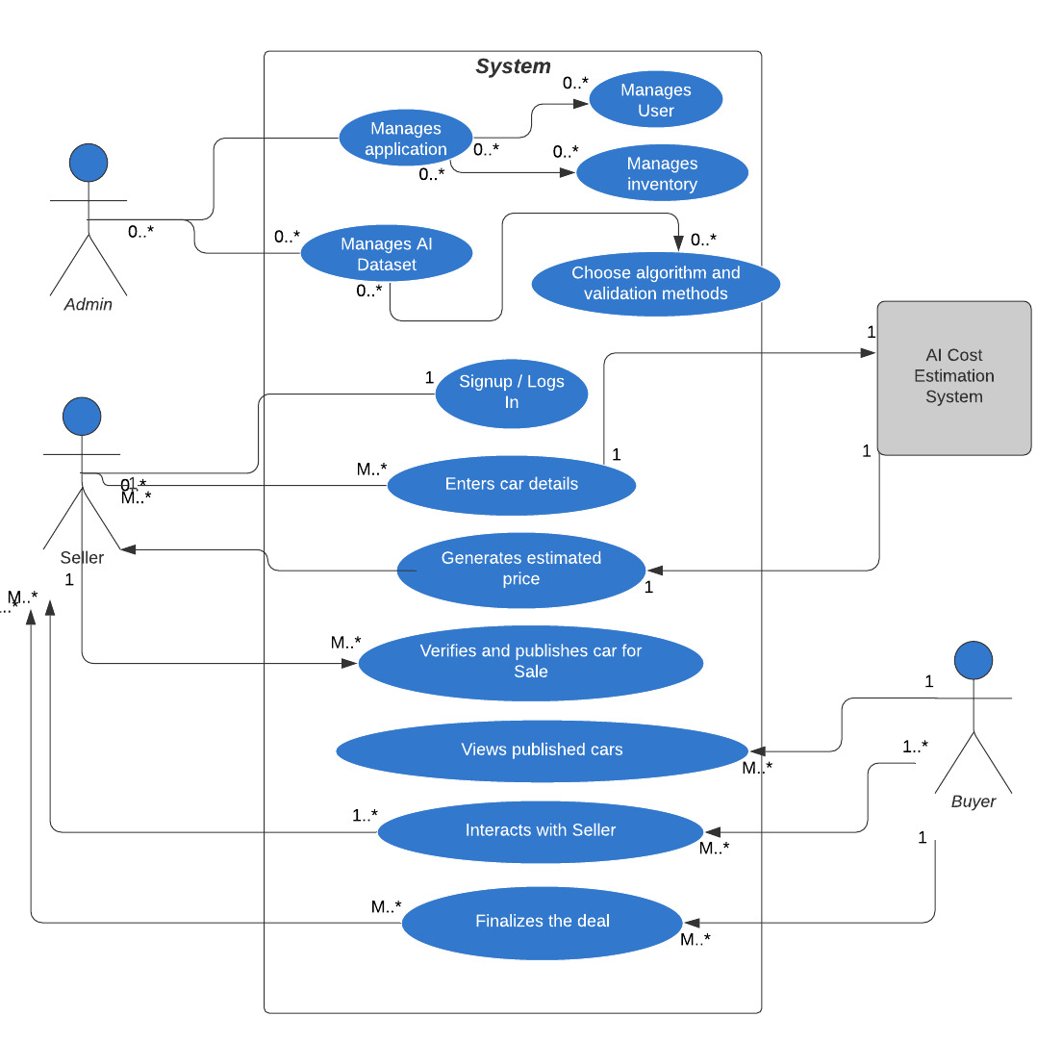

## Data Flow Diagram (DFD Level 0):

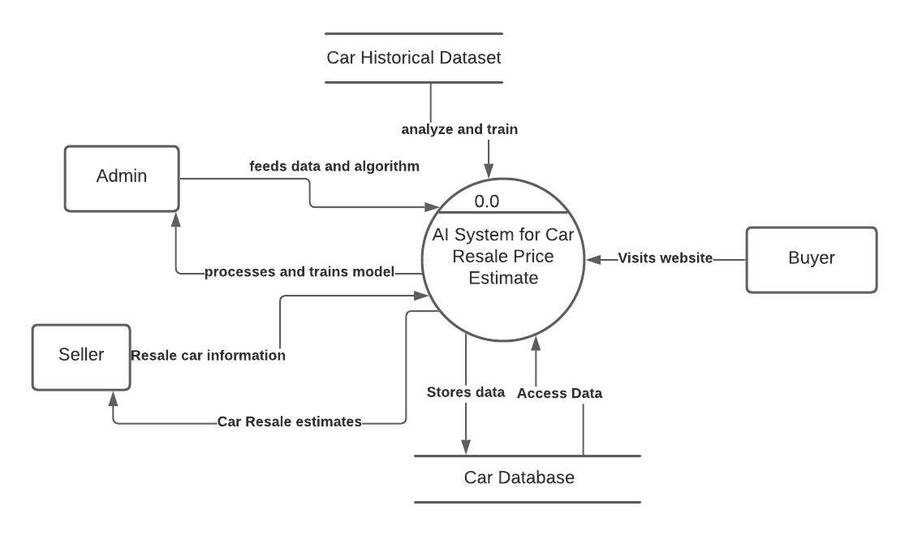

## AI Data Processing System:

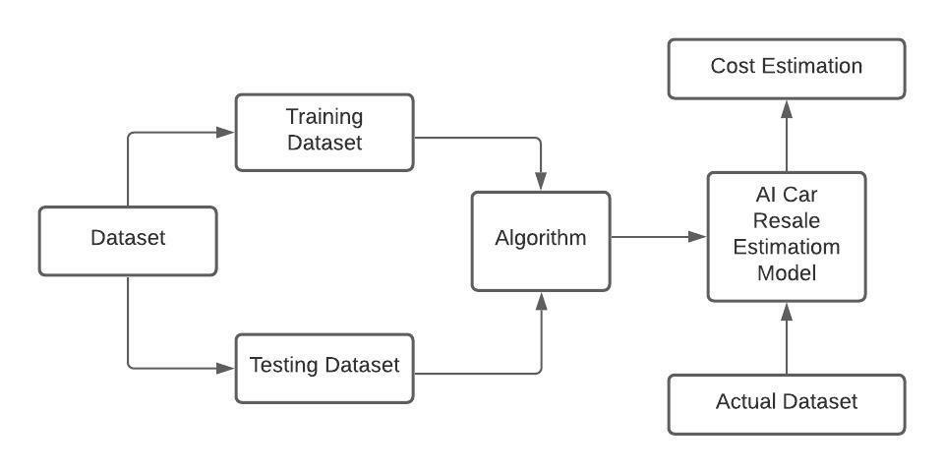

# Module Descriptions

#### Home Page:

Home Page is where all the details of the car will be displayed. This is where a user visits when he first logins to the website. Using this page, a user can mark cars favorite or add cars for reviewing later. This page will also be the main page where sellers as well as web admin will also be redirected when logged in to the website.

#### Login Module:

This module will facilitate the buyer and seller to login to the website to access their data. This module will also contain link to create a new account if a user does not already have an account on this website.

#### Seller Page:

The Seller Page will enable the car sellers to upload the car information on the website. This page will enable them to upload car photos, documents, insurance information, etc. about the car they want to sell. They will also be able to see how many people have visited their advertisement to sell and also helps them connect with buyers who wishes to contact sellers.

#### Admin Module:

The admin module will basically focus on administrative task such as password reset, data evaluation, backup and maintenance, etc. This will help website to be updated with latest information.

# Technologies Used

## Front End:

Front-End of the system will be created using HTML and CSS.

## Back End:

Back-End of the system will be developed using PYTHON and AI based programming languages, libraries, etc.

## Software Specification:

Jupyter Notebook, ANACONDA, PYTHON and other AI-based framework modules.

## Hardware Specification:

* **RAM:**

4 GB RAM or more

* **Processor:**

Intel Core i3 or more

* **Hard Disk:**

10 GB or more

# Future Enhancements

* This system will be in initial version with a newly trained AI module estimating the price of the used car based on various parameters.
* This system will aim to achieve a very high accuracy rate in price estimation as it collects more and more real-life datasets.
* This system can be developed into a system which interacts with various other system such as AADHAR, RTO, etc. to validate the authenticity of users and cars.
* This system will also facilitate the users to make payments directly via the payment gateway so that there is a record of transactions performed and get statistics of car sold.
* It will have feedback mechanism to understand the users needs and to continuously improve this system as per the feedback.