# MongoDB 备份(mongodump)与恢复(mongorestore)

## MongoDB数据备份

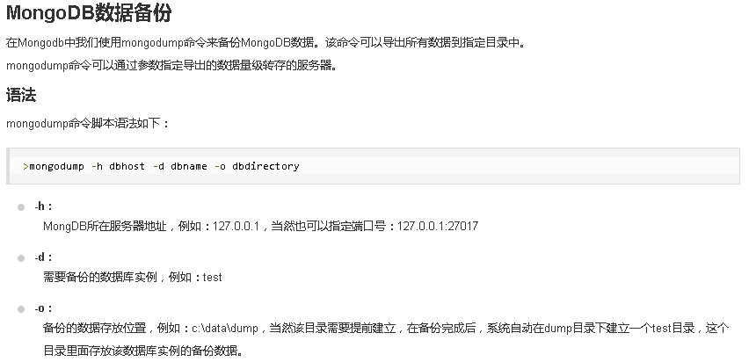

备份本地数据库

mongodump -h 127.0.0.1:27021 -o E:\data\dump

mongodump -h 127.0.0.1 -d test -o E:\data\dump

备份远程数据库

mongodump -h 192.168.5.99:27017 -d test -o E:\data\dump

mongodump -h 192.168.5.99:27017 -d testLog -o E:\data\dump

mongodump -h 192.168.5.99:27017 -d cmt1-test -o E:\data\dump

mongodump -h 192.168.5.99:27017 -d cmt1-testLog -o E:\data\dump

mongodump -h 192.168.5.99:27017 -d cmt1 -o E:\data\dump

mongodump -h 192.168.5.99:27017 -d cmt1Log -o E:\data\dump

## MongoDB数据恢复

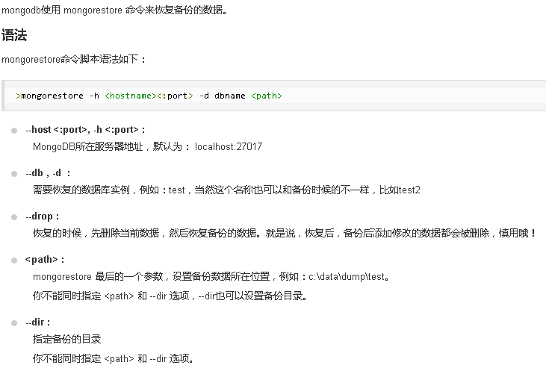

mongorestore -h 192.168.5.99:27017 -drop -d admin E:\data\dump\admin

mongorestore -h 192.168.5.99:27017 -drop -d test E:\data\dump\test

mongorestore -h 192.168.5.99:27017 -drop -d testLog E:\data\dump\testLog

mongorestore -h 192.168.5.99:27017 -drop -d cmt1-test E:\data\dump\cmt1-test

mongorestore -h 192.168.5.99:27017 -drop -d cmt1-testLog E:\data\dump\cmt1-testLog

mongorestore -h 192.168.5.99:27017 -drop -d cmt1 E:\data\dump\cmt1

mongorestore -h 192.168.5.99:27017 -drop -d cmt1Log E:\data\dump\cmt1Log

mongorestore -h 127.0.0.1:27021 -d test E:\data\dump\test

mongorestore -h 127.0.0.1:27021 -d testLog E:\data\dump\testLog

mongorestore -h 127.0.0.1:27021 -d cmt1-test E:\data\dump\cmt1-test

mongorestore -h 127.0.0.1:27021 -d cmt1-testLog E:\data\dump\cmt1-testLog

mongorestore -h 127.0.0.1:27021 -d cmt1 E:\data\dump\cmt1

mongorestore -h 127.0.0.1:27021 -d cmt1Log E:\data\dump\cmt1Log

# MongoDB 删除数据库

db.dropDatabase(){ "dropped" : "test", "ok" : 1 }

db.dropDatabase(){ "dropped" : "testLog", "ok" : 1 }

db.dropDatabase(){ "dropped" : "cmt1-test", "ok" : 1 }

db.dropDatabase(){ "dropped" : "cmt1-testLog", "ok" : 1 }

db.dropDatabase(){ "dropped" : "cmt1", "ok" : 1 }

db.dropDatabase(){ "dropped" : "cmt1Log", "ok" : 1 }

db.test.drop()