### **一、安装编译工具及库文件**

yum -y install make zlib zlib-devel gcc-c++ libtool  openssl openssl-devel

### **二、首先要安装 PCRE**

PCRE 作用是让 Nginx 支持 Rewrite 功能。

1、下载 PCRE 安装包，下载地址： <http://downloads.sourceforge.net/project/pcre/pcre/8.35/pcre-8.35.tar.gz>

[root@bogon src]# cd /usr/local/src/

[root@bogon src]# wget http://downloads.sourceforge.net/project/pcre/pcre/8.35/pcre-8.35.tar.gz

2、解压安装包:

[root@bogon src]# tar zxvf pcre-8.35.tar.gz

3、进入安装包目录

[root@bogon src]# cd pcre-8.35

4、编译安装

[root@bogon pcre-8.35]# ./configure

[root@bogon pcre-8.35]# make && make install

5、查看pcre版本

[root@bogon pcre-8.35]# pcre-config --version

### **安装 Nginx**

1、下载 Nginx，下载地址：<http://nginx.org/download/nginx-1.6.2.tar.gz>

[root@bogon src]# cd /usr/local/src/

[root@bogon src]# wget http://nginx.org/download/nginx-1.6.2.tar.gz

wget <http://nginx.org/download/nginx-1.6.2.tar.gz>

安装包

[root@bogon src]# tar zxvf nginx-1.6.2.tar.gz

3、进入安装包目录

[root@bogon src]# cd nginx-1.6.2

4、编译安装

[root@bogon nginx-1.6.2]# ./configure --prefix=/usr/local/webserver/nginx --with-http\_stub\_status\_module --with-http\_ssl\_module --with-pcre=/usr/local/src/pcre-8.35

[root@bogon nginx-1.6.2]# make

[root@bogon nginx-1.6.2]# make install

5、查看nginx版本

[root@bogon nginx-1.6.2]# /usr/local/webserver/nginx/sbin/nginx -v

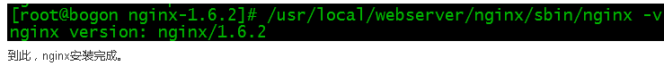

## Nginx 配置

创建 Nginx 运行使用的用户 www：

[root@bogon conf]# /usr/sbin/groupadd www

[root@bogon conf]# /usr/sbin/useradd -g www www

配置nginx.conf ，将/usr/local/webserver/nginx/conf/nginx.conf替换为以下内容

[root@bogon conf]#  cat /usr/local/webserver/nginx/conf/nginx.conf

user www www;

worker\_processes 2; #设置值和CPU核心数一致

error\_log /usr/local/webserver/nginx/logs/nginx\_error.log crit; #日志位置和日志级别

pid /usr/local/webserver/nginx/nginx.pid;#Specifies the value for maximum file descriptors that can be opened by this process.

worker\_rlimit\_nofile 65535;

events{

  use epoll;

  worker\_connections 65535;}

http{

  include mime.types;

  default\_type application/octet-stream;

  log\_format main  '$remote\_addr - $remote\_user [$time\_local] "$request" '

               '$status $body\_bytes\_sent "$http\_referer" '

               '"$http\_user\_agent" $http\_x\_forwarded\_for';

  #charset gb2312;

  server\_names\_hash\_bucket\_size 128;

  client\_header\_buffer\_size 32k;

  large\_client\_header\_buffers 4 32k;

  client\_max\_body\_size 8m;

  sendfile on;

  tcp\_nopush on;

  keepalive\_timeout 60;

  tcp\_nodelay on;

  fastcgi\_connect\_timeout 300;

  fastcgi\_send\_timeout 300;

  fastcgi\_read\_timeout 300;

  fastcgi\_buffer\_size 64k;

  fastcgi\_buffers 4 64k;

  fastcgi\_busy\_buffers\_size 128k;

  fastcgi\_temp\_file\_write\_size 128k;

  gzip on;

  gzip\_min\_length 1k;

  gzip\_buffers 4 16k;

  gzip\_http\_version 1.0;

  gzip\_comp\_level 2;

  gzip\_types text/plain application/x-javascript text/css application/xml;

  gzip\_vary on;

  #limit\_zone crawler $binary\_remote\_addr 10m;

 #下面是server虚拟主机的配置

 server

  {

    listen 80;#监听端口

    server\_name localhost;#域名

    index index.html index.htm index.php;

    root /usr/local/webserver/nginx/html;#站点目录

      location ~ .\*\.(php|php5)?$

    {

      #fastcgi\_pass unix:/tmp/php-cgi.sock;

      fastcgi\_pass 127.0.0.1:9000;

      fastcgi\_index index.php;

      include fastcgi.conf;

    }

    location ~ .\*\.(gif|jpg|jpeg|png|bmp|swf|ico)$

    {

      expires 30d;

  # access\_log off;

    }

    location ~ .\*\.(js|css)?$

    {

      expires 15d;

   # access\_log off;

    }

    access\_log off;

  }

}

检查配置文件nginx.conf的正确性命令：

[root@bogon conf]# /usr/local/webserver/nginx/sbin/nginx -t

IMG_256

## 启动 Nginx

Nginx 启动命令如下：

[root@bogon conf]# /usr/local/webserver/nginx/sbin/nginx



## 访问站点

从浏览器访问我们配置的站点ip：

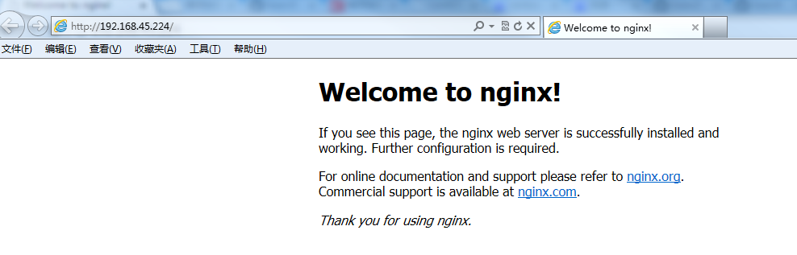

## Nginx 其他命令

以下包含了 Nginx 常用的几个命令：

/usr/local/webserver/nginx/sbin/nginx -s reload # 重新载入配置文件

/usr/local/webserver/nginx/sbin/nginx -s reopen # 重启 Nginx

/usr/local/webserver/nginx/sbin/nginx -s stop # 停止 Nginx