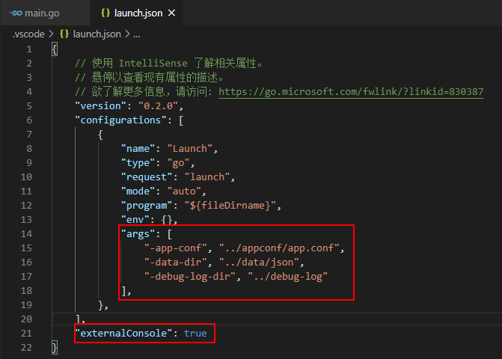

            "args": [

                "-app-conf", "../appconf/app.conf",

                "-data-dir", "../data/json",

                "-debug-log-dir", "../debug-log"

            ],

    "externalConsole": true