3.3V

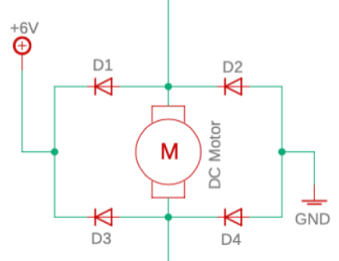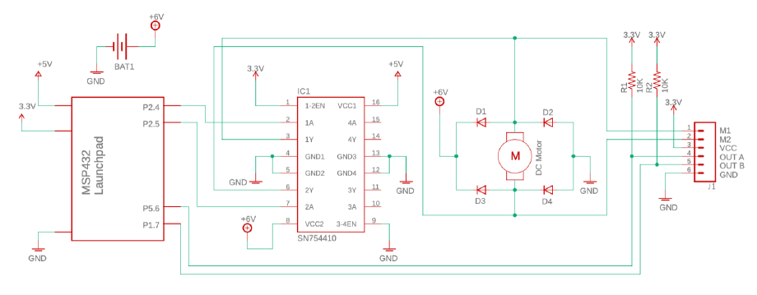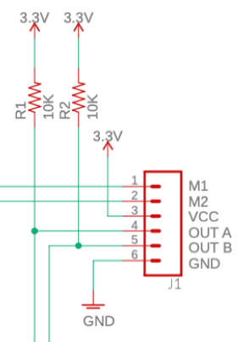

P2.6

P2.7

P5.7

P1.6

Voltage Regulator

in

out

5V

QTRX Sensor Array

GND

5

0

2

GND

VIN

VIN

CTRL EVEN

1

3

CTRL ODD

4

6

7

3.3V

3.3V

P4.0

P4.1

P4.2

P4.3

P4.4

P4.5

P4.6

P4.7

P4.0

P4.1

P4.2

P4.3

P4.4

P4.5

P4.6

P4.7