# PS07 - Answer Sheet

|  |  |
| --- | --- |
| **Assignment:** | PS 07 |
| **Name:** | Tomoki Koike, [koike@purdue.edu](mailto:koike@purdue.edu) |
| **Team-ID** | 002-08 |
| **Contributor(s):** | none |

## Security Camera Placement

Paired

### Flowchart Paired Partner

Each member of the pair will submit their own answer sheet. List your paired partner here.

|  |  |
| --- | --- |
| Flowchart Partner: | Ian Pitman, [ipitman@purdue.edu](mailto:ipitman@purdue.edu) |

### PS07_observatory_login.m Flowchart

*<place your flowchart here>*

### Coding Paired Partner

Each member of the pair will submit their own answer sheet. List your paired partner here.

|  |  |
| --- | --- |
| Coding Partner: | Ian Pitman, ipitman@purdue.edu |

### Test Cases

A test case is a value or set of values that you use to test the completeness of the decisions in your code or flowchart structure. You need to select a set of test cases, with at least one test case for each decision path in your structure. You can use the test cases to help you test whether or not your structure addresses all the possible decision paths required by the problem.

Fill out the table with test case information.

* The *Test Case Description* is an English description of what path is being tested.
* The *Test Case Values* are the values you will use to test the path in the structure or flowchart.
* The *Flowchart Output* is an English description of the flowchart’s result when the test case values go through the structure; it should not be code or MATLAB generated results.
* Add as many rows as necessary to test all possible flowchart paths.
* An example test case is included.

Note: you will also use these test cases to test your completed code

|  |  |  |
| --- | --- | --- |
| **Test Case Description**  **in English** | **Test Case Values**  **(x location, y location)** | **Flowchart Output**  **in English** |
| Test a location inside the exhibit hall: | X _coord = 2  Y_coord = 8 | The surveillence camera is in the exhibit hall. |
| Anywhere in the rectangle defined by -6 < x < 6 and 2 < y < 10 that is also not on the overlapping observatory area | X _coord = 0  Y_coord = 0 | The surveillence camera is in the observatory. |
|  | X _coord = -1  Y_coord = 8.5 | The surveillence camera is in the exhibit hall. |
|  | x_coord = 5*cos(20)  y_coord = 5*sin(20) | ERROR! The surveillence camera is in a improper location. |
|  | x_coord = -4  y_coord = -7 | The surveillence camera is in the mechanical room. |
|  | x_coord = 1  y_coord = -7 | The surveillence camera is in the offices. |

### Flowchart and Code Comparison

Examine how well your code follows your flowchart. Explain any differences between the code and the flowchart, and state why those changes were necessary.

|  |
| --- |
| The flowchart and the code is very different for a our group. In the flowchart we were supposed to set the first “if” statement as “x and y-coordinate (location) that is improper”, this meaning that it is on the wall or outside of the small museum. After this statement we were planning to determine the location of the cameras: observatory, exhibit hall, mechanical room, and offices using the else if and else command. However, in the actual command we changed the first “if” statement to whether the camera is in the observatory or not, and in the subsequent “else if “ and “else” statements, we determines whether the location is in exhibit hall, mechanical room, offices, or improper location. We made this change because we realized it is much more easier to define the domain and range of the x-coordinate and y-coordinate for each rooms then defining one for the locations that the cameras cannot be stationed. |

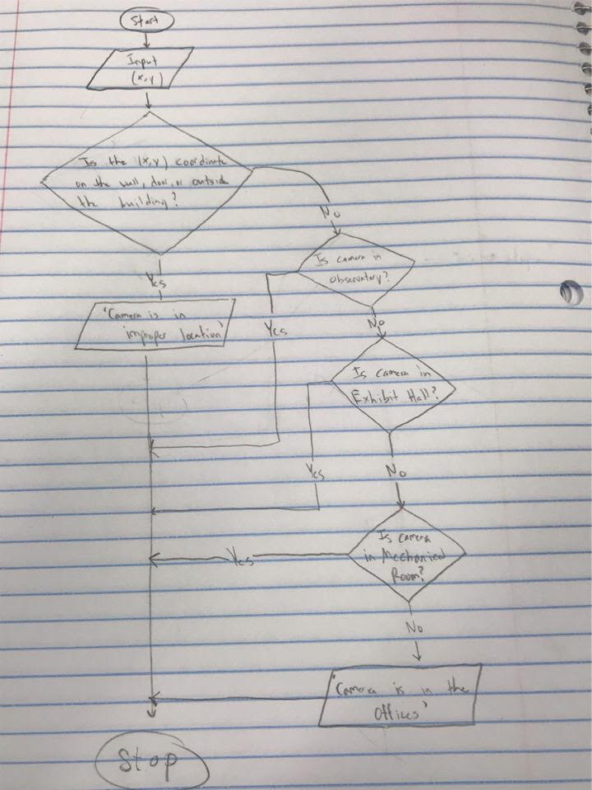

## Academic Integrity

Individual

### Test Cases

A test case is a value or set of values that you use to test the completeness of the decisions in your code or flowchart structure. You need to select a set of test cases, with at least one test case for each decision path in your structure. You can use the test cases to help you test whether or not your structure addresses all the possible decision paths required by the problem.

Fill out the table with test case information.

* The *Test Case Description* is an English description of what path is being tested.
* The *Test Case Values* are the values you will use to test the path in the structure or flowchart.
* The *Flowchart Output* is an English description of the flowchart’s result when the test case values go through the structure; it should not be code or MATLAB generated results.
* Add as many rows as necessary to test all possible flowchart paths.
* An example test case is included.

Note: you will also use these test cases to test your completed code

|  |  |  |
| --- | --- | --- |
| **Test Case Description**  **in English** | **Test Case Values**  ([string_array]) | **Flowchart Output** |
| Test the function with one name | string_array = “student 1” | Displays the academic integrity statement signed by “student 1” |
| Test case with no string | nameArray = [1 2 3]; | Displays an error message |
| Test case with one name | nameArray = ["Tomoki"]; | Displays the academic integrity statement for one student |
| Test case with two names | nameArray = ["Tomoki Koike" "Ian Pitman"]; | Displays the academic integrity statement for two students |
| Test case with three names | nameArray = ["Tomoki Koike" "Ian Pitman" "Yi"]; | Displays the academic integrity statement for three students |
| Test case with four names | nameArray = ["Tomoki Koike" "Ian Pitman" "Yi" "EJ"]; | Displays the academic integrity statement for four students |
| Test case with five names | nameArray = ["Tomoki Koike" "Ian Pitman" "Yi" "EJ" "Danny"]; | Displays the academic integrity statement for five students |
| Test case with more than five names | nameArray = ["Tomoki Koike" "Ian Pitman" "Yi" "EJ" "Danny" "May"]; | Displays an error message saying that there are too many inputs |
|  |  |  |

## Storage Tank Volume

Individual

**PS07_tankVolume_login.m Flowchart**

*<place your flowchart here>*

### Test Cases

A test case is a value or set of values that you use to test the completeness of the decisions in your code or flowchart structure. You need to select a set of test cases, with at least one test case for each decision path in your structure. You can use the test cases to help you test whether or not your structure addresses all the possible decision paths required by the problem.

Fill out the table with test case information.

* The *Test Case Description* is an English description of what path is being tested.
* The *Test Case Values* are the values you will use to test the path in the structure or flowchart.
* The *Flowchart Output* is an English description of the flowchart’s result when the test case values go through the structure; it should not be code or MATLAB generated results.
* Add as many rows as necessary to test all possible flowchart paths.
* An example test case is included.

Note: you will also use these test cases to test your completed code

|  |  |  |
| --- | --- | --- |
| **Test Case Description**  **in English** | **Test Case Values**  **(fluid height (m), orientation)** | **Flowchart Output**  **in English** |
| Test when the tank is horizontal and the fluid height is any value  0 m ≤ fluid height ≤ 3.35 m | Fluid height = 3  Orientation = ‘horizontal’ | Fluid volume = 159.7 m3 |
| Test when the tank is vertical and the fluid height is any value  0 m ≤ fluid height ≤ 1.675 m | Fluid height = 1.5  Orientation = “vertical” | Fluid volume = 8.3056 m^3 |
| Test when the tank is vertical and the fluid height is any value  1.675 m ≤ fluid height ≤ 19.425 m | Fluid height = 10.33  Orientation = “vertical” | Fluid volume = 86.1287 m^3 |
| Test when the tank is vertical and the fluid height is any value  1.675 m ≤ fluid height ≤ 19.425 m | fluid height = 17.59  orientation = “vertical” | Fluid volume = 150.1193 m^3 |
| Test when the tank is vertical and the fluid height is any value  19.425 m ≤ fluid height ≤ 22.1 m | Fluid height = 20  Orientation = “vertical” | fluid volume = 171.1623 m^3 |
| Test when the orientation is defined to be something else besides horizontal or vertical. | Fluid height = 15  Orientation = “h” | Fluid volume = -1  And displays an error message |

### Flowchart and Code Comparison

Examine how well your code follows your flowchart. Explain any differences between the code and the flowchart, and state why those changes were necessary.

|  |
| --- |
| The code follows the exact same sequence as the flowchart. I did not have to make any changes in the code. I took the problem number two of this problem set as an example to create the flowchart below and I believe that was a positive influence in that I did not have to make adjustments to the code so that it differs from the original flowchart. |

