# PS08 - Answer Sheet

|  |  |
| --- | --- |
| **Assignment:** | PS 08 |
| **Name:** | Tomoki Koike, [koike@purdue.edu](mailto:koike@purdue.edu) |
| **Team-ID** | 002-08 |
| **Contributor(s):** | none |

## Taylor Series for $\cos{x}$

Paired

### Paired Partner

Each member of the pair will submit their own answer sheet. List your paired partner here.

|  |  |
| --- | --- |
| Flowchart Partner: | Yi Zhou, [zhou823@purdue.edu](mailto:zhou823@purdue.edu) |

### Test Cases

Fill out the table with test case information.

* The *Test Case Description* is an English description of what path is being tested.
* The *Test Case Values* are the values you will use to test the path in the structure or flowchart.
* The *Flowchart Output* is an English description of the flowchart’s result when the test case values go through the structure; it should not be code or MATLAB generated results.
* Add as many rows as necessary to test all possible flowchart paths.
* An example test case is included.

Note: you will also use these test cases to test your completed code

|  |  |  |
| --- | --- | --- |
| **Test Case Description**  **in English** | **Test Case Values**  **(x, tolerance)** | **Flowchart Output**  **in English** |
| Valid inputs for x and for the tolerance | (0.5,0.05) | * number of terms in series * value of (x) approximation * absolute difference between cos(x) approximation and MATLAB’s cos(x) |
| Valid inputs for x and for the tolerance | (2,0.01) | * 5 * -0.4159 * 2.7382e-4 |
| Invalid input for x and valid input for the tolerance | (“a”,0.1) | * -99 * -99 * -99 * Error message |
| Valid input for x value and invalid input for the tolerance | (12,3) | * -99 * -99 * -99 * Error message |

### Variable Tracking Table – by hand

Complete the necessary parts of this table for input arguments (2.5, 0.001). Add rows as necessary.

|  |  |  |  |
| --- | --- | --- | --- |
|  | nth term value | cos(*x*) approximation | Number of Terms |
| Initialization | 1 | 1 | 1 |
| Iteration 1 | 1 | 1 | 0 |
| Iteration 2 | -3.125000 | -2.125000 | 1 |
| Iteration 3 | 1.627604 | -0.497396 | 2 |
| Iteration 4 | -0.339084 | -0.836480 | 3 |
| Iteration 5 | 0.037844 | -0.798636 | 4 |
| Iteration 6 | -0.002628 | -0.801264 | 5 |
| Iteration 7 | 0.000124 (final) | -0.801139 | 6 |
|  | Matlab built in cosine function gives out: cos(2.5) = -0.8011 | | |

## Infinite Fin Model

Individual

### Flowchart for PS08_fin_length

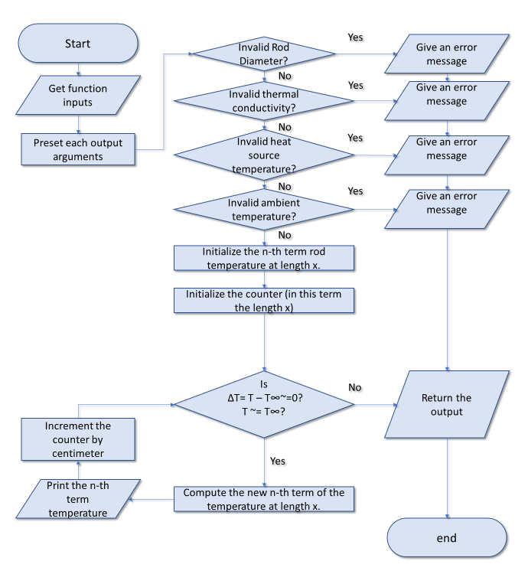

### Variable Tracking Table – by hand

Complete the necessary parts of this table for the following input arguments:

Rod diameter: 0.005 m

Heat source temperature: 373 K

Ambient air temperature: 298 K

Thermal conductivity of stainless steel: 16 W/(m*K)

Add additional rows as necessary.

|  |  |  |
| --- | --- | --- |
|  | **Distance from heat source (m)** | **Temperature at distance (K), rounded to nearest whole number** |
| Initialization | 0 | 1 |
| Iteration 1 | 0.01 | 373 |
| Iteration 2 | 0.02 | 335 |
| Iteration 3 | 0.03 | 316 |
| Iteration 4 | 0.04 | 307 |
| Iteration 5 | 0.05 | 302 |
| Iteration 6 | 0.06 | 300 |
| Iteration 7 | 0.07 | 299 |
| Iteration 8 | 0.08 | 299 |
| Iteration 9 | 0.09 | 298 |
| Iteration 10 | 0.10 | 298 |
| : | : | : |
| Iteration 52 | 0.52 | 298 |