# PS09 - Answer Sheet

|  |  |
| --- | --- |
| **Assignment:** | PS 09 |
| **Name:** | Tomoki Koike, [koike@purdue.edu](mailto:koike@purdue.edu) |
| **Team-ID** | 002-08 |
| **Contributor(s):** | none |

## Approximation of $\ln{3}$

Paired

### Paired Partner

Each member of the pair will submit their own answer sheet. List your paired partner here.

|  |  |
| --- | --- |
| Flowchart Partner: | Ian Pitman, ipitman@purdue.edu |

### Test Cases

Fill out the table with test case information.

* The *Test Case Description* is an English description of what path is being tested.
* The *Test Case Values* are the values you will use to test the path in the structure or flowchart.
* The *Flowchart Output* is an English description of the flowchart’s result when the test case values go through the structure; it should not be code or MATLAB generated results.
* Add as many rows as necessary to test all possible flowchart paths.
* An example test case is included.

Note: you will also use these test cases to test your completed code

|  |  |  |
| --- | --- | --- |
| **Test Case Description**  **in English** | **Test Case Values**  **(n)** | **Flowchart Output**  **in English** |
| Valid input for n: positive integer | 6 | $\ln{3}$* approximation, * Absolute difference between MATLAB log(3) and $\ln{3}$ approximation |
| Invalid input for n | A | * Ln3 approximation comes out as the preset value of -99 * The absolute difference comes out as the preset value of -99 * Error message |
| Invalid input for n | -3 | * Approximation -99 * Absolute difference -99 * Error message |

### Variable Tracking Table – by hand

Complete the necessary parts of this table for input argument n = 3. Leave blank any unneeded cells.

|  |  |  |  |
| --- | --- | --- | --- |
|  | **Index** | **nth term in summation** | **Summation** |
| Initialization |  | 0 | 0 |
| Iteration 1 | 0 | 1.000000 | **1.000000** |
| Iteration 2 | 1 | 0.083333 | 1.083333 |
| Iteration 3 | 2 | 0.012500 | 1.095833 |
| Iteration 4 |  |  |  |
| Iteration 5 |  |  |  |
| Final Approximation of $\ln{3}$ | | | 1.095833 |
| Absolute difference of the approximation and the matlab calculated ln3 | | | 0.0028 |

## Airspeed

Paired Flowchart

Individual Programming

### Paired Partner

Each member of the pair will submit their own answer sheet. List your paired partner here.

|  |  |
| --- | --- |
| Flowchart Partner: | <partner name>, <partner Purdue login> |

### High-Level Flowchart

Examine this high-level flowchart.



You need to create flowchart sections to do the following:

* Perform any loop initialization tasks and then calculate the atmospheric pressure and temperatures for the atmospheric model
* Perform any loop initialization tasks and then calculate the dynamic pressure and speed of sound vectors for the experimental altitudes

### Atmospheric Pressure and Temperature Flowchart

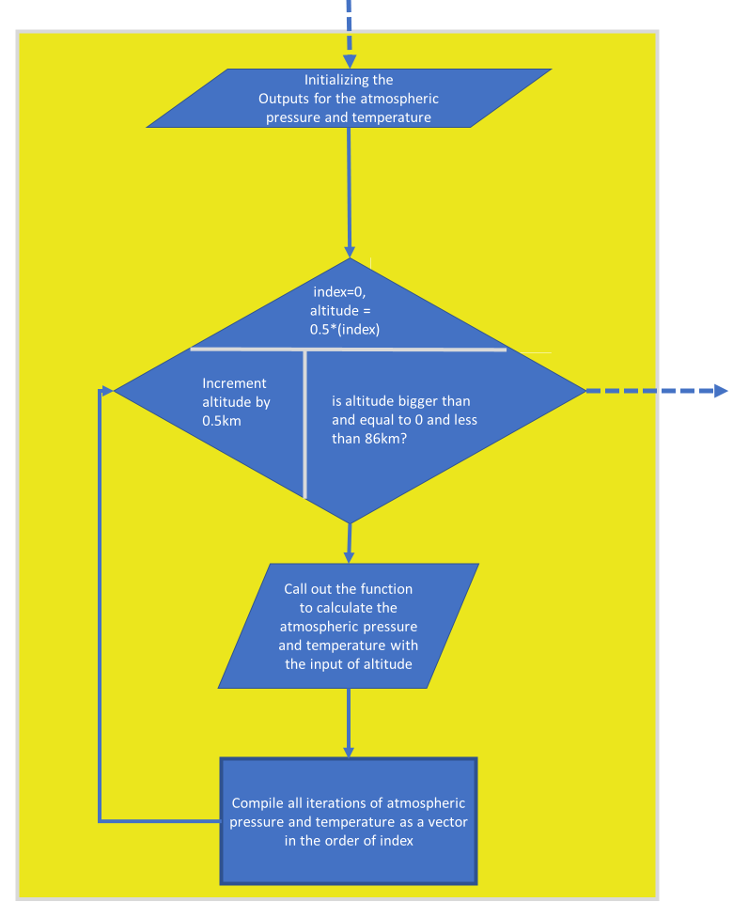

### Dynamic Pressure and Speed of Sound Flowchart

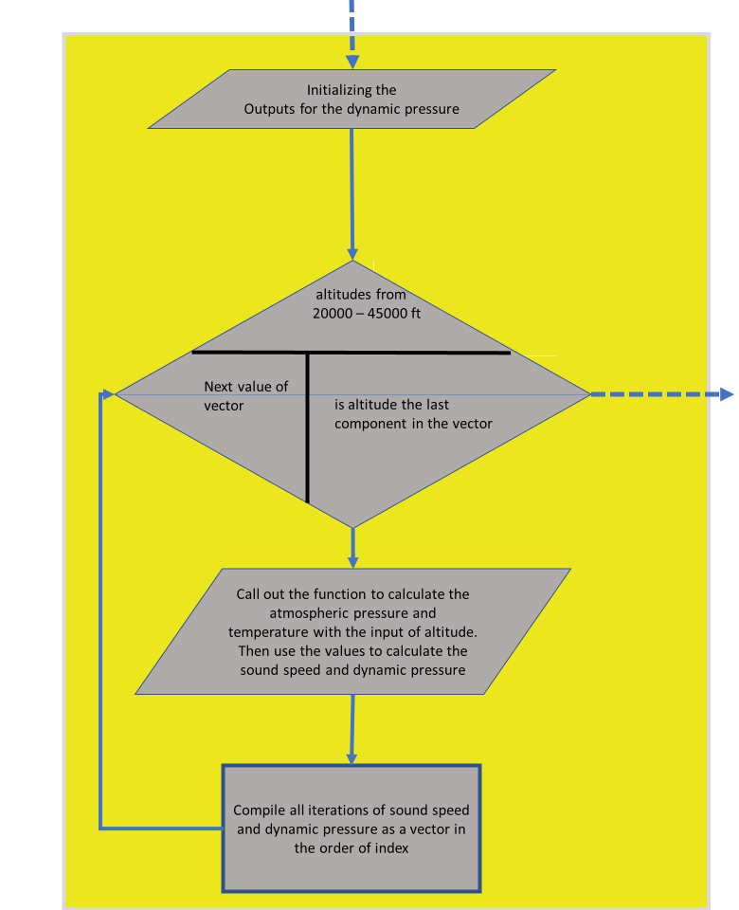

### Variable Tracking Table – by hand

Complete this tracking table, by hand, for the dynamic pressure and speed of sound flowchart section you created earlier. Add rows as necessary. Use USAtmos_1976.p to calculate the required atmospheric temperature and pressure necessary to complete the calculations. Complete this table using the vector of altitudes 22,000 ft, 28,000 ft, 32,000 ft, 36,000 ft, and 45,000 ft.

|  |  |  |  |  |
| --- | --- | --- | --- | --- |
|  | **Index** | **Altitude (km)** | **Dynamic Pressure (kPa)** | **Speed of sound (m/s)** |
| Initialization | 0 | -99 | -99 | -99 |
| Iteration 1 | 1 | 6.1000 | 29.1003 | 316.0083 |
| Iteration 2 | 2 | 8.5400 | 19.8688 | 305.7577 |
| Iteration 3 | 3 | 9.7600 | 16.5580 | 300.5014 |
| Iteration 4 | 4 | 10.9000 | 13.7088 | 295.1514 |
| Iteration 5 | 5 | 13.7250 | 8.8777 | 295.0629 |