# PS10 - Answer Sheet

|  |  |
| --- | --- |
| **Assignment:** | PS 10 |
| **Name:** | Tomoki Koike, [koike@purdue.edu](mailto:koike@purdue.edu) |
| **Team-ID** | 002-08 |
| **Contributor(s):** | <name> , <Purdue login> [repeat for each] |

## Infinite Fin Revisit

Paired

### Paired Partner

Each member of the pair will submit their own answer sheet. List your paired partner here.

|  |  |
| --- | --- |
| Flowchart Partner: | <partner name>, <partner Purdue login> |

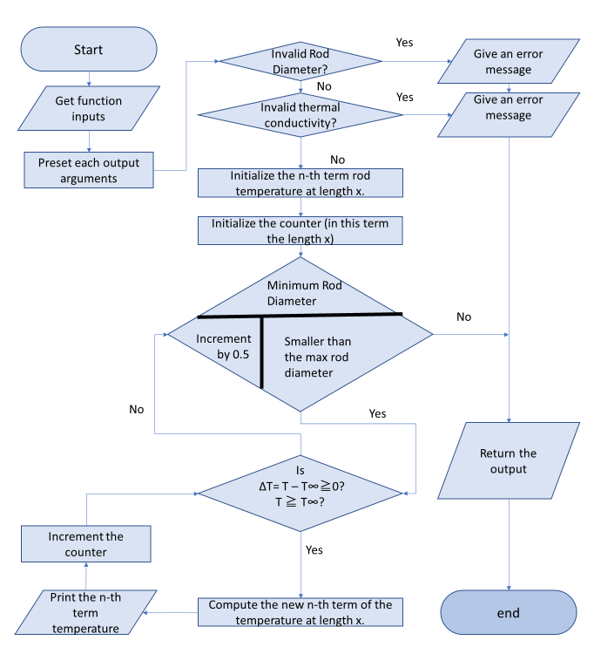**Flowchart**

## Array Sorting

Individual

### Variable Tracking Table – by hand

Complete this table for input argument $A= \left[\begin{matrix}8 & -1 & 2 \\ -5 & 8 & 6\end{matrix}\right]$. Add rows as necessary.

|  |  |  |  |
| --- | --- | --- | --- |
|  | **Row Index** | **Column Index** | **Sorted Matrix** |
| Initialization | rowCount | colCount | newArray [8 -1 2; -5 8 6] |
| Iteration 1 | 1 | 1 | newArray [-5 0 0; 0 0 0] , array [-1 2 6 8 8] |
| Iteration 2 | 1 | 2 | newArray [-5 -1 0; 0 0 0] , array [2 6 8 8] |
| Iteration 3 | 1 | 3 | newArray [-5 -1 2; 0 0 0] , array [6 8 8] |
| Iteration 4 | 2 | 1 | newArray [-5 -1 2; 6 0 0] , array [8 8] |
| Iteration 5 | 2 | 2 | newArray [-5 -1 2; 6 8 0] , array [8] |
| Iteration 6 | 2 | 3 | newArray [-5 -1 2; 6 8 8] |