|  |  |
| --- | --- |
| **Team Member Names:** | Yi Zhou, Tomoki Koike. Ian Pitman, Eu Jin Lee |
| **Purdue Logins:** | zhou823, koike, ipitman, lee2219, |
| **Section Number:** | 002 |
| **Team Number:** | 08 |

|  |
| --- |
| **Submission Instructions:**   1. Rename this answer sheet to be **Project_M1_Part1-2A_*sss*_*tt*.docx** where ***sss*** is your section number (e.g., 001 for section 001) and ***tt*** is your team number (e.g., 07 for team 7). 2. Submit this answer sheet ***along with*** the answer sheet for Part 2B to the M1 drop box on Bb prior to Class 21.   Notes:   * Only one(1) submission per team * Only the last submission to the M1 Dropbox will be graded.   + Make sure Part 1-2A and Part 2B Answer Sheets are all in the last submission.   + Check to make sure the files can be accessed after uploading to Blackboard. * After submission, distribute the submitted files to all team members*. Ensure all members of the team have copies of the submitted files.* |

**M1 Instructions**

Parameter identification is about determining model parameters from available data. This milestone requires you to think carefully about different potential parameter identification approaches, the process of using/coding those approaches, and the consequences of those choices. Your assignment is to develop several ideas for fully automated identification of parameters from first-order time history data. You should use evidence-based rationales when evaluating your ideas. In this context, ‘evidence-based’ means you should refer to the graph of the time history provided - where the graph is a proxy for actual time history data, your knowledge of MATLAB, and other trusted sources when evaluating your ideas.

***Note:*** When external sources are used, each must be properly cited with (1) an in-text citation where referenced in the body of the text and (2) a full citation at the end of the document.

|  |
| --- |
| **Learning Objective (LO): 21.02 Communicate ideas clearly and concisely**  ***Evidence of Proficiency Requires:***   * Purpose of communication is clear * Processes are fully but concisely described   + All steps are included   + Assumptions are stated   + Appropriate technical language is used   + Clarifying images (e.g., sketches, graphs and/flow charts) are provided (as necessary) * External research is accompanied by an in-text citation and full reference |

**Part 1: Brainstorming**

Consider the ‘clean’ step response graph below.

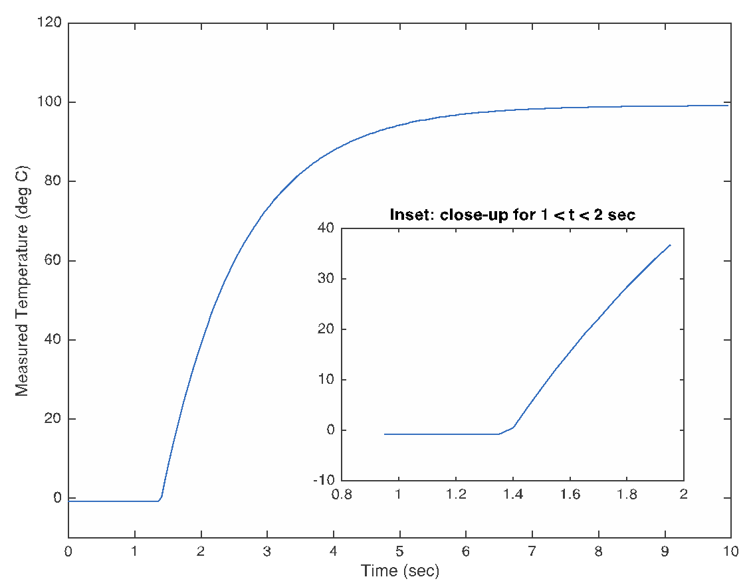

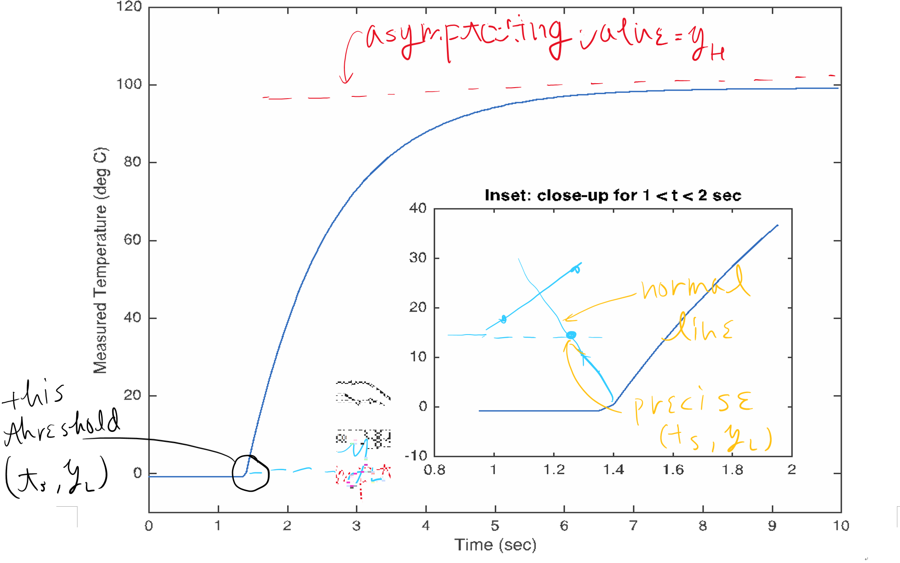

**Part 1A. Graphical Approach to Parameter Identification**

Use the graph above to identify the key parameters (yL, yH, ts, and τ). State the graphical steps followed and provide sketches on the diagram above to help describe your step (if necessary). Record your parameter results below.

|  |
| --- |
| Steps to determine yL  1. Make a while loop that computes a slope using y1, y2, t1, and t2. And, from hypothesize the y L  as the mean of y2 and y1 with a slope with a very high value (the “very high” might be determined arbitrarily or computationally).  2. Finding the min value of the data set  (add more steps as needed)  For the graph above, yL = -0.6 |
| Steps to determine yH  1. Use max function to get maximum value of the data  2. To be more precise, take the t → ∞ and find the asymptoting value  (add more steps as needed)  For the graph above, yH = 97 |
| Steps to determine ts,  1. From the section “Steps to determine yL” method #1, we can say the t1 and t2 corresponding to y1 and y2 are approximate to ts. |
| Steps to determine τ  1. Finding the point in the middle of the (ts , yL) and the threshold point of the yH and its corresponding t point, then subtracting the former from the latter  2. Finding the average slope value of the part of the graph that translate from the yL to yH. And figuring out the corresponding t value and subtracting this with the ts value  (add more steps as needed)  For the graph above, τ = approx. 0.85 |

**Part 1B. Fully Automated Approach to Parameter Identification**

|  |
| --- |
| **Learning Objective (LO): 21.01 Employ idea generation strategies to produce multiple clear, unique, and problem-focused ideas**  ***Evidence of Proficiency Requires*:**   * Multiple ideas are generated to provide choice during idea reduction * Ideas generated are clearly described using appropriate technical language and clarifying images (as necessary) * Ideas generated are clearly different from each other * Ideas generated are clearly related to the problem posed and reflect an understanding of the problem context * Ideas linked to external research are accompanied by an in-text citation and full reference |

For a fully automated process, you will work with step-response time history data, not graphical representations. For this brainstorming step, refer to the step-response graph with ‘clean’ data above – as a proxy for actual time history data. Generate at least 10 different ideas for identifying the key parameters (yL, yH, ts, and τ)from a ‘clean’ step-response time history data (1 idea for yL, 1 idea for yH, 4 ideas for ts, and 4 ideas for τ).

Right now, you should not attempt to evaluate the quality of your ideas. However, your ideas must be clearly described so that someone not on your team can interpret them. Make sketches on the graph as necessary to explain the ideas you describe in the table below. As appropriate and necessary, copy and paste the image above and use Word draw tools to clarify your ideas.

|  |
| --- |
| **Brief description of idea for yL** |
| 1. Find the minimum value for the data points 2. Then find the data values with an error within plus minus 0.5 from the minimum value found in the previous step 3. Take the average of the data points found above   4. chose this average value as yl |
| **Brief description of idea for yH** |
| 1. Find the maximum value of the data sets 2. Then find all data points that have an error within plus minus 0.5 from the maximum value found in the previous step 3. Take the average of the found points in the previous step 4. Chose this average value as yH |
| **Brief description of idea for ts** |
| 1. Create a loop that calculates the slope using the y-values and the t-values 2. The y values subjected to this will be the data values bigger than yL and smaller than yH 3. The loop will be a for loop with a condition of y values (the y-values bounded by the condition mentioned in step 2) with an increment of 0.5 (for now) 4. In this loop the slopes will be calculated by using the y-value depending on the index of the for loop and the (call this y2) and the previous y-value that is 0.5 smaller (call this y1) 5. Find the corresponding t-values t2 and t1 and calculate (y2 - y1)/(t2 - t1) which is the slope 6. Accumulate these slope values as a vector 7. And then find the maximum slope value in the slope 8. Finally find the corresponding t values t2 and t1 for the slope and calculate the average of these two values which we will assign as the ts value |
|  |
| **Brief description of idea for τ** |
| 1. Using the steps to figure out the ts, we will find the average slope value in the vector including all the slope values 2. Find the corresponding t2 and t1 value for the value found in the previous step 3. Take the average of the two t values (call it T) 4. Lastly the difference between the T and ts (T - ts) will in this case be τ |
|  |

**Part 2: Evaluation of Your Ideas**

|  |
| --- |
| **Learning Objective (LO): 21.03 Evaluate model or algorithm development (e.g. ideas, work, functionality) using evidence-based rationales**  ***Evidence of Proficiency Requires:***   * Assumptions, claims, and critical decisions are clearly stated * An appropriate source of evidence is used to support assumptions, claims, and critical decisions * The evidence is clearly articulated * External research is accompanied by an in-text citation and full reference |

Section A: Clean Data

The ‘clean’ data was derived using equation (1) from the project description document. This data was generated using the time vector time = 0:0.05:10.0. For this part, you will use ideas from Part 1B to identify the parameters ts and τ (assuming that yL and yH are known). Fill out the table below with the details of two approaches for identifying ts and two approaches for identifying τ.

You need to think about your approaches in both a conceptual way (describe them in words, flowcharts, and/or sketches) and a practical way (how you will implement it in MATLAB). Write clear steps for identifying each parameter that can be translated into MATLAB code – do not write code. Consider providing a flowcharts to clarify your approaches. Copy and paste the image above and use Word draw tools/ hand sketches to clarify your approach as necessary.

***Note:*** In *future* milestones, you will also have to consider approaches for identifying both yL and yH in both heating systems and cooling systems.

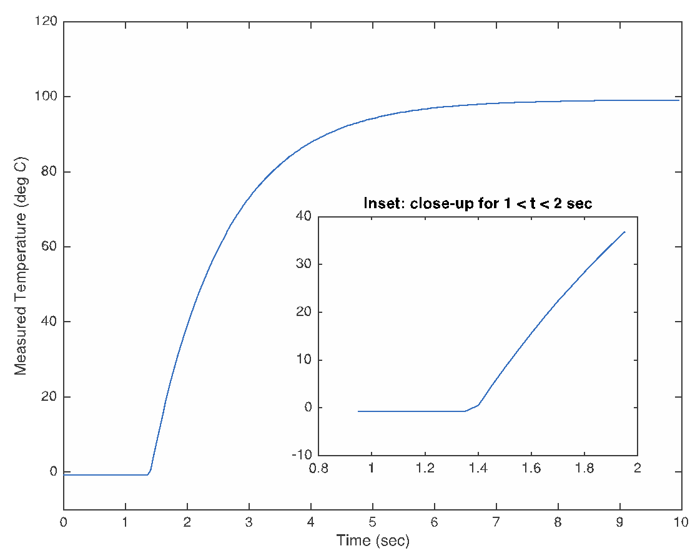

In the table below, focus on ***two*** approaches for identifying ts and ***two*** approaches for identifying τ. For each,

* briefly and clearly explain your approach using steps, a flowchart, and neat sketches.
* check the expected the level difficult for implementing this approach in MATLAB; then justify in 1-2 sentences your selected level of difficulty using evidence-based rationales, keeping in mind that the parameters must by identified in a fully automated way, without any user intervention. Your justifications must make explicit reference to MATLAB functions and coding techniques needed to translate your steps to operational code.

|  |
| --- |
| **Approach #1A: Parameter** ts |
| Approach (words, flowcharts, sketches)  Steps, in English, not code:  This method presumes that we are finding the ts value before the τ value   1. Create a loop that calculates the slope using the y-values and the t-values 2. The y values subjected to this will be the data values bigger than yL and smaller than yH 3. The loop will be a for loop with a condition of y values (the y-values bounded by the condition mentioned in step 2) with an increment of 0.5 (for now) 4. In this loop the slopes will be calculated by using the y-value depending on the index of the for loop and the (call this y2) and the previous y-value that is 0.5 smaller (call this y1) 5. Find the corresponding t-values t2 and t1 and calculate (y2 - y1)/(t2 - t1) which is the slope 6. Accumulate these slope values as a vector 7. Then find the maximum slope value in the slope 8. Finally find the corresponding t values t2 and t1 for the slope and calculate the average of these two values which we will assign as the ts value |
| Expected difficulty for coding in MATLAB: ___ low ___ medium __✔ high  What is your justification for this level of difficulty?  This will be difficult because we will have to deal with a for loop and creating a vector with each iteration and then have to analyze the calculated slope values (namely finding the maximum and minimum values) along with the corresponding time values. |

|  |
| --- |
| **Approach #1B: Parameter** ts (Must be different from Approach 1A) |
| Approach (words, flowcharts, sketches)  Steps, in English, not code:  This method presumes that we have already found the τ value   1. We plug in the yL , yH , and τ values into the theoretical equation y(t) which is given and can be figured out by solving differential equation of the phenomenon 2. We will use the solve command to find the ts corresponding with y = yL |
| Expected difficulty for coding in MATLAB: ___ low __✔_ medium ___ high  What is your justification for this level of difficulty?  This will be an introduction to some new commands however overall the procedures are not that complicated so many (solve, 2018) |

|  |
| --- |
| **Approach #2A: Parameter** τ |
| Approach (words, flowcharts, sketches)  Steps, in English, not code:  In this method we presume that ts value has already been found   1. Using the yτ = yL + 0.632(yH - yL) we will find the y value corresponding with the τ value 2. Then we will find the t value corresponding with the y value computed in the previous step 3. Next we will compare this t value in the second step with all the data points until we find out a point with an error of plus minus 2% 4. This point will have the t value which we will call T 5. Now finally τ = T - ts |
| Expected difficulty for coding in MATLAB: ___ low ___✔ medium ___ high  What is your justification for this level of difficulty?  Since we have already figured out the ts there are only algebraic computations left in order to find the t value corresponding with the yτ; thus, the difficulty is not that high |

|  |
| --- |
| **Approach #2B: Parameter** τ (Must be different from Approach 2A) |
| Approach (words, flowcharts, sketches)  Steps, in English, not code:  1. Use the yτ = yL + 0.632(yH - yL) to find the yH and yL value and t values  2. Determine the initial time (tS) when the change occured which will be related to yL  3. Then determine a final time (tF) when the change stopped ( or when the initial time when yH is reached, or right before yH is reach)  4. The final value of τ will be τ = ts + 0.632(tF - tS) |
| Expected difficulty for coding in MATLAB: __✔_ low ___ medium ___ high  What is your justification for this level of difficulty?  The difficulty will not be too hard. As long as we can find the yL and yH values and their t values then finding parameter τ will not be too hard. |

References Used in Evidence-Based Rationales

|  |
| --- |
| (solve, 2018). Retrieved from Mathworks: *https://www.mathworks.com/help/symbolic/solve.html* |