|  |  |
| --- | --- |
| **Team Member Names:** | Tomoki Koike, Yi Zhou, Ian Pitman, Eu Jin Lee |
| **Purdue Logins:** | koike, zhou823, ipitman, lee2219 |
| **Section Number:** | 002 |
| **Team Number:** | 08 |

|  |
| --- |
| **Submission Instructions:**   1. Rename this answer sheet to be **Project_M1_Part2B_*sss*_*tt*.docx** where ***sss*** is your section number (e.g., 001 for section 001) and ***tt*** is your team number (e.g., 07 for team 7). 2. Submit this answer sheet ***along with*** the answer sheet for Part 1-2A to the M1 drop box on Bb prior to Class 21.   Notes:   * Only one(1) submission per team * Only the last submission to the M1 Dropbox will be graded.   1. Make sure Part 1-2A and Part 2B Answer Sheets are all in the last submission.   2. Check to make sure the files can be accessed after uploading to Blackboard. * After submission, distribute the submitted files to all team members*. Ensure all members of the team have copies of the submitted files.* |

|  |
| --- |
| **Learning Objective (LO): 21.02 Communicate ideas clearly and concisely**  ***Evidence of Proficiency Requires:***   * Purpose of communication is clear * Processes are fully but concisely described   + All steps are included   + Assumptions are stated   + Appropriate technical language is used   + Clarifying images (e.g., sketches, graphs and/flow charts) are provided (as necessary) * External research is accompanied by an in-text citation and full reference |
| **Learning Objective (LO): 21.03 Evaluate model or algorithm development (e.g. ideas, work, functionality) using evidence-based rationales**  ***Evidence of Proficiency Requires:***   * Assumptions, claims, and critical decisions are clearly stated * An appropriate source of evidence is used to support assumptions, claims, and critical decisions * The evidence is clearly articulated * External research is accompanied by an in-text citation and full reference |

**Part 2: Evaluation of Your Ideas**

Section B: Noisy Data

Real experimental data always contains measurement noise, an example of which is shown in the figure below.

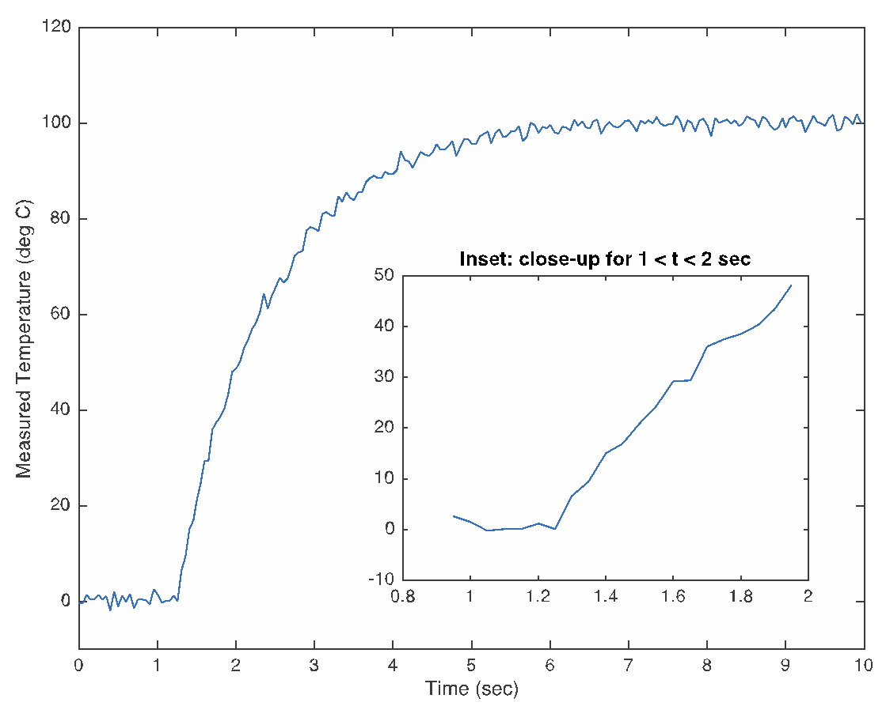

Experimental noise can come from many different sources, and it always makes parameter identification more challenging. In this part of the assignment, you must re-evaluate your approaches from Part 2A in light of the measurement noise.

For each of the approaches you described in Part 2A of Milestone 1:

* explain in a few sentences how the approach might fail in the presence of noise. As appropriate include sketches to clarify your explanation.
* modify your approach to account for the presence of noise in the time history data. Use flowcharts and sketches to clarify your steps as necessary.
* re-assess the difficulty of coding this approach in MATLAB for analysis of noisy data and then justify in a few sentences your selected level of difficulty using evidence-based rationales (remember, your parameter identification must be fully automated). Again, your justifications must make explicit reference to MATLAB functions and coding techniques needed to translate your steps to operational code.

|  |
| --- |
| **Approach #1A: Parameter** ts (Must be the same Approach#1A from Part 2A) |
| How could your approach fail in the presence of noise?  This method presumes that we are finding the ts value before the τ value   1. Create a loop that calculates the slope using the y-values and the t-values 2. The y values subjected to this will be the data values bigger than yL and smaller than yH 3. The loop will be a for loop with a condition of y values (the y-values bounded by the condition mentioned in step 2) with an increment of 0.5 (for now) 4. In this loop the slopes will be calculated by using the y-value depending on the index of the for loop and the (call this y2) and the previous y-value that is 0.5 smaller (call this y1) 5. Find the corresponding t-values t2 and t1 and calculate (y2 - y1)/(t2 - t1) which is the   slope   1. Accumulate these slope values as a vector 2. Then find the maximum slope value in the slope 3. Finally find the corresponding t values t2 and t1 for the slope and calculate the average of these two values which we will assign as the ts value   This method will succeed in the clean data sets but fail in the noisy data sets because there will be slope values that become a negative value |
| Modify your approach to account for noise.  Steps, in English, not code:   1. we can first create a linear regression line for t<= ts 2. and for ts <= t we can create a non linear regression line with the noisy data 3. than find the equation for the regression lines and use the method above   (add more steps as needed) |
| Expected difficulty for coding in MATLAB: ___ low ___✔ medium ___ high  What is your justification for this level of difficulty?  since we have done creating nonlinear and linear regression lines in early problem sets the workload is probably manageable and since after processing the data points into a regression line will make the evaluation of slope values easier to do. |

|  |
| --- |
| **Approach #1B: Parameter** ts (Must be the same Approach#1B from Part 2A) |
| How could your approach fail in the presence of noise?  First of all, the theory of finding the τ value first is not plausible and cannot be done. This makes the implementation of the y(t) equation unrealistic.  so i will propose another method  with the clean data we will find the linear regression line for the t<= ts and differentiate this  equation to find the slope. And we will chose the point with a slope larger than zero or a when the slope increases dramatically. The t value in this point will be ts.  However, with the noisy data points this will lack precision; therefore, we will find the nonlinear regression line for the same range as above (clean data) and conduct differentiation to find the slope and determine a point when the slope becomes dramatically high. |
| Modify your approach to account for noise.  Steps, in English, not code:  1. aforementioned we will find the nonlinear regression line for the estimated range 5% of the data points each  2.. then differentiate this to find the slopes for each points included in that 5%  3. we will see if there is a dramatic rise in the value of the slope within that 5% of data points  4. if there is we will chose the corresponding data point as to include the ts value. if there is not a rise, we will repeat the process for the next 5% of the data set |
| Expected difficulty for coding in MATLAB: ___ low ___ medium _✔__ high  What is your justification for this level of difficulty?  This will include looping, nonlinear regression, and differentiation that will be a very intense workload. and determining a “dramatic rise” is arbitrary and we will have to come up with a criteria for what means a “dramatic rise” (Differentiation, 2018) |

|  |
| --- |
| **Approach #2A: Parameter** τ (Must be the same Approach#2A from Part 2A) |
| How could your approach fail in the presence of noise?  In this method we presume that ts value has already been found   1. Using the yτ = yL + 0.632(yH - yL) we will find the y value corresponding with the τ value 2. Then we will find the t value corresponding with the y value computed in the previous step 3. Next we will compare this t value in the second step with all the data points until we find out a point with an error of plus minus 2% 4. This point will have the t value which we will call T 5. Now finally τ = T - ts   in this method 2% might not be precise enough due to the fluctuation of data points |
| Modify your approach to account for noise.  Steps, in English, not code:  1. the error of plus minus 2% can be lowered to 1% or perhaps lower than that  2..  (add more steps as needed) |
| Expected difficulty for coding in MATLAB: ___ low _✔__ medium ___ high  What is your justification for this level of difficulty?  This protocol depends on the difficulty level of finding out the ts value and the τ value can be figured out relatively easily by using the theoretical equation so the weight of difficulty is not that high for this method. |

|  |
| --- |
| **Approach #2B: Parameter** τ (Must be the same Approach#2B from Part 2A) |
| How could your approach fail in the presence of noise?  in this method we will first have to find the tF in which the data points start to asymptote to yH and also the ts . using the ratio of 0.632 for the temperature we can use the same ratio for the t values as well.  However, because the data fluctuates finding a approximate data point to the theoretical yτ might lack precision because of a high deviation from the actual data |
| Modify your approach to account for noise.  Steps, in English, not code:  1. we can collect the data points that are in the 5% vicinity for the yτ and compute the average value of those data points and compare it to the theoretical value  2. when compare it means to take the average of the those points  3. then figure out the standard deviation and if the this is considerably large we will take only the 3% vicinity into account next.  4. we will make the % vicinity smaller until the standard deviation becomes something optimal to conceive as trivial  (add more steps as needed) |
| Expected difficulty for coding in MATLAB: _✔__ low ___ medium ___ high  What is your justification for this level of difficulty?  Coding is not too hard, we only need to get a more accurate yτ by collect more data and get the average of it. |

References Used in Evidence-Based Rationales

|  |
| --- |
| (Differentiation , 2018). Retrieved from Mathworks: *https://www.mathworks.com/help/symbolic/differentiation.html* |