**FAINT SUN PARADOX: ELUCIDATION AND POSSIBLE EXPLANATIONS.** Tomoki Koike. Purdue University.

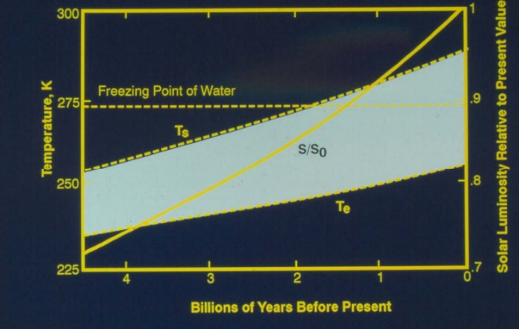**Introduction:** The “Faint Sun Paradox” is a contradiction between the existence of liquid water during the early epoch of the Earth and the astrophysical estimate of the Sun’s heat output being merely 70% of the today’s output. With the high ratio of hydrogen to helium in the Sun’s core it is expected for the sun to have had only 70% of today’s radiating heat output. From this evidence, in 1972, astronomers Carl Sagan and George Mullen postulated that this would not have provided the Earth with sufficient radiative forcing to sustain the temperature equilibrium moderate for the existence of liquid water. The geological and paleontological standpoint has a counterargument evidently stating that there was enough heat provided to the earth from the Sun for water to exist.

Kasting, James et al., *Scientific American (1988)*

There are several hypotheses which attempt to give a valid explanation to this contradiction. The most prominent theory is the Greenhous Gas Hypothesis. Another is the Cold Genesis Hypothesis, and the third one is the Sun’s Mass Loss Hypothesis. In the following sections we shall learn the concepts and will validate each theory.

**Greenhous Gas Hypothesis:** First we will go over how greenhouse gas heats the earth. Greenhouse gases are able to pass most of the visible solar radiation into the earth but can also absorb and reradiate infrared radiation that reflects out to the outer atmosphere. In theory, higher CO­2, NH3, or CH4 in the atmosphere could have offset the decreasing solar luminosity.

According to the carbonate-silicate cycle, while the planet cools there should be an increase in atmospheric CO2. The cycle was, in other words, a planetary thermostat which regulated the atmospheric CO2 levels over long time spans. However, the absence of siderite, FeCO3 inside paleosols sets a limit for the possible amount of existing pCO2. This implies that there should have been other greenhouses gases besides CO2 that created additional heating. Researches show that in the distant past mass-independently fractionated S isotopes influenced to lower the O2 in the atmosphere resulting in a higher level of CH4. NH3 is also mentioned as to have contributed to the greenhouse effect; however, NH3 is generally known to be an ineffective greenhouse gas since it is easily disintegrated into nitrogen and hydrogen due photochemical processes. Scientists predicate that some kind of photochemical haze could have occurred to prevent the destruction of NH3.

**Cold Genesis Hypothesis:** This theory is based on the idea that though the earth might have been cold and frozen over, life could have formed under an unordinary circumstance. This biological solution is controversial and is insufficient in evidence.

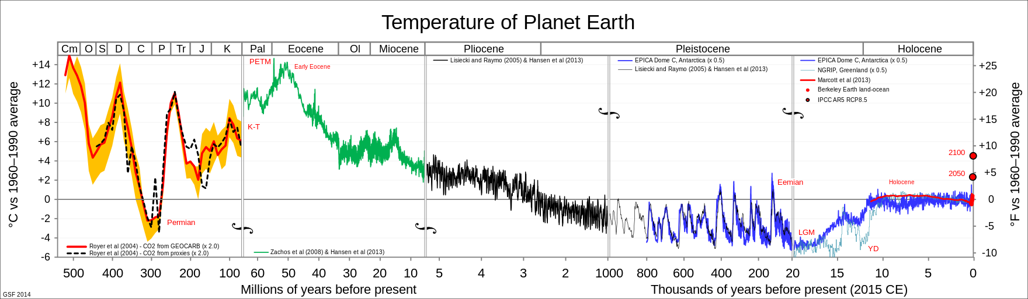 From open source file: ALL_palaeotemps.svg

The primary species of life, methanogenic bacteria is possible to have survived the severities and set the stones for biological evolution of early species. Albeit this hypothesis contradicts with several biological evidences found on earth. For example, the evidences of liquid water found on continents and early Earth life forms such as the Precambrian stromatolite, which lived at least 3.5 Gyrs (10­9 years) ago, are said to have lived on the surface lands of earth. The persuasiveness of this theory is lower than that of the Greenhouse Gas Hypothesis.

**Sun’s Mass Loss Hypothesis:** This suggests that during the cold period of the earth the Sun undergone a dramatic loss in mass from an order of 5 to 10 percent. This generated a stronger magnitude of solar winds. The mass loss and increase in solar wind flux is directly correlated to solar luminosity. The mass loss is said to have occurred within a very short period – approximately 1% per billion years. Additional facts to this theory are the spin-down of solar type clouds that took place over the star’s evolution. The spin-down of the Sun assumes that with the inside Alfven radius rigid co-rotation the outside mass is lost. This mass loss causes momentum drop and magnetic braking. This chain of reactions result in the increase in a stream of charged particles released from the upper atmosphere of the sun, called the corona.

Counterarguments to this theory is that the mass loss of solar type stars is difficult to detect due to the small portion of lost mass compared to the entire mass. Observations are challenging to conduct and there is not enough evidence to support this theory.