**NASA Genesis Mission: It’s Mission Objective and Accomplishments**

**- Tomoki Koike**

The Genesis mission was a solar system exploration mission designed and managed by NASA JPL. The main objective of this prominent mission was to collect solar wind samples from the Sun and explore the Sun-Earth L1 Lagrange point.

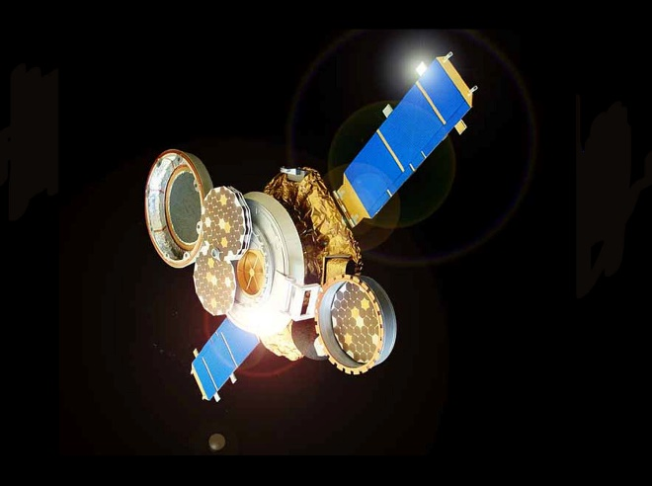

Figure 1- Concept design of Genesis, from: https://solarsystem.nasa.gov/missions/genesis/in-depth/

The Genesis spacecraft was designed to have four of the same collection devices which was a circular metallic tray. They were stacked together and one of them was exposed constantly to the Sun’s emissions and the other three were deployed accordingly to the specific solar wind conditions that the scientists required. This mission was officially launched on August 8th, 2001, and the third stage made its way to the L1 Lagrange point as planned. Then the spacecraft entered a Halo orbit around the L1 to collect samples. After sample collection, the Genesis swung around the L2 Lagrange point and headed toward the earth for return. The capsulated samples made its reentry into the Earth’s

atmosphere and successfully landed on the Earth’s surface on September 8th, 2004. The capsule was severely damaged; however, research teams were able to glean an astonishing amount of invaluable data from the collected samples.

The reason behind collecting the ejected solar winds from the outer layer of the Sun was to reveal the Universes origins. Scientific evidences suggested that the material composition of the Sun’s surface is not measurably different from that of the material compositions of the solar abundance since the birth of the universe. Therefore, collecting solar winds is equivalent to collecting the fossils of our universe, let alone our galaxy.

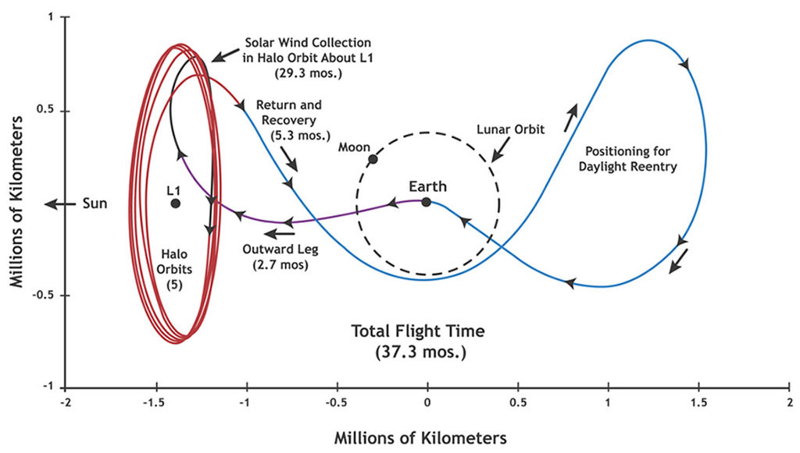

Figure 2- NASA JPL from: http://genesismission.jpl.nasa.gov/gm2/images/gallery/artist_renderings/index.htm

From the sample extractions, scientists were able to discover detailed data of neon and argon isotopes. With further analysis, they were also able to find out that the Sun had a higher proportion of ­16O composition compared to that of the Earth, Moon, Mars, and meteorites in the solar system. One of the key elements which variation in the solar system was remained unknown was nitrogen, and from this mission scientists were able to reveal the existence ratios of nitrogen isotopes in space including 14N and 15N.

Even though the recovered capsule was crumpled due to the impacts of reentry and having other mishaps occurred, the mission did not experience a fatal accident enabling it to bring home significant results and contributions to the research of the universe.

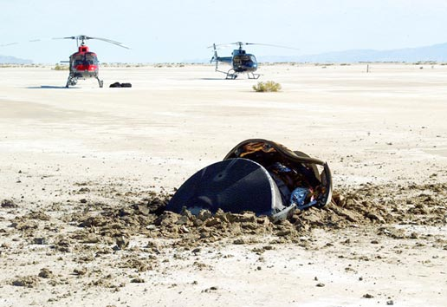

Figure 3- Landing site of Genesis, from: https://www.nasa.gov/mission_pages/genesis/multimedia/genesisrecov090804-2.html