Messenger Spacecraft: The Seventh Discovery Class Mission of Mercury. Tomoki Koike

The Messenger spacecraft stands for, Mercury Surface, Space Environment, Geochemistry and Ranging. As the acronym depicts, this spacecraft was primarily designed to investigate the geology, magnetic field, and geochemical traits of Mercury. For NASA, this was the seventh discovery-class mission launched.

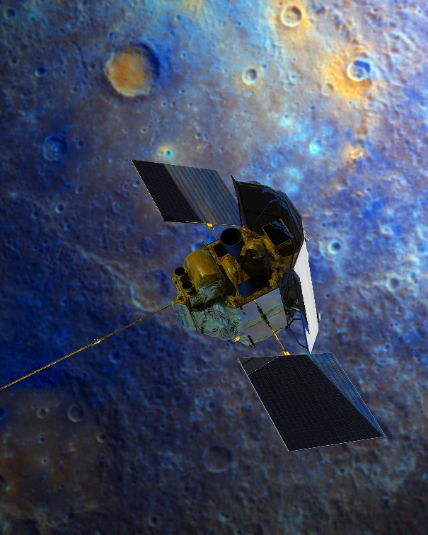

Figure 1: nasa.gov: Mercury fly-by

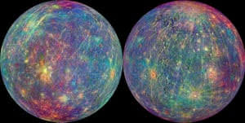The spacecraft headed out for a six-and-a-half journey to Mercury on August 3, 2004. It was planned to be maneuver itself with the assist of inner space gravity, and the spacecraft successfully entered an escape trajectory into a heliocentric orbit and with some inclination to ecliptic orbit. One of the challenges for this fly-by mission was to prevent the spacecraft to accelerate excessively due to the gravity of the Sun. Gravity-assist maneuvering was what

Figure 2: The Gaurdian: Mercury Mapping Image

allowed the spacecraft to overcome this issue and also save more fuel.

The mission was highlighted with three major fly-by missions. The first was around Earth, and the purpose of this fly-by was to give the mission controllers to calibrate the instruments loaded on the spacecraft. Next, the spacecraft flew by Venus, which returned substantial amount of data such as visible and near-infrared imaging data of Venus’s upper atmosphere. The third fly-by made was around Mercury. One appraising accomplishments of Messenger was the discovery of large amounts of water in Mercury’s exosphere and the past volcanic activities on the planet. Also Messenger discovered high concentrations of magnesium and calcium on the dark side of Mercury. Moreover, the spacecraft has

collected a 100% mapping of Mercury. At the end of the yearlong mission, the controllers of the spacecraft managed to lower the altitude of the spacecraft to collect more data from a proximity of the surface of Mercury. The mission was extended several times to collect additional data.

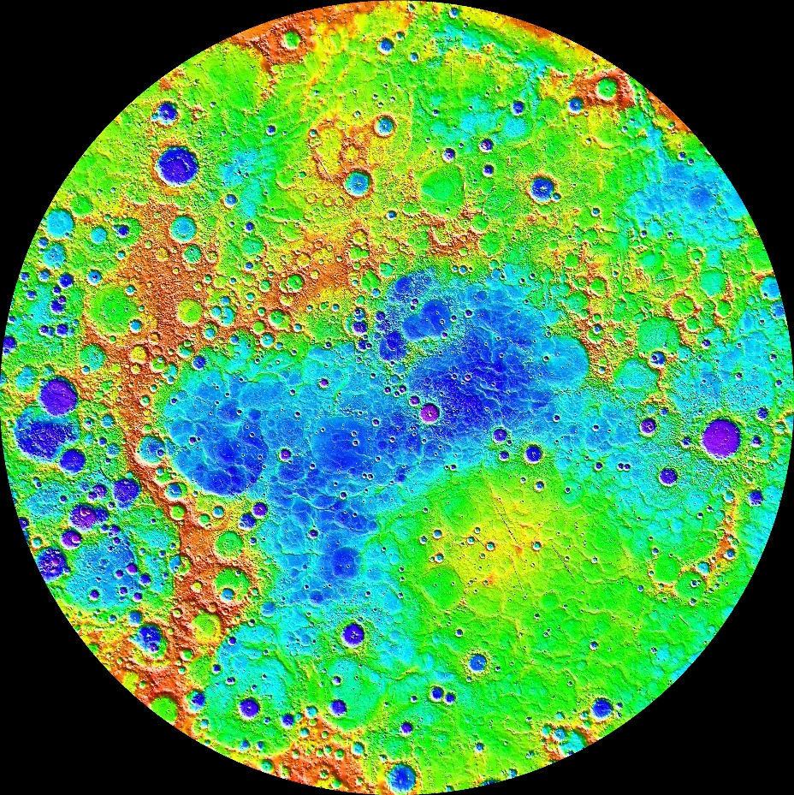Gradually, the fuel was going down to zero, and on April 20, 2015 Messenger was finally out of fuel and crashed into the surface Mercury which put an end to the mission. This termination of the mission was planned beforehand and was overall a success for NASA.

Figure 3: nasa.gov: mercury thermal mapping image

Reference

NASA Science Solar System Exploration. https://solarsystem.nasa.gov/missions/messenger/in-depth/. Accessed 1 December 2019.