|  |  |
| --- | --- |
| **NAME** | **DUE** |
| **Tomoki Koike** | **Sep. 12 (Thur)** |

**EBEC – Intermediate Level Programming in Python**

**Week 1 – Programming Exercises**

|  |  |
| --- | --- |
| **#** | **SCORE** |
| **1** |  |
| **2** |  |
| **3** |  |
| **TOTAL** |  |

1. (15 points) Write a Python program that uses nested loops to draw this pattern:

##

# #

# #

# #

# #

# #

# #

# #

# #

**>>CODE**

###  
# AUTHOR: Tomoki Koike  
# DATE: Sept. 12, 2019  
# DESCRIPTION: This program will generate a certain pattern of asterisks using nested loops  
###  
  
**def main():** # Set the range for the outer loop corresponding to the number of rows  
 rows **=** 9  
 # Loop creating the pattern  
 **for** x **in** range**(**1, rows**+**1**):** print**('#'**, end**='')  
 for** y **in** range**(**x**):  
 if** y **==** x**-**1**:** print**('#')  
 else:** print**(' '**, end**='')  
if** __name__ **== '__main__':** main**()**

**>>OUTPUT**

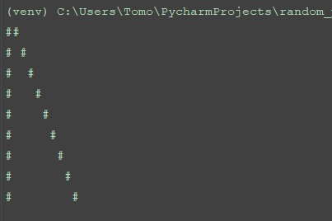

1. (15 points) A prime integer number is one that has exactly two different divisors: 1 and the number itself. Write a Python program that finds and prints all the prime numbers between 0-100.

**>>CODE**

###  
# AUTHOR: Tomoki Koike  
# DATE: Sept. 12, 2019  
# DESCRIPTION: This program will find and print out all the prime integer numbers between 1-100.  
###  
  
**def main():** low, high **=** 1, 100 # Defining the range for the list  
 # The for loop  
 **for** x **in** range**(**low, high**+**1**):** ct **=** 0 # Counter to determine the numbers of divisors  
 **for** y **in** range**(**1,x**+**1**):  
 if** x **%** y **==** 0**:** # If y is a divisor of x increment the counter by 1  
 ct **+=** 1  
 **if** ct **==** 1 **or** ct **==** 2**:** # If the counter indicates 1 or 2 print the prime number  
 **if** x **<** 10**:** # **This if-else is just to make the output neater  
 print**(''**, x, **' '**, end**='')  
 else:** print**(**x, **' '**, end**='')  
 else:** # If there are more than two divisors, the number x is not a prime number  
 print**(' -'**, **' '**, end**='')** # **Just to make the output neater  
 **if** x **%** 10 **==** 0**:** print**()  
  
if** __name__ **== '__main__':** main**()**

**>>OUTPUT**

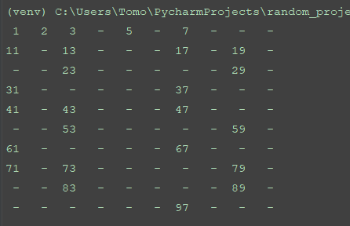

1. (20 points) Metrix practice (You should not directly call any NumPy functions or other standard library functions) ：
   1. **Metrix Transpose.** Suppose there is a matrix M:

2 -5 8 11

M =

3 7 -9 -5

4 0 -1 7

Write a Python program that creates the transpose of M and displays MT in Matrix format such as:

2 3 4

-5 7 0

8 -9 -1

11 -5 7

* 1. **Metrix Multiplication.** Write a Python program that calculates the multiplication of M and MT, and displays the results (M * MT) in Matrix format.

**>>CODE**

###  
# AUTHOR: Tomoki Koike  
# DATE: Sept. 12, 2019  
# DESCRIPTION: This python program will tranpose a certain matrix and also conduct a matrix multiplication  
###  
  
**def main():** # Define matrix M  
 M **= [[**2, **-**5, 8, 11**]**, **[**3, 7, **-**9, **-**5**]**, **[**4, 0, **-**1, 7**]]** # Defining the number of rows and columns  
 rows **=** 3  
 cols **=** 4  
 # Create an empty matrix to use in part b  
 M_t **= [[**0,0,0**]**,**[**0,0,0**]**,**[**0,0,0**]**,**[**0,0,0**]]** print**('---PART A---')** #<a>  
 # Nested loops to transpose the matrix  
 **for** x **in** range**(**cols**):  
 for** y **in** range**(**rows**):** temp **=** M**[**y**][**x**]** M_t**[**x**][**y**] =** temp  
 print**(**temp, **' '**, end**='')** # The if statement below is just to make the output neater  
 **if** temp **<** 10 **and** temp **>** 0**:** print**(' '**, end**='')** print**()** print**()** print**('---PART B---')** #<b>  
 # Nested loop to conduct a matrix multiplication  
 **for** x **in** range**(**rows**):** temp **=** 0 # Initialize temporary place holder  
 **for** y **in** range**(**cols**):** temp **+=** M**[**x**][**y**] \*** M_t**[**y**][**x**]** print**(**temp**)  
  
if** __name__ **== '__main__':** main**()**

**>>OUTPUT**

