College of Engineering

School of Aeronautics and Astronautics

AAE 36401 Lab

Control Systems Lab

Lab 1 Pre-Lab

The Cart on a Track

*Author:*

Tomoki Koike

*Supervisor:*

A. E. Frazho

September 4th, 2020

Purdue University

West Lafayette, Indiana

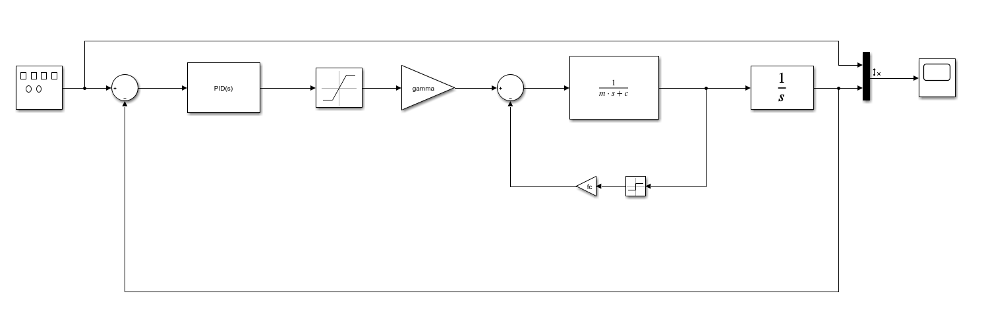

I have tuned the following system for the cart on a track model using a PID controller. The PID controllers have the gains listed in the following table

|  |  |
| --- | --- |
|  | Gains |
| $$K_{p}$$ | 200 |
| $$K_{i}$$ | 2 |
| $$K_{d}$$ | 10 |

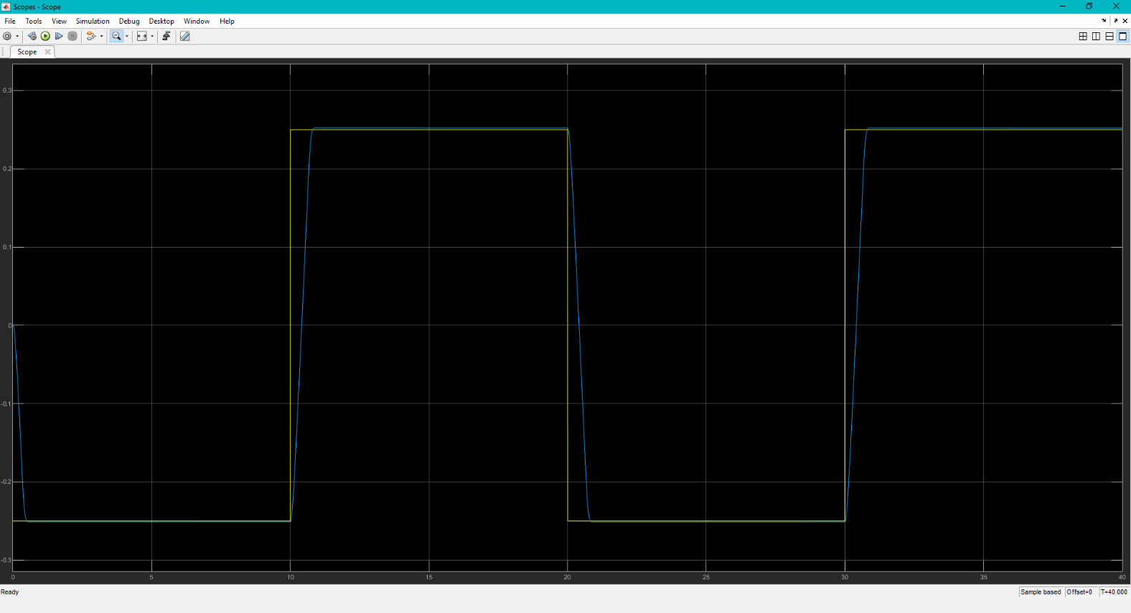The plot for the output response is the following,

And the output parameters are listed in the following table

|  |  |
| --- | --- |
| parameter | value |
| rise time [s] | 0.0815 |
| percent overshoot [%] | 4.05% |
| settling time [s] | 0.266 |
| steady state error | ~0 |

