College of Engineering

School of Aeronautics and Astronautics

AAE 36401 Lab

Control Systems Lab

Lab 2 Report

The Control of Gantry

*Author:*

Tomoki Koike

*Supervisor, TA:*

A. E. Frazho, Zihao Liang

October 23th, 2020

Purdue University

West Lafayette, Indiana

## Introduction

### Objective

This experiment setup has a cart with a mass of M on top of a track that spans one dimensionally. This cart has a pendulum attached to the cart that swings to apply perturbations to the cart. The objective of this lab is to control the cart so that the cart moves to halt the swinging of the pendulum. This resembles a functionality of a gantry or crane.

### Method

In the first part of the experiment, the natural frequency of the pendulum was measured experimentally by swinging the pendulum with a small angle while holding the cart still. The sinusoidal oscillations plotted in the scope will give the experimental natural frequency. Meanwhile, the theoretical natural frequency will be computed using the equation of motion (EOM). The EOM will be linearized (assuming that the initial angle of the pendulum is small) and manipulated to give the theoretical formula of the time derivative of the angle of the pendulum.

In the second part of the experiment, four gain values $K_{1},{ K}_{2},{ K}_{3}, and{ K}_{4}$ were input to the feedback system to control the cart to terminate the swing of the pendulum with desired response parameters. The gains were generated using the pole placement method and fed to the Simulink model to simulate the results.

The pole placement method is possible when for a state space system of

$$\dot{x}=Ax+Bv$$

Is defined where the matrices *{A, B}* are controllable. Thereby, a state feedback vector *K* exists, and *A-BK* has the eigenvalues of ${\left(λ_{j}\right)}_{1}^{n}$ which correspond to the poles of the feedback system $G_{K}$.

$$G_{K}\left(s\right)=C{\left(sI-\left(A_{B}K\right)\right)}^{-1}B=\frac{q\left(s\right)}{\left(s-λ_{1}\right)\left(s-λ_{2}\right)⋯\left(s-λ_{n}\right)}$$

Knowing this, we are able to use the MATLAB command of place() to compute the feedback gains

$K=place\left(A,B,\left[λ_{1},λ_{2},⋯,λ_{n}\right]\right)$

## Results

### Part (i)

In this part of the experiment, the natural frequency was computed both theoretically and experimentally.

#### Theoretical Method

The EOM of the cart on the track with a pendulum with force exerted by the servo motor is expressed as the following system equation.

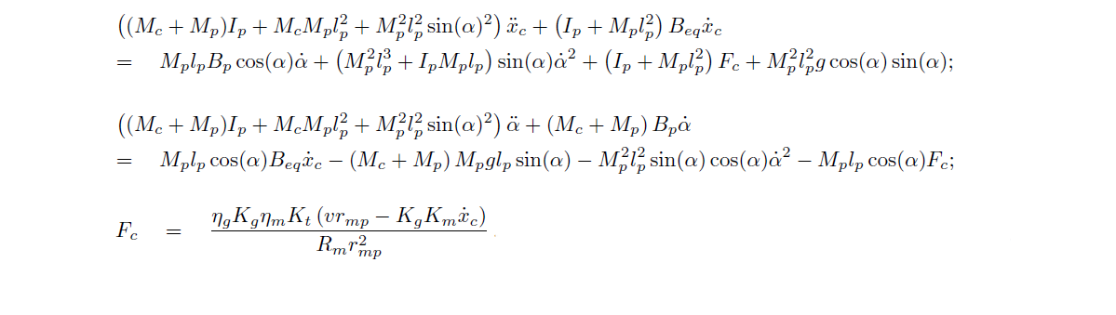

Solving these nonlinear equations for the high order differential terms gives the following

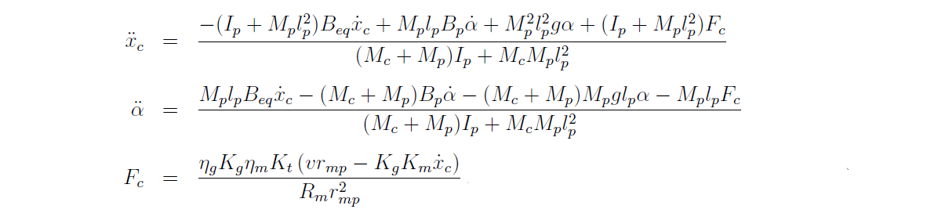

Assuming that the cart is fixed onto the track, the equation of motion becomes

$$\left(I_{p}+M_{p}l_{p}^{2}\right)\ddot{α}+M_{P}l_{p}gsin\left(α\right)=0$$

Now, considering the small angle $α$, we can change $sin\left(α\right)≈α$. This linearizes the EOM to

$$\left(I_{p}+M_{p}l_{p}^{2}\right)\ddot{α}+M_{P}l_{p}gα=0$$

Thus, the EOM is boiled down to the second order differential equation of a undamped harmonic oscillator

$$\ddot{α}+ω_{p}^{2}α=0$$

$$where{ ω}_{p}=\sqrt{\frac{M_{p}l_{p}g}{I_{p}+M_{p}l_{p}^{2}}}$$

Plugging in the constants identified in the “Notations for Variables” in the appendix, we get the following theoretical natural frequency

$$ω_{p}=4.7543 rad/s$$

This is equivalent to the period of

$$τ= \frac{2π}{ω_{p}} =1.3216 s$$

#### Experimental Method

From the data obtained in the first part of the experiment, the following graph can be plotted

From this graph, we can see the t-values (or time values) when the angle periodically goes to zero. The values are tabulated below.

|  |  |  |  |
| --- | --- | --- | --- |
| Cycle | start [s] | end [s] | period [s] |
| 1 | 4.93 | 6.25 | 1.32 |
| 2 | 6.25 | 7.56 | 1.31 |
| 3 | 7.56 | 8.87 | 1.31 |
| 4 | 8.87 | 10.18 | 1.31 |
| 5 | 10.18 | 11.49 | 1.31 |
| 6 | 11.49 | 12.79 | 1.30 |
| 7 | 12.79 | 14.10 | 1.31 |
| 8 | 14.10 | 15.41 | 1.31 |
|  |  |  |  |
|  |  | Average Period | 1.31 |

Thus, the experimental period becomes 1.31 and the corresponding natural frequency is

$$ω_{p}=\frac{2π}{1.31}=4.7963 rad/s$$

### Part (iii)

#### Pre-Lab Results

The values of the gains, *K* from the pre-lab are the following

|  |  |
| --- | --- |
| K | Gains |
| $$K_{1}$$ | 38.9466 |
| $$K_{2}$$ | -33.0734 |
| $$K_{3}$$ | 14.9005 |
| $$K_{4}$$ | 2.9887 |

The corresponding pole values are

|  |
| --- |
| poles |
| -3+2.8i |
| -3-2.8i |
| -8 |
| -10 |

The plot of the angle, $α$ becomes the following,

2.845 seconds

This indicates that settling time $t_{s}$ for when $dα/dt\left(0\right)=π/2$ is

$$t_{s}=2.845 s$$

#### Experiment Results

## Appendix

### Notations for Variables

|  |  |  |  |
| --- | --- | --- | --- |
| **Symbol** | **Description** | **Value** | **Unit** |
| *Rm* | motor armature resistance | 2.6 | Ω |
| *Lm* | motor armature inductance | 0.18 | *mH* |
| *Kt* | motor torque constant | 0.00767 | *N.m/A* |
| *ηm* | motor eﬃciency | 100% | % |
| *Km* | back-electromotive-force(EMF) constant | 0.00767 | *V.s/rad* |
| *Jm* | rotor moment of inertia | 3*.*9 *×* 10*−*7 | *kg.m*2 |
| *Kg* | planetary gearbox ratio | 3*.*71 |  |
| *ηg* | planetary gearbox eﬃciency | 100% | % |
| *Mc*2 | cart mass | 0*.*57 | *kg* |
| *Mw* | cart weight mass | 0*.*37 | *kg* |
| *Mc* | total cart weight mass including motor inertia | 1*.*0731 | *kg* |
| *Beq* | viscous damping at motor pinion | 5*.*4000 | *N.s/m* |
| *Lt* | track length | 0*.*990 | *m* |
| *Tc* | cart travel | 0*.*814 | *m* |
| *Pr* | rack pitch | 1*.*664 *×* 10*−*3 | *m/tooth* |
| *rmp* | motor pinion radius | 6*.*35 *×* 10*−*3 | *m* |
| *Nmp* | motor pinion number of teeth | 24 |  |
| *rpp* | position pinion radius | 0*.*01482975 | *m* |
| *Npp* | position pinion number of teeth | 56 |  |
| *KEP* | cart encoder resolution | 2*.*275 *×* 10*−*5 | *m/count* |
| *Mp* | long pendulum mass with T-fitting | 0*.*230 | *kg* |
| *Mpm* | medium pendulum mass with T-fitting | 0*.*127 | *kg* |
| *Lp* | long pendulum length from pivot to tip | 0*.*6413 | *m* |
| *Lpm* | medium pendulum length from pivot to tip | 0*.*3365 | *m* |
| *lp* | long pendulum length: pivot to center of mass | 0*.*3302 | *m* |
| *lpm* | medium pendulum length: pivot to center of mass | 0*.*1778 | *m* |
| *Jp* | long pendulum moment of inertia ⟳ center of mass | 7*.*88 *×* 10*−*3 | *kg.m*2 |
| *Jpm* | medium pendulum moment of inertia ⟳ center of mass | 1*.*20 *×* 10*−*3 | *kg.m*2 |
| *Bp* | viscous damping at pendulum axis | 0*.*0024 | *N.m.s/rad* |
| *g* | gravitational constant | 9*.*81 | *m/s*2 |
| *v* | voltage of servo motor | variable | *V* |