College of Engineering

School of Aeronautics and Astronautics

AAE 36401 Lab

Control Systems Lab

Lab 2 Report

The Control of Gantry

*Author:*

Tomoki Koike

*Supervisor, TA:*

A. E. Frazho, Zihao Liang

October 23th, 2020

Purdue University

West Lafayette, Indiana

## Introduction

### Objective

This experiment setup has a cart with a mass of M on top of a track that spans one dimensionally. This cart has a pendulum attached to the cart that swings to apply perturbations on the cart. The objective of this lab is to control the cart so that the cart moves to halt the swinging pendulum. This resembles a functionality of a gantry or crane that are used in many applications.

### Method

In the first part of the experiment, the natural frequency of the pendulum was measured experimentally by swinging the pendulum with a small angle while holding the cart still. The sinusoidal oscillations plotted in the scope will give the experimental natural frequency. Meanwhile, the theoretical natural frequency will be computed using the equation of motion (EOM). The EOM will be linearized (assuming that the initial angle of the pendulum is small) and manipulated to give the theoretical formula of the time derivative of the pendulum’s angle.

In the second part of the experiment, four gain values were input to the feedback system to control the cart to terminate the swing of the pendulum with desired response parameters. The gains were generated using the pole placement method and fed to the Simulink model to simulate the results.

The pole placement method is possible when for a state space system of

Is defined where the matrices *{A, B}* are controllable. Thereby, a state feedback vector *K* exists, and *A-BK* has the eigenvalues of which correspond to the poles of the feedback system .

Knowing this, we are able to use the MATLAB command of place() to compute the feedback gains

The experiment setup is shown in an image in the appendix.

## Results

### Part (i)

In this part of the experiment, the natural frequency was computed both theoretically and experimentally.

#### Theoretical Method

Assuming that the cart is fixed onto the track, the equation of motion becomes

Now, considering the small angle , we can change . This linearizes the EOM to

Thus, the EOM is boiled down to the second order differential equation of an undamped harmonic oscillator

Plugging in the constants identified in the “Notations for Variables” in the appendix, we get the following theoretical natural frequency

This is equivalent to the period of

#### Experimental Method

From the data obtained in the first part of the experiment, the following graph can be plotted

Figure : angle oscillation plot from part (i) of the experiment

From this graph, we can see the t-values (or time values) when the angle periodically goes to zero. The values are tabulated below.

Table : organization of the periods for each cycle

|  |  |  |  |
| --- | --- | --- | --- |
| Cycle | start [s] | end [s] | period [s] |
| 1 | 4.93 | 6.25 | 1.32 |
| 2 | 6.25 | 7.56 | 1.31 |
| 3 | 7.56 | 8.87 | 1.31 |
| 4 | 8.87 | 10.18 | 1.31 |
| 5 | 10.18 | 11.49 | 1.31 |
| 6 | 11.49 | 12.79 | 1.30 |
| 7 | 12.79 | 14.10 | 1.31 |
| 8 | 14.10 | 15.41 | 1.31 |
|  |  |  |  |
|  |  | Average Period | 1.31 |

Thus, the experimental period becomes 1.31 and the corresponding natural frequency is

### Part (iii)

#### Pre-Lab Results

The values of the gains, *K* from the pre-lab are the following

Table : gains from the pole placement obtained from the pre-lab

|  |  |
| --- | --- |
| K | Gains |
|  | 38.9466 |
|  | -33.0734 |
|  | 14.9005 |
|  | 2.9887 |

The corresponding pole values are

Table : poles used for the pole placement for the pre-lab

|  |
| --- |
| poles |
| -3+2.8i |
| -3-2.8i |
| -8 |
| -10 |

The plot of the position is the following

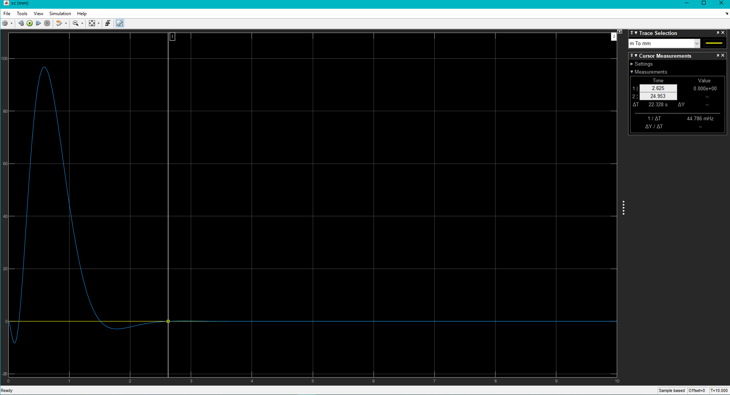

2.625 seconds

Figure : xc response for the pre-lab

The angle, response becomes the following,

2.845 seconds

Figure : angle response for the pre-lab

This indicates that settling time for when is

#### Experiment Results

In the experiment, the exact same gains and poles from the pre-lab were used.

Table : gains for the experiment

|  |  |
| --- | --- |
| K | Gains |
|  | 38.9466 |
|  | -33.0734 |
|  | 14.9005 |
|  | 2.9887 |

Table : poles for the experiment

|  |
| --- |
| poles |
| -3+2.8i |
| -3-2.8i |
| -8 |
| -10 |

The displacement response was the following

Figure : xc response for the experiment

The angle response is the following

Figure : angle response for the experiment

From the two points indicated on the graph we can figure out the settling time, to be

## Analysis & Discussions

### Nonlinear EOMs

The EOM of the cart on the track with a pendulum with force exerted by the servo motor is expressed as the following system equation.

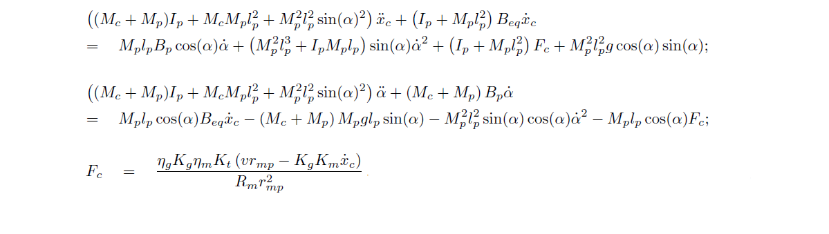

This system equation is highly nonlinear and complicated with terms such as the voltage of the servo motor, angle of pendulum, force exerted on the cart via the motor, viscous damping of the motor, etc. In order to solve this system analytically, it is essential to linearize the system equations.

### Linearized EOMs & Equilibrium Points

Solving these nonlinear equations for the high order differential terms while linearizing them gives the following system equations

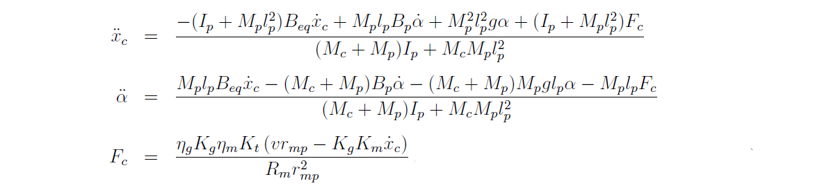

From the nonlinear EOMs we can find the following relationships

Set the input as the voltage , and the output equal to the position of the cart . Then we model a simple Simulink model.

Figure : Simulink model originally made to find the equilibrium points and system matrices

The embedded MATLAB blocks in the model have the following functions

FUNCTION 1:

function y = fcn(u, data)

% FUNCTION 1

Mp = data(1); lp = data(2); Bp = data(3); Ip = data(4); g = data(5);

Beq = data(6); Mc = data(7);

xcdot = u(1); a = u(2); adot = u(3); Fc = u(4);

den = (Mc + Mp)*Ip + Mc*Mp*lp^2 + Mp^2*lp^2*sin(a)^2;

num1 = Mp*lp*Bp*cos(a)*adot;

num2 = (Mp^2*lp^3 + Ip*Mp*lp)*sin(a)*adot^2;

num3 = (Ip + Mp*lp^2)*Fc;

num4 = Mp^2*lp^2*g*cos(a)*sin(a);

num5 = -(Ip + Mp*lp^2)*Beq*xcdot;

y = (num1 + num2 + num3 + num4 + num5) / den;

end

FUNCTION 2:

function y = fcn(u, data)

% FUNCTION 2

Mp = data(1); lp = data(2); Bp = data(3); Ip = data(4); g = data(5);

Beq = data(6); Mc = data(7);

xcdot = u(1); a = u(2); adot = u(3); Fc = u(4);

den = (Mc + Mp)*Ip + Mc*Mp*lp^2 + Mp^2*lp^2*sin(a)^2;

num1 = Mp*lp*cos(a)*Beq*xcdot;

num2 = -(Mc + Mp)*Mp*g*lp*sin(a);

num3 = -Mp^2*lp^2*sin(a)*cos(a)*adot^2;

num4 = -Mp*lp*cos(a)*Fc;

num5 = -(Mc + Mp)*Bp*adot;

y = (num1 + num2 + num3 + num4 + num5) / den;

end

FUNCTION 3:

function y = fcn(u, data)

% FUNCTION 3

Eff_g = data(1); Kg = data(2);

Eff_m = data(3); Kt = data(4); r_mp = data(5);

Km = data(6); Rm = data(7);

xcdot = u(1); v = u(2);

den = Rm*r_mp^2;

num = Eff_g*Kg*Eff_m*Kt * (v*r_mp - Kg*Km*xcdot);

y = num / den;

end

With this model we use the trim(‘sys’, X0) (code is in the appendix) to find the equilibrium points of the system variables. (*X0 is equal to where and everything else is 0). The raw MATLAB results are the following.

Table : raw output of the equilibrium points from MATLAB

|  |  |
| --- | --- |
| xe = 4×1  10-23 ×  0.0000  0  0.0009  0.1654 | dxe = 4×1  10-23 ×  0.0009  0.1654  0.0065  -0.0271 |
| ue = 1.0340e-25 | ye = 1.1638e-38 |

The results are organized to be.

Table : organized equilibrium points

|  |  |
| --- | --- |
| Variable | Equilibrium Point |
|  | ~0 |
|  | ~0 |
|  | ~0 |
|  | ~0 |
|  | ~0 |
|  | ~0 |

### State Variables, State Vector, System Matrices, and Transfer Function

Defining the state variables as,

The state space of this system is

Here,

Then, we use these equilibrium points to compute the A, B, C, and D matrices of the linearized model based on those equilibrium points. The raw output of A, B, C, and D are the following

Table : raw output of the sysmte matrices from MATLAB

|  |  |
| --- | --- |
| A = 4×4  0 0 1.0000 0  0 0 0 1.0000  0 1.5216 -11.6513 0.0049  0 -26.1093 26.8458 -0.0841 | B = 4×1  0  0  1.5304  -3.5261 |
| C = 1×4  1 0 0 0 | D = 0 |

These values agree with the values on the provided lab manual. Now that we have verified the system matrices, use the ss(‘sys’) command is used to create state space system. Next, convert the state space system to a transfer function using the tf(‘sys’) command and obtain the following,

|  |
| --- |
| sys_tf =    1.53 s^2 + 0.1114 s + 34.59  -------------------------------------  s^4 + 11.74 s^3 + 26.96 s^2 + 263.4 s    Continuous-time transfer function. |

This also agrees with the transfer function provided by the lab manual. (*The full code is in the appendix).

### Part (i)

For this part of the experiment we got somewhat close values for the theoretical and experimental natural frequencies.

The percent error of this is

12% deviation is slightly above the bounds of an acceptable experimental result. We will look into why there is a difference between the two in the next conclusion section.

### Part (iii)

For this part of the experiment, there was only one combination of gains, *K* used for the experiment. This is because the response for the gains obtained in the pre-lab was worked out very well for the experiment. Considering the Simulink models being different for the pre-lab and actual experiment, this was fortunate. The settling time for the experiment was faster by 0.641 seconds and showed a very smooth control of the swinging pendulum. However, when observing figure 4 it is notable that there is a slight steady state error for the returning position of the cart. This steady state error was not visible in the pre-lab. The discussion of this will be elucidated in the next section.

### State Feedback and Pole Placement

With the state feedback implemented on the closed loop system, we are able to force the state of the system to go to zero. This is why we can see how the system controls the pendulum quickly and smoothly.

When observing the poles in tables, it is evident that all the poles are located in the left-hand side of the complex plane. This indicates that the feedback system is stable and remains consistent with how the system is controllable. If any of the poles are located in the right-hand side of the complex plane, the system will become unstable and the results will become erroneous.

## Conclusion & Recommendation

### Main Points

For the first part of the experiment, the natural frequencies computed using the theoretical derivation from the EOM and the data from the actual swinging of the pendulum agreed with a 12% deviation. Ideally, it would be better to have a percent error of under 5%-10% but the results are not significantly bad.

For the second part of the experiment, the gantry system was tested using the gains obtained in the pre-lab and the results were very good. The settling time for the pendulum was more than 0.5 seconds quicker than the pre-lab. However, there was a slight error, which is the steady state error for the position of the cart. This is obvious that this error was produced when the angular momentum of the pendulum was offset by the slight momentum of the cart to stop the pendulum from swinging.

### Theoretical/Experimental Limitations

In the first part of the experiment where the experimental natural frequency of the pendulum was measured, a probable cause for the discrepancy between the theoretical and experimental values is how the experimenter held the cart down on the track to keep it still. The shaking of the hand could have been a factor of human error that changed the behavior of the pendulum. Meanwhile, the voltage input could also have been a potential cause of error.

From the results, it is reasonable to deduce the limitations of the cart having a steady state error of its position. As discussed, there has to a slight displacement in order to stop the pendulum from swinging. The tradeoff of reducing the settling time of the pendulum and smoothness of its transition is made by this displacement. Another limitation is the maximum possible values of the gains, *K*. Due to the providable maximum voltage input the gains cannot exceed a number of 200. The system does not necessarily need such high gains but still is a constraint set on the system.

Moreover, theoretically the system must be fed gains that have stable poles. This is crucial to the system and must be satisfied at all times.

### Lessons Learned & Suggestions for Improvement

For the part (i) of the experiment, it would have been better to clip the cart onto the track firmly than to hold it by hand. This will solve the issue of potential human errors.

From this experiment, the most valuable lesson learned was the determination of the gains from the pole placement and how it improved the systems performance by a significant degree. This preaches students to always consider the best method of a closed loop feedback system for future projects.

## Appendix

### Experiment Setup

### Notations for Variables

|  |  |  |  |
| --- | --- | --- | --- |
| **Symbol** | **Description** | **Value** | **Unit** |
| *Rm* | motor armature resistance | 2.6 | Ω |
| *Lm* | motor armature inductance | 0.18 | *mH* |
| *Kt* | motor torque constant | 0.00767 | *N.m/A* |
| *ηm* | motor eﬃciency | 100% | % |
| *Km* | back-electromotive-force(EMF) constant | 0.00767 | *V.s/rad* |
| *Jm* | rotor moment of inertia | 3*.*9 *×* 10*−*7 | *kg.m*2 |
| *Kg* | planetary gearbox ratio | 3*.*71 |  |
| *ηg* | planetary gearbox eﬃciency | 100% | % |
| *Mc*2 | cart mass | 0*.*57 | *kg* |
| *Mw* | cart weight mass | 0*.*37 | *kg* |
| *Mc* | total cart weight mass including motor inertia | 1*.*0731 | *kg* |
| *Beq* | viscous damping at motor pinion | 5*.*4000 | *N.s/m* |
| *Lt* | track length | 0*.*990 | *m* |
| *Tc* | cart travel | 0*.*814 | *m* |
| *Pr* | rack pitch | 1*.*664 *×* 10*−*3 | *m/tooth* |
| *rmp* | motor pinion radius | 6*.*35 *×* 10*−*3 | *m* |
| *Nmp* | motor pinion number of teeth | 24 |  |
| *rpp* | position pinion radius | 0*.*01482975 | *m* |
| *Npp* | position pinion number of teeth | 56 |  |
| *KEP* | cart encoder resolution | 2*.*275 *×* 10*−*5 | *m/count* |
| *Mp* | long pendulum mass with T-fitting | 0*.*230 | *kg* |
| *Mpm* | medium pendulum mass with T-fitting | 0*.*127 | *kg* |
| *Lp* | long pendulum length from pivot to tip | 0*.*6413 | *m* |
| *Lpm* | medium pendulum length from pivot to tip | 0*.*3365 | *m* |
| *lp* | long pendulum length: pivot to center of mass | 0*.*3302 | *m* |
| *lpm* | medium pendulum length: pivot to center of mass | 0*.*1778 | *m* |
| *Jp* | long pendulum moment of inertia ⟳ center of mass | 7*.*88 *×* 10*−*3 | *kg.m*2 |
| *Jpm* | medium pendulum moment of inertia ⟳ center of mass | 1*.*20 *×* 10*−*3 | *kg.m*2 |
| *Bp* | viscous damping at pendulum axis | 0*.*0024 | *N.m.s/rad* |
| *g* | gravitational constant | 9*.*81 | *m/s*2 |
| *v* | voltage of servo motor | variable | *V* |

### MATLAB Code

#### Data Manipulation (loading & plotting)

% MATLAB CODE TO FIND THE NATURAL FREQUENCY FROM EXPERIMENTALLY

% TOMOKI KOIKE

clear all; close all; clc;

fdir = 'C:\Users\Tomo\Desktop\studies\2020-Fall\AAE364lab\matlab\lab2\outputs';

set(groot, 'defaulttextinterpreter','latex');

set(groot, 'defaultAxesTickLabelInterpreter','latex');

set(groot, 'defaultLegendInterpreter','latex');

% Load the experimental data

load("lab2-part1-theta-tomoki.mat");

% Plotting the angles

tspan = part1_theta.time;

thetaS = part1_theta.signals.values;

fig1 = figure(1);

plot(tspan, thetaS)

title('Pendulum Angle When the Cart is Fixed - T. Koike')

xlabel('time, [s]')

ylabel('angle $\theta$, [rad]')

grid on; grid minor; box on;

% MATLAB CODE FOR PART (III) OF THE EXPERIMENT

% TOMOKI KOIKE

clear all; close all; clc;

fdir = 'C:\Users\Tomo\Desktop\studies\2020-Fall\AAE364lab\matlab\lab2\outputs';

set(groot, 'defaulttextinterpreter','latex');

set(groot, 'defaultAxesTickLabelInterpreter','latex');

set(groot, 'defaultLegendInterpreter','latex');

load("lab2-part2-displacemnet-tomoki.mat");

load("lab2-part2-theta-tomoki.mat");

% Get the data

tspan = part2_displacement.time;

xc = part2_displacement.signals.values;

alpha = part2_theta.signals.values;

% Plot

fig1 = figure(1);

plot(tspan, xc)

title('Gantry Stabilizing Back to Original Position - T. Koike')

xlabel('time, [s]')

ylabel('position $x_c$, [m]')

grid on; grid minor; box on;

fig1 = figure(1);

plot(tspan, alpha)

title('Gantry Stabilizing of Pendulum - T. Koike')

xlabel('time, [s]')

ylabel('angle $\alpha$, [m]')

grid on; grid minor; box on;

#### Data Analysis

% EXPERIMENT DATA ANALYSIS MATLAB CODE

% TOMOKI KOIKE

clear all; close all; clc;

% Get the equilibrium points of the system

[xe, ue, ye, dxe] = trim('linearized_EOM')

[A, B, C, D] = linmod('linearized_EOM', xe, ue)

sys_ss = ss(A,B,C,D)

sys_tf = tf(sys_ss)

### Simulink Models

#### Prelab Models

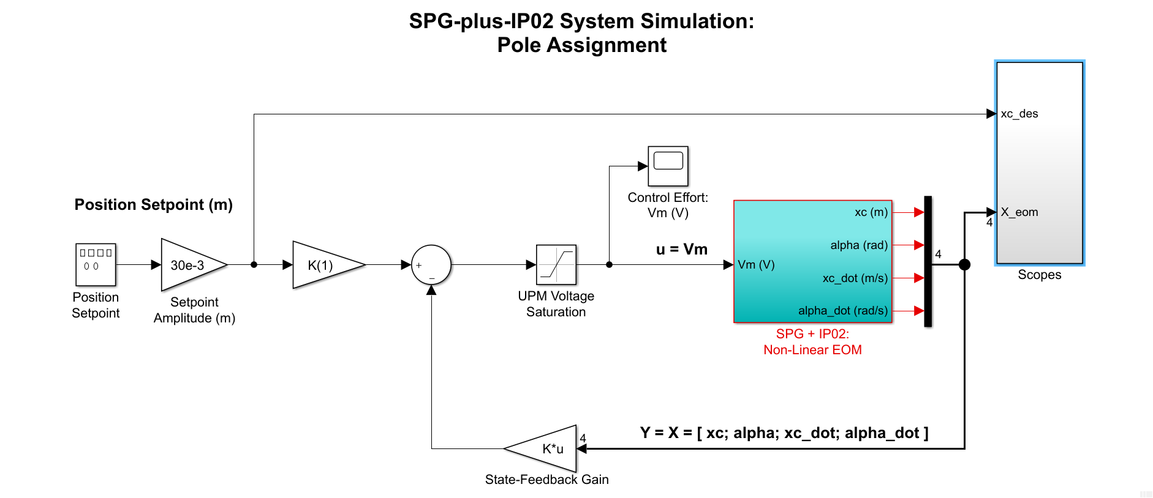

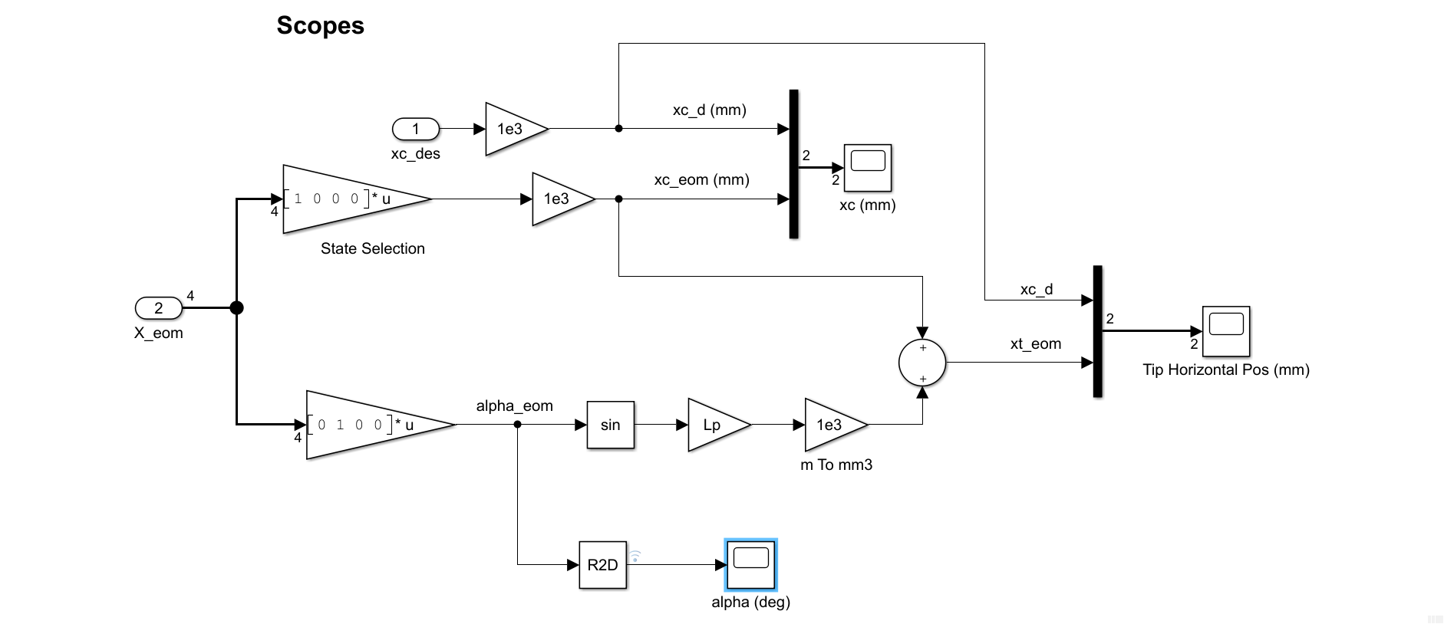

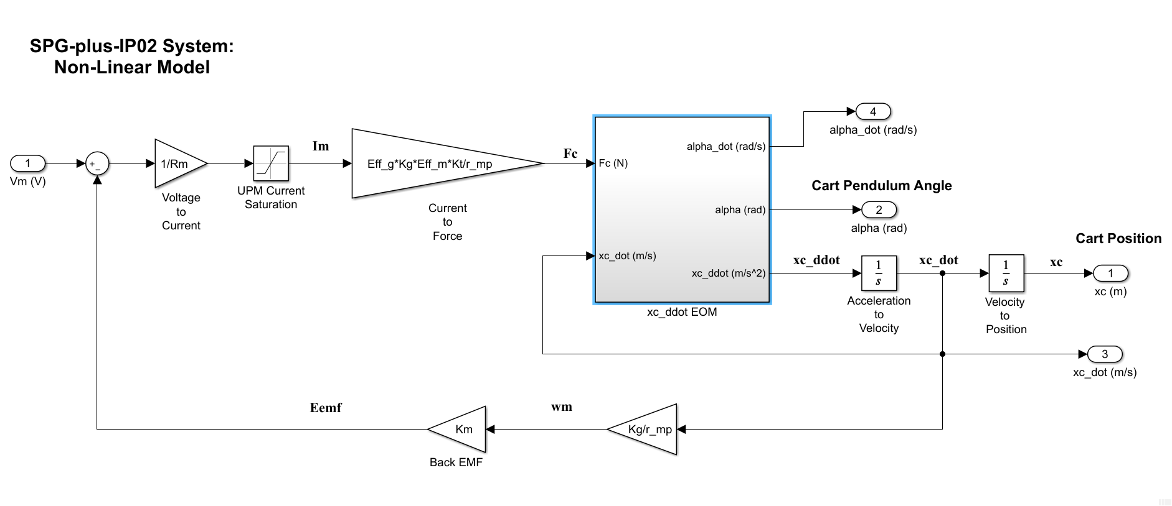

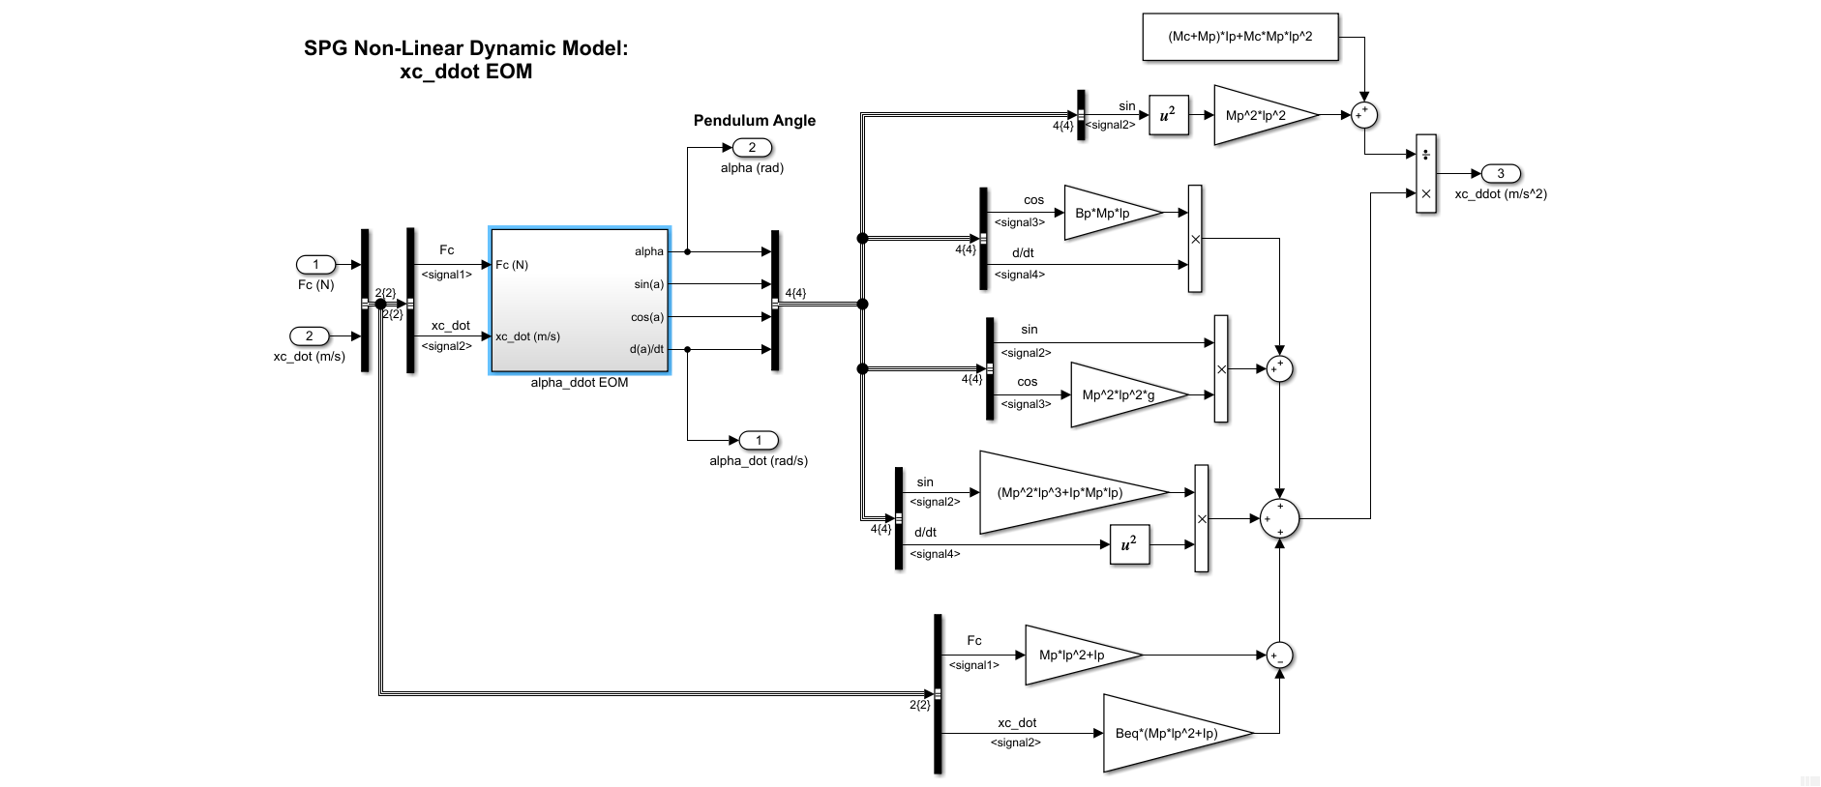

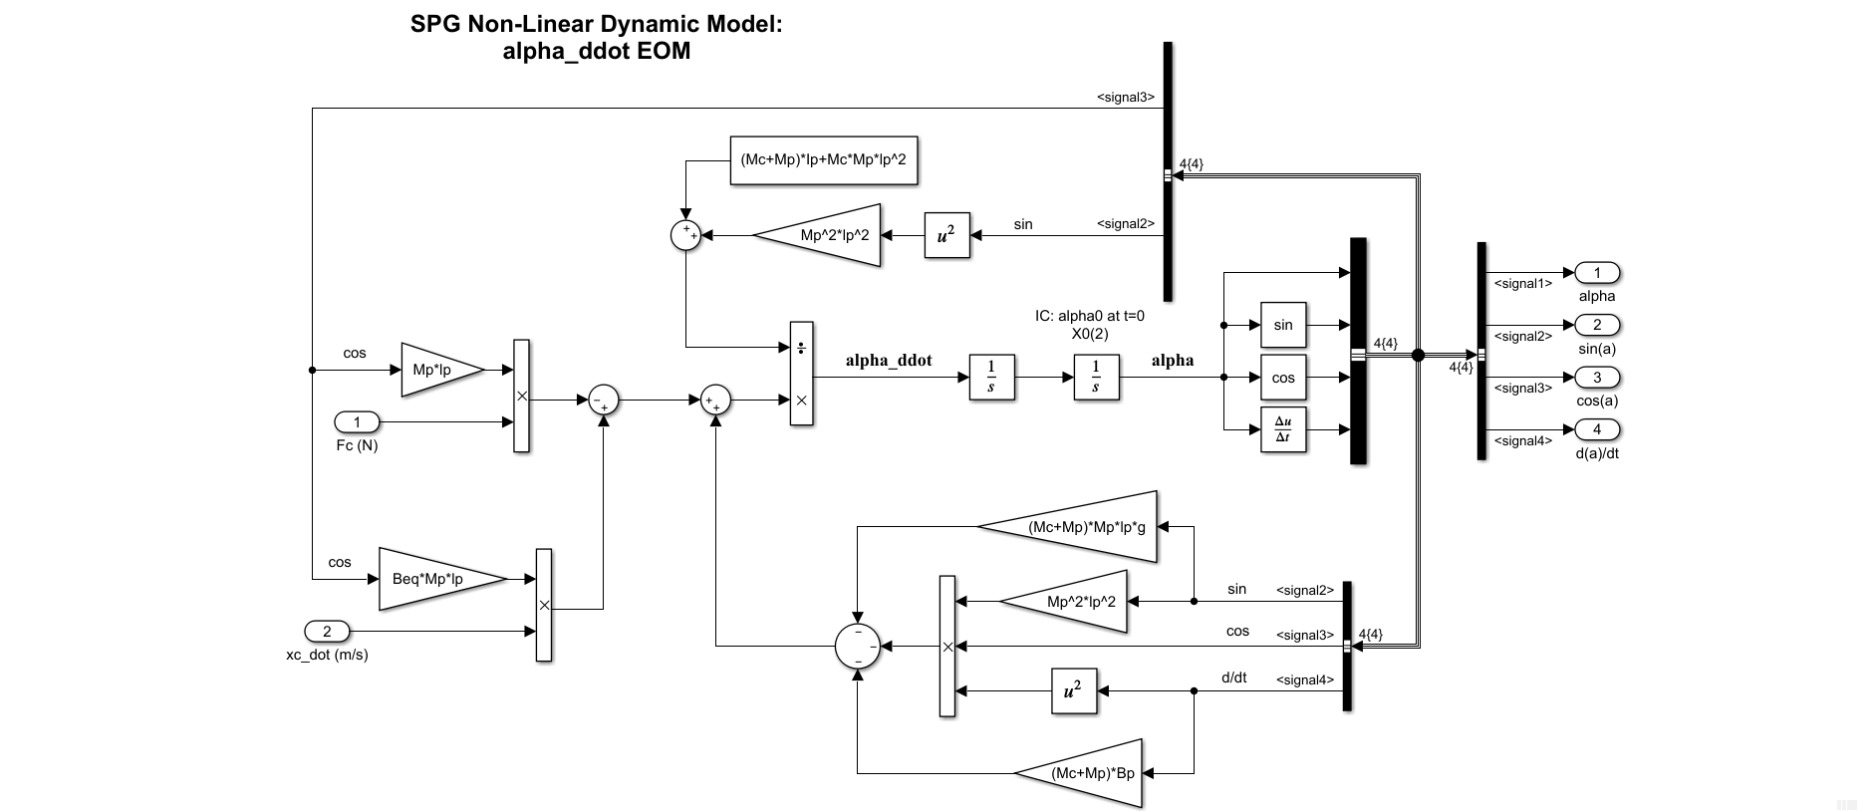

#### Original Models

