College of Engineering

School of Aeronautics and Astronautics

AAE 36401 Lab

Control Systems Lab

Lab 3 Report

The Control of Inverted Pendulum to Balance

*Author:*

Tomoki Koike

*Supervisor, TA:*

A. E. Frazho, Zihao Liang

November 6th, 2020

Purdue University

West Lafayette, Indiana

## Introduction

### Objective

The object of this lab is to control an inverted pendulum on a cart which is place on a track. Alike the previous lab, the pendulum will be controlled in its upright orientation; however, in this experiment the pendulum will maintain the orientation while having the cart move sideways based on a square wave input. The objective is the input gains into the feedback system to maintain a stable upright orientation.

### Method

To accomplish the objective, we have to come up with the gains of the feedback control system. For this experiment, the gains will be computed by the LQR method. Then the gains will be input to the Simulink model that is synced to the experimental setup. The cart will move based on the square wave input and the data is obtain from the response.

## Results

### Part (i)

The gains used for each method are the following

The gains using LQR:

Table 1: gains for linear quadratic regulator

|  |  |  |  |  |
| --- | --- | --- | --- | --- |
|  |  |  |  |  |
| -68.8145 | 156.0625 | -51.6130 | 33.2344 | 44.7214 |

The diagonal matrix, Q used for the linear quadratic regulator is the following

The weight, R is

The poles for LQR:

Table 2: poles for linear quadratic regulator

|  |  |  |  |  |
| --- | --- | --- | --- | --- |
|  |  |  |  |  |
| -40.5785 | -2.6398+0.8961i | -2.6398-0.8961i | -2.0395+0.8637i | -2.0395-0.8637i |

## Analysis & Discussions

### Part (i)

The time history is graphed as the following.

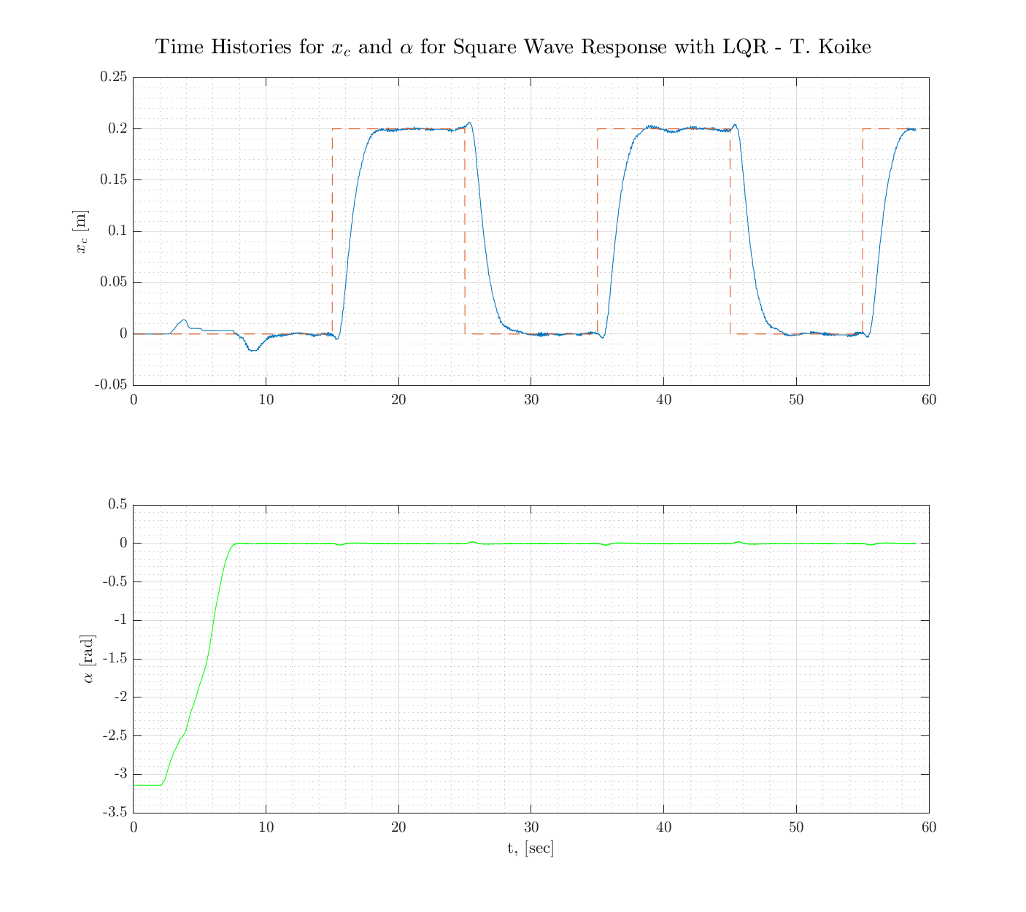

Initially the angle of the pendulum is , but its lifted up slowly be . From the results we can see that we have a system that satisfies the requirements of maintaining the upright orientation of the pendulum while the cart is moving sideways with a square wave input.

We can see that the position values of the cart have some degree of discrepancy. Namely, there is some steady state error at the end of each square wave but overall it is smooth and coherent with the input.

## Conclusion & Recommendation

### Main Points

From the results, we can observe that the experiment is successful with a system that maintains a pendulum at a upright position while the cart has a dynamic motion. The angle of the pendulum is maintaining 0 degrees with a significantly small error.

### Theoretical/Experimental Limitations

The motion of the cart is one limitation that we can see from the plots.

Another limitation common to all the other labs performed is the voltage limit that prevents us to have a gain larger than 200.

### Lessons Learned & Suggestions for Improvement

The utmost lesson from this lab is the implementation of linear quadratic regulators to control complex tasks.

## Appendix

### Experiment Setup

### Notations for Variables

|  |  |  |  |
| --- | --- | --- | --- |
| **Symbol** | **Description** | **Value** | **Unit** |
| *Rm* | motor armature resistance | 2.6 | Ω |
| *Lm* | motor armature inductance | 0.18 | *mH* |
| *Kt* | motor torque constant | 0.00767 | *N.m/A* |
| *ηm* | motor eﬃciency | 100% | % |
| *Km* | back-electromotive-force(EMF) constant | 0.00767 | *V.s/rad* |
| *Jm* | rotor moment of inertia | 3*.*9 *×* 10*−*7 | *kg.m*2 |
| *Kg* | planetary gearbox ratio | 3*.*71 |  |
| *ηg* | planetary gearbox eﬃciency | 100% | % |
| *Mc*2 | cart mass | 0*.*57 | *kg* |
| *Mw* | cart weight mass | 0*.*37 | *kg* |
| *Mc* | total cart weight mass including motor inertia | 1*.*0731 | *kg* |
| *Beq* | viscous damping at motor pinion | 5*.*4000 | *N.s/m* |
| *Lt* | track length | 0*.*990 | *m* |
| *Tc* | cart travel | 0*.*814 | *m* |
| *Pr* | rack pitch | 1*.*664 *×* 10*−*3 | *m/tooth* |
| *rmp* | motor pinion radius | 6*.*35 *×* 10*−*3 | *m* |
| *Nmp* | motor pinion number of teeth | 24 |  |
| *rpp* | position pinion radius | 0*.*01482975 | *m* |
| *Npp* | position pinion number of teeth | 56 |  |
| *KEP* | cart encoder resolution | 2*.*275 *×* 10*−*5 | *m/count* |
| *Mp* | long pendulum mass with T-fitting | 0*.*230 | *kg* |
| *Mpm* | medium pendulum mass with T-fitting | 0*.*127 | *kg* |
| *Lp* | long pendulum length from pivot to tip | 0*.*6413 | *m* |
| *Lpm* | medium pendulum length from pivot to tip | 0*.*3365 | *m* |
| *lp* | long pendulum length: pivot to center of mass | 0*.*3302 | *m* |
| *lpm* | medium pendulum length: pivot to center of mass | 0*.*1778 | *m* |
| *Jp* | long pendulum moment of inertia ⟳ center of mass | 7*.*88 *×* 10*−*3 | *kg.m*2 |
| *Jpm* | medium pendulum moment of inertia ⟳ center of mass | 1*.*20 *×* 10*−*3 | *kg.m*2 |
| *Bp* | viscous damping at pendulum axis | 0*.*0024 | *N.m.s/rad* |
| *g* | gravitational constant | 9*.*81 | *m/s*2 |
| *v* | voltage of servo motor | variable | *V* |

### MATLAB Code

% AAE 364L LAB4 MATLAB CODE

% TOMOKI KOIKE

clear all; close all; clc;

set(groot, 'defaulttextinterpreter','latex');

set(groot, 'defaultAxesTickLabelInterpreter','latex');

set(groot, 'defaultLegendInterpreter','latex');

% Load result data

pos = load("koike_lab4\koike_lab4_xc.mat");

angle = load("koike_lab4\koike_lab4_theta.mat");

% PP

t = pos.x_and_coimmand_part3.time;

xc = pos.x_and_coimmand_part3.signals.values(:,1);

command = pos.x_and_coimmand_part3.signals.values(:,2);

theta = angle.theta_part3.signals.values;

% Plotting

fig = figure('Renderer',"painters", 'Position', [10 10 900 800]);

subplot(2,1,1)

plot(t,xc)

grid on; grid minor; box on; hold on;

plot(t, command, '--')

hold off

ylabel('$x_c$ [m]')

subplot(2,1,2)

plot(t,theta, '-g')

grid on; grid minor; box on;

ylabel('$\alpha$ [rad]')

xlabel('t, [sec]')

sgtitle('Time Histories for $x_c$ and $\alpha$ for Square Wave Response with LQR - T. Koike')

saveas(fig, 'response.png')

### Simulink Models

