College of Engineering

School of Aeronautics and Astronautics

AAE 36401 Lab

Control Systems Lab

Lab 5 Pre-Lab

The Control of the Inverted Pendulum

*Author:*

Tomoki Koike

*Supervisor:*

A. E. Frazho

October 9th, 2020

Purdue University

West Lafayette, Indiana

The gains using Pole Placement:

|  |  |  |  |  |
| --- | --- | --- | --- | --- |
| $$K_{1}$$ | $$K_{2}$$ | $$K_{3}$$ | $$K_{4}$$ | $$K_{5}$$ |
| -76.5544 | 91.0760 | -37.9289 | 18.5217 | 94.4953 |

The gains using LQR:

|  |  |  |  |  |
| --- | --- | --- | --- | --- |
| $$K_{1}$$ | $$K_{2}$$ | $$K_{3}$$ | $$K_{4}$$ | $$K_{5}$$ |
| -49.9747 | 156.3945 | -45.5208 | 36.5653 | 31.6228 |

The poles for Pole Placement:

|  |  |  |  |  |
| --- | --- | --- | --- | --- |
| $$λ_{1}$$ | $$λ_{2}$$ | $$λ_{3}$$ | $$λ_{4}$$ | $$λ_{5}$$ |
| -5+3.5i | -5-3.5i | -3+4.5i | -3-4.5i | -3 |

The poles for LQR:

|  |  |  |  |  |
| --- | --- | --- | --- | --- |
| $$λ_{1}$$ | $$λ_{2}$$ | $$λ_{3}$$ | $$λ_{4}$$ | $$λ_{5}$$ |
| -64.3972 | -2.0915 + 1.3698i | -2.0915 - 1.3698i | -1.2125 + 1.1168i | -1.2125 - 1.1168i |

Plot for LQR

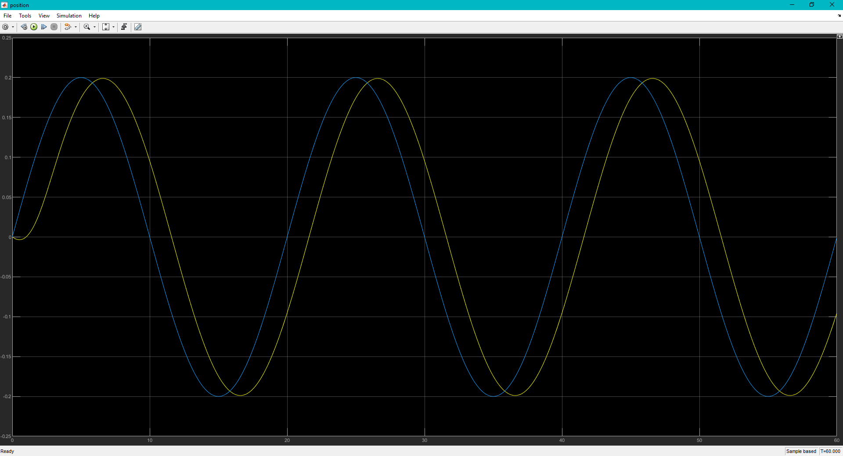

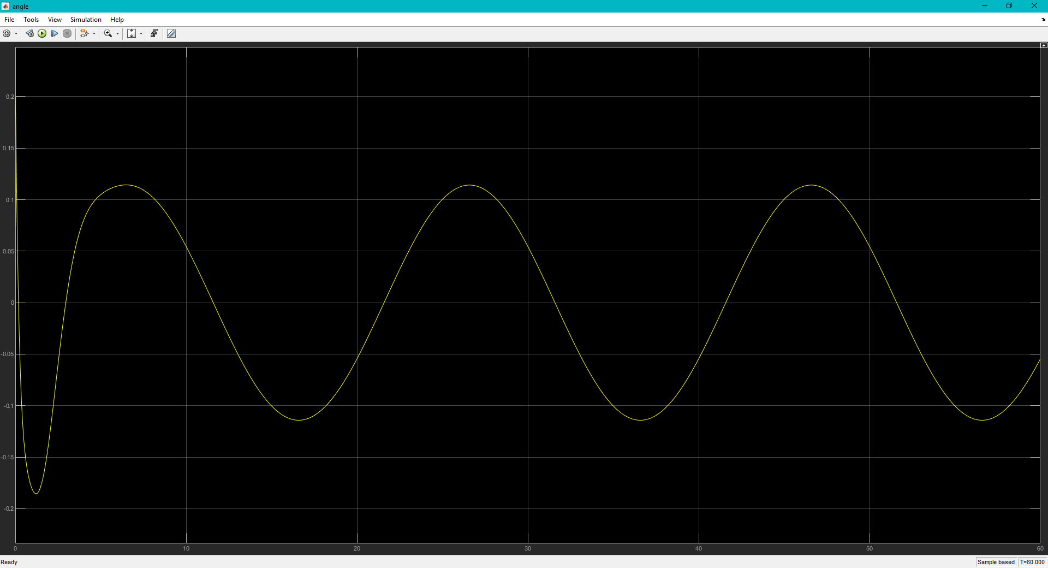

Plot for Pole Placement

