College of Engineering

School of Aeronautics and Astronautics

AAE 421

Flight Dynamics and Controls

HW 2

Aerodynamics, Longitudinal Stability, & Linearization

*Author:*

Tomoki Koike

*Supervisor:*

Ran Dai

September 29th, 2020

Purdue University

West Lafayette, Indiana

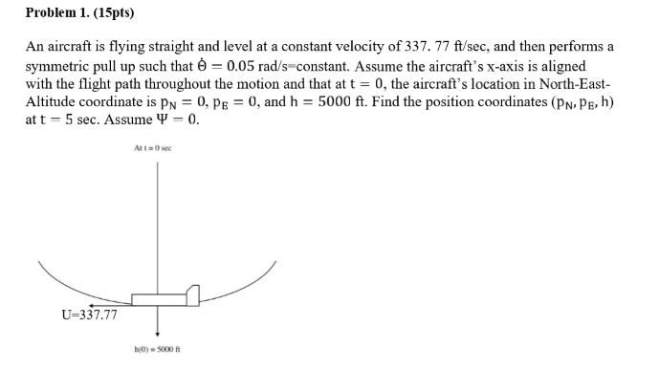

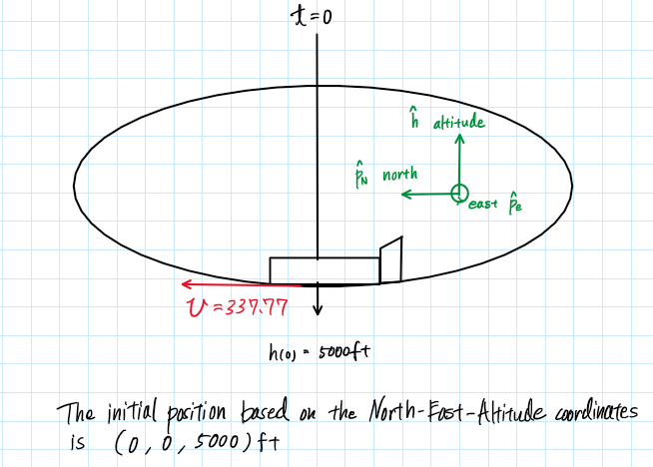

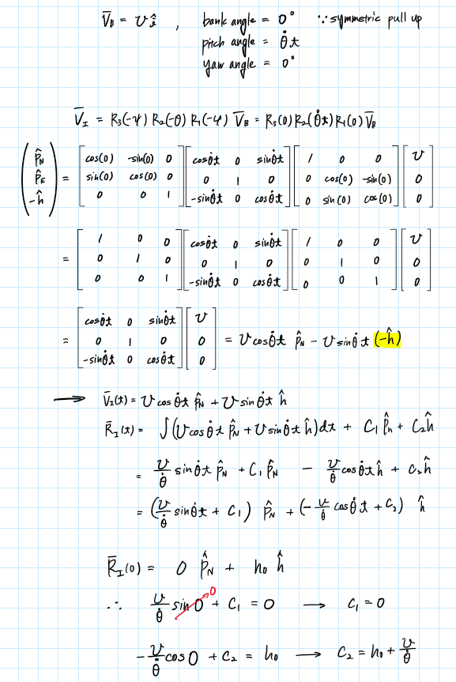

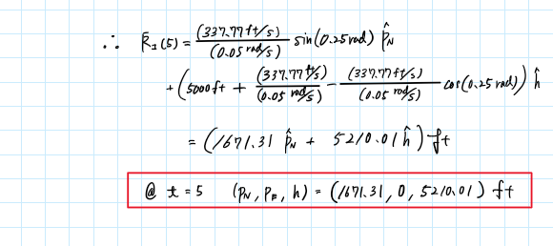

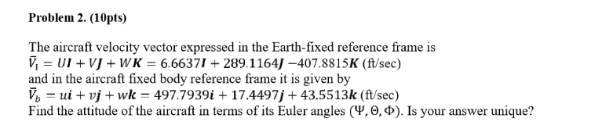

From the lecture notes, we know that

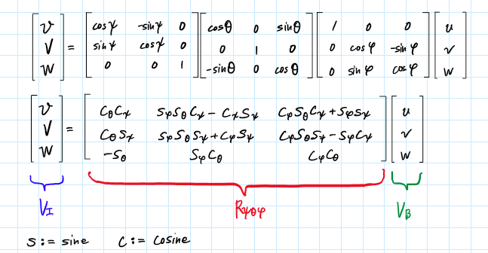

Then using the following code implementing the Global Optimization Toolbox in MATLAB we can get the Euler Angles

clear all; close all; clc;

V_i = [6.6637; 289.1164; -407.8815]; % [ft/s]

V_b = [497.7939; 17.4497; 43.5513]; % [ft/s]

% Global optimization

start = [0,0,0];

lb = [0,0,0]; ub = [2*pi, 2*pi, 2*pi];

A = []; b = [];

Aeq = []; beq = [];

objective = @(param) objfunc(param, V_i, V_b);

[angles, fval] = patternsearch(objective,start,A,b,Aeq,beq,lb,ub);

psi_opt=angles(1)-2*pi

theta_opt=angles(2)

phi_opt=angles(3)-2*pi

rad2deg(psi_opt)

rad2deg(theta_opt)

rad2deg(phi_opt)

% Objective function for the global optimization

function res = objfunc(param, V_i, V_b)

psi = param(1); theta = param(2); phi = param(3);

R_psi = [cos(psi), -sin(psi), 0;

sin(psi), cos(psi), 0;

0, 0, 1];

R_theta = [ cos(theta), 0, sin(theta);

0, 1, 0;

-sin(theta), 0, cos(theta)];

R_phi = [1, 0, 0;

0, cos(phi), -sin(phi);

0, sin(phi), cos(phi)];

temp = R_psi * R_theta * R_phi * V_b - V_i;

res = norm(temp);

end

This gives us the following angles

|  |  |  |
| --- | --- | --- |
| Euler Angle | radian | degree |
|  | -1.4667 | -84.0359 |
|  | 2.1250 | 121.7535 |
|  | -1.8623 | -106.7615 |

Then validate that this is correct with the following code

function V_i = Vrot_BF2IF(psi, theta, phi, V_b)

%{

NAME: ROT_BF2IF

AUTHOR: TOMOKI KOIKE

INPUTS: (1) psi: THE YAW ANGLE (AROUND THE BODY Z-AXIS) IN

RADIANS

(2) theta: THE PITCH ANGLE (AROUND THE BODY Y-AXIS) IN

RADIANS

(3) phi: THE ROLL/BANK ANGLE (AROUND THE BODY X-AXIS) IN

RADIANS

(4) V_b: THE VELOCITY VECTOR IN THE BODY FRAME 3x1

OUTPUTS: (1) V_i: THE VELOCITY VECTOR IN THE INERTIAL FRAME 3x1

DESCRIPTION: CONVERTS THE VELOCITY WITH RESPECT TO THE BODY FRAME TO

THE VELOCITY WITH RESPECT TO THE INERTIAL FRAME.

%}

[rows, cols] = size(V_b);

if rows == 3 && cols == 1

elseif rows == 1 && cols == 3

V_b = reshape(V_b, [3, 1]);

else

error('Incorrect dimensions for the velocity vector');

end

R_psi = [cos(psi), -sin(psi), 0;

sin(psi), cos(psi), 0;

0, 0, 1];

R_theta = [ cos(theta), 0, sin(theta);

0, 1, 0;

-sin(theta), 0, cos(theta)];

R_phi = [1, 0, 0;

0, cos(phi), -sin(phi);

0, sin(phi), cos(phi)];

V_i = R_psi * R_theta * R_phi * V_b;

end

% Validate optimization

V_i_validation = Vrot_BF2IF(psi_opt, theta_opt, phi_opt, V_b)

The validation gives us the following velocity vector for the inertial frame

|  |
| --- |
| V_i_validation = 3×1  6.6639  289.1167  -407.8812 |

This is approximately the same as the values given in the problem statement. Thus, we confirmed that our Euler angles are correct.

Now, for the Euler angles, we can add 360 degrees to all the angles, and we will still get the same outcome. Thus, the Euler angle that we have obtained are not unique.

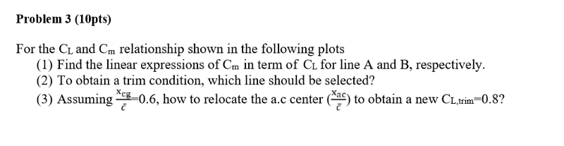

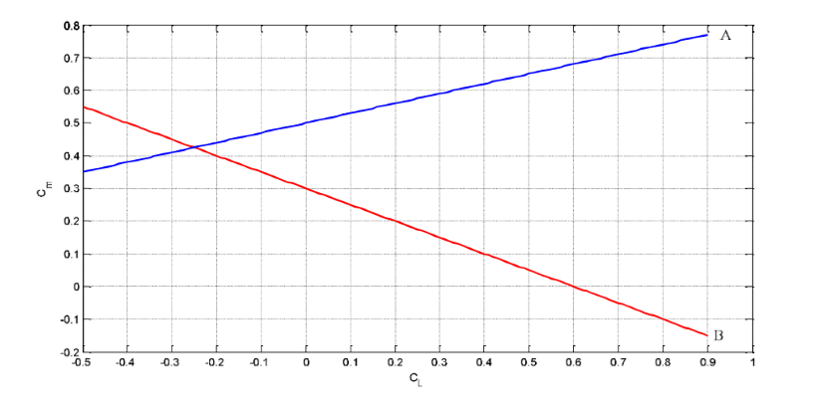

1. The 4 points have the following values

|  |  |  |
| --- | --- | --- |
| Point |  |  |
|  | -0.50 | 0.35 |
|  | 0.34 | 0.60 |
|  | -0.20 | 0.40 |
|  | 0.40 | 0.10 |

The slope for each line A and B becomes

The y-intercepts for each line A and B is (indicated as a cross in the graph) 0.50 and 0.30 respectively. Thus, the equations for line A and B are given by

Answers:

(b) Since the condition for longitudinal static stability is

Since with , then an equivalent condition for longitudinal static stability is that

Thus, line B is the line that should be selected to obtain a trim condition.

(c) From the relation

Then we have,

Hence, if we change then changes. This means that we want to change the slope of line B to have . For this the new slope becomes

Hence, where

The original location of the aerodynamic center was

Hence,

We have to relocate the aerodynamic center by 0.125 from the original position for line B.

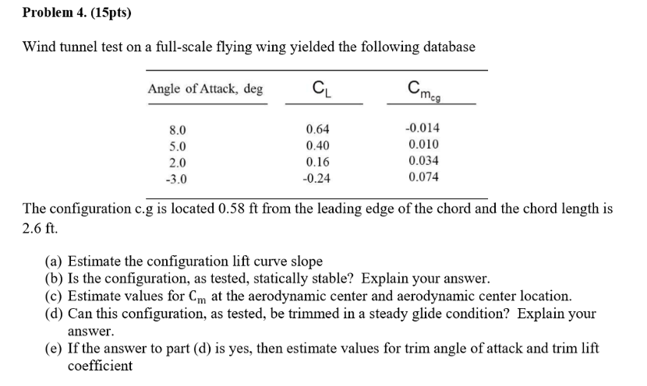

1. .

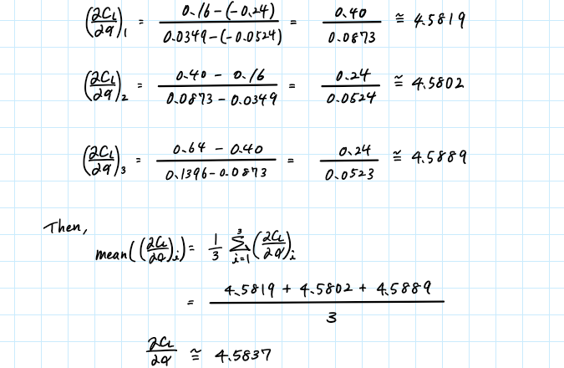

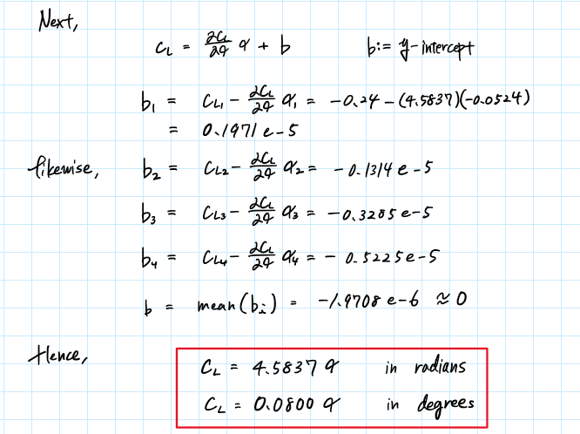

Verify this using MATLAB

clear all; close all; clc;

% (a)

alpha_deg = [-3.0, 2.0, 5.0, 8.0]; % angle of attack [deg]

alpha_rad = deg2rad(alpha_deg); % angle of attack array in radians [rad]

Cl = [-0.24, 0.16, 0.40, 0.64]; % lift coefficients

Cm_cg = [0.074, 0.034, 0.010, -0.014]; % pitch moment coefficients w.r.t the cg

x_cg = 0.58; % [ft] from the leading edge of the chord

% y-intercept estitmation

slope = 4.5837;

bs = []

for i = 1:numel(alpha_rad)

b = Cl(i) - slope*alpha_rad(i);

bs = [bs, b];

end

bs

b_mean = mean(bs)

% Linear fit for the lift coefficient over angle of attack (deg)

p = polyfit(alpha_deg, Cl, 1)

Cl_fit = polyval(p, alpha_deg)

Cl_resid = Cl - Cl_fit

SSresid = sum(Cl_resid.^2)

SStotal = (length(Cl)-1) * var(Cl)

rsq = 1 - SSresid/SStotal

rsq_adj = 1 - SSresid/SStotal * (length(Cl)-1)/(length(Cl)-length(p))

% Linear fit for the lift coefficient over angle of attack (rad)

p = polyfit(alpha_rad, Cl, 1)

Cl_fit = polyval(p, alpha_rad)

Cl_resid = Cl - Cl_fit

SSresid = sum(Cl_resid.^2)

SStotal = (length(Cl)-1) * var(Cl)

rsq = 1 - SSresid/SStotal

rsq_adj = 1 - SSresid/SStotal * (length(Cl)-1)/(length(Cl)-length(p))

The result is identical to the calculations done by hand.

|  |  |  |
| --- | --- | --- |
|  | slope | y-intercept |
| radians | 4.5837 | ~0 |
| degrees | 0.0800 | ~0 |
|  |  |  |
|  |  | ~ 1 |

1. .

Compute the pitch moment gradient with respect to the angle of attack for the given data using MATLAB

dCm_da = [];

for i = 1:numel(alpha_rad)-1

dCm_da_i = (Cm_cg(i+1) - Cm_cg(i)) / (alpha_rad(i+1) - alpha_rad(i));

dCm_da = [dCm_da, dCm_da_i];

end

dCm_da

dCm_da_mean = mean(dCm_da)

Thus,

The pitch moment gradient with respect to the angle of attack is negative meaning that the configuration is statically stable.

1. .

From the equation of that we have computed in part (a) we know that the lift coefficient is zero when the angle of attack, is zero. Thus, we interpolate the pitching moment values for angle of attack of zero. This pitching moment is the moment at the aerodynamic center.

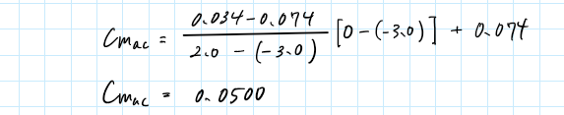

MATLAB also gives us the same value

% Interpolation

Cm_ac = interp1(alpha_deg, Cm_cg, 0);

Cm_ac = 0.0500

Hence,

Then, to find we use the following two values

We are also given that

We can plug these values into the following equation

Hence,

Thus, from the leading edge

1. .

Since, and , the graph of the pitching moment becomes like the follow

Thus, we can tell that this configuration is possible to have a trim condition for a steady level flight.

1. .

From interpolation, we can find the angle where the pitching moment is zero.

This agrees with the MATLAB results

% Interpolation to find the trim angle of attack

alpha_trim = interp1(Cm_cg, alpha_deg, 0);

alpha_trim = 6.2500

Then interpolate the lift coefficient based on this trim angle of attack

This is congruent with the results computed by MATLAB

% Interpolation to find the trim lift coefficient

Cl_trim = interp1(alpha_deg, Cl, alpha_trim);

Cl_trim = 0.5000

**Problem 5. (10pts)**

Consider the following nonlinear 2nd-order system

where and are constant, and .

1. For a constant input , determine the equilibrium points of the system
2. Obtain the linearized equations of the system at the equilibrium points
3. Express the linearized model in state equations, choosing , , and
4. .

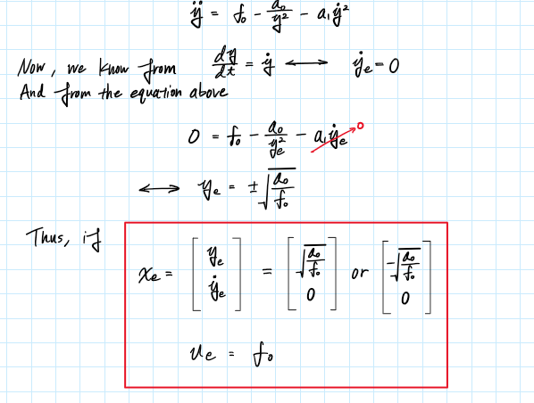

1. .

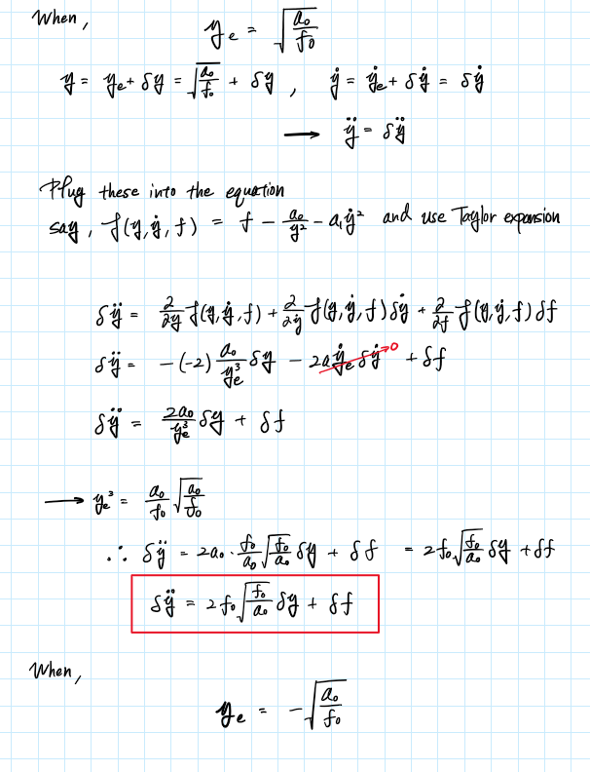

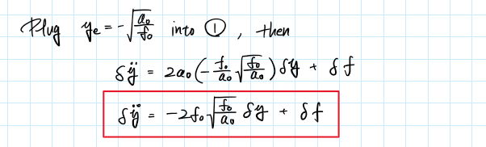

1. .

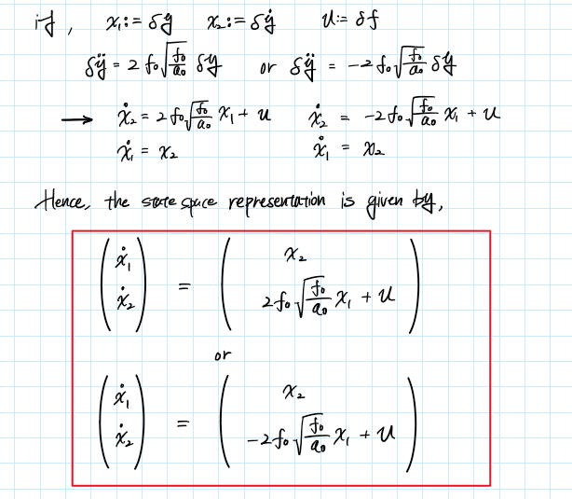

**Problem 6. (10 pts)**

consider an airplane in constant-altitude, straight-line flight. The velocity equation is

where the second term represents aerodynamic drag, and assume = constant, and is the engine thrust acceleration. Treat as the control (input). Let be a given constant cruise speed. Obtain the linearized differential equation for the velocity around .

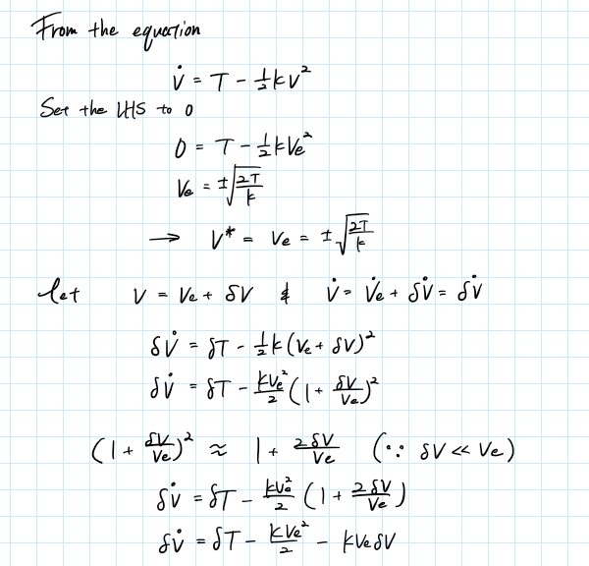

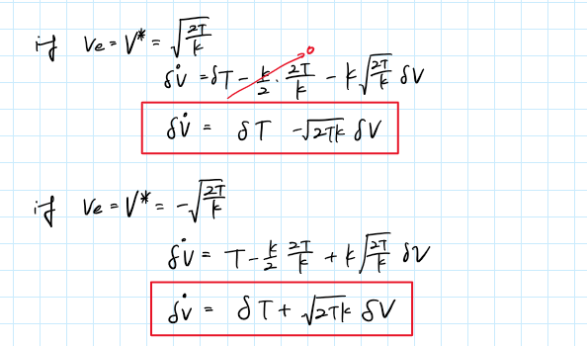

**Problem 7. (15pts)**

From the nonlinear flight dynamics model, derive the following linear perturbation equations for Y force

And moments

Show all steps.

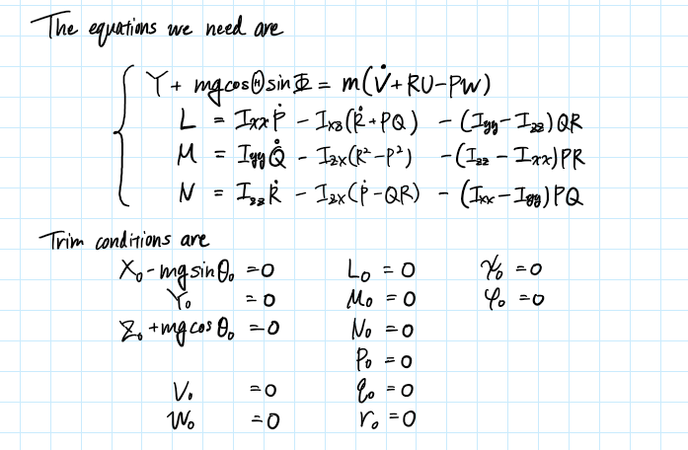

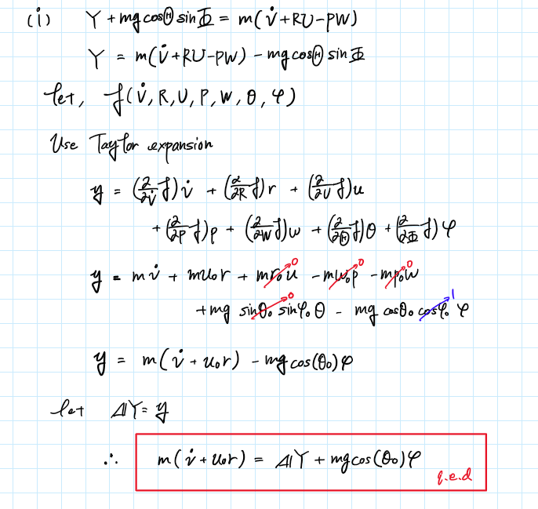

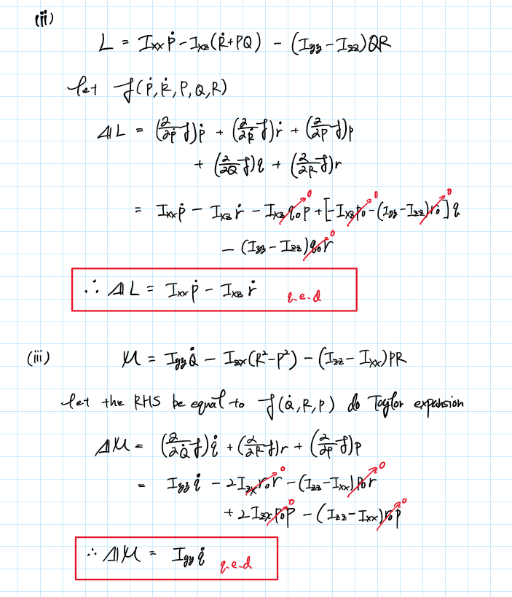

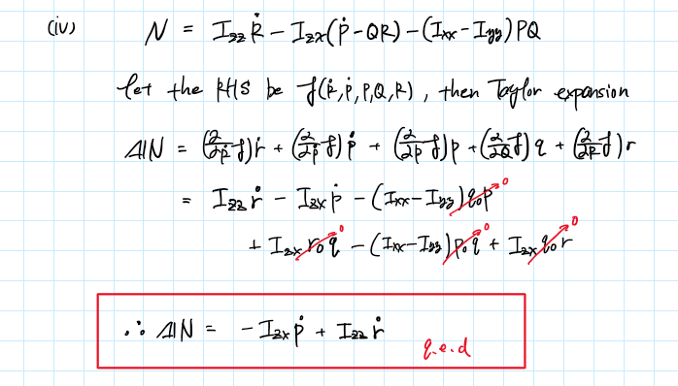

**Problem 8. (15 pts)**

Consider the 2-degree-of-freedom spring mass pendulum shown below (All motion is in the plane of the picture shown). The nonlinear equations of motion are given by

where is the original spring length.

Linearize the equations of motion for this system. Let the reference condition be the equilibrium (no motion) state for the pendulum mass. In particular

1. Define a set of perturbation variables
2. Substitute the results of Part (a) into the equations of motion
3. Expand the equations and discard appropriate terms (show the terms that are to be discarded)

