College of Engineering

School of Aeronautics and Astronautics

AAE 532

Orbital Mechanics

PS 1

Discussion of Space Missions and Dwarf Planets

*Author:*

Tomoki Koike

*Supervisor:*

K. C. Howell

September 4th, 2020 Friday

Purdue University

West Lafayette, Indiana

Problem 1:

NASA’s OSIRIS-REx (Origins, Spectral Interpretation, Resource Identification, Security, Regolith Explorer) is the first mission from the US to return an asteroid sample to Earth. The goal is a visit to an asteroid whose regolith may contain precursors to the molecules that originally seeded life. So, the spacecraft will collect a sample and then return it to Earth. The selected asteroid is 101955 Bennu. The physical and chemical properties of Bennu well also offer information concerning the natural resources of asteroids for use in future exploration missions. The spacecraft is currently orbiting asteroid Bennu and spent two years mapping the asteroid before collecting a sample and then preparing for the return to Earth.

The spacecraft was launched September 8, 2016. On December 3, 2018m maneuvers allowed the spacecraft to rendezvous with the asteroid. This step commenced the two years of mapping and now, in 2020, OSIRIS-REx is ready to collect the sample. In March 2021, the appropriate phasing for a successful trajectory that returns to Earth becomes available and, after two and one half years, the spacecraft and its sample (2.1 ounces) arrives back at Earth in September 2023.

A planar projection of the trajectory path for OSIRIS-REx appears on the left. On the right, the image focuses on the arrival scenario.

1. Consider the candidate asteroid 101955 Bennu. Go to a NASA website and collect information about Bennu. Information from near Earth observations suggest that Bennu has an interesting shape as shown above. Find its size, dimensions, and density. Compare its size to a structure in your local community. Bennu is a B-type asteroid. What does that mean?

|  |  |  |
| --- | --- | --- |
| 101955 Bennu | | |
| size | equatorial radius [km] | 0.25 |
| dimensions | equatorial circumference [km] | 1.6 |
|  | volume [km^3] | 0.0623 |
|  | mass [kg] | 78000000000 |
|  | surface area [km^2] | 0.79 |
| density [g/cm^3] | 1.26 |  |

101955 Bennu is classified as a B-type asteroid which means that they are relatively similar to C-type asteroids that are fecund with carbonaceous composition, however are different from them in that its spectrum is more bluish rather than reddish because the ultraviolet absorption below 0.5 μm is small or close to absent. Also, the albedo of the B-type is more likely to be greater than the C-type. From spectroscopy shows that B-type asteroids are mainly composed of anhydrous silicates, organic polymers, hydrated clay minerals, magnetite, and sulfides.

1. Bennu’s surface is believed to be relatively rough and strewn with boulders. Can you find an image of the surface? OSIRIS-REx will touch down on the surface to collect a sample. Describe that plan in a short paragraph. Note the one of the concepts is reflected in this image. What date is OSIRIS-REx scheduled to collect the sample?

Image showing the four sides of Bennu (source from NASA: <https://solarsystem.nasa.gov/asteroids-comets-and-meteors/asteroids/101955-bennu/galleries/?page=0&per_page=25&order=created_at+desc&search=&fancybox=true&href_query_params=category%3Dsmall-bodies_asteroids&button_class=big_more_button&tags=bennu&condition_1=1%3Ais_in_resource_list&category=51>)

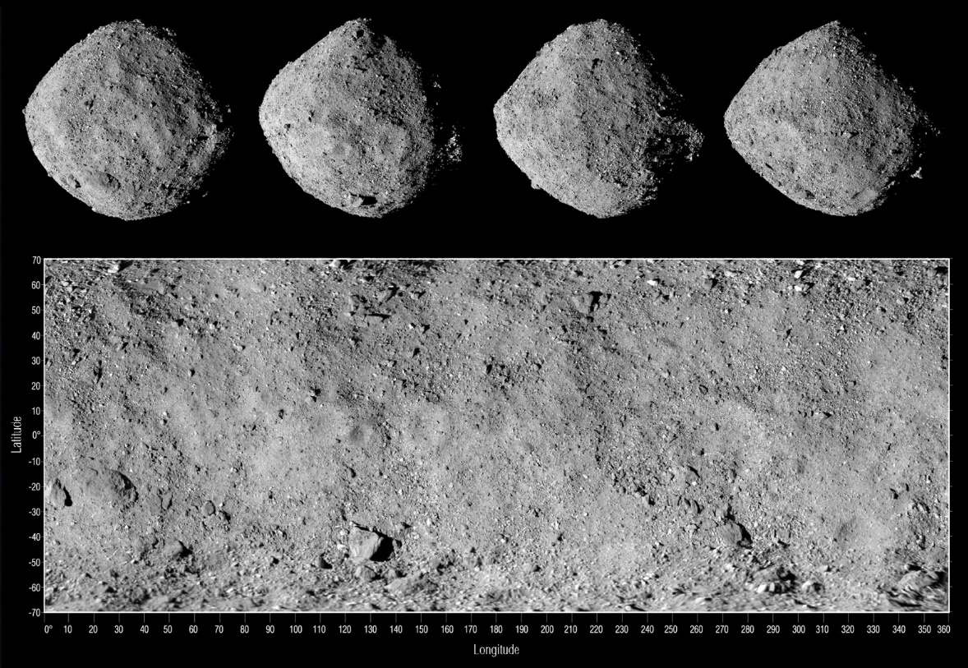

Figure : surface of Bennu

The plan of the Touch-and-Go (TAG) sample collection sequence can be broken down to 4 major steps: orbit departure burn, “Checkpoint” burn, Matchpoint burn, and back-away burn. The first burn is to leave the orbit and start its descent down to the surface of Bennu. The second burn allows OSIRIS-REx to descent to the “Checkpoint” which is the point where the spacecraft is not capable of autonomously checking its position and velocity before adjusting the trajectory for the third maneuver. The third maneuver moves the spacecraft to a point where the spacecraft matches the Bennu’s rotation to fly in tandem with the surface. This moment is defined as the “Matchpoint.” After these maneuvers the spacecraft will reach the sample site – Nightingale – to instigate its sampling sequence by extending its robotic sampling arm; and this sampling mechanism is called Touch-And-Go Sample Acquisition Mechanism (TAGSAM). The Natural Feature Tracking (NFT) is an autonomous guidance system that works to compare the images from the onboard image catalog of the surface of the sample site with the navigation images collected during the descent. This system navigates the spacecraft to the best point to collect samples. After samples are collected, the spacecraft initiates its last burn to fly back up away from the surface and back to the orbit to return to Earth.

(Source from <https://www.asteroidmission.org> – which is the OSIRIS-REx page hosted by University of Arizona, NASA, and Lockheed Martin)

1. Take a look at the orbit of 101955 Bennu. Go to the website: <https://ssd.jpl.nasa.gov/sbdb.cgi?sstr=Bennu;old=0;orb=1;cov=0;log=0;cad=0#orb>. This site is the JPL Small-Body Database Browser. We entered ‘101955 Bennu’ in the Search box; it switches to the page with the ‘orbit diagram’ and data. There is a link on the left that says [Show Orbit Diagram] that you can click if the orbit is not already in the view. Use the ‘Play’ button to observe the orbit evolution. There is a menu in the upper left to adjust the view. Use ‘Default’ for a standard view. You can also click ‘Settings’ to add additional planets to the view, for example. You can use the mouse buttons to zoom in-and-out as well as rotate for a 3D view. Note that the asteroid orbit is in two different colors; where the colors change indicates the location at which the asteroid crosses the orbital plane of the Earth about the Sun, i.e., the ecliptic plane. Locate each of the bodies in their heliocentric orbits at the dates specified below by clicking on the clock in the upper right and clicking a calendar ‘Date’. The date in the bottom left of the diagram will change to reflect this selection.
2. Save the image on the date that corresponds to YOUR birthday in 2021 in two different view: (1) one view straight down onto the ecliptic plane to assess the locations of some of the planets on the same date; (2) a view that is edge-on to the Earth’s orbit to highlight the out-of-plane nature of the orbit.

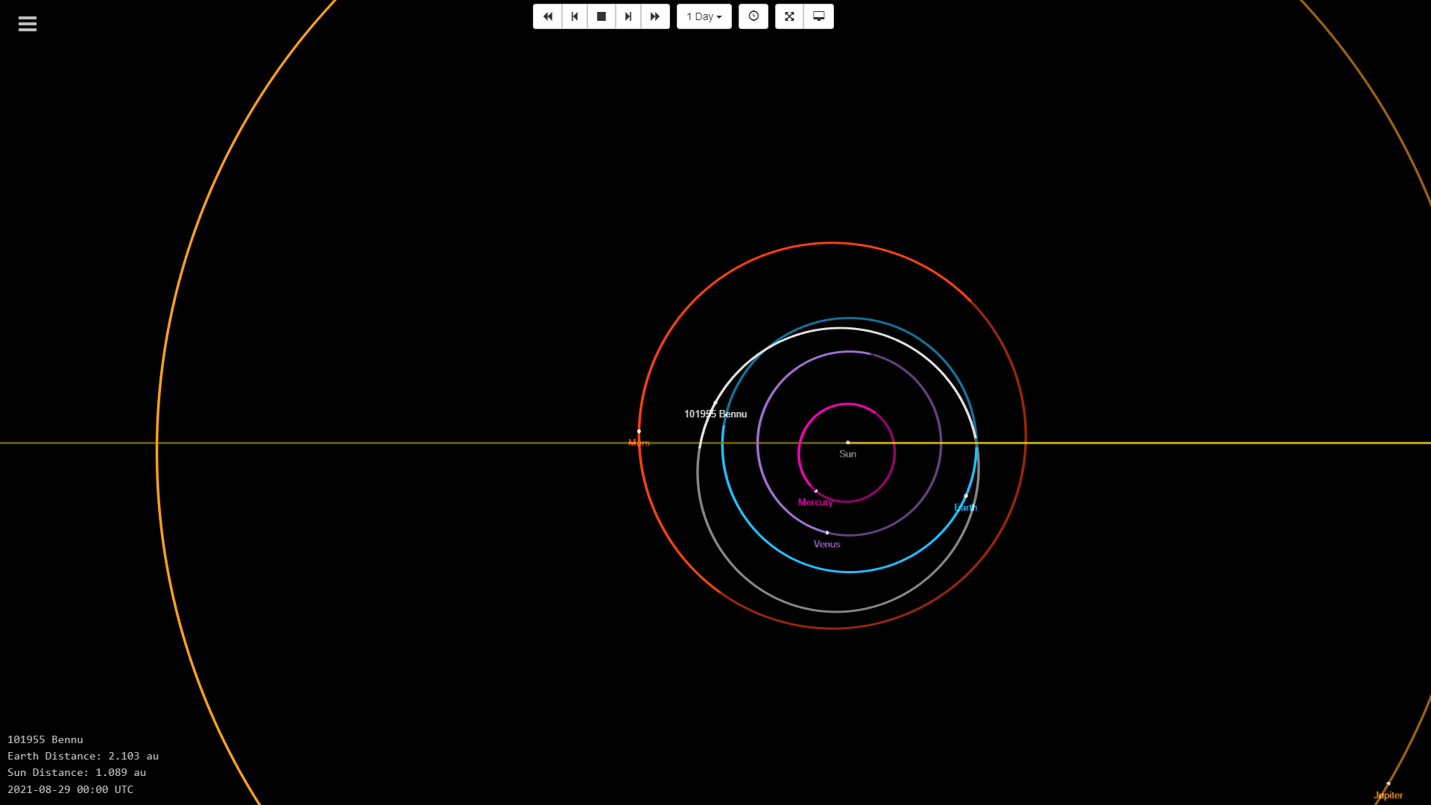

Figure : Orbit of Bennu at 08/29/2021 from above

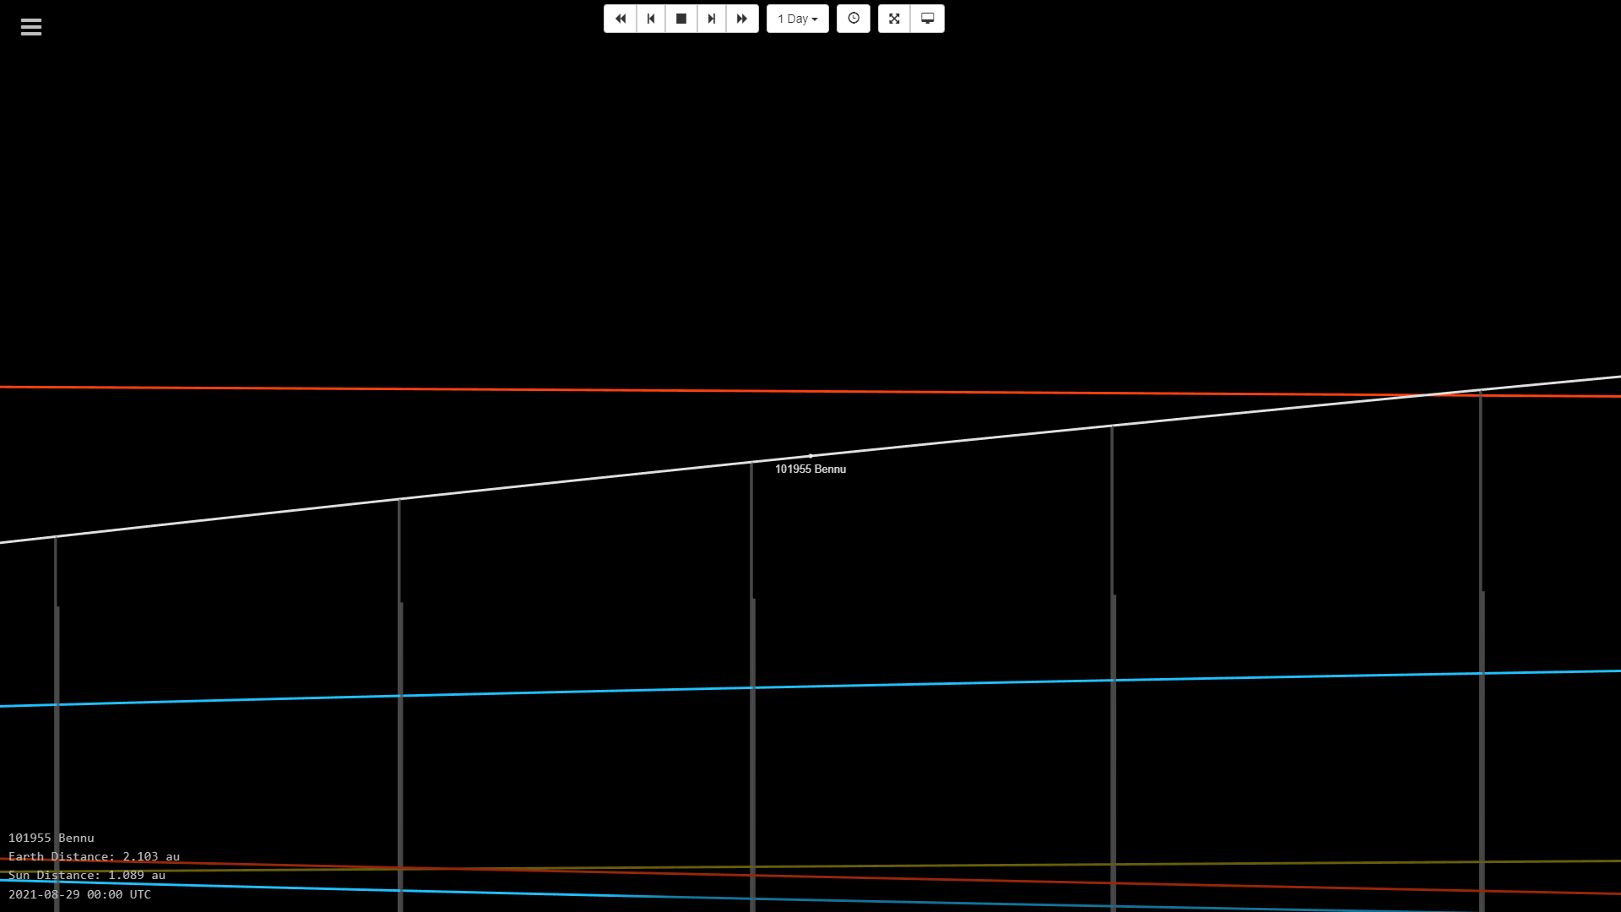

Figure : Orbit of Bennu at 08/29/2021 from the Earth's perspective

1. On the applet, the distance of the asteroid relative to the Earth and the Sun are given in the bottom left in AU (1AU = Sun-Earth distance). On this date, how far is Bennu from the Earth? Is this distance to the Earth considered small?

The distance shown on the applet was 2.103 AU. This is twice the distance from the Sun at this time (1.089 AU); however; in the astronomical standard it is not that much of a large distance but not small either.

1. Does the heliocentric orbit of Bennu cross the orbits of any of the planets? Does Bennu have a significant out-of-plane component relative to the Earth orbital plane? Where is the Sun relative to Bennu and the Earth?

Yes, Bennu’s orbit crosses the orbit of Earth.

The orbital plane of Bennu has an angle with the ecliptic plane and it also has a wider orbit as you can see in figure 2. Thus, you can observe a significant out-of-plane component compared to the Earth’s orbital plane.

The Sun is at the one of the foci of Earth’s elliptical orbit (which is almost a circle) and is also at one of the foci of Bennu’s orbit.

1. Using the tables below the Java applet, find the inclination and period of Bennu. Note that the inclination is reported relative to the ecliptic plane. How do these orbital parameters compare to those of the Earth in its orbit about the Sun?

|  |  |  |
| --- | --- | --- |
|  | 101955 Bennu | Earth |
| inclination [deg] (w.r.t the ecliptic plane) | 6.034939533607825 | 0 |
| period [days] | 436.6487281348487 | 365.25636 |

This shows that the Bennu orbit is not parallel to the ecliptic plane and has a larger ellipse which makes the period longer than the Earth. But because of this it is possible for the orbits of the Earth and Bennu to cross each other and have a spacecraft rendezvous with both orbits and conduct a relatively simple travel between the two.

1. Advance the date the August 1, 2023 using either the “Date” selection box or the time stepping arrows and step size options. Step through each day in the months of August and September 2023 using the time stepping arrows and determine the date on which Bennu is closest to the Earth during these two months. What is the date? What is the smallest distance between Earth and Bennu in AU? In km?

Date: August 30, 2023

Distance [AU]: 0.456 AU

Distance [km]: 68216629

1. During August/September 2023, does Bennu pass within the Moon’s orbit about the Earth? (1 Earth-Moon Distance ~ 384,400 km) How do you know?

The Earth-Moon distance is 0.00257 AU. Bennu does not pass through the Moon’s orbit around the Earth because the minimum distance between the Earth and Bennu was 0.456 AU for the period of August to September of 2023.

1. On the date of Bennu’s closest Earth approach, save two images using the same views as in part (i). Is Bennu significantly above, significantly below or close to Earth’s orbital plane on this date.?

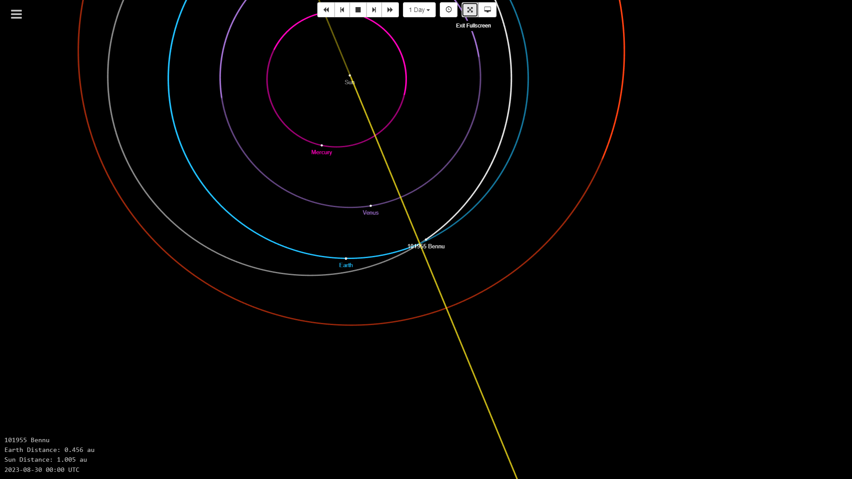

Figure : Orbit of Bennu at 08/30/2023 from above

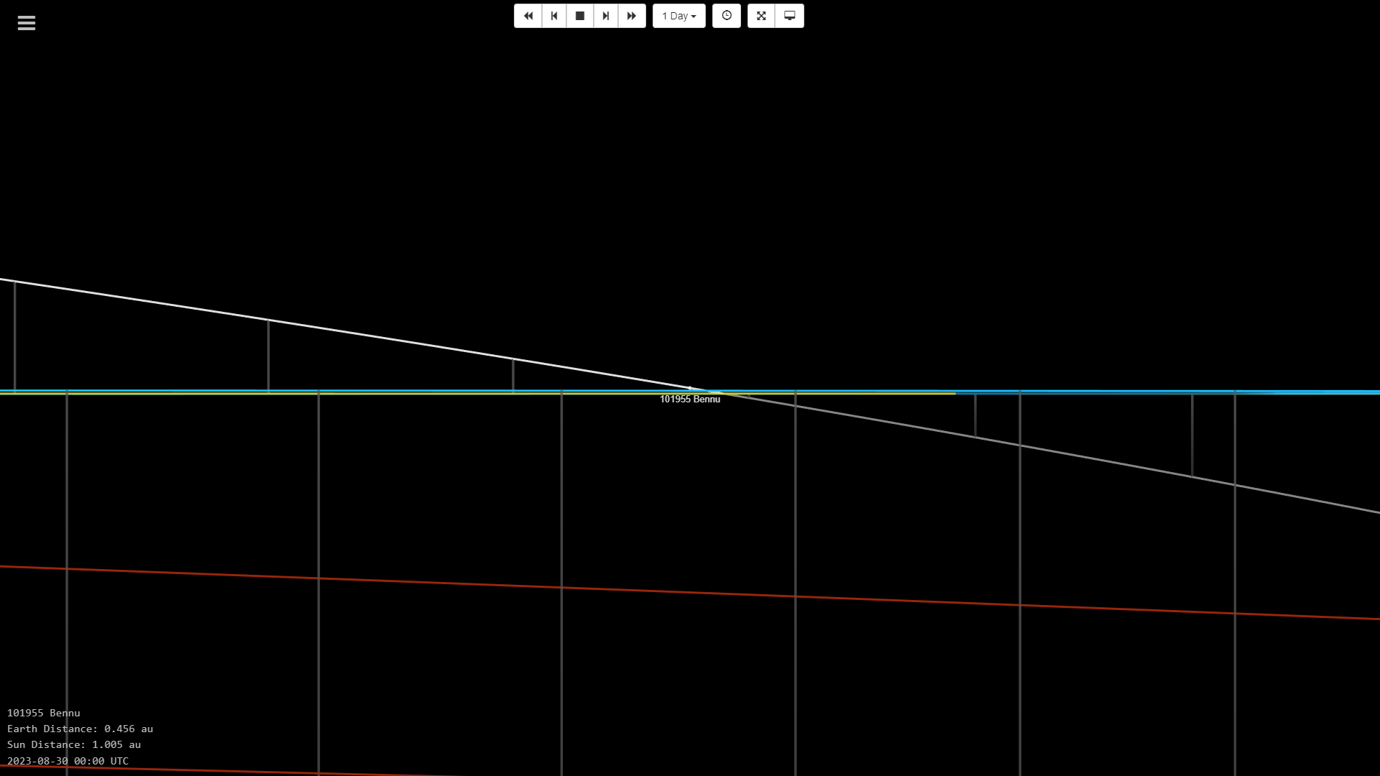

Figure : Orbit of Bennu at 08/30/2023 from the Earth's perspective

At this date, Bennu is significantly close to Earth’s orbital plane which makes it the closest to Earth.

1. Imagine that you were a mission designer working on the OSITSI-REx mission concept several years ago and had to select an asteroid approach date for the robotic rendezvous to eventually collect the sample. The arrival phase started in April 2018 with ‘rendezvous’ in December 2018. View the relative positions of Earth and Bennu over those months. Based on the knowledge you have gained during this exercise about the orbit of Bennu, why might you have selected December 2018 for the approach date? How does it compare with the arrival video in the problem introduction? Could the spacecraft have arrived in November 2018?

During November, the inclination of Bennu is at a negative angle (as you can see in figure 6) with the Earth’s orbital plane and it is also farther away from the Earth. Whereas, in December the inclination becomes a positive angle and crosses the trajectory of OSIRIS-REx while the distance between the Earth and Bennu becomes smaller. This makes the rendezvous maneuver and connection with the spacecraft to be easier which at the end will make the possibility of mission success greater.

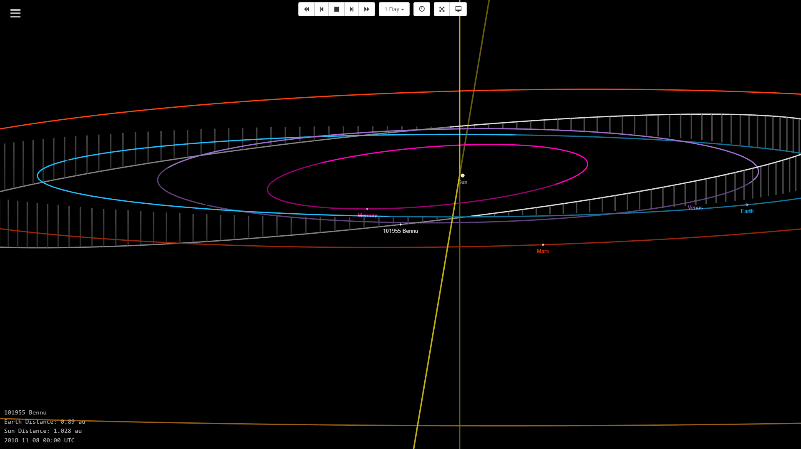

Figure : Orbit of Bennu in November 2018

This date of December 2018 matches the rendezvous simulation depicted in the introduction video.

As aforementioned, due to the inclination and the trajectory not being on the same plane of Bennu’s orbit it would not been probable for OSIRIS-REx to rendezvous with Bennu in November 2018.

Problem 2:

In 2006, the word ‘planet’ was officially given an updated scientific definition by the International Astronautical Federation; textbooks were quickly updated, and many objects were re-evaluated. Thus, the category ‘dwarf planet’ was also introduced. Following the new definitions, NASA relatively quickly acknowledged the first 5 dwarf planets and dwarf planet number 6 is currently on the ‘watch list’. However, it is generally agreed that there may be 100 to 2000 objects that fit the definition.

1. Go to the NASA Solar System Exploration website and obtain the definition of a dwarf planet. Identify the five that are now generally accepted as dwarf planets plus one that might be on the watch list. Include an interesting fact about each one.

Definition:

Dwarf planets are planets that are massive, round, and orbit the Sun, but have not cleared their orbital path.

|  |  |
| --- | --- |
| Dwarf Planet | Interesting Fact |
| Ceres | * Closest dwarf planet to the Sun * Ceres has a mysterious white spot * Ceres accounts for one third of the mass in the asteroid belt |
| Pluto | * Pluto was reclassified from a planet to a dwarf planet in 2006 * Pluto is the largest dwarf planet * Pluto has five known moons * The New Horizon visited Pluto |
| Makemake | * Makemake has one moon * Named after the creator of humanity and god of fertility in the mythos of the Rapa Nui (native people of Easter Island). Since the date of discovery was close to Easters day. |
| Haumea | * A day on Haumea lasts 3.9 hours * There is a big dark red spot on Haumea |
| Eris | * Eris was once considered for the position of tenth planet * Eris was named after the Greek goddess of discord |
| Orcus (watch list) | * Predominantly crystalline form which might be due to past cryovolcanic activity |

1. Using the website from Problem 1, just type the name of a dwarf planet in the ‘Search’ box. Then grab one image of the orbit for each of the first 5 dwarf planets. Use an image that highlights their out-of-plane motion. Find their inclinations and periods.

Ceres

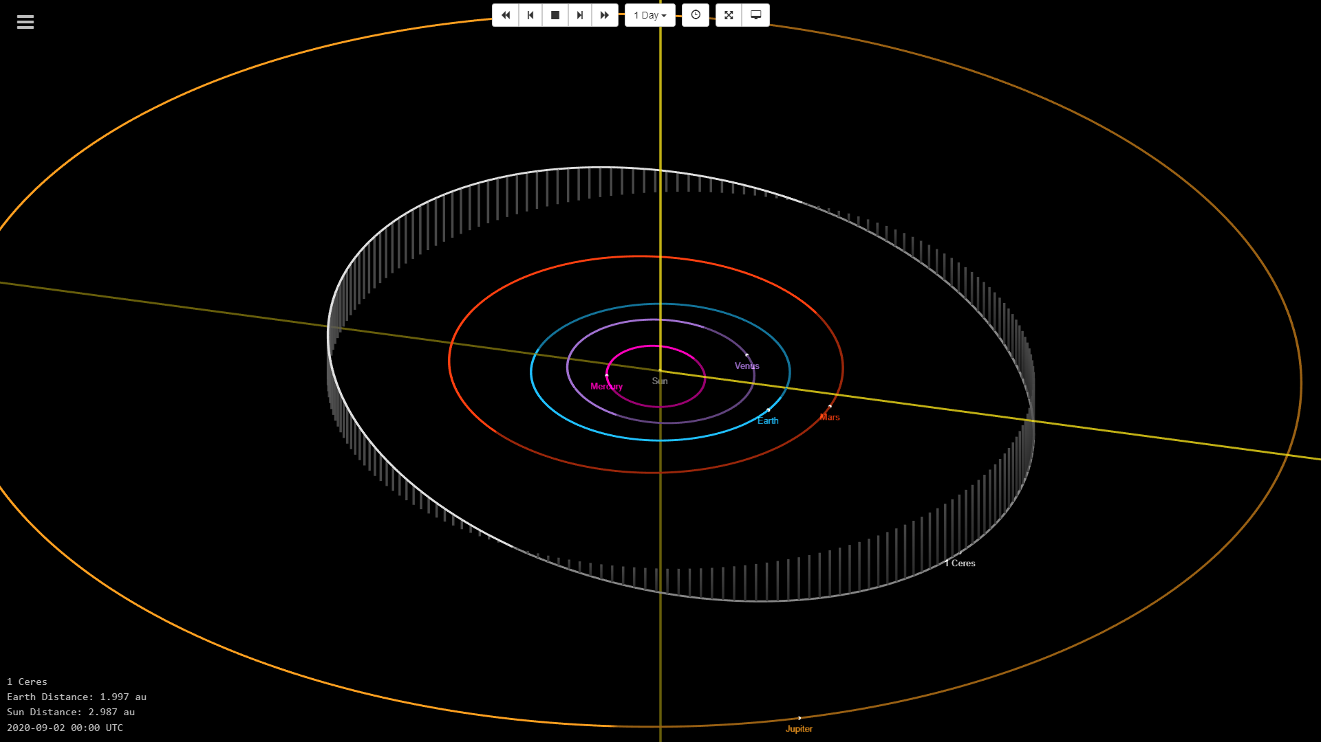

Figure : orbit of Ceres

Pluto

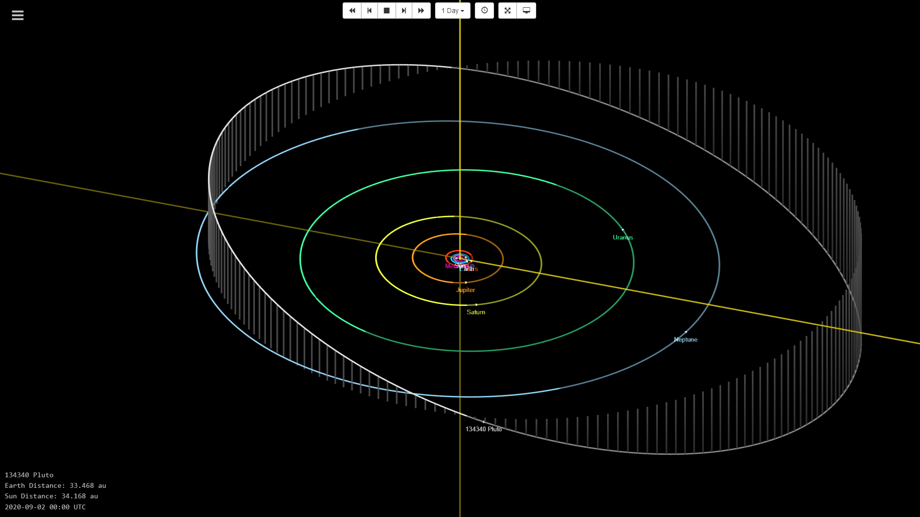

Figure : Orbit of Pluto

Makemake

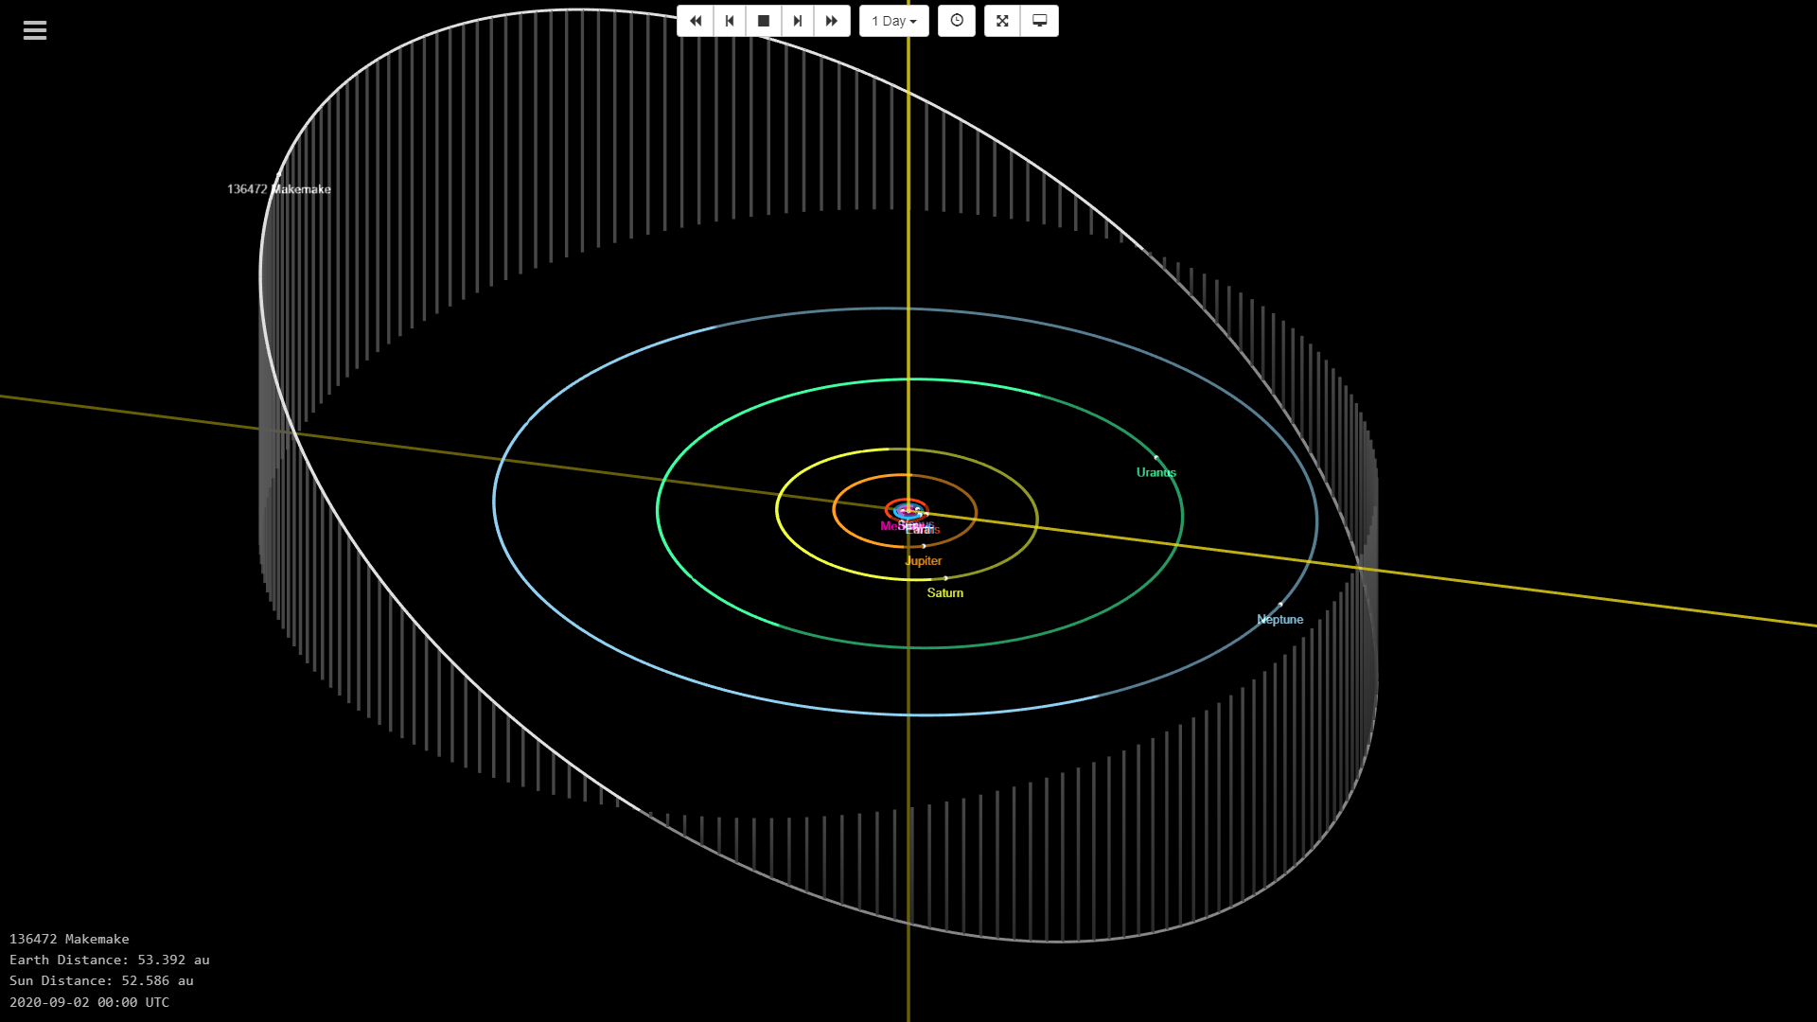

Figure : Orbit of Makemake

Haumea

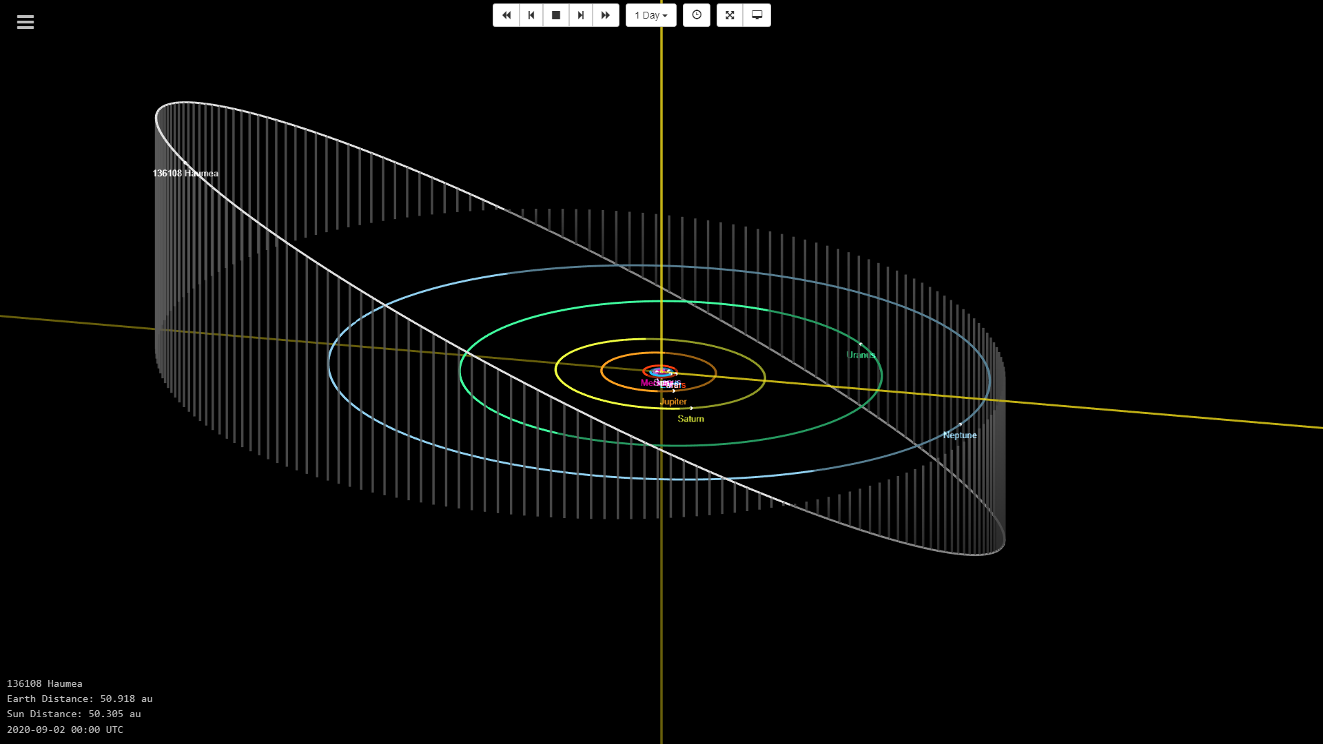

Figure : Orbit of Haumea

Eris

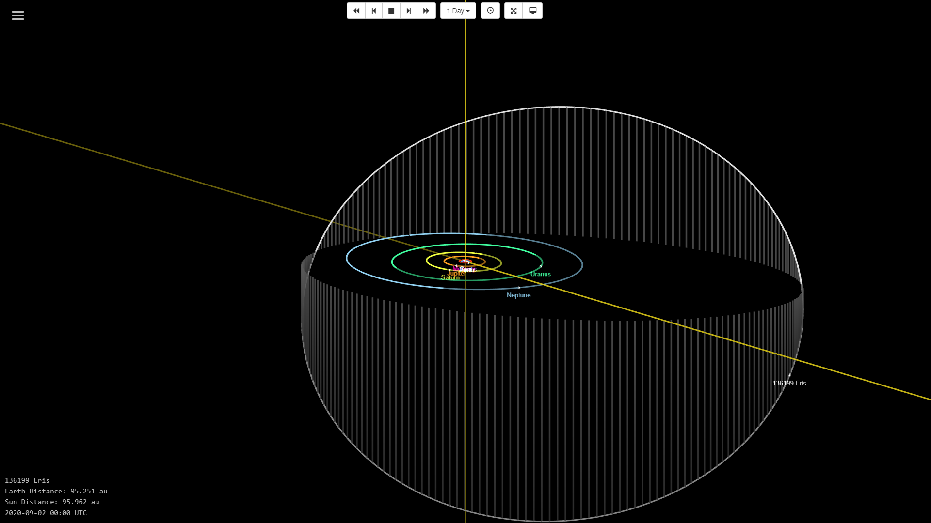

Figure : Orbit of Eris

|  |  |  |
| --- | --- | --- |
| Dwarf Planet | Inclination [deg] | Period [days] |
| Ceres | 10.59406719506626 | 1683.145702657688 |
| Pluto | 17.089000919562 | 90487.27692706819 |
| Makemake | 28.98346562278651 | 111846.5143257531 |
| Haumea | 28.21354457652879 | 103646.7825048959 |
| Eris | 44.03925411522998 | 204202.3414039491 |

1. To reduce the propulsive requirements for a spacecraft, it is most efficient in terms of propellant to approach a dwarf planet when it is close to the ecliptic plane. There are currently some early proposals for a mission to Haumea. Haumea is a triple system with two moons, Hi’iaka and Namaka, so it is intriguing. Consider an edge-on view of the orbit of Haumea. Given its period, when is the earliest month/year that a mission to Haumea can arrive at the dwarf planet as it crosses the ecliptic plane? How long do we have to wait from today? Print the image for that arrival condition.

Earliest Arrival: 01/2100

We have to wait: 79 years and 4 months

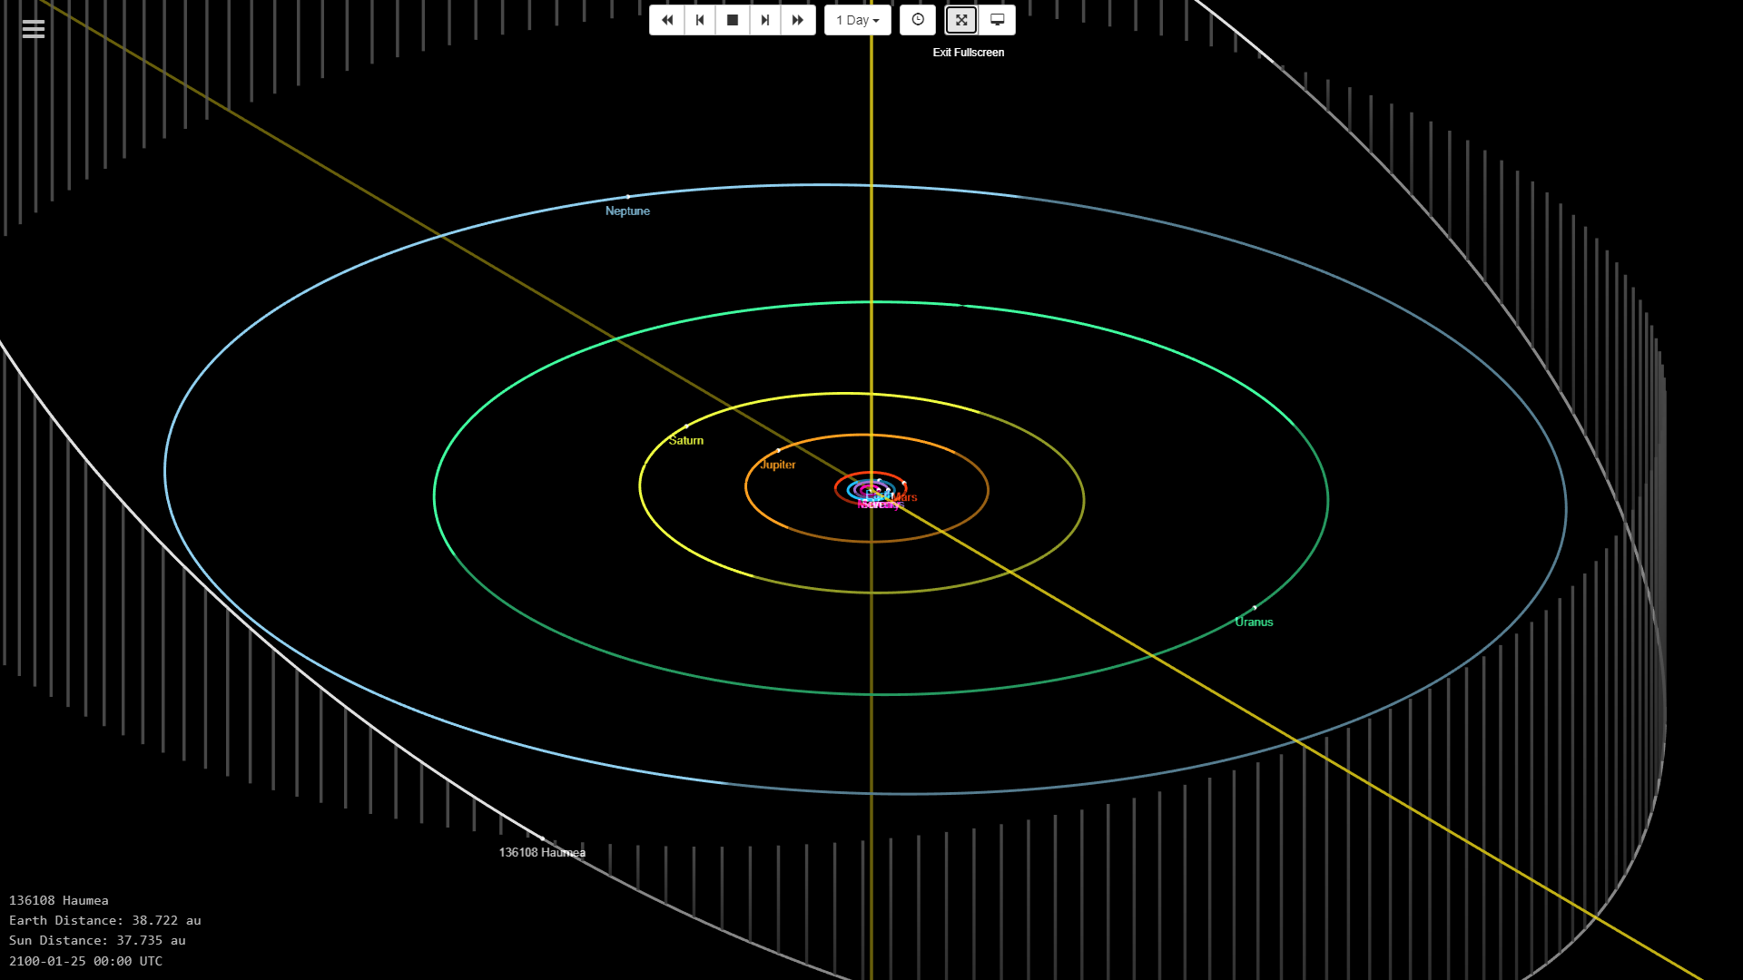

1. The spacecraft Dawn encountered Ceres during its recent mission. What date did Dawn arrive in the vicinity of Ceres? What date did it depart? Produce an image of the location of Ceres during Dawn’s encounter. Are the encounter conditions similar to those of Osiris-REx arriving at Bennu? Differences? Similarities?

Arrive in the vicinity of Ceres: Approached at December 29, 2014; Arrival at March 6, 2015

Date of departure: June 21, 2018

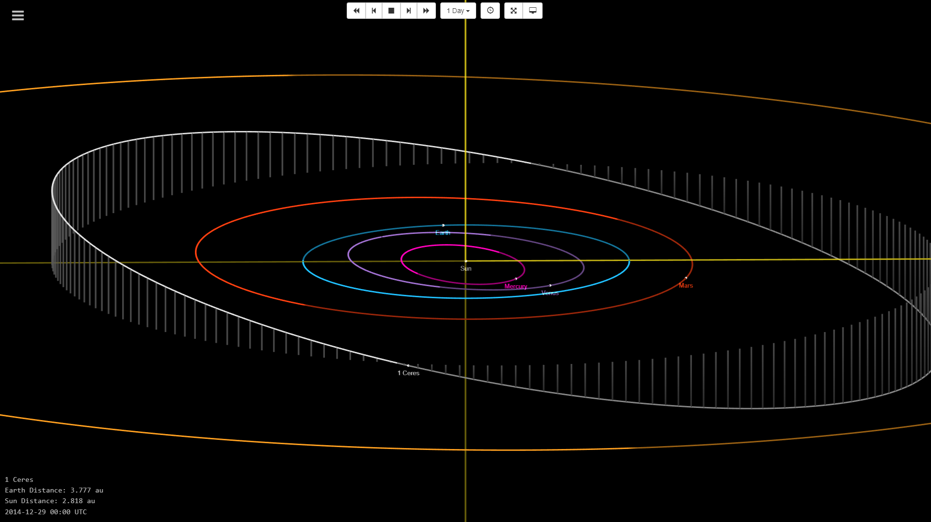

The encounter conditions are similar to that of OSIRIS-REx where the target (Bennu or Ceres) is almost on the ecliptic plane. However, Dawn seemed to be more far away from the earth compared to OSIRIS-REx.

1. Besides distance to Earth, also consider the line-of-sight (LOS) to Earth during the Bennu and Ceres arrival phases. Why might LOS be an important trajectory design condition? During the Bennu sample collection, is LOS to Earth ‘clear’? What might impede LOS to Earth? When is LOS a challenge?

For space missions LOS is important for the navigation of the spacecraft which uses interplanetary probes which are the antennas of the Deep Space Network. Navigations of mission controllers are dependent on such antennas transmitting radio signals to probes which is then sent to the ground station. The connectivity of these devices rely heavily on LOS and to guarantee the accuracy required in space missions it is ideal to have the LOS cleared when designing the trajectory.

On the date of OSIRIS-REx’s sample collection (October 20, 2020) the orbital image is the following.

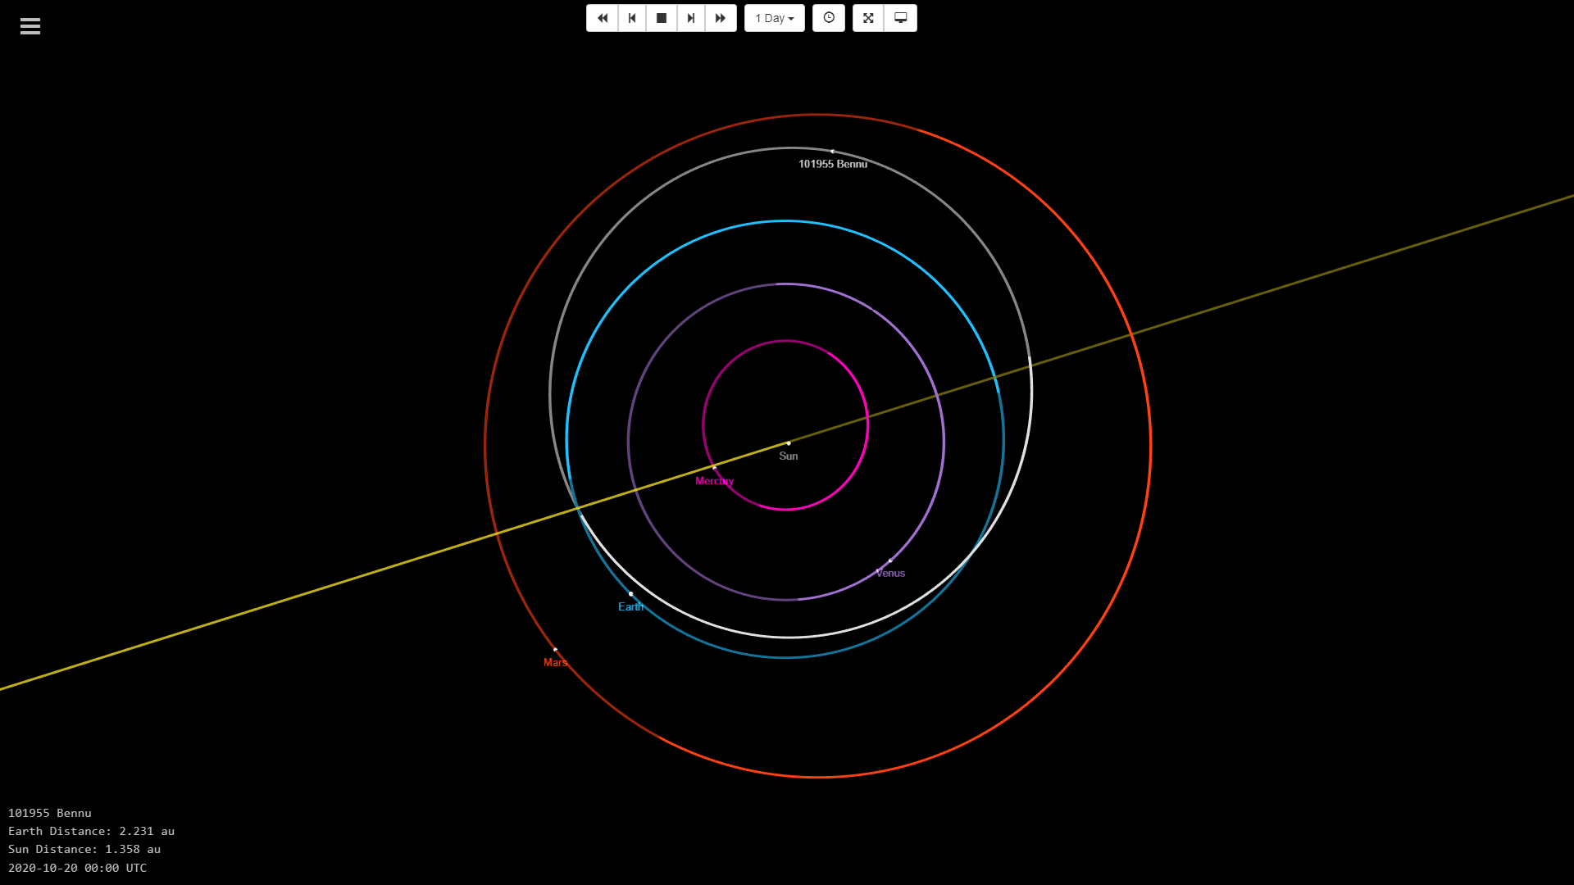

Looking at this image, we can say that the LOS is clear. However, Mercury seems to be close to impeding the LOS between Earth and Bennu. But the Sun is a much more source of trouble when considering LOS because of the electromagnetic activities involved in the Sun. Luckily, the Sun is farther away than Mercury from the LOS but could have a slight effect for mission controls. As mentioned, LOS is a challenge when there are many planetary objects, especially ones that have high level of electromagnetic activity.