College of Engineering

School of Aeronautics and Astronautics

AAE 532

Orbital Mechanics

PS 10

Lambert’s Theorem

*Author:*

Tomoki Koike

*Supervisor:*

K. C. Howell

December 4th, 2020 Friday

Purdue University

West Lafayette, Indiana

**Problem 1**:

Recall the example problem that was discussed in class concerning a small robotic explorer sent to the Martian system to observe and characterize the two moons – Phobos and Deimos. The Martian moons Phobos and Deimos are assumed to be in circular and coplanar about Mars, with a radius equal to the semi-major axis listed in the Table of Constants for moons and dwarfs under Supplementary Documents on Brightspace. Let’s again assume that the spacecraft has completed its observations in the orbit of Phobos and must transfer to the orbit of Deimos. But, now an option for a transfer with different characteristics is sought. [Assume that it is reasonable to assume a relative two-body problem and consider only the gravity of Mars.]

1. In the class example, recall that the planned transfer is based on a transfer angle and a minimum energy transfer. But recall that a wide variety of elliptical arcs could be used to connect these two orbits. Perhaps the maneuver costs could be improved by extending the transfer time. Use the space triangle but try to extend the transfer time to 15 hours.   
   Produce the transfer and include the following: . As usual, supply all the appropriate justifications for these results. Include the and distances for the transfer ellipse. Does the difference in the true anomalies equal the transfer angle?

The transfer is as follows.

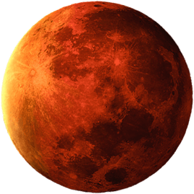

From the characteristics of Mars, Phobos, and Deimos, we know that

From the given transfer angle, we know that this is a TYPE-2 transfer. And from the geometry of the space triangle we also know the following values

For the minimum energy transfer we know that the transfer orbit is elliptical, and the semi-major axis is the possible minimum value.

Then,

Using the 2A/2B Lambert TOF equations we can compute the minimum TOF for the transfer orbit

The minimum TOF is smaller than our assumed TOF of 15 hours. Thus, we can update our transfer orbit to be a TYPE-2B orbit

Now, if our orbit is a TYPE-2B, we can iterate over the Lambert TOF equation to find the optimal semi-major axis for the assumed TOF. This is computationally done using the MATLAB function ‘find_lambert_SMA()’ (the code is in the Appendix).

We decide which semi-latus rectum values is valid by checking the true anomalies.

If ,

From the relationship

No combinations of the true anomaly satisfy this condition, so this is not valid.

If ,

From the relationship

From the true anomalies we can tell if the orbit is ascending or descending, which means that we can tell whether the flight path angles are positive of negative.

The radial distance of the periapsis and the apoapsis are

From the calculations of the true anomalies, we can see that the difference between the true anomalies equal the transfer orbit of .

1. Determine the maneuvers at departure and arrival. i.e., and . Transform the maneuvers to VNB coordinates. How do the maneuvers compare to the minimum energy transfer in terms of time and total maneuver cost?

At departure:



From the cosine rule,

Then, from the sine rule

The delta-V can be expressed in the VNB coordinates with the

At arrival:



From the cosine rule,

Then, from the sine rule

The delta-V can be expressed in the VNB coordinates with the

The total maneuver cost is

From the notes we know that for the minimal energy transfer case the total maneuver cost is . With a TOF of 15 hours there is an increase in maneuver cost and 82.6847% increase in TOF. Whereby the transfer is less efficient.

1. Plot the transfer in GMAT. Plot a full revolution of the spacecraft orbit as the circular orbit of Phobos. Then apply the maneuver. Upon arrival, implement the arrival maneuver; end with a complete revolution in the final orbit (i.e., the circular orbit of Deimos).  
   Does the transfer pass through the periapsis or apoapsis?

The mission is Simulated in GMAT

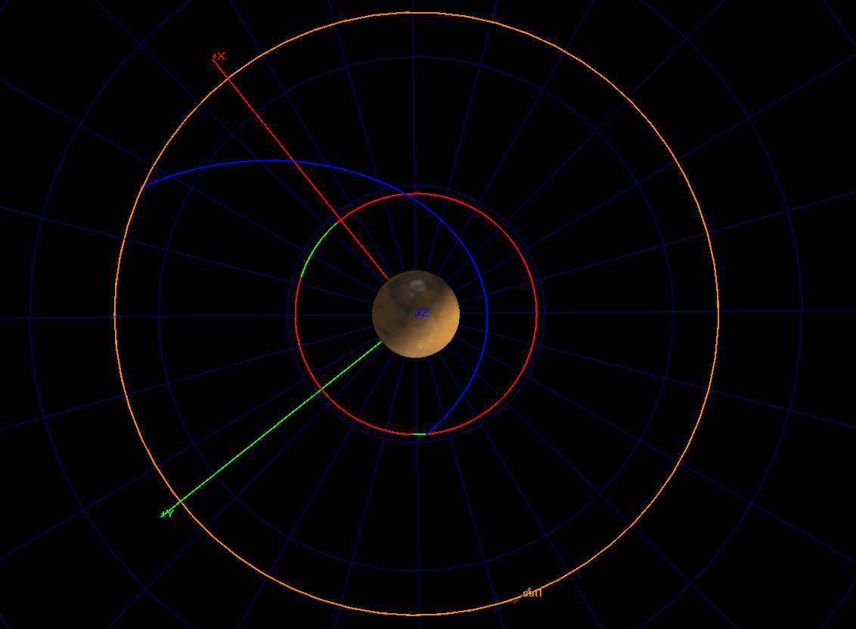

We can see that the transfer passes through the periapsis.

1. To implement such a transfer and rendezvous with Deimos, it is necessary to phase the departure correctly. What is the required phase angle between Phobos and Deimos at departure? How often does the correct phase angle recur (in hours)? Compare this result to the periods of Phobos and Deimos.

The phase angle is computed as

The synodic period of Phobos and Deimos is

The periods of each orbit are

For comparison

This shows that it takes Phobos 8.4077 periods and Deimos 2.1246 periods to have the correct phase angle between the two bodies.

**Problem 2**:

Recall the 2015 movie “The Martian” where the character Mark Watney must be rescued from Mars. The astrodynamicist designs the critical transfer trajectory to send the spacecraft Hermes from Earth to Mars and enable the rescue. [Are there any other movies where the astrodynamicist is the star and ‘saves the day’?!!]

Recall that Rich Purnell (the astrodynamicist) spent extensive time exploring Lambert arcs and incorporating an Earth gravity assist that could satisfy all the requirements! Let’s explore the possible Earth-to-Mars transfer arcs. Assume that Earth and Mars move along circular coplanar orbits. For the Earth-to-Mars transfer, initially ignore the local fields; the relative two-body problem involves only solar gravity.

1. Consider first a transfer with an angle of 120 degrees and a time of flight of 160 days. Given this space triangle, is the transfer elliptic or hyperbolic? A transfer of what type then emerges?

The orbit diagram is as follows.

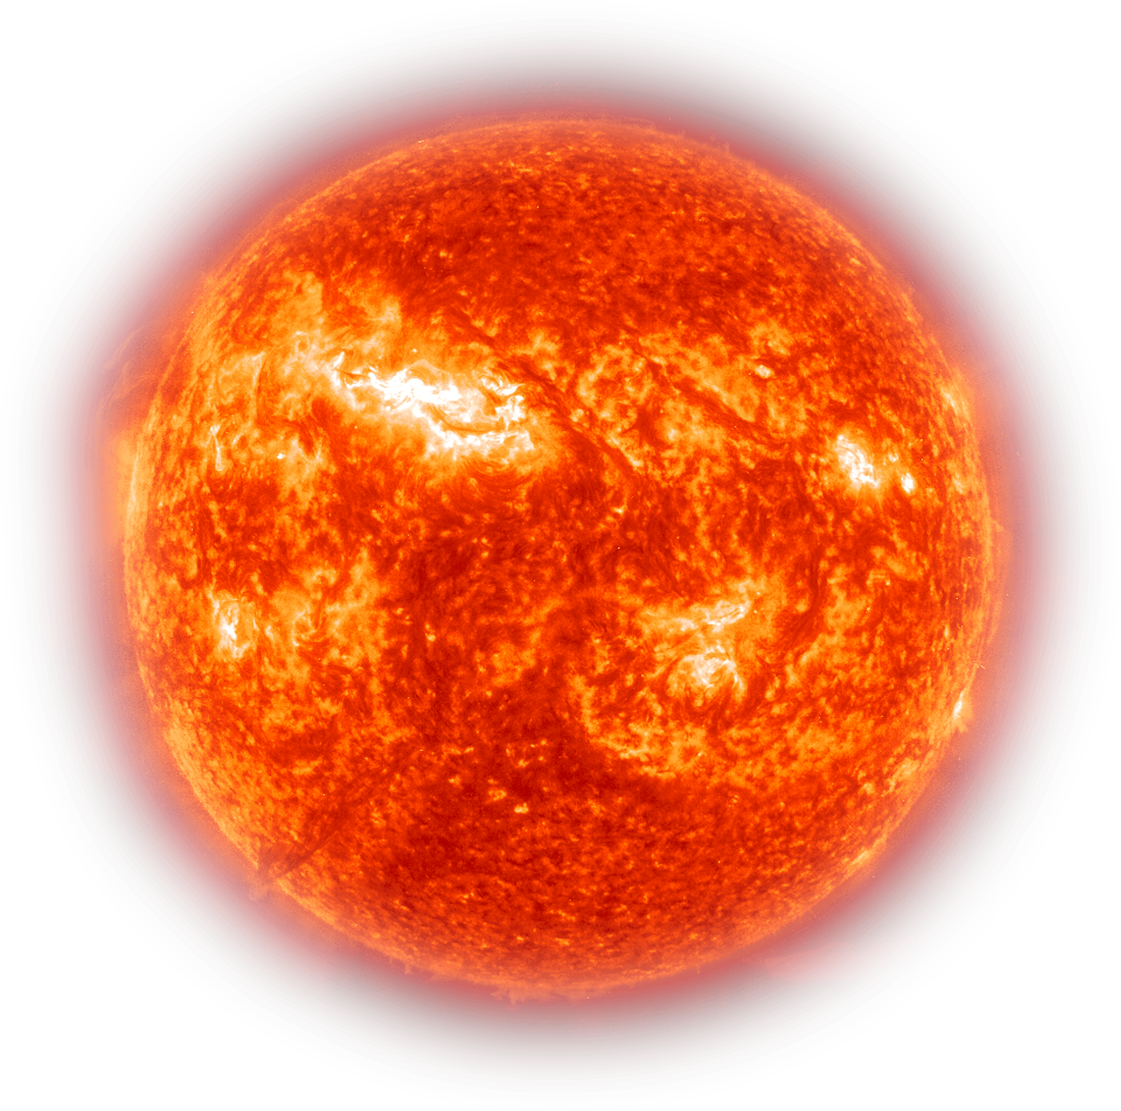

From the characteristics of Earth and Mars, we know that

From the given transfer angle, we know that this is a TYPE-1 transfer. And from the geometry of the space triangle we also know the following values

For the minimum energy transfer we know that the transfer orbit is elliptical, and the semi-major axis is the possible minimum value.

Then,

Using the 2A/2B Lambert TOF equations we can compute the minimum TOF for the transfer orbit