College of Engineering

School of Aeronautics and Astronautics

AAE 532

Orbital Mechanics

PS 9

Transfers with Return Orbits

*Author:*

Tomoki Koike

*Supervisor:*

K. C. Howell

November 13th, 2020 Friday

Purdue University

West Lafayette, Indiana

**Problem 1**:

As noted last week in Problem 2 in PS 8, the US is currently planning for humans to reach the Moon in 2024. Return to consideration of a trajectory to the Moon and its return. Assume departure from a 190 km altitude circular Earth parking orbit; include the local gravity field at the Moon.

1. The path to the Moon last week was planned as a Hohmann transfer so the outbound leg was a transfer. But, the passage by the Moon modified the orbit relative to the Earth. Recall the conditions immediately after the lunar encounter, i.e., .  
     
   Assume that the goal is to return to the Earth orbit. Should the vehicle pass on the light side or the dark side? Was the lunar passage a light side or dark side pass in PS8? If the goal is to return to the Earth, which pass is better, light-side or dark-side? Why?  
     
   Assume that the pass occurs with a plan to return to Earth; what are the post-encounter conditions? To immediately, return to Earth orbit, assume that a maneuver is implemented to offset the lunar gravity and to return the crew to the second half of the Hohmann transfer path and to the original Earth orbit. Determine the maneuver and that would be required to immediately return the vehicle to the Hohmann transfer path for the return/inbound arc back to the Earth parking orbit.  
     
   Does this maneuver seem reasonable? Recall the analysis from last week, if this return maneuver is missed, can the crew return?

In the diagram above, the Earth is positioned downwards, and as we can see from it, when the goal is to return to the Earth’s orbit, it is important to have the vehicle pass on the dark-side so that the vehicle travels under the Earth with a new velocity that is directed towards the Earth. However, even if you pass the light-side you can theoretically have it enter a large orbit centered by the Earth. Then, if the fuel is sufficient, by conducting several maneuvers we can shrink the orbit while maintaining the Earth as the center of the orbit. Thus, if the goal is to return to an Earth’s orbit it could be both sides.

In problem 2 of PS8, the passage was a light-side pass. Now, if the goal is to return to the Earth, like in notes K-FR 3 (diagram below) we can see that it is important to have the vehicle pass the dark-side to have the spacecraft go below the Moon and on an orbit that heads back to the Earth.

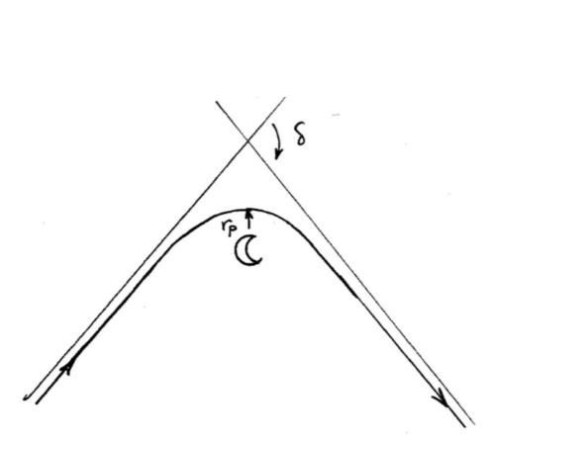

Dark-side pass

Light-side pass

Since we are assuming dark-side pass to return to the transfer ellipse, the vector diagram for pre and post encounter will look as follows.

From problem 2 of PS8 we have the values

We also know from PS8 that the hyperbola characteristics for the flyby are

From cosine rule,

Then from the sine rule

The flight path angle is positive since the orbit is ascending at this point.

The new true anomaly becomes

Now if we want to return immediately to the original transfer ellipse from the flyby the spacecraft will have to undergo a maneuver depicted as the following vector diagram. Note that the new velocity has an equal magnitude and direction to .

This has an equivalent magnitude as and opposite direction as it. From PS8 we know that

And becomes

This maneuver seems very counterproductive in that it requires a large magnitude in the opposite direction of the to decrease the velocity to the velocity at the apoapsis of the transfer orbit. Thus, it is rather unreasonable.

Recalling problem 2 of PS8, we know that the spacecraft misses the maneuver the spacecraft will enter a hyperbolic orbit meaning that the crew on board will not be able to return to Earth.

1. To avoid reliance on a return maneuver, reconsider the transfer as a free-return. Assume a circular, coplanar lunar orbit. Assume that the vehicle departs the same 190-km Earth parking orbit. However, rather than a Hohmann transfer, design a free-return trajectory such that the transfer angle is . Determine the transfer orbit characteristics:   
   The Earth 🡪Moon *TOF* on the outbound leg?  
   Phase angle at departure from the parking orbit?

We know from the altitude of the Earth parking orbit, , that

From the diagram, we can tell that

The transfer angle, implies that , so

To find the *TOF* at the arrival point we first find the eccentric anomaly at the point using the following relation

Thus, the *TOF* of the outbound leg from the Earth to Moon can be computed as

Then the phase angle, from the departure of parking orbit becomes

1. What is the pass distance at the Moon to ensure a free return? Altitude? Is this altitude reasonable?  
   What are the orbital characteristics, relative to the Earth, after the lunar encounter, i.e., in the new orbit?  
   What is the that corresponds to the free return?

The vector diagram for the flyby is as follows.

We first find the pre and post encounter velocities.

The flight path angle is

From the properties of an isosceles triangle we know that

The geocentric velocity of the Moon is

Next the v-infinity can be calculated using vector calculation

The magnitude of v-infinity is

Then

Then we can find the eccentricity of the flyby hyperbola

Also,

Then, finally we can compute the periapsis of the flyby hyperbola

This periapsis of the flyby hyperbola is about twice of the mean radius of the Moon. This is somewhat large but is a feasible passage. Thus, it is reasonable.

After the lunar encounter the characteristics of the orbit are going to be

Finally,

1. For the free-return, plot the orbit in Matlab: (i) in the Earth centered frame, plot the parking orbit, then the outbound and the return arcs only. On the plot, add (ii) in the Moon centered frame, plot the hyperbola. Add the asymptotes, the vectors, .

(i)

(ii)

MATLAB

% AAE 532 HW 9 Problem 1

% Tomoki Koike

close all; clear all; clc;

fdir = 'C:\Users\Tomo\Desktop\studies\2020-Fall\AAE532\matlab\outputs\ps9';

set(groot, 'defaulttextinterpreter','latex');

set(groot, 'defaultAxesTickLabelInterpreter','latex');

set(groot, 'defaultLegendInterpreter','latex');

% Set constants

planet_consts = setup_planetary_constants(); % Function that sets up all the constants in the table

sun = planet_consts.sun; % structure of sun

earth = planet_consts.earth; % structure of earth

moon = planet_consts.moon; % structure of moon

G = 6.6743015e-20; % Gravitational constant [km^3/kg/s^2]

%% From Problem 2 of PS8

% Set given constants

h_PO = 190; % earth parking orbit altitude

h_cap = 200; % moon capture orbit altitude

% (a)

r_minus = earth.mer + h_PO;

r_plus = moon.smao - h_cap - moon.mer ;

a_T = 0.5*(r_minus+r_plus);

e_T = (r_plus - r_minus) / (r_plus + r_minus);

p_T = a_T * (1 - e_T^2);

IP_minus = 2*pi*sqrt(a_T^3 / earth.gp);

IP_minus_days = IP_minus / 60 / 60 / 24;

xi_minus = -earth.gp / 2 / a_T;

v_PO = sqrt(earth.gp / r_minus);

v_plus = vis_viva(r_minus, a_T, earth.gp);

Dv_dep = v_plus - v_PO;

v_minus = vis_viva(r_plus, a_T, earth.gp);

v_moon = sqrt(earth.gp / moon.smao);

v_inf_moon = abs(v_minus - v_moon);

v_c_moon = sqrt(moon.gp / (moon.mer + h_cap));

Dv_arr = sqrt( v_inf_moon^2 + 2*moon.gp / (moon.mer + 200) ) - v_c_moon;

Dv_total = Dv_dep + Dv_arr;

TOF = IP_minus / 2 ;

TOF_days = TOF / 60 / 60 / 24;

phi = rad2deg(pi - sqrt(earth.gp / moon.smao^3)*TOF);

% (b)

xi_plus = v_inf_moon^2 / 2

a_plus = -moon.gp / 2 / xi_plus

e_plus = 1 - (h_cap + moon.mer) / a_plus

delta = 2*asind(1 / e_plus)

v_plus = sqrt( v_inf_moon^2 + v_moon^2 - 2*v_inf_moon*v_moon*cosd(delta) )

FPA_plus = asind( v_inf_moon / v_plus * sind(delta))

% True anomaly

temp = r_plus * v_plus^2 / earth.gp

TA_plus = atand( temp*sind(FPA_plus)*cosd(FPA_plus) / ( temp*cosd(FPA_plus)^2 - 1 ))

Domega = 180 - TA_plus

% characterisitic

a_N = -earth.gp / 2 / (v_plus^2 / 2 - earth.gp / r_plus)

h_N = r_plus*v_plus*cosd(FPA_plus)

p_N = h_N^2 / earth.gp

e_N = sqrt(1 - p_N / a_N)

r_aN = a_N * (1 + e_N)

r_pN = abs(a_N) * (e_N - 1)

xi_N = -earth.gp / 2 / a_N

IP_N = 2*pi * sqrt(a_N^3 / earth.gp)

IP_N_year = IP_N / 60 /60 / 24 / 365

% (c);

Dv_eq = 2 * v_inf_moon * sind(delta / 2)

alpha = (180 - delta) / 2

Dv_eq_vec = Dv_eq * [cosd(alpha), sind(alpha), 0]

% (a)

Dv_N = Dv_eq

alpha = FPA_plus + (180 + delta) / 2

% (b)

% Find the transfer orbit characteristics

psi = 173.8; % transfer angle

h_earth = 190; % Altitude of parking orbit around the Earth

r_p = h_earth + earth.mer % periapsis of transfer orbit

r_minus = moon.smao

e = (r_minus/r_p - 1) / (1 - r_minus/r_p * cosd(psi)) % eccentricity

a = r_p / (1 - e) % semi-major axis

r_a = a*(1 + e) % apoapsis

IP = 2*pi*sqrt(a^3 / earth.gp) % period in seconds

IP_day = IP / 60 / 60 / 24 % period in days

En = -earth.gp / 2 / a % specific energy

% Find the TOF at the arrival point

EA = T2E_anomaly(e, psi, "deg") % the eccentric anomaly at the arrival point

TOF = sqrt(a^3 / earth.gp) * (deg2rad(EA) - e*sind(EA)) % the tof at the arrival point

TOF_day = TOF / 60 / 60 / 24

% Find the phase angle for this departure

phi = rad2deg(deg2rad(psi) - sqrt(earth.gp / moon.smao^3) * TOF )

% (c)

% Find the periapsis distance for the lunar flyby

v_minus = vis_viva(r_minus, a, earth.gp) % velocity pre encounter

p_minus = a*(1 - e^2);

FPA_minus = acosd(sqrt(earth.gp*p_minus) / r_minus / v_minus) % flight path angle

Dv_eq = 2*v_minus*sind(FPA_minus) % equivalent delta-V

v_moon = sqrt(earth.gp / r_minus) % the geocentric velocity of the moon

v_minus_vec = v_minus * [sind(FPA_minus), cosd(FPA_minus), 0]

v_moon_vec = v_moon * [sind(0), cosd(0), 0]

v_inf_moon_vec = v_minus_vec - v_moon_vec

v_inf_moon = norm(v_inf_moon_vec)

delta = 2*asind(Dv_eq / 2 / v_inf_moon)

% characteristics of the hyperbolic flyby

e_fb = 1 / sind(delta / 2)

En_fb = v_inf_moon^2 / 2

a_fb = -moon.gp / 2 / En_fb

r_p_fb = a_fb * (1 - e_fb)

r_plus = r_minus;

v_plus = v_minus;

FPA_plus = -FPA_minus;

% True anomaly

temp = r_plus * v_plus^2 / earth.gp;

TA_plus = atan_dbval( temp*sind(FPA_plus)*cosd(FPA_plus) / ( temp*cosd(FPA_plus)^2 - 1 ), "deg")

TA_plus = TA_plus(TA_plus < 0);

TA_plus = TA_plus + 360;

a_plus = (-earth.gp / 2) / (v_plus^2 / 2 - earth.gp / r_plus)

h_plus = r_plus*v_plus*cosd(FPA_plus)

p_plus = h_plus^2 / earth.gp

e_plus = sqrt(1 - p_plus / a_plus)

r_p_plus = a_plus*(1 - e_plus)

r_a_plus = a_plus * ( 1 + e_plus)

Domega = psi - TA_plus

alpha = 90 + FPA_minus

% (d)

% plotting

% (i)

angles = 0:0.001:2*pi;

% Earth

Xearth = earth.mer * cos(angles); Yearth = earth.mer * sin(angles);

% Earth parking orbit

Xearth_po = r_p * cos(angles); Yearth_po = r_p * sin(angles);

% Outbound

angles = 0:0.001:deg2rad(psi);

Rout = p_minus ./ (1 + e*cos(angles)); Xout = Rout.*cos(angles); Yout = Rout.*sin(angles);

% return

angles = psi:0.1:360;

Rre = p_plus ./ (1 + e_plus*cosd(angles - (Domega)));

Xre = Rre .* cosd(angles); Yre = Rre .* sind(angles);

fig = figure("Renderer","painters","Position",[10, 10, 900, 700]);

plot(Xearth,Yearth)

hold on; grid on; grid minor; box on; axis equal;

plot(Xearth_po, Yearth_po)

plot(Xout, Yout)

plot(Xre, Yre)

hold off

title('Earth Centered Frame with Transfer Orbits - T. Koike')

xlabel('$\hat{e}$ [km]')

ylabel('$\hat{p}$ [km]')

saveas(fig, fullfile(fdir, "p1_earthCenter.png"))

% (ii)

% moon

angles = 0:0.1:360;

Xmoon = moon.mer * cosd(angles); Ymoon = moon.mer * sind(angles);

% moon parking orbit

Xmoon_po = (r_p_fb) * cosd(angles); Ymoon_po = r_p_fb * sind(angles);

% hyperbola

angles = -95:0.1:95;

Rhyp = a_fb*(1 - e_fb^2) ./ (1 + e_fb * cosd(angles));

Xhyp = Rhyp .* cosd(angles); Yhyp = Rhyp .* sind(angles);

fig = figure("Renderer","painters","Position",[10, 10, 900, 700]);

plot(Xmoon,Ymoon)

hold on; grid on; grid minor; box on; axis equal;

plot(Xmoon_po, Ymoon_po)

plot(Xhyp, Yhyp)

hold off

xlabel('$\hat{e}$ [km]')

ylabel('$\hat{p}$ [km]')

title("Moon Centered Frame with Hyperbola - T. Koike")

saveas(fig, fullfile(fdir, "p1_moonCenter.png"));

**Problem 2**:

The Messenger spacecraft offered exploration of the planet Mercury after launch in 2004 with Mercury orbit insertion in March 2011. The transfer to Mercury employed more than one Venus gravity assist.

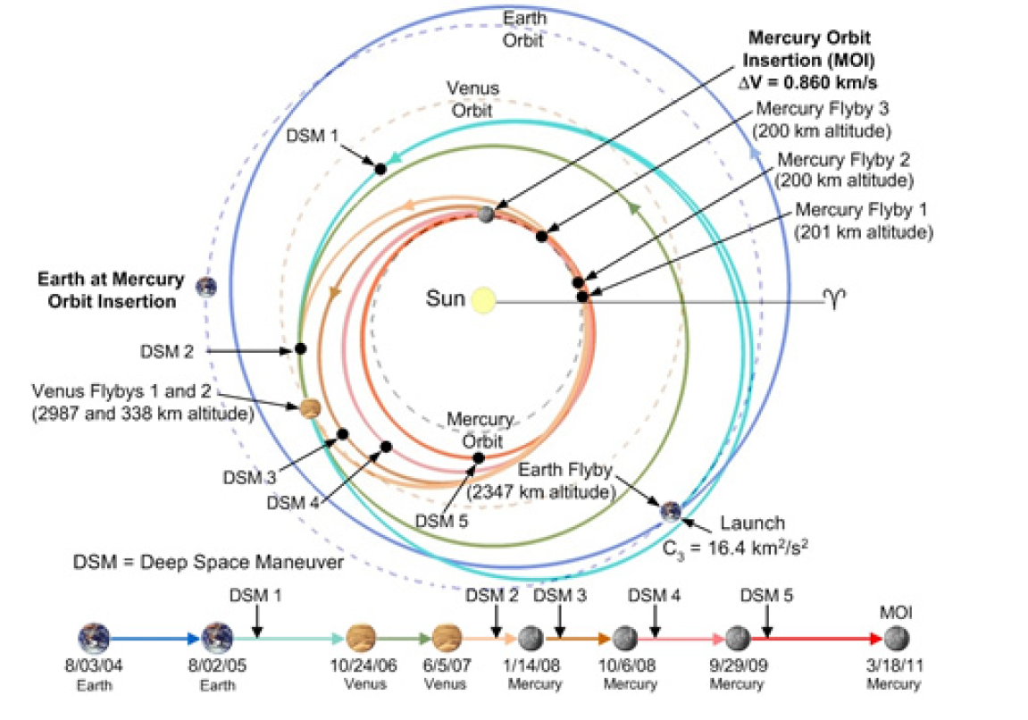

1. Determine the actual values for *TOF* for the following:  
   (i) Earth launch to the first Venus flyby  
   (ii) Earth launch to first Mercury flyby   
   (iii) Earth launch to MOI (Mercury Orbit Insertion)

|  |  |  |  |
| --- | --- | --- | --- |
|  | **Start** | **End** | **TOF [days]** |
| (i) | 08/03/2004 | 10/24/2006 | 812 |
| (ii) | 08/03/2004 | 01/14/2008 | 1259 |
| (iii) | 08/03/2004 | 03/18/2011 | 2418 |

1. Assume that you are completing a preliminary analysis for such a Mercury mission but assume that all planetary orbits are coplanar and circular and use patch conics. A Venus gravity assist will aid in reducing the launch maneuver. So, to assess the possible gravity assist, consider a Hohmann transfer; but let the transfer path possess a perihelion distance equal to 0.50 AU. As a result, the transfer path does not reach Mercury; however, along the path the spacecraft encounters Venus. Examine a Venus gravity assist and explore whether Venus can deliver the spacecraft to Mercury.  
     
   Sketch the heliocentric view to describe the path and identify the location for the Venus encounter. Compute the along the heliocentric path at which the Venus encounter occurs. *TOF* from Earth to Venus?

The sketch of the orbit is as follows.

The original transfer orbit has the characteristics of

Then the true anomaly at the Venus encounter can be computed as

This true anomaly is in the descending orbit.

The eccentric anomaly corresponding to this true anomaly is

Thus, the time of flight becomes

1. For the actual Venus Flyby 1, the flyby distance was 2990 km altitude. How many Venus radii was the actual encounter? Assume that your Venus encounter uses the same pass distance.  
   To continue down to Mercury most efficiently, is it desirable to gain or lose energy? Should the spacecraft pass ‘ahead’ or ‘behind’ Venus? Determine the following quantities for the post-encounter heliocentric orbit: . {Don’t forget the Venus-centered vector diagram!]  
   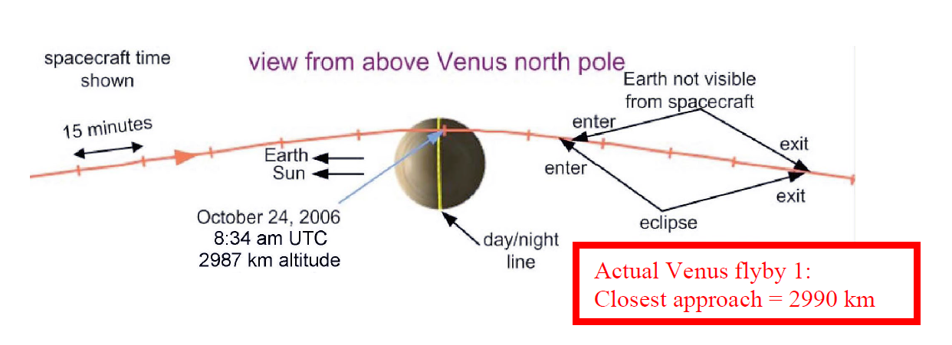  
   Determine the equivalent due to the Venus encounter. What is the magnitude and direction, i.e. and ?

The flyby altitude of 2990 km is 0.4941 , and the actual distance from the center of Venus is .

Since, we want to shorten the perihelion distance of the original transfer orbit, it is desirable to lose energy whilst the flyby. That means that the spacecraft should pass ahead of Venus.

The heliocentric velocity of Venus is

The pre-encounter conditions are

From the vector diagram

The hyperbola has the

characteristics of

Then the diagram can be updated as

From the sine rule

From cosine rule

At the position of

Then from the sine rule the flight path angles becomes (note that it is descending).

Then

Since it is in the descending orbit .

Now we can compute the post-encounter characteristics

The new orbit reaches mercury at a true anomaly of

Finally,

And

1. Plot the old and the new orbits. (Use either Matlab or GMAT.) identify line of apsides, . Add Mercury’s orbit to the plot.  
   Does the s/c now reach the orbit of Mercury? If it does, mark the crossing.  
     
   If the orbit does cross Mercury’s orbit, you could further reduce the launch cost by launching into a smaller heliocentric orbit (selecting a larger value of the perihelion in part (b)). If your resulting orbit does NOT reach Mercury, you will need to increase the launch maneuver cost by selecting a smaller perihelion value. Discuss: if you try a new initial heliocentric orbit for the transfer, what perihelion distance will you try? Why?  
   [Note: no more calculations! Just discuss what you might select and why.]

From the plot we can see that the new orbit does cross Mercury’s orbit, and the point is indicated with the red dot.

To reduce the cost of the mission it would be preferrable to select a larger distance for the perihelion of the first orbit because we can see from the plot that we can still largen the new orbit by a small amount and still have the new orbit intersect with Mercury’s orbit.

MATLAB

% AAE 532 HW 9 Problem 2

% Tomoki Koike

close all; clear all; clc;

fdir = 'C:\Users\Tomo\Desktop\studies\2020-Fall\AAE532\matlab\outputs\ps9';

set(groot, 'defaulttextinterpreter','latex');

set(groot, 'defaultAxesTickLabelInterpreter','latex');

set(groot, 'defaultLegendInterpreter','latex');

% Set constants

planet_consts = setup_planetary_constants(); % Function that sets up all the constants in the table

sun = planet_consts.sun; % structure of sun

earth = planet_consts.earth; % structure of earth

mercury = planet_consts.mercury; % structure of mercury

venus = planet_consts.venus; % structure of venus

G = 6.6743015e-20; % Gravitational constant [km^3/kg/s^2]

% (a)

% Original Transfer Orbit

mu_sun = sun.gp;

mu_earth = earth.gp;

mu_venus = venus.gp;

mu_mercury = mercury.gp;

r_p0 = 0.5 * earth.smao

r_a0 = earth.smao

a_0 = 0.5*(r_p0 + r_a0)

e_0 = (r_a0 - r_p0) / (r_a0 + r_p0)

p_0 = a_0 * (1 - e_0^2)

r_venus = venus.smao

TA_venus = acos_dbval(1 / e_0 * (p_0 / r_venus - 1), "deg")

TA_venus = TA_venus(TA_venus < 0)

E_venus = T2E_anomaly(e_0, TA_venus, "deg")

MM_0 = sqrt(a_0^3 / mu_sun);

TOF_venus = pi*MM_0 - MM_0 * (deg2rad(-E_venus) - e_0 * sind(-E_venus))

TOF_venus_days = TOF_venus / 60 / 60 / 24

% (b)

% What is the actual venus radii of the encounter

h_venus = 2990;

r_p_fb = h_venus + venus.mer

% Find the pre-encounter conditions

v_venus = sqrt(mu_sun / r_venus)

v_minus = vis_viva(r_venus, a_0, mu_sun)

FPA_minus = -acosd(sqrt(mu_sun*p_0) / r_venus / v_minus)

% Find the v-infinity

v_inf_venus = sqrt(v_venus^2 + v_minus^2 - 2*v_venus*v_minus*cosd(FPA_minus))

% Find hyperbola characteristics

En_fb = v_inf_venus^2 / 2

a_fb = -mu_venus / 2 / En_fb

e_fb = 1 - r_p_fb / a_fb

delta = 2*asin_dbval(1 / e_fb, "deg")

delta = delta(1)

% New orbit

eta = asind(v_minus / v_inf_venus * sind(-FPA_minus)) - abs(delta)

v_plus = sqrt(v_inf_venus^2 + v_venus^2 - 2*v_inf_venus*v_venus*cosd(eta))

FPA_plus = -asind(v_inf_venus / v_plus * sind(eta))

% True anomaly

r_plus = r_venus;

temp = r_plus * v_plus^2 / mu_sun;

TA_plus = atan_dbval( temp*sind(FPA_plus)*cosd(FPA_plus) / ( temp*cosd(FPA_plus)^2 - 1 ), "deg")

TA_plus = TA_plus(TA_plus == min(TA_plus))

h_plus = r_plus*v_plus*cosd(FPA_plus)

p_plus = h_plus^2 / mu_sun

e_plus = 1/cosd(TA_plus) * (p_plus/r_plus - 1)

a_plus = p_plus / (1 - e_plus^2)

r_p_plus = a_plus * (1 - e_plus)

r_a_plus = a_plus * (1 + e_plus)

IP_plus = 2*pi * sqrt(a_plus^3 / mu_sun)

IP_plus_years = IP_plus / 60 / 60 / 24

Domega = TA_venus - TA_plus

r_mercury = mercury.smao;

TA_mercury = acosd(1/e_plus * (p_plus/r_mercury - 1))

Dv_eq = 2*v_inf_venus*sind(delta / 2)

alpha = (abs(FPA_plus)-abs(FPA_minus)) + (180 - delta)/2 + (180 - eta - abs(FPA_plus))

% (d)

% plotting

angles = 0:0.001:2*pi;

% Earth orbit

Xearth = earth.smao * cos(angles); Yearth = earth.smao * sin(angles);

% Venus orbit

Xvenus = venus.smao * cos(angles); Yvenus = venus.smao * sin(angles);

% Mercury orbit

Xmercury = mercury.smao * cos(angles); Ymercury = mercury.smao * sin(angles);

% Sun

Xsun = sun.mer * cos(angles); Ysun = sun.mer * sin(angles);

% Earth to Venus

angles = 0:0.1:360;

R_E2V = p_0 ./ (1 + e_0*cosd(angles)); X_E2V = R_E2V.*cosd(angles); Y_E2V = R_E2V.*sind(angles);

% Venus to Mercury

R_V2M = p_plus ./ (1 + e_plus*cosd(angles - Domega));

X_V2M = R_V2M .* cosd(angles); Y_V2M = R_V2M .* sind(angles);

fig = figure("Renderer","painters","Position",[10, 10, 900, 700]);

plot(Xearth,Yearth, '--')

hold on; grid on; grid minor; box on; axis equal;

plot(Xvenus, Yvenus, '--')

plot(Xmercury, Ymercury, '--')

plot(Xsun, Ysun)

plot(X_E2V, Y_E2V, "LineWidth", 2)

plot(X_V2M, Y_V2M, "LineWidth", 2)

plot([-r_a0, r_p0], [0, 0], '-k', 'LineWidth', 1)

r_a_plus_vec = r_a_plus * [-cosd(Domega), -sind(Domega)];

r_p_plus_vec = r_p_plus * [cosd(Domega), sind(Domega)];

temp = vertcat(r_a_plus_vec, r_p_plus_vec);

plot(temp(:, 1), temp(:, 2), '-k', "LineWidth", 1)

hold off

title('Earth to Mercury with Venus Flyby - T. Koike')

xlabel('$\hat{e}$ [km]')

ylabel('$\hat{p}$ [km]')

saveas(fig, fullfile(fdir, "p2_earth2mercury.png"))

**Problem 3**:

The Juno spacecraft remains in orbit about Jupiter until at least 2021; now consider a follow-up mission to the Jovian system. Currently, 79 moons are orbiting Jupiter and the number is increasing as sky searches continue. Assume there exists a new Jovian moon (Remus) with the following characteristics:

The spacecraft orbit is in the same plane as Remus with

1. The spacecraft encounters the moon when Remus is at the end of the minor axis and is ascending. The spacecraft is outbound in its orbit.   
   Compare the orientation of the s/c orbit line of apsides with that of Remus prior to the encounter. Sketch the orbits. What is the angle between the lines of apsides?

For the Remus orbit

For the spacecraft orbit

The true anomaly of the Remus at the end of the semi-minor axis in the ascending orbit will be

Similarly, for the spacecraft

Then

Thus, the sketch or MATLAB plot is as follows.

Remus

Spacecraft

1. For the spacecraft, determine .

Since the location of encounter is at the end of the semi-minor axis of Remus’s orbit, the distance of the spacecraft from Jupiter becomes

Then the velocity can be computed as

Then the flight path angle can be found by first calculating the specific angular momentum

And, from part (a),

1. Sketch the vector diagram for the encounter and the appropriate Remus-centered trajectory.  
   The Remus gravity assist will be used to change the spacecraft orbit and the goal is to decrease the s/c orbital energy. Should the spacecraft pass “ahead” or “behind” the moon? Why?

The velocity of Remus at this point is

The flight path angle is

The velocity vectors we need to know are

The Remus centered diagram becomes

Then the vector diagram becomes

We can see from the diagrams that when decreases, the flyby should occur ahead of Remus. When decreases the energy is decreased, and thus it is reasonable.

1. The closest approach during the encounter with Remus is 1500 km altitude. Compute the new spacecraft orbit relative to Jupiter, i.e., determine .  
   Also determine the new orbital characteristics: .  
   Use your vector diagram and determine the equivalent with its magnitude and direction and . Express in *VNB* coordinates.

First, we look at the flyby hyperbola characteristics

From the vector diagram

Then

At the position of

Then from the vector of

Then

Since it is in the ascending orbit .

Now we can compute the post-encounter characteristics

Finally,

In the *VNB* coordinate

1. Plot the old and new spacecraft orbits:   
   (i) in the Jupiter centered frame, plot old and new spacecraft orbits. On the plot, add .   
   (ii) in the Remus centered frame, plot the hyperbola. Add the asymptotes, the vectors , as well as the aim point, and the flyby angle δ.

MATLAB

% AAE 532 HW 9 Problem 3

% Tomoki Koike

close all; clear all; clc;

fdir = 'C:\Users\Tomo\Desktop\studies\2020-Fall\AAE532\matlab\outputs\ps9';

set(groot, 'defaulttextinterpreter','latex');

set(groot, 'defaultAxesTickLabelInterpreter','latex');

set(groot, 'defaultLegendInterpreter','latex');

% Set constants

planet_consts = setup_planetary_constants(); % Function that sets up all the constants in the table

sun = planet_consts.sun; % structure of sun

earth = planet_consts.earth; % structure of earth

mercury = planet_consts.mercury; % structure of mercury

venus = planet_consts.venus; % structure of venus

jupiter = planet_consts.jupiter; % structure of Juipter

G = 6.6743015e-20; % Gravitational constant [km^3/kg/s^2]

% (a)

mu_jup = jupiter.gp;

% Remus

a_R = 15 * jupiter.mer

R_R = 3000;

e_R = 0.25;

mu_R = 1e5;

p_R = a_R * (1 - e_R^2)

b_R = a_R * sqrt(1 - e_R^2)

rp_R = a_R * (1 - e_R)

ra_R = a_R * (1 + e_R)

% Spacecraft

r_p = 7.5 * jupiter.mer

e_0 = 0.5;

a_0 = r_p / (1 - e_0)

p_0 = a_0 * (1 - e_0^2)

% True anomaly at the semi-minor axis of Remus

TA_Rb = acosd(1 / e_R * (p_R / a_R - 1))

TA_0b = acosd(1 / e_0 * (p_0 / a_R - 1))

Domega_0 = -TA_0b + TA_Rb

% % Plot

% % Jupiter

% angles = 0:0.1:360;

% Xj = jupiter.mer * cosd(angles); Yj = jupiter.mer * sind(angles);

% % Remus

% Rrem = p_R ./ (1 + e_R * cosd(angles));

% Xrem = Rrem .* cosd(angles); Yrem = Rrem .* sind(angles);

% % spacecraft

% Rsc = p_0 ./ (1 + e_0 * cosd(angles - Domega_0));

% Xsc = Rsc .* cosd(angles); Ysc = Rsc .* sind(angles);

%

% fig = figure("Renderer","painters","Position",[10, 10, 900, 700]);

% plot(Xj,Yj, '-', 'LineWidth', 3)

% hold on; grid on; grid minor; box on; axis equal;

% plot(Xrem, Yrem)

% plot(Xsc, Ysc)

%

% plot([-ra_R, rp_R], [0, 0], '-k')

% plot([-a_R*e_R, -a_R*e_R], [-b_R, b_R], '-k')

% hold off

% title('The Original Orbits of Remus and Spacecraft About Jupiter - T. Koike')

% xlabel('$\hat{e}$ [km]')

% ylabel('$\hat{p}$ [km]')

% saveas(fig, fullfile(fdir, "p3_remus_sc_original.png"))

% (b)

% Spacecraft

r_minus = a_R;

v_minus = vis_viva(r_minus, a_0, mu_jup)

h_minus = sqrt(mu_jup * p_0)

FPA_minus = acosd(h_minus / r_minus / v_minus)

TA_minus = TA_0b;

% Remus

v_R = vis_viva(r_minus, a_R, mu_jup)

FPA_R = acosd(sqrt(mu_jup * p_R) / r_minus / v_R)

% (c)

v_minus_vec = v_minus * [sind(FPA_minus), cosd(FPA_minus)]

v_R_vec = v_R * [sind(FPA_R), cosd(FPA_R)]

v_inf_R_vec = v_minus_vec - v_R_vec

v_inf_R = norm(v_inf_R_vec)

% (d)

% Hyperbola

E_fb = v_inf_R^2 / 2;

a_fb = -mu_R / 2 / E_fb

rp_fb = R_R + 1500

e_fb = 1 - rp_fb / a_fb

delta = 2 * asind(1 / e_fb)

v_inf_R_plus_vec = v_inf_R_vec * [cosd(-delta), sind(-delta); -sind(-delta), cosd(-delta)]

v_plus_vec = v_R_vec + v_inf_R_plus_vec

v_plus = norm(v_plus_vec)

r_plus = r_minus;

FPA_plus = atand(v_plus_vec(1) / v_plus_vec(2))

% True anomaly

temp = r_plus * v_plus^2 / mu_jup;

TA_plus = atan_dbval( temp*sind(FPA_plus)*cosd(FPA_plus) / ( temp*cosd(FPA_plus)^2 - 1 ), "deg")

TA_plus = TA_plus(TA_plus == max(TA_plus))

h_plus = r_plus*v_plus*cosd(FPA_plus)

p_plus = h_plus^2 / mu_jup

e_plus = 1/cosd(TA_plus) * (p_plus/r_plus - 1)

a_plus = p_plus / (1 - e_plus^2)

r_p_plus = a_plus * (1 - e_plus)

r_a_plus = a_plus * (1 + e_plus)

IP_plus = 2*pi * sqrt(a_plus^3 / mu_jup)

IP_plus_days = IP_plus / 60 / 60 / 24

Domega = TA_minus - TA_plus

Dv_eq_vec = v_plus_vec - v_minus_vec

Dv_eq = norm(Dv_eq_vec)

alpha = acosd(dot(v_minus_vec, Dv_eq_vec) / Dv_eq / v_minus)

Dv_eq_vec_VBN = Dv_eq * [cosd(alpha), -sind(alpha)]

% Plot

% (i) Jupiter

angles = 0:0.1:360;

Xj = jupiter.mer * cosd(angles); Yj = jupiter.mer * sind(angles);

% Remus

Rrem = p_R ./ (1 + e_R * cosd(angles));

Xrem = Rrem .* cosd(angles); Yrem = Rrem .* sind(angles);

% spacecraft

Rsc = p_0 ./ (1 + e_0 * cosd(angles - Domega_0));

Xsc = Rsc .* cosd(angles); Ysc = Rsc .* sind(angles);

% new orbit

Rnew = p_plus ./ (1 + e_plus*cosd(angles - (Domega + Domega_0)));

Xnew = Rnew .* cosd(angles); Ynew = Rnew .* sind(angles);

fig = figure("Renderer","painters","Position",[10, 10, 900, 700]);

plot(Xj,Yj, '-', 'LineWidth', 3)

hold on; grid on; grid minor; box on; axis equal;

plot(Xrem, Yrem)

plot(Xsc, Ysc)

plot(Xnew, Ynew)

plot([-ra_R, rp_R], [0, 0], '--k')

plot([-a_R*e_R, -a_R*e_R], [-b_R, b_R], '--k')

r_a_plus_vec = r_a_plus * [-cosd(Domega + Domega_0), -sind(Domega + Domega_0)];

r_p_plus_vec = r_p_plus * [cosd(Domega + Domega_0), sind(Domega + Domega_0)];

temp = vertcat(r_a_plus_vec, r_p_plus_vec);

plot(temp(:, 1), temp(:, 2), '--k', "LineWidth", 1)

hold off

ylim([-1.6e6, 1.6e6])

title('The Original and New Orbits of Spacecraft with Remus About Jupiter - T. Koike')

xlabel('$\hat{e}$ [km]')

ylabel('$\hat{p}$ [km]')

saveas(fig, fullfile(fdir, "p3_jupCenter.png"))

% (ii)

% moon

angles = 0:0.1:360;

XR = R_R * cosd(angles); YR = R_R * sind(angles);

% moon parking orbit

Xpo = (rp_fb) * cosd(angles); Ypo = rp_fb * sind(angles);

% hyperbola

angles = -105:0.1:105;

Rhyp = a_fb*(1 - e_fb^2) ./ (1 + e_fb * cosd(angles));

Xhyp = Rhyp .* cosd(angles); Yhyp = Rhyp .* sind(angles);

fig = figure("Renderer","painters","Position",[10, 10, 900, 700]);

plot(XR,YR)

hold on; grid on; grid minor; box on; axis equal;

plot(Xpo, Ypo)

plot(Xhyp, Yhyp)

hold off

xlabel('$\hat{e}$ [km]')

ylabel('$\hat{p}$ [km]')

title("Remus Centered Frame with Hyperbola - T. Koike")

saveas(fig, fullfile(fdir, "p3_remusCenter.png"));