College of Engineering

School of Aeronautics and Astronautics

AAE 564

System Analysis and Synthesis

Homework 1

State Space Representation of Dynamic Systems

*Author:*

Tomoki Koike

*Supervisor:*

Martin Corless

September 4th, 2020 Friday

Purdue University

West Lafayette, Indiana

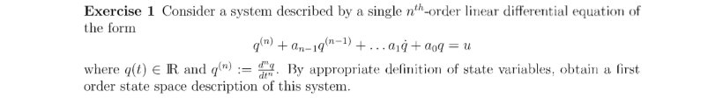

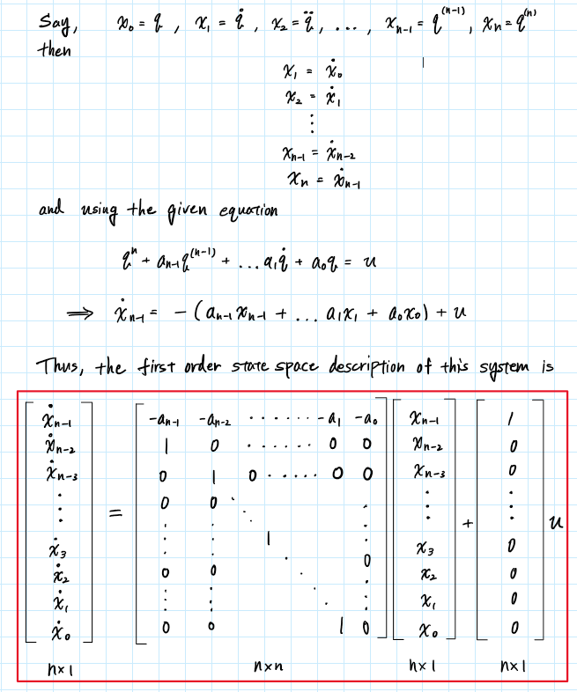

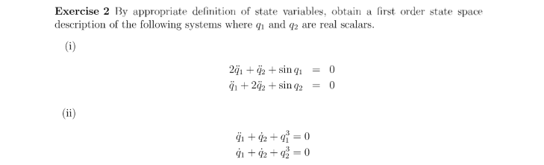

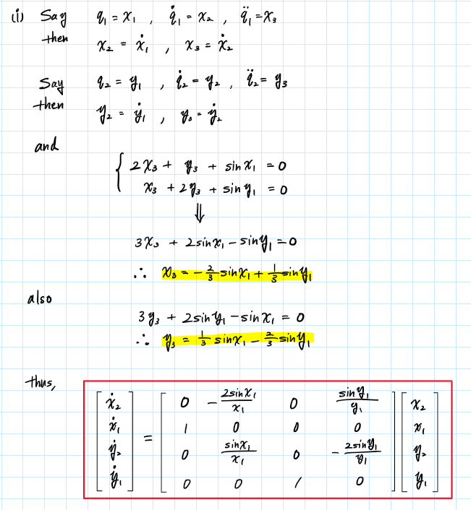

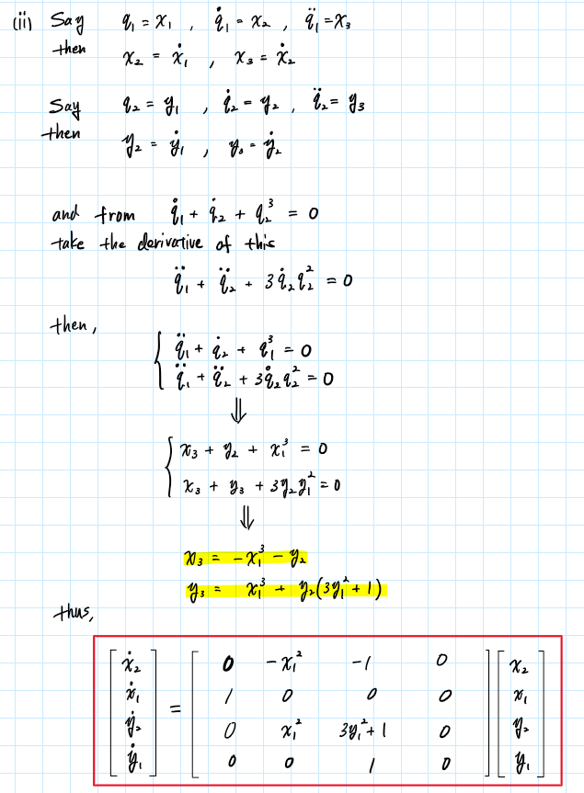

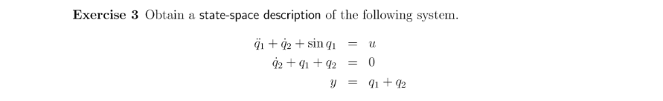

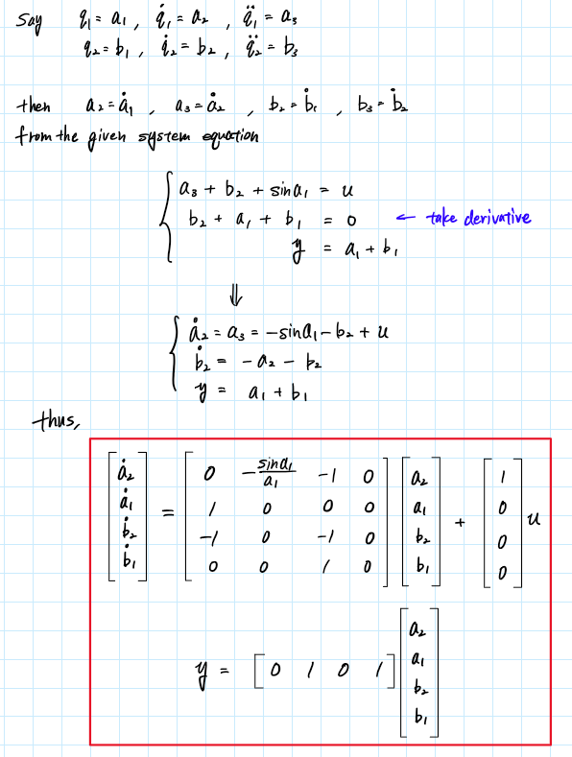

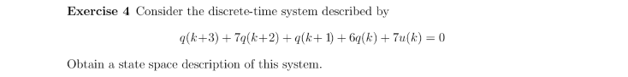

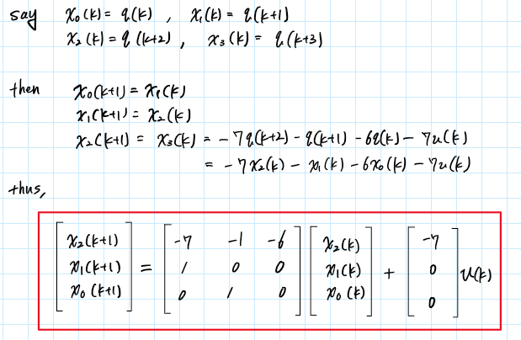



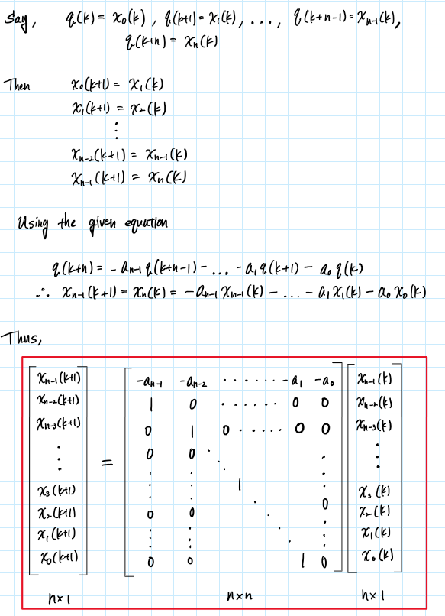

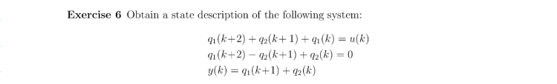

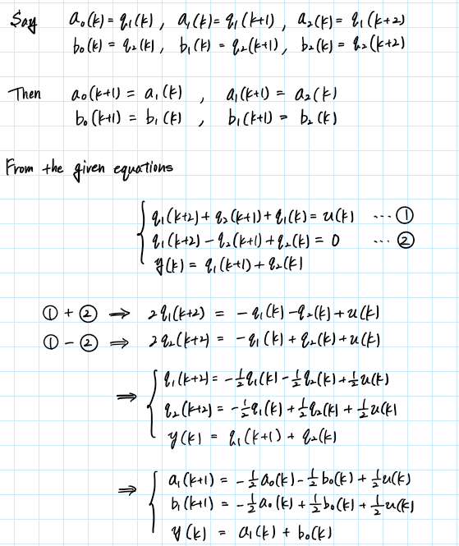

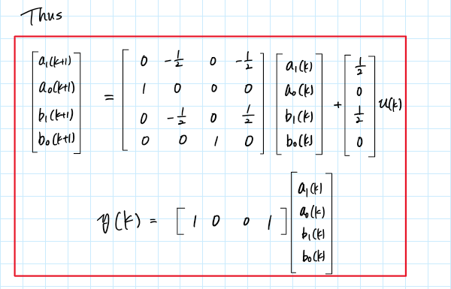

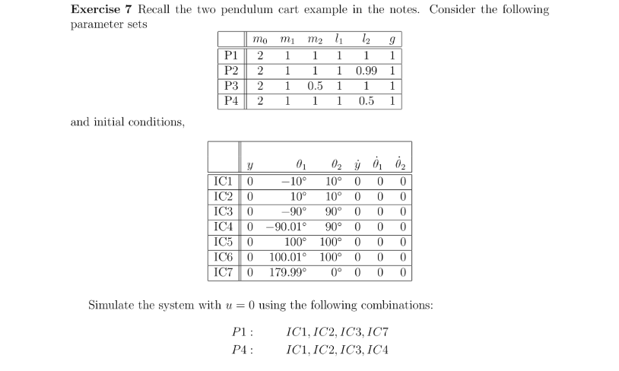

Derivation:

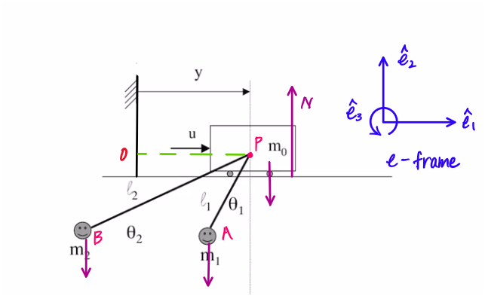

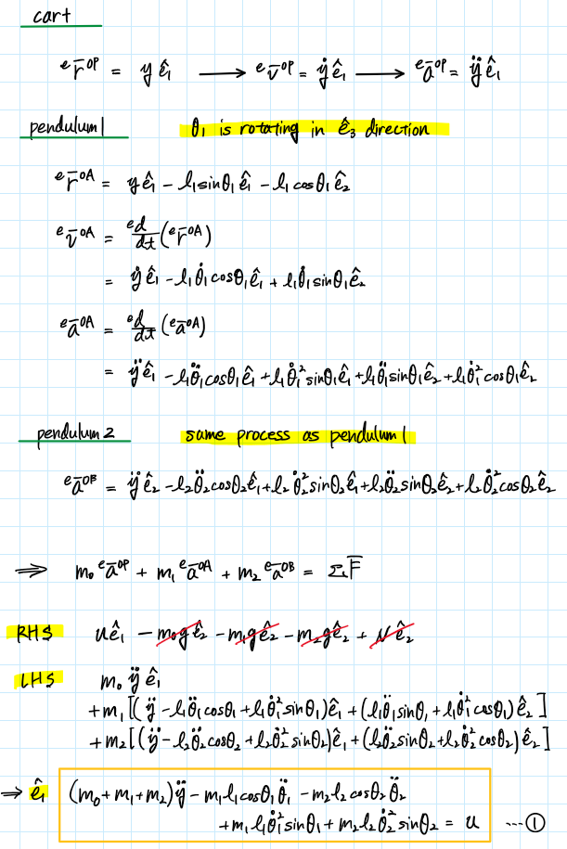

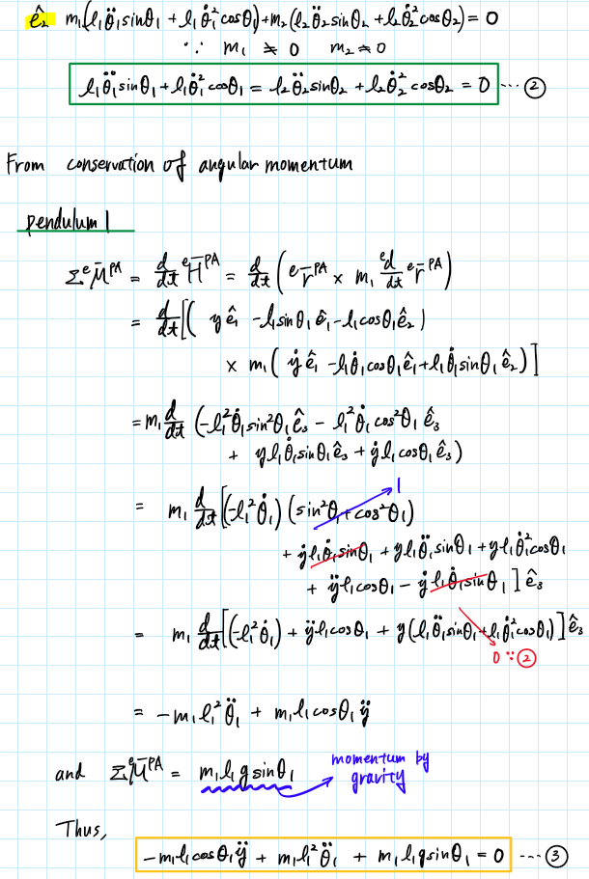



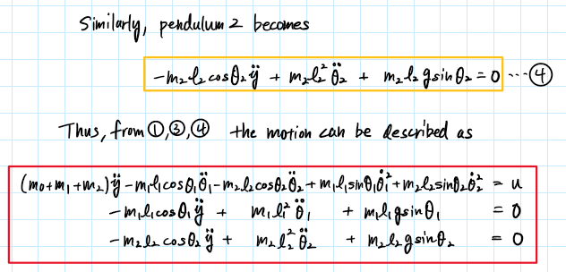

The system equation for the double pendulum cart system is

We simulate this system of equations using MATLAB for given initial conditions and input parameters. The given initial conditions and input parameters are organized in the following table.

|  |  |  |  |  |  |  |  |
| --- | --- | --- | --- | --- | --- | --- | --- |
|  |  |  |  |  |  |  |  |
| P1 | 2 | 1 | 1 | 1 | 1 | 1 | 0 |
| P2 | 2 | 1 | 1 | 1 | 0.99 | 1 | 0 |
| P3 | 2 | 1 | 0.5 | 1 | 1 | 1 | 0 |
| P4 | 2 | 1 | 1 | 1 | 0.5 | 1 | 0 |

|  |  |  |  |  |  |  |
| --- | --- | --- | --- | --- | --- | --- |
|  |  |  |  |  |  |  |
| IC1 | 0 | -10° | 10° | 0 | 0 | 0 |
| IC2 | 0 | 10° | 10° | 0 | 0 | 0 |
| IC3 | 0 | -90° | 90° | 0 | 0 | 0 |
| IC4 | 0 | -90.01° | 90° | 0 | 0 | 0 |
| IC5 | 0 | 100° | 100° | 0 | 0 | 0 |
| IC6 | 0 | 100.01° | 100° | 0 | 0 | 0 |
| IC7 | 0 | 179.99° | 0° | 0 | 0 | 0 |

Simulations:



P1 and IC1

P1 and IC2

P1 and IC3

P1 and IC7

P4 and IC1

P4 and IC2

P4 and IC3

P4 and IC4

Appendix

MATLAB Code

AAE 564 HW 1

**Author: Tomoki Koike**

clear all; close all; clc;

fdir = 'C:\Users\Tomo\Desktop\studies\2020-Fall\AAE564\matlab_simulink\outputs\hw1';

set(groot, 'defaulttextinterpreter','latex');

set(groot, 'defaultAxesTickLabelInterpreter','latex');

set(groot, 'defaultLegendInterpreter','latex');

**Simulation**

% Simulate this system for given initial conditions

% Initial conditions

IC1 = [0, -10, 10, 0, 0, 0];

IC2 = [0, 10, 10, 0, 0, 0];

IC3 = [0, -90, 90, 0, 0, 0];

IC4 = [0, -90.01, 90, 0, 0, 0];

IC5 = [0, 100, 100, 0, 0, 0];

IC6 = [0, 100.01, 100, 0, 0, 0];

IC7 = [0, 179.99, 0, 0, 0, 0];

% P1

m0 = 2;

m1 = 1;

m2 = 1;

l1 = 1;

l2 = 1;

g = 1;

u = 0;

t_span = linspace(0, 60, 2^10); % time span

% opts = odeset('RelTol',1e-6,'AbsTol',1e-7); % option for ode

% P1 and IC1, IC2, IC3, IC7

IC = [IC1; IC2; IC3; IC7];

counter = 1;

for i = [1, 2, 3, 7]

[t, q] = ode45(@(t, x) double_pendulum_system(t, x, m0, m1, m2, l1, l2, g, u), t_span, IC(counter,:));

plot_simulation(t, q, fdir, "P1&IC"+num2str(i));

counter = counter + 1;

end

% P4

m0 = 2;

m1 = 1;

m2 = 1;

l1 = 1;

l2 = 1;

g = 0.5;

u = 0;

% P4 and IC1, IC2, IC3, IC4

IC = [IC1; IC2; IC3; IC4];

counter = 1;

for i = [1, 2, 3, 4]

[t, q] = ode45(@(t, x) double_pendulum_system(t, x, m0, m1, m2, l1, l2, g, u), t_span, IC(counter,:));

plot_simulation(t, q, fdir, "P4&IC"+num2str(i));

counter = counter + 1;

end

**Functions**

function dxdt = double_pendulum_system(t, x, m0, m1, m2, l1, l2, g, u)

dxdt = zeros(6, 1); % Preallocate the derivative vector

% Set the variables

y = x(1);

theta1 = x(2);

theta2 = x(3);

y_dot = x(4);

theta1_dot = x(5);

theta2_dot = x(6);

% Create matrices to simplify the calculations

M = [ m0 + m1 + m2, -m1*l1.*cosd(theta1), -m2*l2.*cosd(theta2);

-m1*l1.*cosd(theta1), m1*l1.^2, 0;

-m2*l2.*cosd(theta2), 0, m2*l2.^2 ];

G = [(m1*l1.*sind(theta1).*theta1_dot.^2 + m2*l2.*sind(theta2).*theta2_dot.^2); m1*l1*g.*sind(theta1); m2*l2*g.*sind(theta2)];

W = [1; 0; 0];

dxdt(1) = y_dot;

dxdt(2) = theta1_dot;

dxdt(3) = theta2_dot;

dxdt(4:end) = M \ (W * u - G);

end

function plot_simulation(t, q, file_dir, file_name_str)

P_IC = split(file_name_str, "&");

% Plot position of cart vs time

fig1 = figure(1);

plot(t, q(:, 1))

title("Position of Cart Over Time "+P_IC(1)+"/"+P_IC(2)+ " - T. Koike")

xlabel('t [s]')

ylabel('y [m]')

grid on; grid minor; box on;

saveas(fig1, fullfile(file_dir, "y_"+file_name_str+".png"));

% Plot the angles of pendulums vs time

fig2 = figure(2);

plot(t, q(:, 2))

hold on

plot(t, q(:, 3))

hold off

title("Angles of Pendulums Over Time "+P_IC(1)+"/"+P_IC(2)+ " - T. Koike")

xlabel('t [s]')

ylabel('$\theta$ [deg]')

legend('$\theta_1$', '$\theta_2$')

grid on; grid minor; box on;

saveas(fig2, fullfile(file_dir, "theta1&2_"+file_name_str+".png"));

% Plot the velocity of cart vs time

fig3 = figure(3);

plot(t, q(:, 4))

title("Velocity of Cart Over Time "+P_IC(1)+"/"+P_IC(2)+ " - T. Koike")

xlabel('t [s]')

ylabel('$\dot{y}$ [m/s]')

grid on; grid minor; box on;

saveas(fig3, fullfile(file_dir, "ydot_"+file_name_str+".png"));

% Plot the angular velocities vs time

fig4 = figure(4);

plot(t, q(:, 5))

hold on

plot(t, q(:, 6))

hold off

title("Angular Velocities of Pendulums Over Time "+P_IC(1)+"/"+P_IC(2)+ " - T. Koike")

xlabel('t [s]')

ylabel('$\dot{\theta}$ [deg/s]')

legend('$\dot{\theta_1}$', '$\dot{\theta_2}$')

grid on; grid minor; box on;

saveas(fig4, fullfile(file_dir, "thetadot1&2_"+file_name_str+".png"));

end