College of Engineering

School of Aeronautics and Astronautics

AAE 564

System Analysis and Synthesis

Homework 12

State Feedback and Stabilization

*Author:*

Tomoki Koike

*Supervisor:*

Martin Corless

November 20th, 2020 Friday

Purdue University

West Lafayette, Indiana

**Exercise 1**

(By hand) Determine whether or not each of the following systems are controllable, stabilizable, or not stabilizable.

(a)

(b)

(c)

(a)

The *A* matrix and *B* matrix are

Then the controllability matrix becomes

The reduced echelon form of this matrix is

Thus, this system is controllable.

For any gain matrix

Then

If and

The characteristics polynomial has all positive coefficients, so the corresponding eigenvalues have a negative real part and is asymptotically stable. Thus, this system is stabilizable.

(b)

The *A* matrix and *B* matrix are

Then the controllability matrix becomes

The reduced echelon form of this matrix is

Thus, this system is uncontrollable.

The eigenvalues of this system are

The uncontrollable eigenvalue can be found by the PBH test

For

For

Thus, the uncontrollable eigenvalue has a negative real part so this system is stabilizable.

(c)

The *A* matrix and *B* matrix are

Then the controllability matrix becomes

The reduced echelon form of this matrix is

Thus, this system is uncontrollable.

The eigenvalues of this system are

The uncontrollable eigenvalue can be found by the PBH test

For

For

Thus, the uncontrollable eigenvalue does not have a negative real part so this system is not stabilizable.

**Exercise 2**

Obtain an open loop control which drives the following system from to .

From the problem we know that

The controllability grammian is going to be

Then,

Then the control input will become

Thus, the open loop control that drives to for a given time frame of is

**Exercise 3**

(By hand) Consider the system described by

Obtain a state feedback controller which results in a closed loop system which is asymptotically stable about the zero state.

The matrix of this system are

The controllability matrix is

This system is controllable.

Choose two asymptotically stable poles

Use the eigenvalue placement method to stabilize the system.

Say the feedback gains are

Then

Then

The characteristic equation with the desired poles is

Then, equate

**Exercise 4**

(By hand) Consider the system described by

Where all quantities are scalars.

1. Is this system stabilizable via state feedback?
2. Does there exist a linear state feedback controller which results in closed loop eigenvalues -1, -4?
3. Does there exist a linear state feedback controller which results in closed loop eigenvalues -2, -4?

In parts (b) and (c): If no controller exists, explain why; if one does exist, give an example of one.

(a)

The *A* matrix and *B* matrix are

Then the controllability matrix becomes

Thus, this system is uncontrollable.

The eigenvalues of this system are

The uncontrollable eigenvalue can be found by the PBH test

For

For

From the PBH test we know that the uncontrollable eigenvalue has a negative real part so this is stabilizable.

For a feedback gain matrix

Then

(b)

If the desired poles are -1 and -4, the corresponding characteristic equation will be

Then from part (a) we can find the gains of the state feedback controller.

The augmented matrix is

So, there are infinite amount of gains that satisfy

And one example is

Thus, there exists a linear state feedback controller of .

(c)

If the desired poles are -2 and -4, the corresponding characteristic equation will be

Then from part (a) we can find the gains of the state feedback controller.

The augmented matrix is

In the second row, 2 cannot be equal to 0. Thus, there does NOT exist a linear state controller for the eigenvalues of -2, -4.

**Exercise 5**

(Stabilization of cart pendulum system via state feedback.) (MATLAB)

Carry out the following parameter sets P2 and P4 and equilibriums E1 and E2. Illustrate the effectiveness of your controllers with numerical simulations.

Using eigenvalue placement techniques, obtain a state feedback controller which stabilizes the nonlinear system about the equilibrium.

What is the largest value of (in degrees) for which your controller guarantees convergence of the closed loop system to the equilibrium for initial conditions

Where and are the equilibrium values of and .

The system equation for the double pendulum cart system is

Have the system be a single output of the displacement y.

|  |  |  |  |  |  |  |  |
| --- | --- | --- | --- | --- | --- | --- | --- |
|  |  |  |  |  |  |  |  |
| P1 | 2 | 1 | 1 | 1 | 1 | 1 | 0 |
| P2 | 2 | 1 | 1 | 1 | 0.99 | 1 | 0 |
| P3 | 2 | 1 | 0.5 | 1 | 1 | 1 | 0 |
| P4 | 2 | 1 | 1 | 1 | 0.5 | 1 | 0 |

|  |  |  |
| --- | --- | --- |
| L1 | P1 | E1 |
| L2 | P1 | E2 |
| L3 | P2 | E1 |
| L4 | P2 | E2 |
| L5 | P3 | E1 |
| L6 | P3 | E2 |
| L7 | P4 | E1 |
| L8 | P4 | E2 |

The Simulink model used for this is shown below,

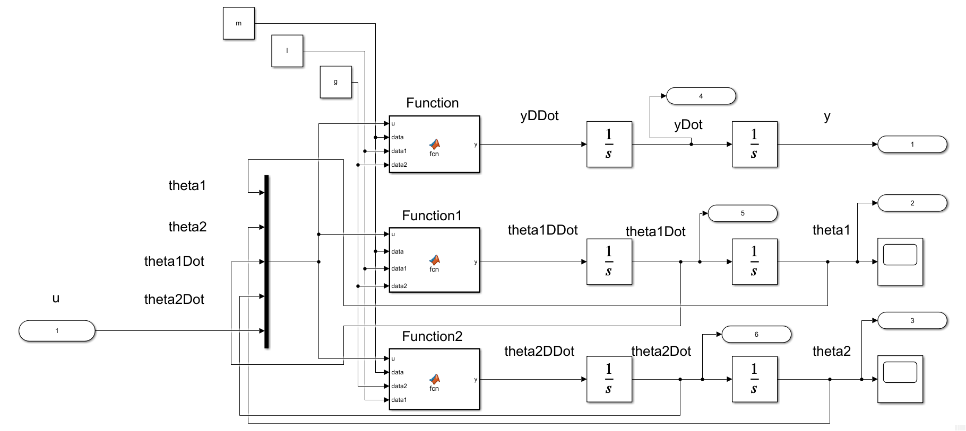

Embedded MATLAB Block – Function (code)

function y = fcn(u, data, data1, data2)

%{

EMBEDDED MATLAB BLOCK FUNCTION

%}

m0 = data(1); m1 = data(2); m2 = data(3); l1 = data1(1); l2 = data1(2);

g = data2;

num = -m1*l1*sin(u(1))*u(3)*u(3) - m2*l2*sin(u(2))*u(4)*u(4)...

- m1*g*sin(u(1))*cos(u(1)) - m2*g*sin(u(2))*cos(u(2))...

+ u(5);

den = m0 + m1 + m2 - m1*cos(u(1))^2 - m2*cos(u(2))^2;

y = num / den;

end

Embedded MATLAB Block – Function1 (code)

function y = fcn(u, data, data1, data2)

%{

EMBEDDED MATLAB BLOCK FUNCTION1

%}

m0 = data(1); m1 = data(2); m2 = data(3); l1 = data1(1); l2 = data1(2);

g = data2;

num = -(m1*l1*cos(u(1))*sin(u(1))*u(3)*u(3) + m2*l2*cos(u(1))*sin(u(2))*u(4)*u(4))...

+ m2*g*(sin(u(1))*cos(u(2))^2 - cos(u(1))*sin(u(2))*cos(u(2)))...

- (m0 + m1 + m2)*g*sin(u(1)) + u(5)*cos(u(1));

den = l1*(m0 + m1 + m2 - m1*cos(u(1))^2 - m2*cos(u(2))^2);

y = num / den;

end

Embedded MATLAB Block – Function2 (code)

function y = fcn(u, data, data2, data1)

%{

EMBEDDED MATLAB BLOCK FUNCTION2

%}

m0 = data(1); m1 = data(2); m2 = data(3); l1 = data1(1); l2 = data1(2);

g = data2;

num = -(m1*l1*cos(u(2,1))*sin(u(1))*u(3)*u(3) + m2*l2*cos(u(2))*sin(u(2))*u(4)*u(4))...

+ m1*g*(sin(u(2))*cos(u(1))^2 - cos(u(2))*sin(u(1))*cos(u(1)))...

- (m0 + m1 + m2)*g*sin(u(2)) + u(5)*cos(u(2));

den = l2*(m0 + m1 + m2 - m1*cos(u(1))^2 - m2*cos(u(2))^2);

y = num / den;

end

For the conditions E1 and E2, we set the initial conditions of the integrator block of y, , and correspondingly to ; like in the following windows,

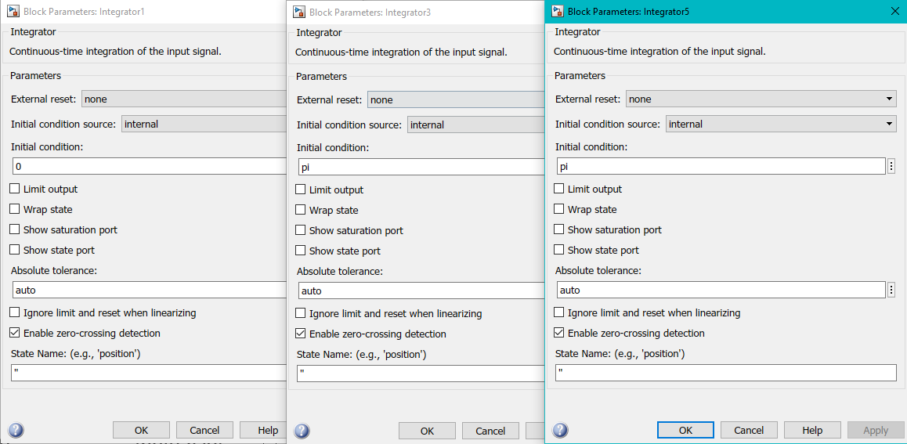

The feedback control system is the following Simulink model

“hw12_feedbackControl”

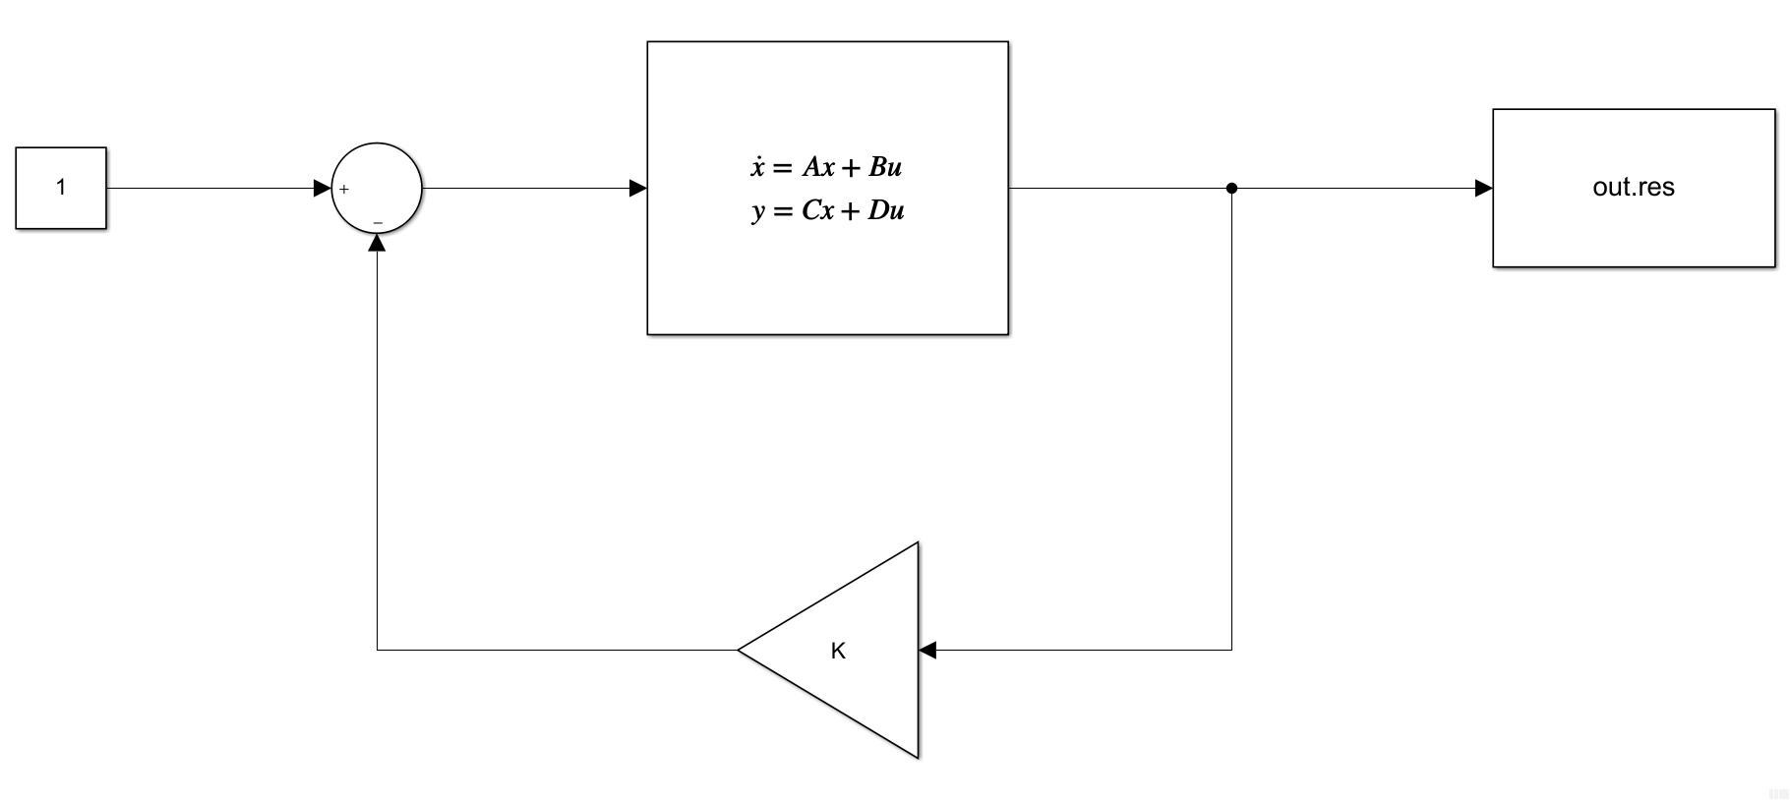

Procedure:

1. Linearize the system for P# and E# and obtain the A, B, C, D matrices for corresponding equilibrium conditions
2. Define the system requirements – eigenvalues to be placed
3. Compute the feedback gain K with eigenvalue placement
4. Plot the response of the controlled system with the system above

L3 (P2 & E1):

1.

|  |  |
| --- | --- |
| A = 6×6  0 0 0 1.0000 0 0  0 0 0 0 1.0000 0  0 0 0 0 0 1.0000  0 -0.5000 -0.5000 0 0 0  0 -1.5000 -0.5000 0 0 0  0 -0.5051 -1.5152 0 0 0 | B = 6×1  0  0  0  0.5000  0.5000  0.5051 |
| C = 1×6  1 0 0 0 0 0 | **D = 0** |

2.

|  |
| --- |
| p =  -23/15 + 1207/363i -11/50 + 0i -3 + 0i  -23/15 - 1207/363i -3/2 + 0i -9/2 + 0i |

3.

|  |
| --- |
| K = 1×6  104 ×  0.0118 6.2267 -6.1632 0.0709 -2.7555 2.6601 |

4.

L4 (P2 & E2):

1.

|  |  |
| --- | --- |
| A = 6×6  0 0 0 1.0000 0 0  0 0 0 0 1.0000 0  0 0 0 0 0 1.0000  0 -0.5000 -0.5000 0 0 0  0 1.5000 0.5000 0 0 0  0 0.5051 1.5152 0 0 0 | B = 6×1  0  0  0  0.5000  -0.5000  -0.5051 |
| C = 1×6  1 0 0 0 0 0 | **D = 0** |

2.

|  |
| --- |
| p =  -23/15 + 1207/363i -11/50 + 0i -3 + 0i  -23/15 - 1207/363i -3/2 + 0i -9/2 + 0i |

3.

|  |
| --- |
| K = 1×6  105 ×  0.0012 1.1301 -1.1191 0.0071 1.1914 -1.1727 |

4.

L7 (P4 & E1):

1.

|  |  |
| --- | --- |
| A = 6×6  0 0 0 1.0000 0 0  0 0 0 0 1.0000 0  0 0 0 0 0 1.0000  0 -0.5000 -0.5000 0 0 0  0 -1.5000 -0.5000 0 0 0  0 -1.0000 -3.0000 0 0 0 | B = 6×1  0  0  0  0.5000  0.5000  1.0000 |
| C = 1×6  1 0 0 0 0 0 | **D = 0** |

2.

|  |
| --- |
| p =  -23/15 + 1207/363i -11/50 + 0i -3 + 0i  -23/15 - 1207/363i -3/2 + 0i -9/2 + 0i |

3.

|  |
| --- |
| K = 1×6  59.7291 627.9728 -279.9391 358.1599 -278.3304 -27.6281 |

4.

L8 (P4 & E2):

1.

|  |  |
| --- | --- |
| A = 6×6  0 0 0 1.0000 0 0  0 0 0 0 1.0000 0  0 0 0 0 0 1.0000  0 -0.5000 -0.5000 0 0 0  0 1.5000 0.5000 0 0 0  0 1.0000 3.0000 0 0 0 | B = 6×1  0  0  0  0.5000  -0.5000  -1.0000 |
| C = 1×6  1 0 0 0 0 0 | **D = 0** |

2.

|  |
| --- |
| p =  -23/15 + 1207/363i -11/50 + 0i -3 + 0i  -23/15 - 1207/363i -3/2 + 0i -9/2 + 0i |

3.

|  |
| --- |
| K = 1×6  103 ×  0.0597 1.1405 -0.6133 0.3582 1.2035 -0.4349 |

4.

**Exercise 6**

(By hand) Consider the discrete time system

Obtain a state feedback controller which always drives the state of this system to zero in at most two steps.

The state matrices become

The controllability matrix is

This system is controllable.

Define a gain so that .

Take the determinant, and it becomes

If the system goes to zero in two steps (or two seconds with a sampling time of one second), the Cayley-Hamilton Theorem implies that the following should be satisfied

Thus, the characteristic polynomial of the desired poles become

Thus, we solve

Which gives us

**Exercise 7**

For the system described by

Obtain a feedback controller generating and which stabilizes this system. Assume that can be measured. You can use MATLAB for some of this.

Manipulating the given equations, we get the following relations

Let, . Then *A*, *B* matrices of this system are

The controllability matrix becomes

The row reduced echelon form of this matrix is

Thus,

And this system is controllable, so we can choose any poles to control this system. The arbitrary poles that we choose are

Now we find the controller gains using the Brogan’s Algorithm

Step 1:

Find

Step 2:

Compute

Step 3:

Calculate

Where correspond to the columns of .

Step 4:

Find the gains with

Where

Thus,

And

The eigenvalues become

**Exercise 8**

Consider the system described by

Obtain (by hand) a state-feedback controller (it will not be a static controller) which always results in the state of the closed loop going to zero in at most 2 secs. Illustrate your results with a simulation.

The *A* and *B* matrices of this continuous time system is

The discrete time state space becomes

Let the sampling time, T be 1 second. Then

The controllability matrix is

This system is controllable.

Define a gain so that .

Take the determinant, and it becomes

If the system goes to zero in two steps (or two seconds with a sampling time of one second), the Cayley-Hamilton Theorem implies that the following should be satisfied

Thus, the characteristic polynomial of the desired poles become

Thus, we solve

Solving these linear equations, we obtain

Now we create the following Simulink to simulate the system.

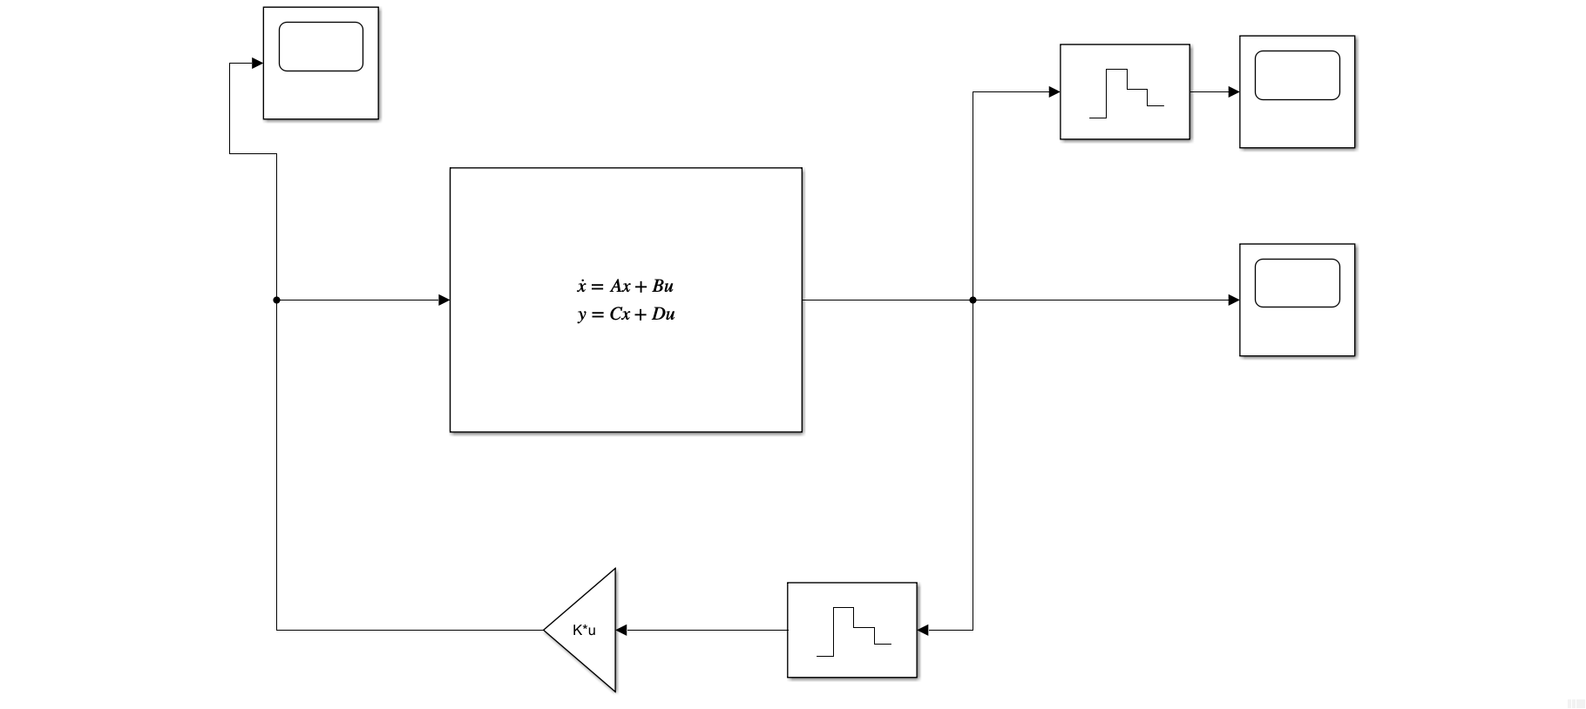

Where the state space block has

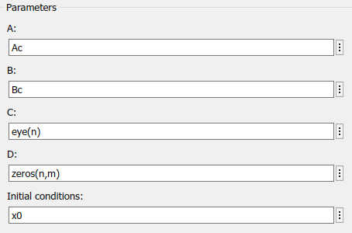

And

The input is

The discrete output is

The continuous output is

