College of Engineering

School of Aeronautics and Astronautics

AAE 564

System Analysis and Synthesis

Homework 2

State Space Representation, Linearization, and Transfer Functions

*Author:*

Tomoki Koike

*Supervisor:*

Martin Corless

September 11th, 2020 Friday

Purdue University

West Lafayette, Indiana

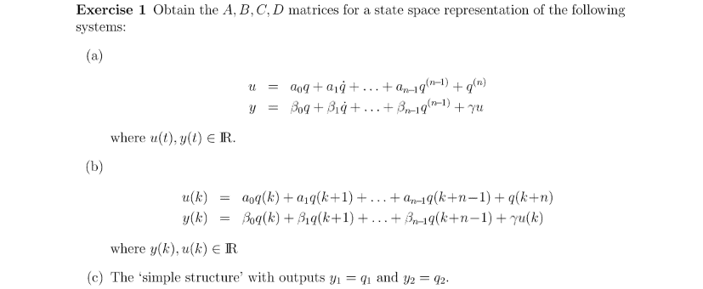

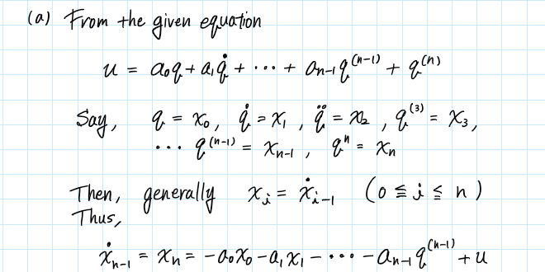

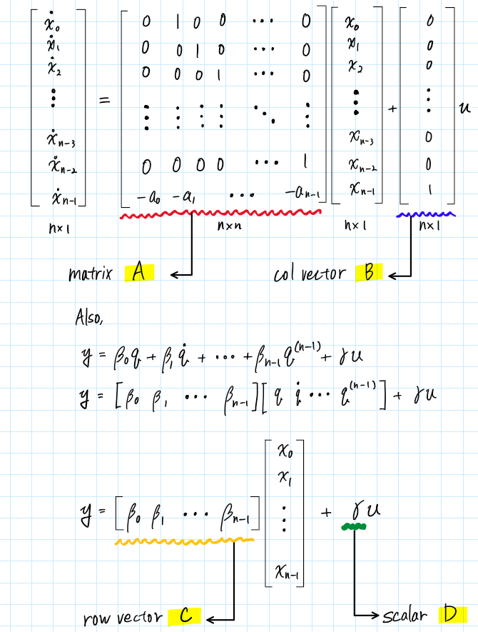

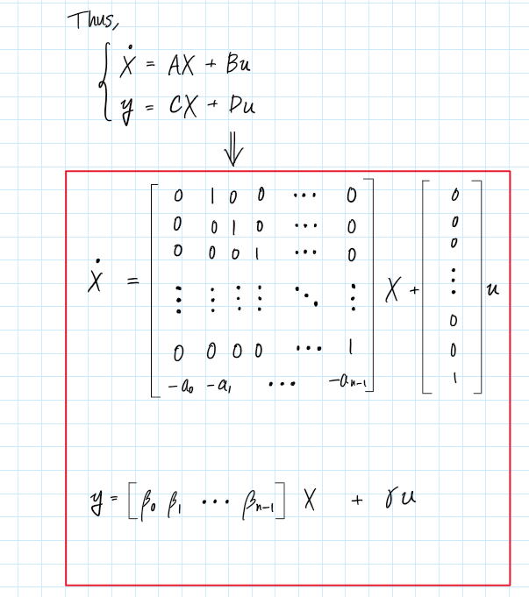

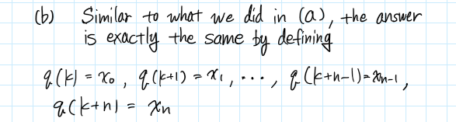

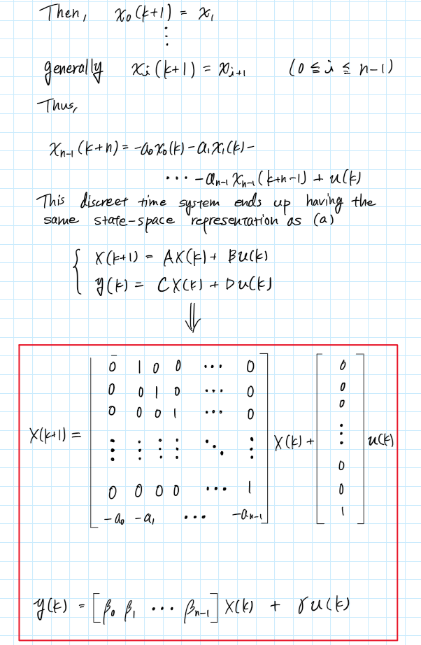

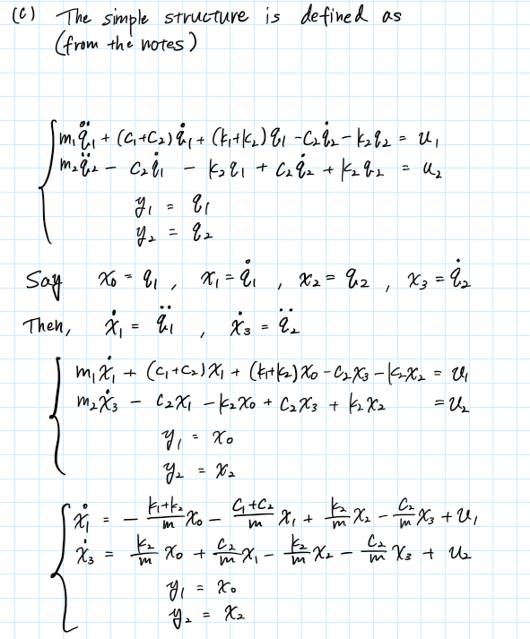

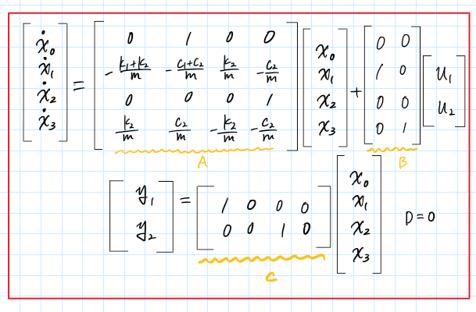

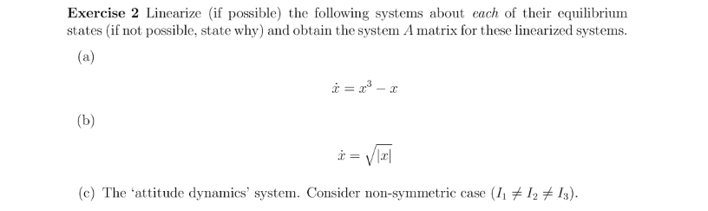

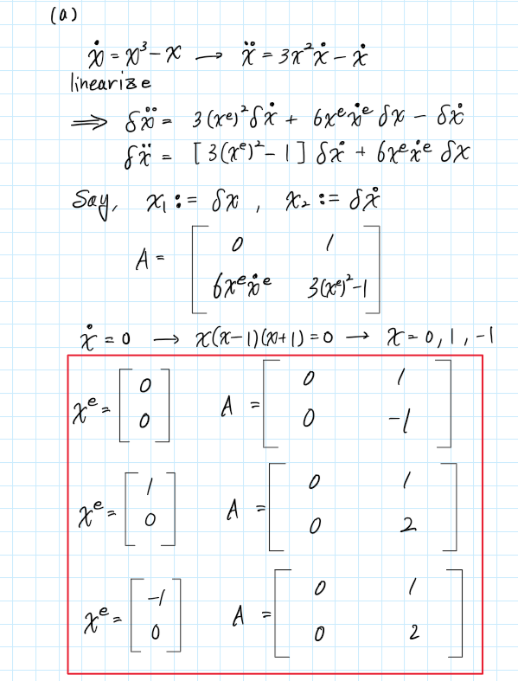

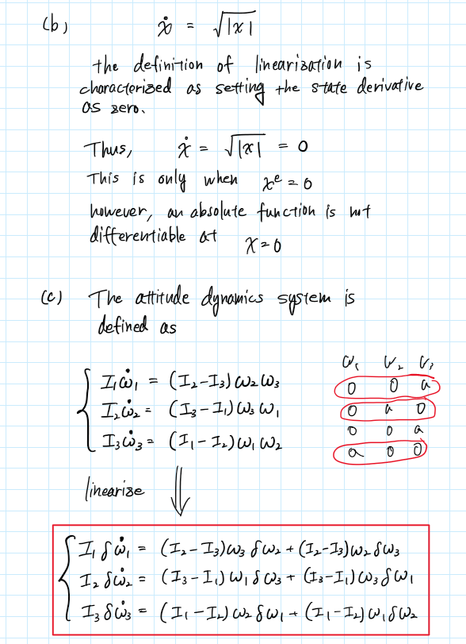

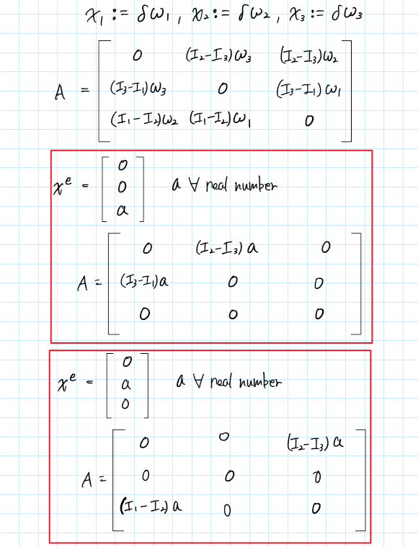

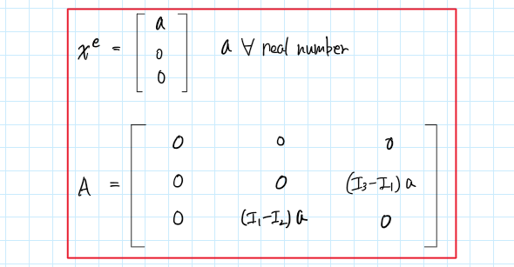

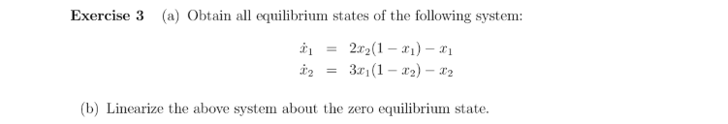

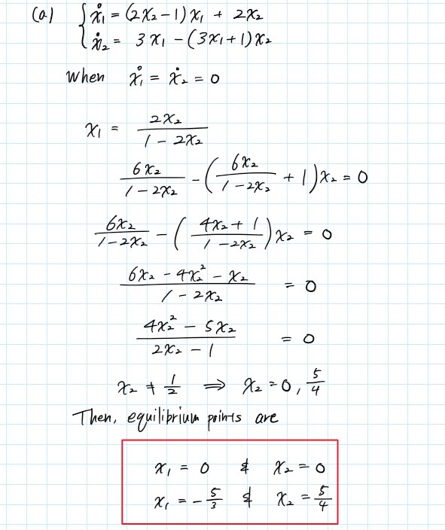

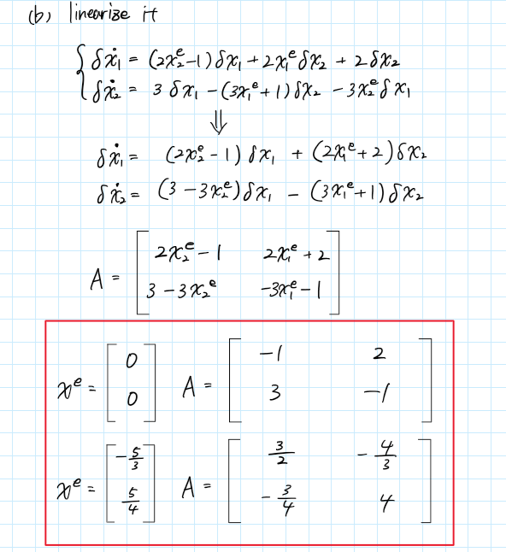

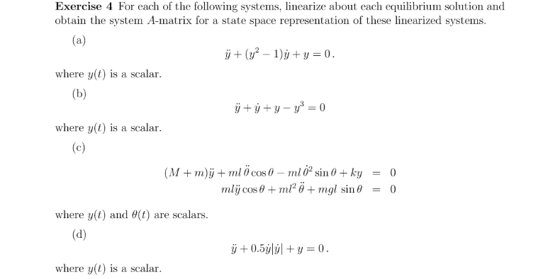

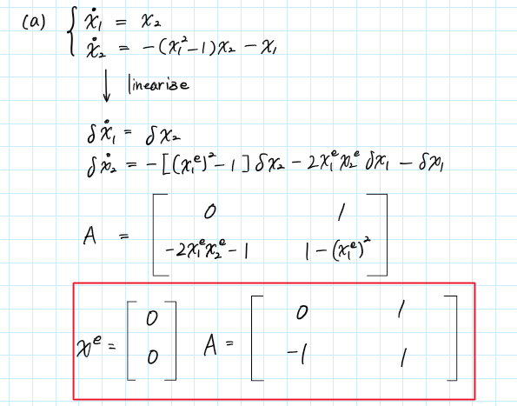

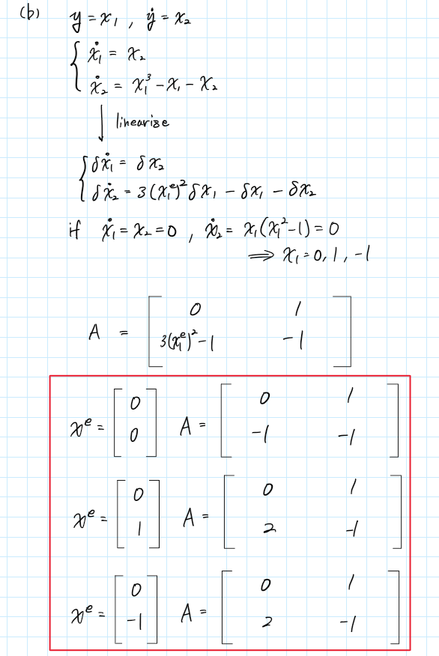

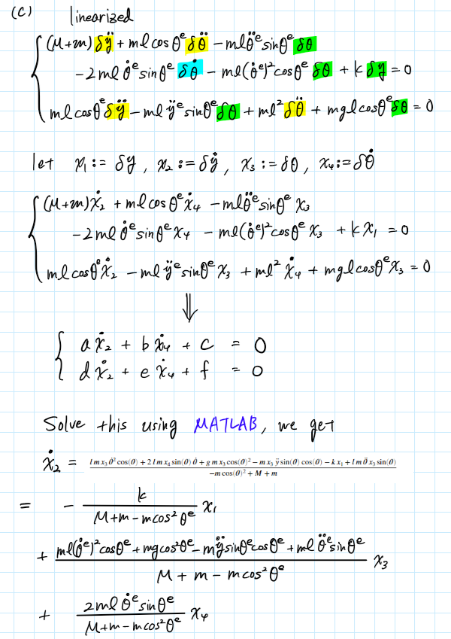

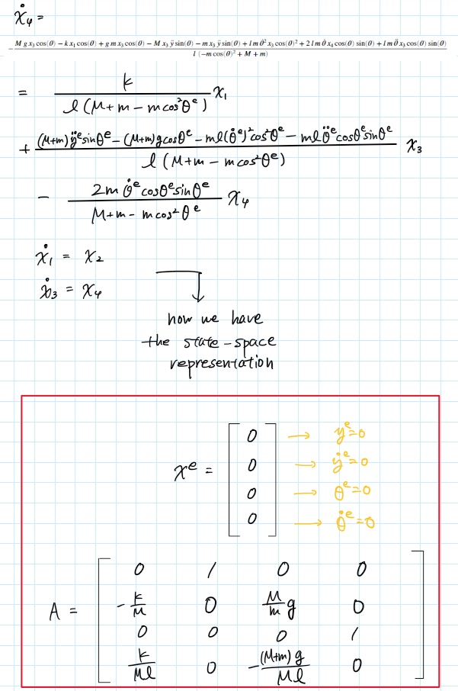

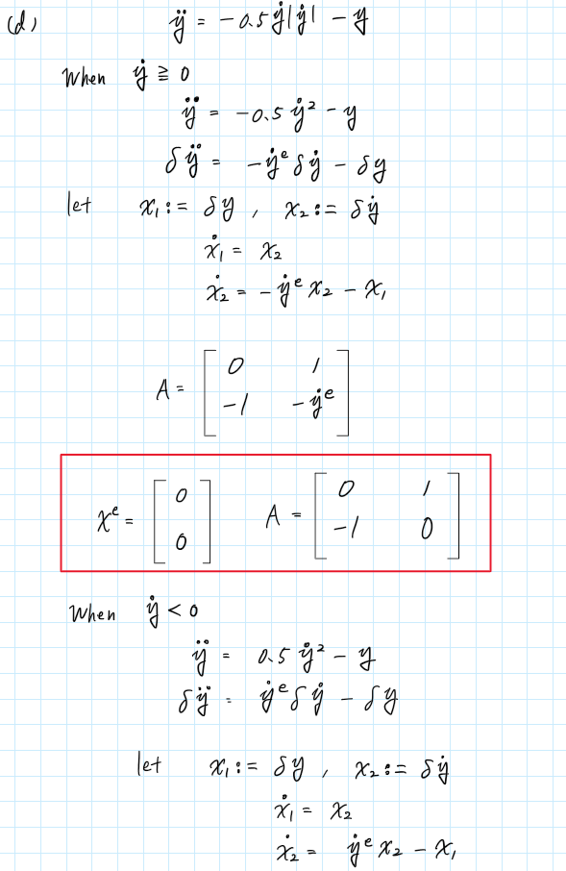

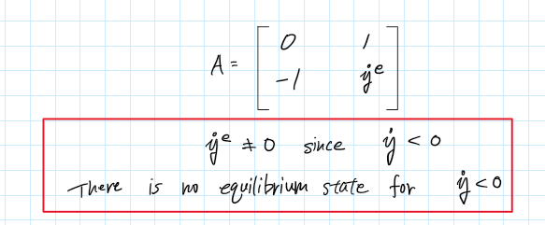

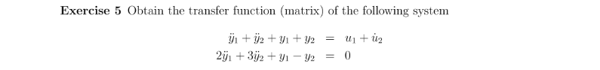

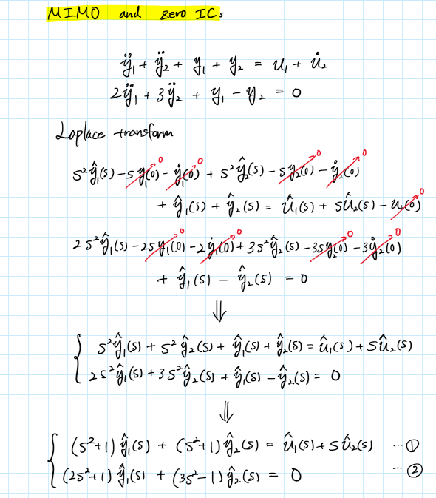

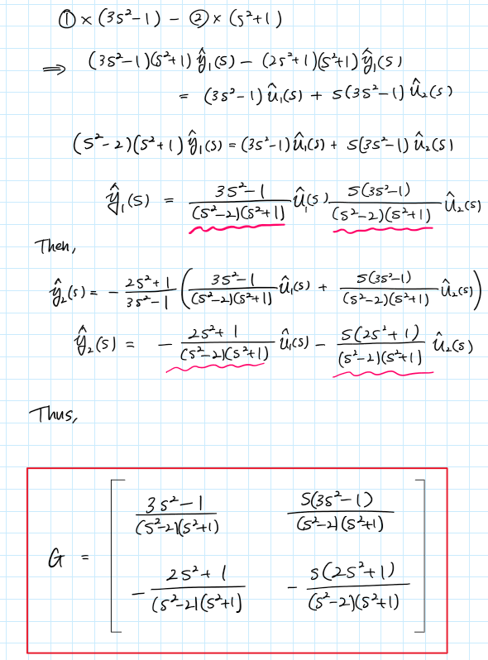

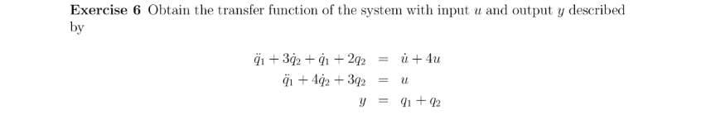

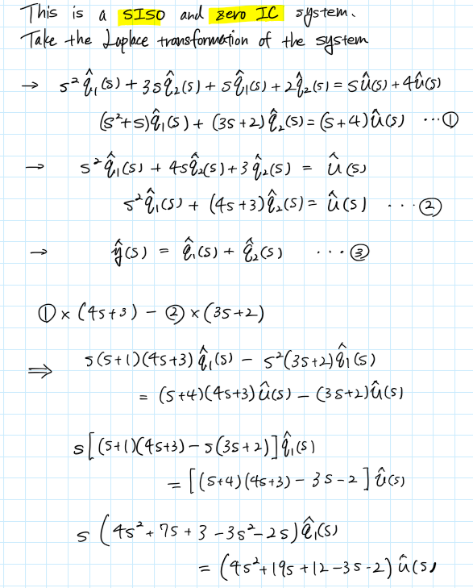

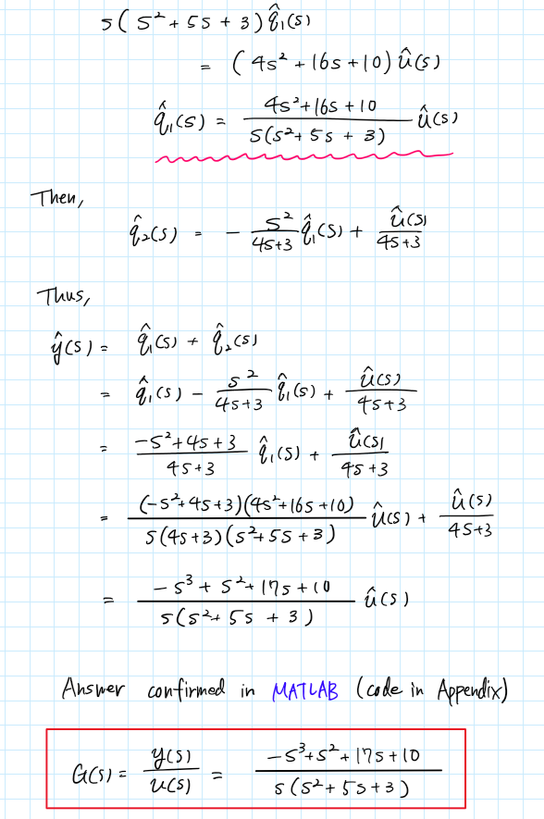



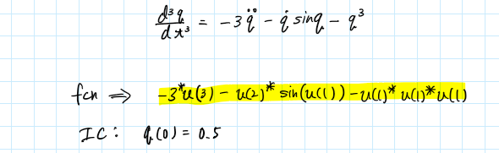

Plot with the IC of q(0) = 0.5

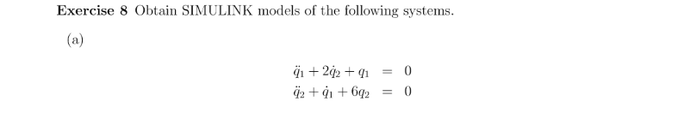

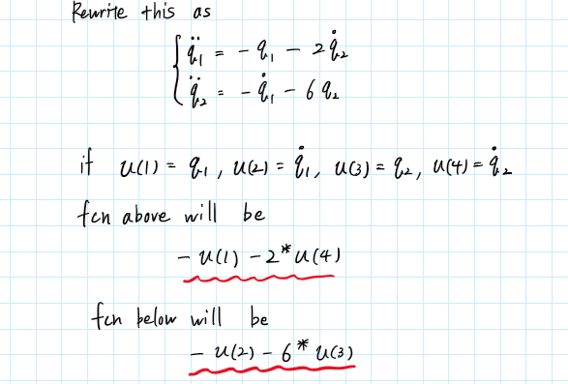

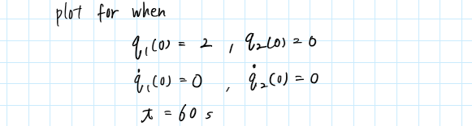

Output from Scope 1

Output from Scope 2

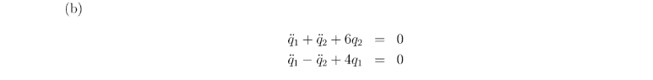

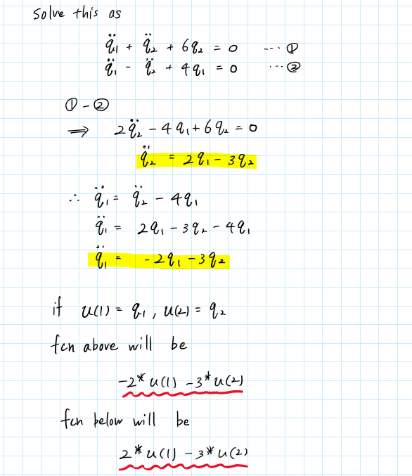

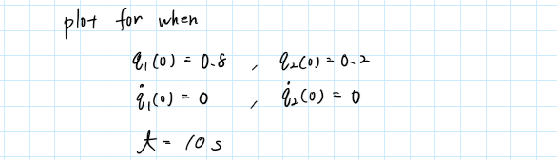

Output from Scope 1

Output from Scope 2

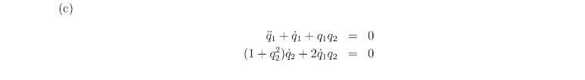

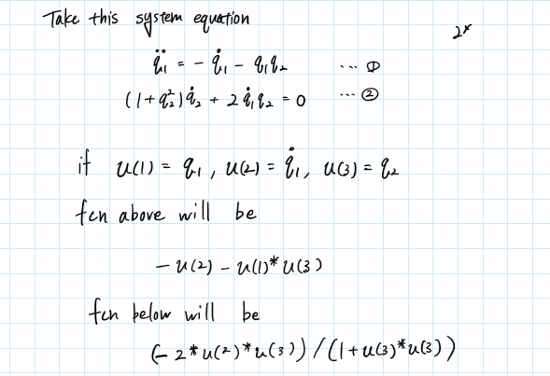

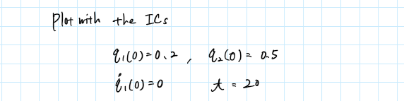

Output from Scope 1

Output from Scope 2

