College of Engineering

School of Aeronautics and Astronautics

AAE 564

System Analysis and Synthesis

Homework 8

Stability of LTI Systems

*Author:*

Tomoki Koike

*Supervisor:*

Martin Corless

October 23th, 2020 Friday

Purdue University

West Lafayette, Indiana

**Exercise 1**

Determine (by hand) whether each of the following systems is asymptotically stable, stable, or unstable.

$$\begin{matrix}\dot{x_{1}} & = & -x_{1}+2001x_{2} \\ \dot{x_{2}} & = & -x_{1}\end{matrix}$$

$$\begin{matrix}\dot{x_{1}} & = & -x_{1} \\ \dot{x_{2}} & = & x_{2}\end{matrix}$$

(c)

$$\begin{matrix}\dot{x_{1}} & = & jx_{1}+x_{2} \\ \dot{x_{2}} & = & jx_{2}\end{matrix}$$

(d)

$$\begin{matrix}x_{1}\left(k+1\right) & = & -2x_{1}\left(k\right) \\ x_{2}\left(k+1\right) & = & 0.5x_{2}\left(k\right)\end{matrix}$$

(a)

$$A=\left(\begin{matrix}-1 & 2001 \\ -1 & 0\end{matrix}\right)$$

The eigenvalue of this matrix is

$$\left(A-λI\right)=\left(\begin{matrix}-1-λ & 2001 \\ -1 & -λ\end{matrix}\right)$$

$$det\left(A-λI\right)=\left(-1-λ\right)\left(-λ\right)+2001=λ^{2}+λ+2001$$

$$λ=-0.5±j44.7297 .$$

The eigenvectors become,

$$v_{1}=\left(\begin{matrix}0.5-j44.7297 \\ 1\end{matrix}\right), λ_{1}=-0.5+j44.7297$$

$$v_{2}=\left(\begin{matrix}0.5+j44.7297 \\ 1\end{matrix}\right), λ_{2}=-0.5-j44.7297$$

Thus, the $A$ matrix is nondefective and has a complex eigenvalue with a negative real part. Hence this system is asymptotically stable and bounded.

(b)

$$A=\left(\begin{matrix}-1 & 0 \\ 0 & 1\end{matrix}\right)$$

The eigenvalue of this matrix is

$$\left(A-λI\right)=\left(\begin{matrix}-1-λ & 0 \\ 0 & 1-λ\end{matrix}\right)$$

$$det\left(A-λI\right)=\left(-1-λ\right)\left(1-λ\right)$$

$$λ=1, -1.$$

The geometric and algebraic multiplicity is equal, so this matrix is nondefective. The eigenvalues of this $A$ matrix consists of one negative real value and another value that is a positive real value. Thus, this system is unstable and unbounded.

(c)

$$A=\left(\begin{matrix}j & 1 \\ 0 & j\end{matrix}\right)$$

The eigenvalue of this matrix is

$$\left(A-λI\right)=\left(\begin{matrix}j-λ & 1 \\ 0 & j-λ\end{matrix}\right)$$

$$det\left(A-λI\right)={\left(j-λ\right)}^{2}$$

$$λ=j.$$

This is a defective matrix $A$, and has a repeating eigenvalue on the imaginary axis of the complex plane. Thus, this system is unstable and unbounded.

(d)

$$A=\left(\begin{matrix}-2 & 0 \\ 0 & 0.5\end{matrix}\right)$$

The eigenvalue of this matrix is

$$\left(A-λI\right)=\left(\begin{matrix}-2-λ & 0 \\ 0 & 0.5-λ\end{matrix}\right)$$

$$det\left(A-λI\right)=\left(-2-λ\right)\left(0.5-λ\right)$$

$$λ=0.5, -2.$$

Since this system is nondefective and has a negative eigenvalue that is smaller than -1, the system will grow with increasing age and is unstable and unbounded.

**Exercise 2**

Determine (by hand) the stability properties of a linear continuous-time system with

$$A=\left(\begin{matrix}\frac{1}{2} & 1 & -\frac{1}{2} & 0 \\ -1 & \frac{1}{2} & 0 & -\frac{1}{2} \\ \frac{1}{2} & 0 & -\frac{1}{2} & 1 \\ 0 & \frac{1}{2} & -1 & -\frac{1}{2}\end{matrix}\right)$$

Using the eig() command on MATLAB, what would you stability conclusion be?

The eigenvalue of this matrix is

$$\left(A-λI\right)=\left(\begin{matrix}\frac{1}{2}-λ & 1 & -\frac{1}{2} & 0 \\ -1 & \frac{1}{2}-λ & 0 & -\frac{1}{2} \\ \frac{1}{2} & 0 & -\frac{1}{2}-λ & 1 \\ 0 & \frac{1}{2} & -1 & -\frac{1}{2}-λ\end{matrix}\right)$$

$$∴det\left(A-λI\right)=λ^{4}+2λ^{2}+1$$

$$λ=±j .$$ This matrix $A$ is defective because the geometric multiplicity and the algebraic multiplicity are not equal. Thus, it will have solutions such as

$$e^{jt}, e^{-jt}, te^{jt}, te^{-jt}$$

Since there is a repeated eigenvalue on the imaginary axis of the complex plane, we know that this $A$ matrix is unstable and unbounded.

The eig() command on MATLAB, gives the following result

$$e^{At}=\left(\begin{matrix}\left(0.5t+1\right)cos\left(t\right) & \left(0.5t+1\right)sin\left(t\right) & -0.5tcos\left(t\right) & -0.5tsin\left(t\right) \\ -\left(0.5t+1\right)sin\left(t\right) & \left(0.5t+1\right)cos\left(t\right) & 0.5tsin\left(t\right) & -0.5tcos\left(t\right) \\ 0.5tcos\left(t\right) & 0.5tsin\left(t\right) & -0.5\left(t-2\right)cos\left(t\right) & -0.5\left(t-2\right)sin\left(t\right) \\ -0.5tsin\left(t\right) & 0.5tcos\left(t\right) & 0.5t-1 & -0.5\left(t-2\right)cos\left(t\right)\end{matrix}\right)$$

As you can see all of them keep growing with respect to time. So, it is unstable and unbounded.

**Exercise 3**

Using linearization determine (if possible) the stability properties of each of the following systems about their corresponding specified equilibrium solution $q^{e}$. If not possible, provide a reason.

(a)

$$\ddot{q}+\left(\dot{q}-1\right)\left|\dot{q}-1\right|+2sinq=0$$

and $q^{e}=π/6$

(b)

$$\begin{matrix}\dot{q_{1}} & = & e^{q_{1}}q_{2}-q_{1}^{3} \\ \dot{q_{2}} & = & -q_{1}cosq_{2}\end{matrix}$$

and $q^{e}={\left[0, 0\right]}^{T}.$

(c)

$$\begin{matrix}\ddot{q_{1}} & = & q_{2} \\ \ddot{q_{2}} & = & sinq_{1}\end{matrix}$$

and $q^{e}={\left[0, 0\right]}^{T}$.

(a)

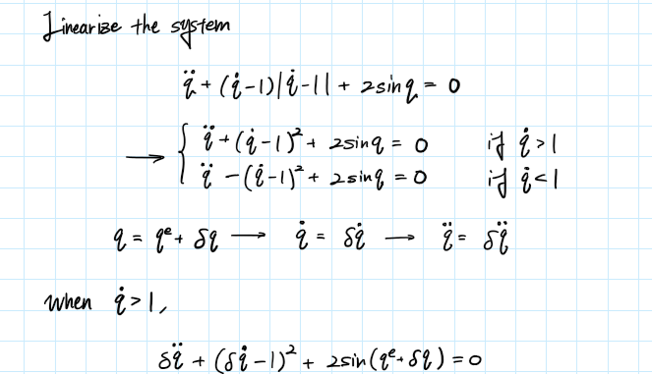

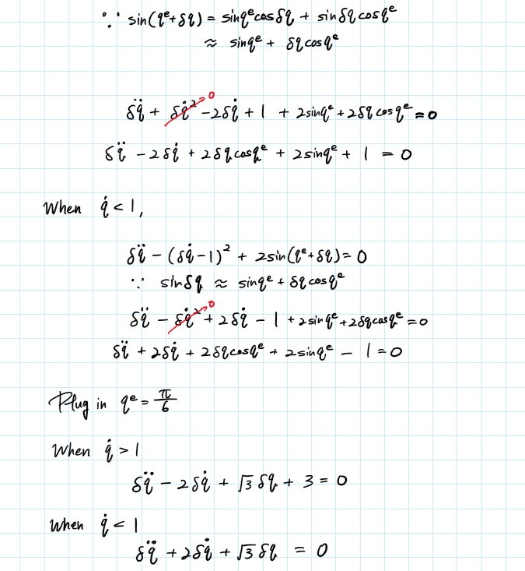

When $\dot{q}>1$

$$\dot{x}=\left(\begin{matrix}0 & 1 \\ -\sqrt{3} & 2\end{matrix}\right)x+\left(\begin{matrix}0 \\ -3\end{matrix}\right)u$$

The eigenvalues of the $A$ matrix is

$$\left(A-λI\right)=\left(\begin{matrix}-λ & 1 \\ -\sqrt{3} & 2-λ\end{matrix}\right)$$

$$det\left(A-λI\right)=\left(2-λ\right)\left(-λ\right)+\sqrt{3}=λ^{2}-2λ+\sqrt{3}$$

$$λ=1±j0.8556.$$

Since the real part is a positive this is unstable and unbounded.

When $\dot{q}<1$

$$\dot{x}=\left(\begin{matrix}0 & 1 \\ -\sqrt{3} & -2\end{matrix}\right)x$$

The eigenvalues of the $A$ matrix is

$$\left(A-λI\right)=\left(\begin{matrix}-λ & 1 \\ -\sqrt{3} & -2-λ\end{matrix}\right)$$

$$det\left(A-λI\right)=\left(-2-λ\right)\left(-λ\right)+\sqrt{3}=λ^{2}+2λ+\sqrt{3}$$

$$λ=-1±j0.8556.$$

Since the real part is a negative this is GAS and bounded.

Thus, if $\dot{q}>1$, the nonlinear system is unstable. Whereas if $\dot{q}<1$, the nonlinear system is stable.

Verify this with Simulink

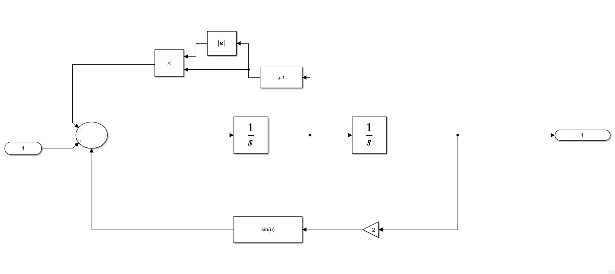

Then,

% simulink

qe = pi/6; qde = 0;

xe = trim("ex3_a")

[A, B, C, D] = linmod("ex3_a",xe)

|  |  |
| --- | --- |
| A = 2×2  0 1.0000  -1.5238 -2.0000 | B = 2×1  0  1 |
| C = 1×2  1 0 | D = 0 |

This agrees with our results done by hand.

(b)

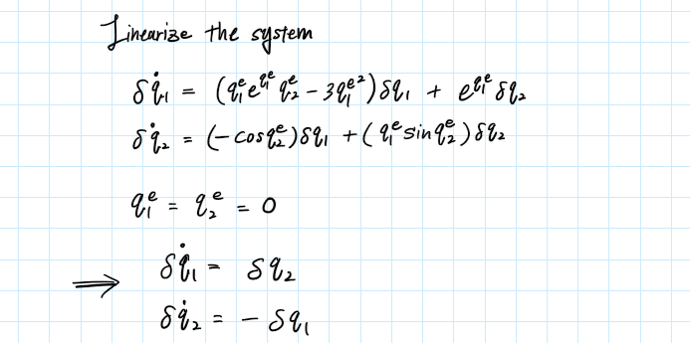

Then the matrix $A$ becomes

$$A=\left(\begin{matrix}0 & 1 \\ -1 & 0\end{matrix}\right)$$

The eigenvalues of the $A$ matrix is

$$\left(A-λI\right)=\left(\begin{matrix}-λ & 1 \\ -1 & -λ\end{matrix}\right)$$

$$det\left(A-λI\right)=λ^{2}+1$$

$$λ=±j.$$

Since the linearized system has an eigenvalue on the imaginary axis, it is unstable and unbounded. Thus, the nonlinear system is undetermined for an eigenvalue on the imaginary axis.

Verify this with Simulink

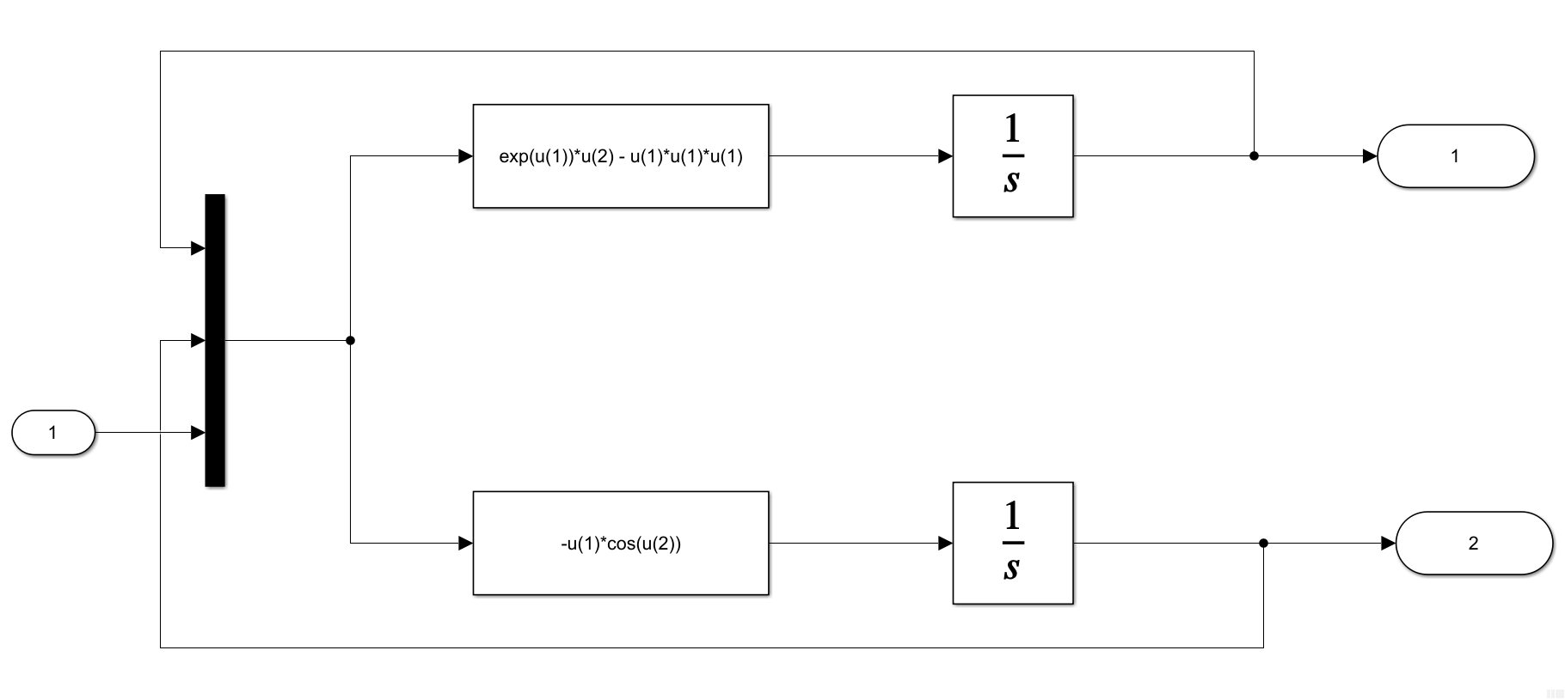

% simulink

xe = trim("ex3_b")

[A, B, C, D] = linmod("ex3_b",xe)

|  |  |
| --- | --- |
| A = 2×2  -0.0000 1.0000  -1.0000 0 | B = 2×1  0  0 |
| C = 2×2  1 0  0 1 | D = 0 |

This agrees with our results done by hand.

(c)

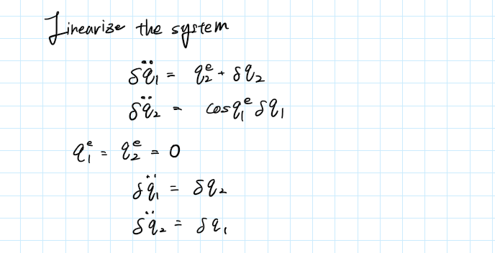

The $A$ matrix becomes

$$A=\left(\begin{matrix}0 & 0 & 1 & 0 \\ 0 & 0 & 0 & 1 \\ 0 & 1 & 0 & 0 \\ 1 & 0 & 0 & 0\end{matrix}\right)$$

The eigenvalues of the $A$ matrix is

$$\left(A-λI\right)=\left(\begin{matrix}-λ & 0 & 1 & 0 \\ 0 & -λ & 0 & 1 \\ 0 & 1 & -λ & 0 \\ 1 & 0 & 0 & -λ\end{matrix}\right)$$

$$det\left(A-λI\right)=λ^{4}-1$$

$$λ=±1, ±j.$$

Since the eigenvalue includes a positive real value the linearized system will grow exponentially and is unstable and unbounded. Thus, the nonlinear system is also unstable.

Verify with Simulink

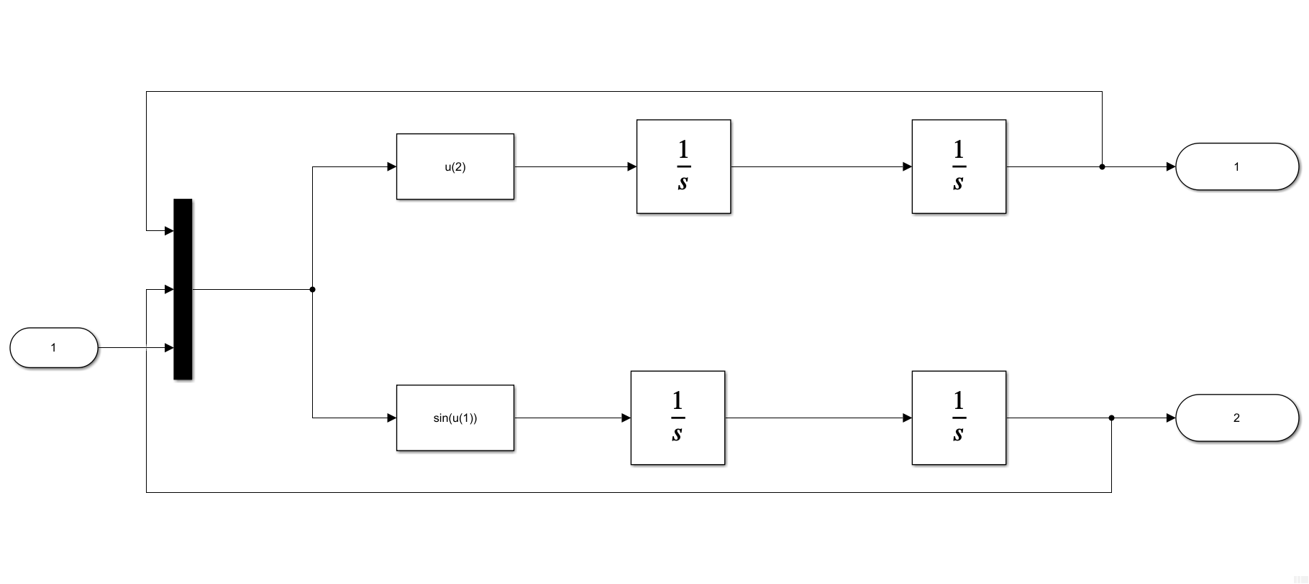

% simulink

xe = trim("ex3_c")

[A, B, C, D] = linmod("ex3_c",xe)

|  |  |
| --- | --- |
| A = 4×4  0 0 1.0000 0  0 0 0 1.0000  0 1.0000 0 0  1.0000 0 0 0 | B = 4×1  0  0  0  0 |
| C = 2×4  1 0 0 0  0 1 0 0 | D = 2×1  0  0 |

This agrees with our results done by hand.

**Exercise 4**

Determine the stability properties of the following system about the zero solution.

$$x_{1}\left(k+1\right)=x_{1}{\left(k\right)}^{3}+sin\left(x_{2}\left(k\right)\right)$$

$$x_{2}\left(k+1\right)=-\frac{1}{2}cos\left(x_{2}\left(k\right)\right)x_{1}\left(k\right)+x_{2}{\left(k\right)}^{3}$$

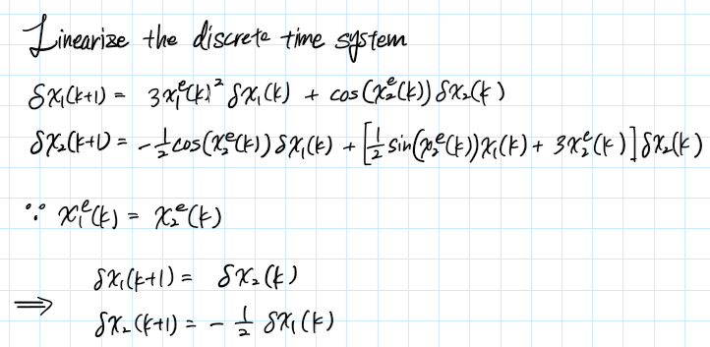



The nondefective $A$ matrix becomes

$$A=\left(\begin{matrix}0 & 1 \\ -0.5 & 0\end{matrix}\right)$$

The eigenvalues of the $A$ matrix is

$$\left(A-λI\right)=\left(\begin{matrix}-λ & 1 \\ -0.5 & -λ\end{matrix}\right)$$

$$det\left(A-λI\right)=λ^{2}+0.5$$

$$λ=±j0.7071 .$$

Since the eigenvalues are on the imaginary axis the linearized system is unstable but the nonlinear system is undetermined.

**Exercise 5**

Stability properties of the two pendulum cart system. Using MATLAB, determine the stability properties of the linearizations L1 and L2. What can you say about the stability properties of the nonlinear system about the corresponding equilibrium states?

Given parameters and initial and equilibrium conditions

$$E1: \left(y^{e},θ_{1}^{e},θ_{2}^{e}\right)=\left(0,0,0\right)$$

$$E2: \left(y^{e},θ_{1}^{e},θ_{2}^{e}\right)=\left(0,π,π\right)$$

|  |  |  |  |  |  |  |  |
| --- | --- | --- | --- | --- | --- | --- | --- |
|  | $$m_{0}$$ | $$m_{1}$$ | $$m_{2}$$ | $$l_{1}$$ | $$l_{2}$$ | $$g$$ | $$u$$ |
| P1 | 2 | 1 | 1 | 1 | 1 | 1 | 0 |
| P2 | 2 | 1 | 1 | 1 | 0.99 | 1 | 0 |
| P3 | 2 | 1 | 0.5 | 1 | 1 | 1 | 0 |
| P4 | 2 | 1 | 1 | 1 | 0.5 | 1 | 0 |

|  |  |  |
| --- | --- | --- |
| L1 | P1 | E1 |
| L2 | P1 | E2 |
| L3 | P2 | E1 |
| L4 | P2 | E2 |
| L5 | P3 | E1 |
| L6 | P3 | E2 |
| L7 | P4 | E1 |
| L8 | P4 | E2 |

The Simulink model used for this is shown below,

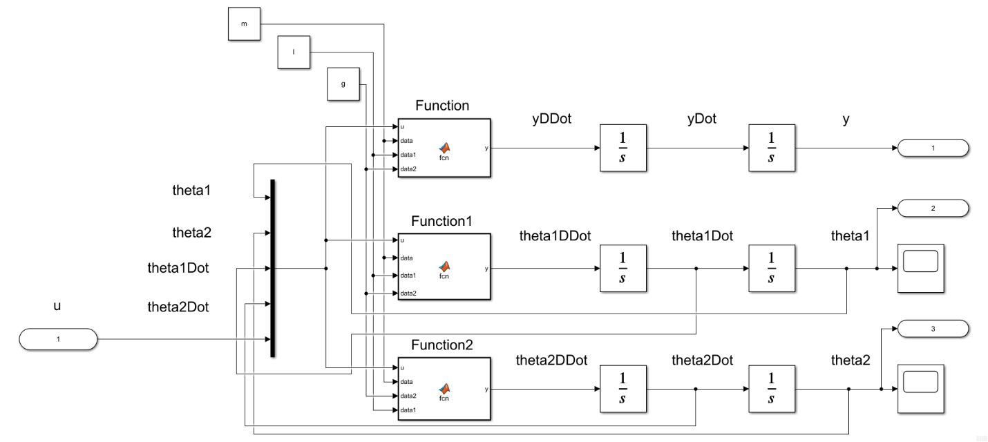

Embedded MATLAB Block – Function (code)

function y = fcn(u, data, data1, data2)

%{

EMBEDDED MATLAB BLOCK FUNCTION

%}

m0 = data(1); m1 = data(2); m2 = data(3); l1 = data1(1); l2 = data1(2);

g = data2;

num = -m1*l1*sin(u(1))*u(3)*u(3) - m2*l2*sin(u(2))*u(4)*u(4)...

- m1*g*sin(u(1))*cos(u(1)) - m2*g*sin(u(2))*cos(u(2))...

+ u(5);

den = m0 + m1 + m2 - m1*cos(u(1))^2 - m2*cos(u(2))^2;

y = num / den;

end

Embedded MATLAB Block – Function1 (code)

function y = fcn(u, data, data1, data2)

%{

EMBEDDED MATLAB BLOCK FUNCTION1

%}

m0 = data(1); m1 = data(2); m2 = data(3); l1 = data1(1); l2 = data1(2);

g = data2;

num = -(m1*l1*cos(u(1))*sin(u(1))*u(3)*u(3) + m2*l2*cos(u(1))*sin(u(2))*u(4)*u(4))...

+ m2*g*(sin(u(1))*cos(u(2))^2 - cos(u(1))*sin(u(2))*cos(u(2)))...

- (m0 + m1 + m2)*g*sin(u(1)) + u(5)*cos(u(1));

den = l1*(m0 + m1 + m2 - m1*cos(u(1))^2 - m2*cos(u(2))^2);

y = num / den;

end

Embedded MATLAB Block – Function2 (code)

function y = fcn(u, data, data2, data1)

%{

EMBEDDED MATLAB BLOCK FUNCTION2

%}

m0 = data(1); m1 = data(2); m2 = data(3); l1 = data1(1); l2 = data1(2);

g = data2;

num = -(m1*l1*cos(u(2,1))*sin(u(1))*u(3)*u(3) + m2*l2*cos(u(2))*sin(u(2))*u(4)*u(4))...

+ m1*g*(sin(u(2))*cos(u(1))^2 - cos(u(2))*sin(u(1))*cos(u(1)))...

- (m0 + m1 + m2)*g*sin(u(2)) + u(5)*cos(u(2));

den = l2*(m0 + m1 + m2 - m1*cos(u(1))^2 - m2*cos(u(2))^2);

y = num / den;

end

For the conditions E1 and E2, we set the initial conditions of the integrator block of y, $θ_{1}$, and $θ_{2}$ correspondingly to $y^{e},{ θ}_{1}^{e},{ θ}_{2}^{e}$; like in the following windows,

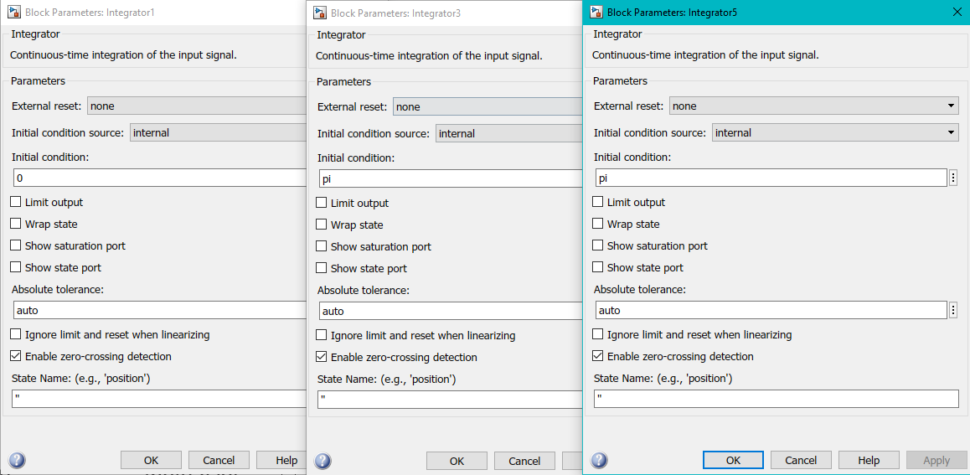

The code to run the linearization and eigenvalue computation is the following

% (a)

global m l g ye t1e t2e

param_combo = ["L1","L2"];

for i = 1:numel(param_combo)

define_params(param_combo(i));

[A, B, C, D] = linmod('db_pend_cart_lin');

lin_sys(i).Amat = A;

lin_sys(i).Bmat = B;

lin_sys(i).Cmat = C;

lin_sys(i).Dmat = D;

sys_ss = ss(A, B, C, D); % get the state space system

sys_tf = tf(sys_ss); % get the transfer function

lin_sys(i).eigVal = pole(sys_tf); % get the eigenvalues

end

function define_params(L)

% Function to define parameters

global m l g ye t1e t2e

if L == "L1"

m = [2,1,1]; l = [1,1]; g = 1; % P1

ye = 0; t1e = 0; t2e = 0; % E1

elseif L == "L2"

m = [2,1,1]; l = [1,1]; g = 1; % P1

ye = 0; t1e = pi; t2e = pi; % E2

elseif L == "L3"

m = [2,1,1]; l = [1,0.99]; g = 1; % P2

ye = 0; t1e = 0; t2e = 0; % E1

elseif L == "L4"

m = [2,1,1]; l = [1,0.99]; g = 1; % P2

ye = 0; t1e = pi; t2e = pi; % E2

elseif L == "L5"

m = [2,1,0.5]; l = [1,1]; g = 1; % P3

ye = 0; t1e = 0; t2e = 0; % E1

elseif L == "L6"

m = [2,1,0.5]; l = [1,1]; g = 1; % P3

ye = 0; t1e = pi; t2e = pi; % E2

elseif L == "L7"

m = [2,1,1]; l = [1,0.5]; g = 1; % P4

ye = 0; t1e = 0; t2e = 0; % E1

elseif L == "L8"

m = [2,1,1]; l = [1,0.5]; g = 1; % P4

ye = 0; t1e = pi; t2e = pi; % E2

else

print('error: did not match any')

end

end

The eigenvalues for the configurations L1 and L2 are

L1:

|  |  |
| --- | --- |
| A = 6×6  0 0 0 1.0000 0 0  0 0 0 0 1.0000 0  0 0 0 0 0 1.0000  0 -0.5000 -0.5000 0 0 0  0 -1.5000 -0.5000 0 0 0  0 -0.5000 -1.5000 0 0 0 | B = 6×1  0  0  0  0.5000  0.5000  0.5000 |
| C = 1×6  1 0 0 0 0 0 | **D = 0** |

|  |
| --- |
| eigVal = 6×1 complex  0.0000 + 0.0000i  0.0000 + 0.0000i  0.0000 + 1.4142i  0.0000 - 1.4142i  -0.0000 + 1.0000i  -0.0000 - 1.0000i |

L2:

|  |  |
| --- | --- |
| A = 6×6  0 0 0 1.0000 0 0  0 0 0 0 1.0000 0  0 0 0 0 0 1.0000  0 -0.5000 -0.5000 0 0 0  0 1.5000 0.5000 0 0 0  0 0.5000 1.5000 0 0 0 | B = 6×1  0  0  0  0.5000  -0.5000  -0.5000 |
| C = 1×6  1 0 0 0 0 0 | **D = 0** |

|  |
| --- |
| eigVal = 6×1  0  0  -1.4142  -1.0000  1.4142  1.0000 |

From the linearized models we can see that L1 has eigenvalues on the imaginary axis. Thus, the linearized model is unstable and unbounded. However, for the nonlinear model the stability is undetermined.

Whereas for L2 there are positive real values that blow up the linearized system. This means that the linearized system is unstable and unbounded, and the nonlinear model is also unstable and unbounded.

|  |  |  |
| --- | --- | --- |
|  | Linear | Nonlinear |
| L1 | unstable | undetermined |
| L2 | unstable | unstable |